

**Important! Keep in mind that the purpose of writing this document is to showroom your skills, abilities, and accomplishments.**

[**G-Architech website**](https://softarchitech.cs.grinnell.edu/)

1. **Permission to add to the G-ArchiTech website**
   1. Do you give us permission to post the materials from this page into the course online presence G-ArchiTech? Either way is fine. Every team member must provide their decision. If one or more group members does not agree, do you want the project to be shared without your name on it or not at all?
   2. Mae Bernacchi – I give permission.
   3. Zitan Wang - I give permission.
   4. Pyait Myat – I give permission.
   5. Brian Sung - I give permission.
2. **Project title** 
   1. GCIEL Viking Longship Virtual Reality Project Design Document
3. **Group name**
   1. Design Document Team
4. **Link to your application**
   1. [Design Document](https://docs.google.com/document/d/1ahpt8RlQ58NMocUhqjjqLX6mTlBZTGIRhK_KIxh_9O8/edit?usp=sharing)
5. **Relevant Skills**
   1. User Experience Models, UML Diagram Creations, Virtual Reality Experience
6. **Project Summary. What is this project about?**
   1. The Virtual Viking Longship Virtual Reality Experience is a digital humanities-based project that will be looking at the outcome of a long-term digital humanities research project. For this project to begin, there need to be blueprints that lay out the groundwork for how the user will interact with the digital environment. The Design Document will hold all the necessary information about the project and allow for a universal understanding among the development team of the vital parts that make up the virtual experience. It will also act as an ever-growing train of thought since as the project develops, the document can always be altered to adapt to changes made. With an ever-changing document, it acts as the medium of communication for design decisions that can be easily referenced by both stakeholders and the development team.
7. **Relevant tags**
   1. Design Document, Viking Longship, UML Diagrams, Virtual Reality
8. **Add a screenshot of the app developed by your group.**

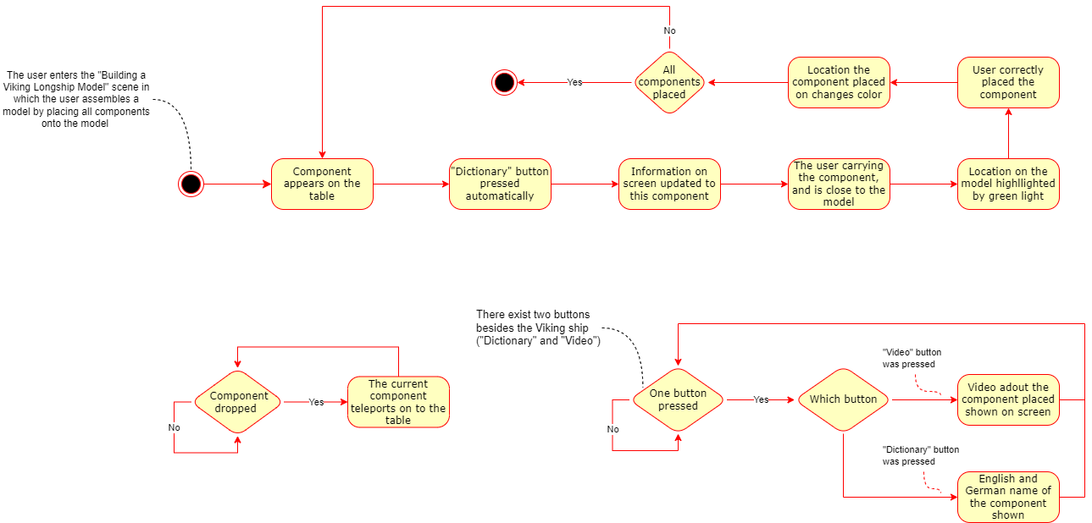

Figure 1. Build the Viking Longship (Model) Scene

1. **End Product**
   1. What is this project about? What are the goals/vision for this project?
      1. Our project is the beginning steps of the Viking Longship Virtual Reality Experience, creating the guidelines upon which an entire educational experience will be based. Our goal for the project was to outline the most basic user actions and create diagrams that describe the basic steps taken by the user. This will give the development team and stakeholders a place to reference the baseline steps and add onto the diagrams, giving the stakeholders and development team a clear understanding of the work being done.
   2. Talk a bit about your audience.
      1. Our audience is the development team of the Virtual Viking Longship Project. They will find the information given most useful, though some who might be interested in the user interactivity methods within this project might also find the information interesting.
   3. Show and describe your process to develop your app.
      1. Talk with our community partner (David) to understand what his expectation of this project is, and some details of what has been done.
      2. Play around with existing VR games to learn how they have designed hand controllers so to make control intuitive to the users. So, we can adopt so good ones and try to avoid some bad ones.
      3. Do brainstorming and bodystorming to design how the experience control and different scenes should be designed.
      4. Communicate with David and the development team asking for their suggestions on the design choices we have made, and then revise accordingly.
      5. Repeat step iii and iv repetitively until the design was finished.
      6. Summarize what we have down into the design document.
   4. Talk about your challenges and achievements.
      1. The biggest challenge we faced as a group was that there was not a lot of development in terms of the virtual reality experience, especially at the beginning of our process. We were working off of little in terms of what the development team wanted, as there had not been many hard decisions made. Given this situation, we were able to create many of the basic ways that the user goes about interacting with the virtual environment. What had initially seemed like a setback gave us a lot of creative freedom, which was unexpected, but not disliked.
   5. **Future work**. If you were to continue this project, what would be the next steps?
      1. Given that we have finished how experience control and the general flow and layout of the “Building a Viking Longship Model Scene”, our next step should be focused on the details of the tutorial scene, for which we only have a general flow. Therefore, we should go into each step of the tutorial scene to make them explicit. These details include data collection, preferences selections, walkthrough for moving, picking and dropping objects and assembling the model. Also, the layout of the tutorial scene should also be designed.
      2. Besides this, since this is an immersive experience, we need this game to be as accessible and intuitive as possible, which has the potential for future refinement given we have already had some. Therefore, these two aspects should also be addressed in the future.
   6. Images:

Figure 2. General flow of the tutorial scene

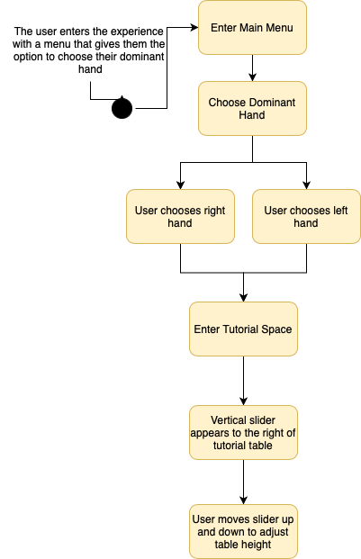

Figure 3. Accessibility - Choosing the Dominant and Non-Dominant Hand Controllers & Adjusting Table Heights

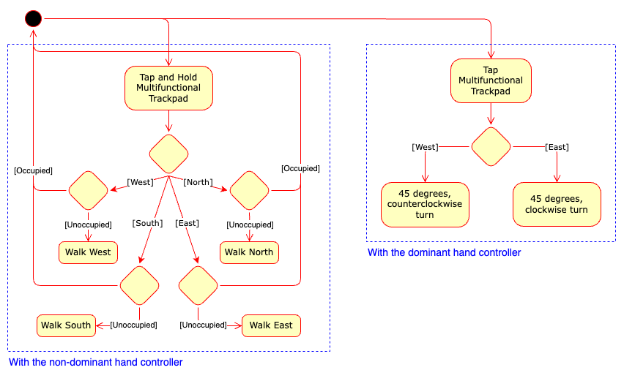

Figure 4. Moving - Walking and Turning

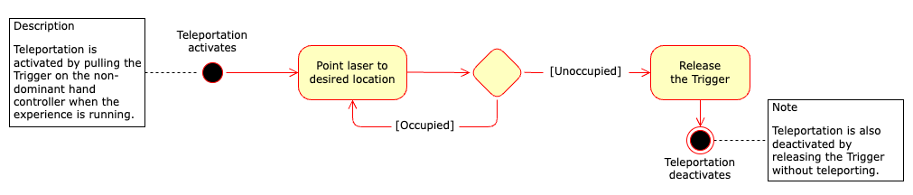

Figure 5. Moving - Teleporting

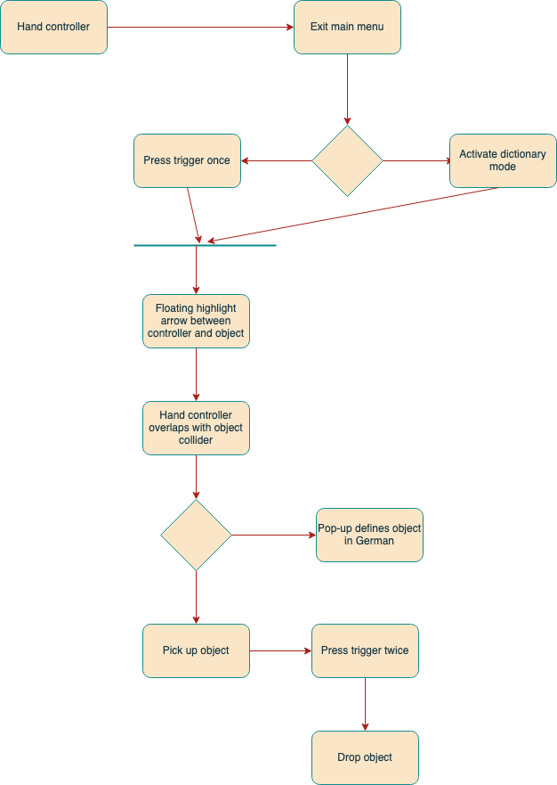

Figure 6. Picking Up and Dropping Objects

1. **Acknowledgements**
   1. Thank you to David Neville for helping us through the entire process of creating the design document, as your input led us to embrace the creative process and think outside the box.
   2. Thank you to Professor Jimenez for giving us the much-needed assistance on how to keep on track while also working on the creative process. Without her guidance we would not have achieved many of our goals.