RIT-Dubai Fall 2023

GCIS-123

Class Activity & Problem Solving #02

Turtle Drawing

## Goals of the Assignment

The goal of this assignment is to give you more practice using while loops and basic string processing. You will write a basic command-line interface that will prompt the user to enter strings of characters, and will interpret those strings into works of pixel art.

## Activities (20% for each step)

1. Please note that you will be expected to use ***test-driven development*** (***TDD***) to the extent that it is possible to do so, at least for the functions in your pixart module.
2. Create a new Python module for this assignment in a file named “checkers.py”. When this module is executed it should use your pixart module to draw a 20x20 checkerboard like the one shown in the image below.

***Hint***: consider writing a helper function that can draw a single row of pixels in alternating colors.

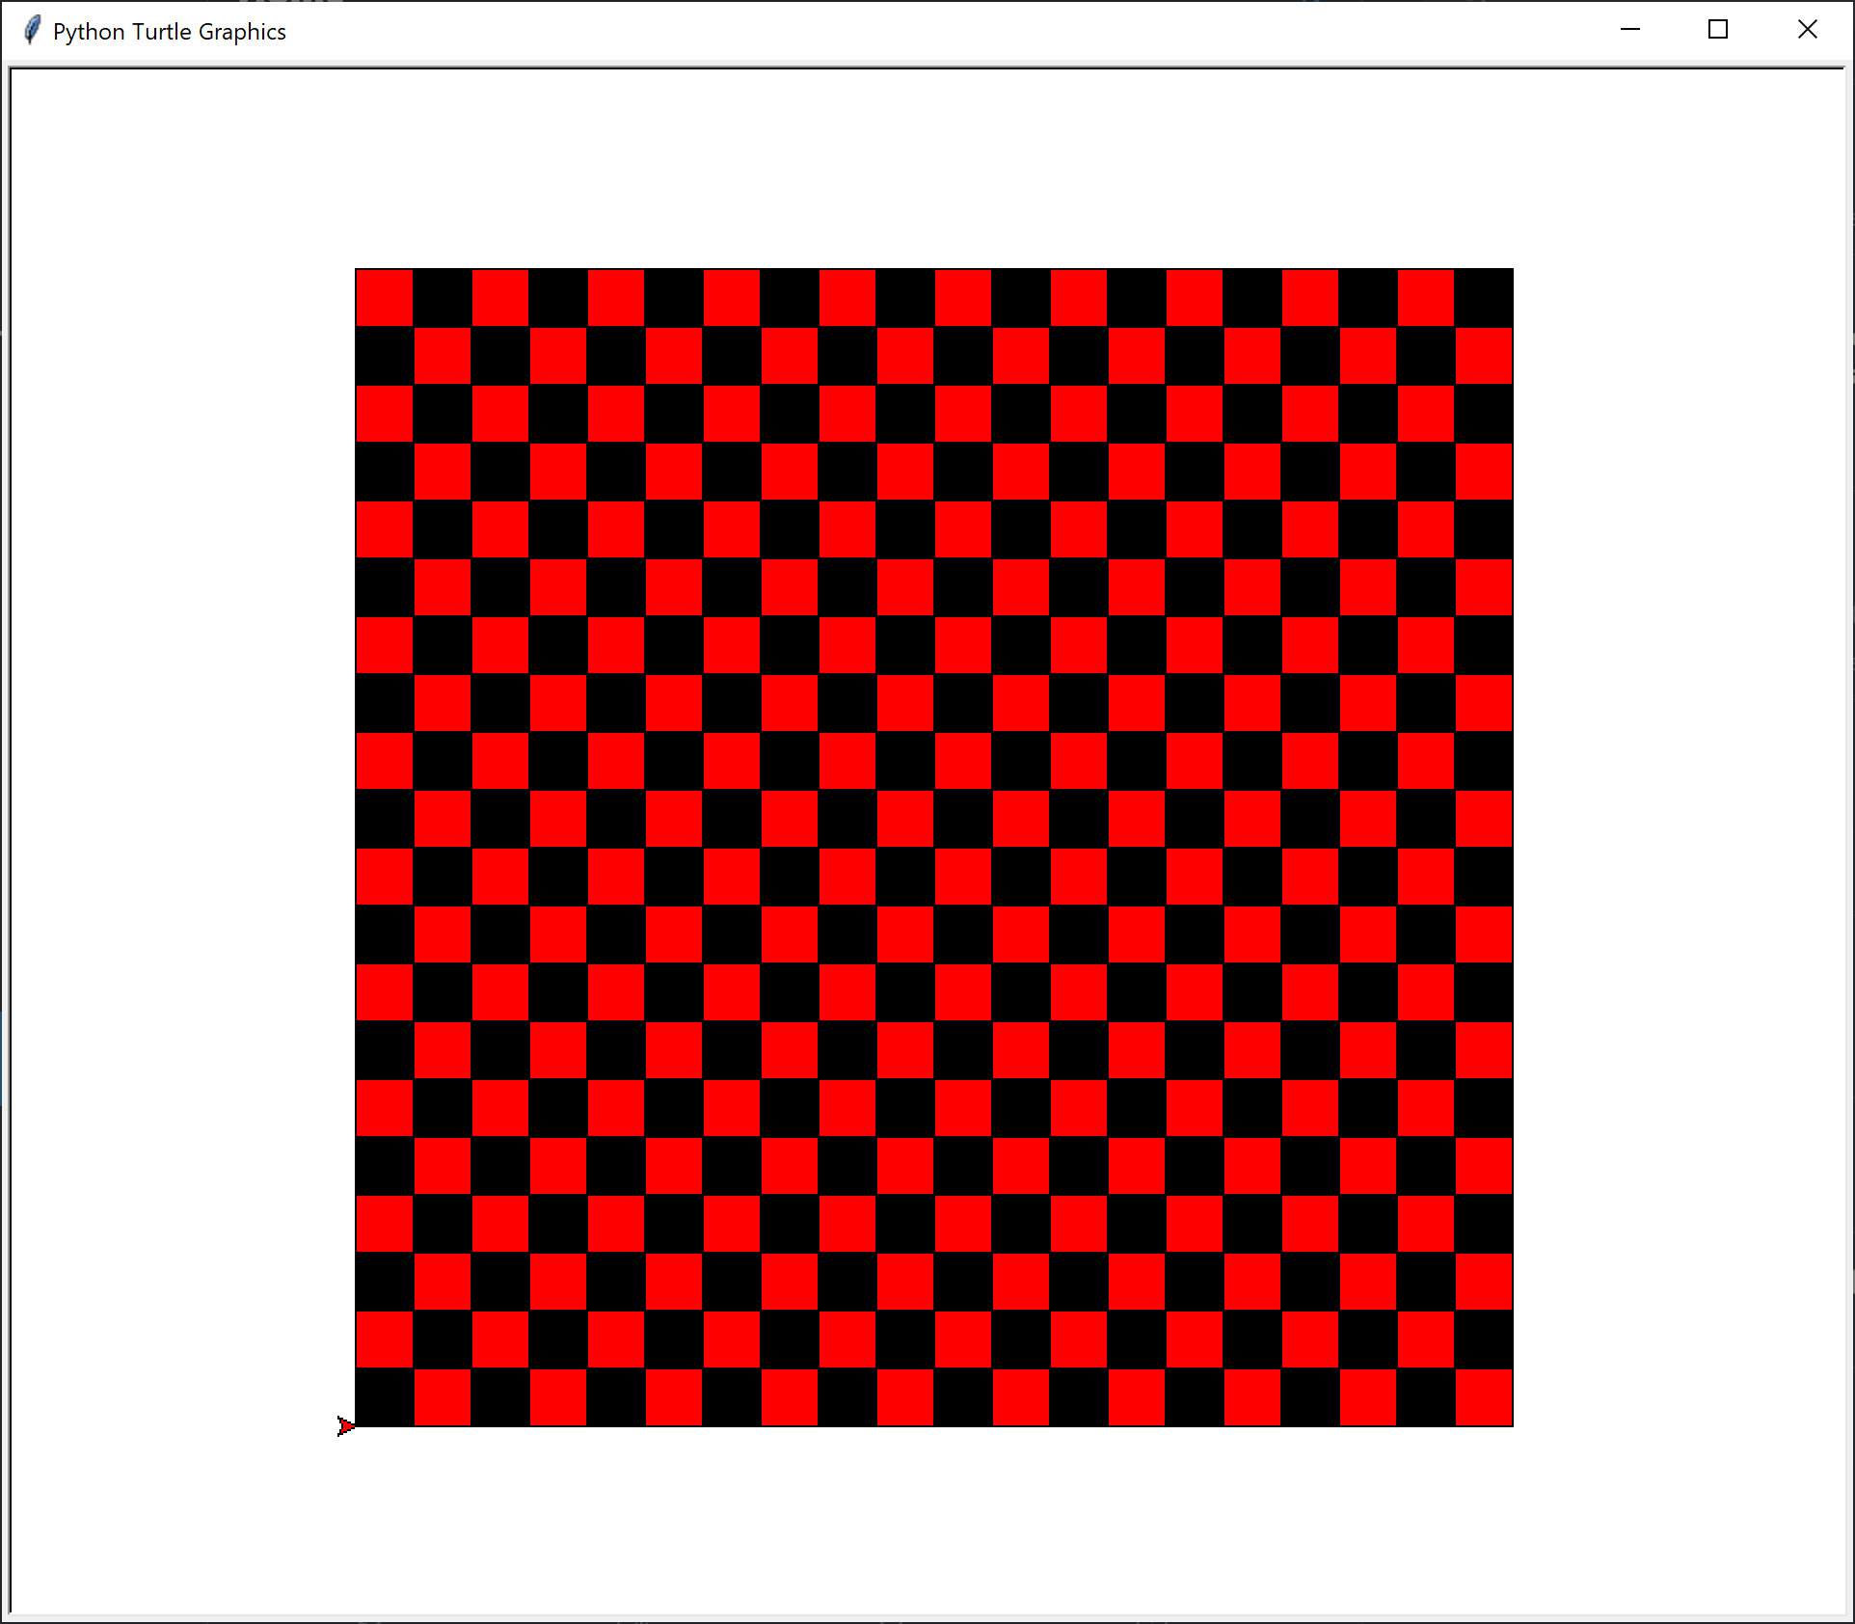

1. Add a separate function to your pixart module for each of the colors in the table below that draws a pixel of that color. For example, draw_green_pixel() would draw a single green pixel. You may add other colors if you wish.

|  |  |  |
| --- | --- | --- |
| **Character** | **Turtle Color** | **Color** |
| 0 | 'black' |  |
| 1 | 'white' |  |
| 2 | 'red' |  |
| 3 | 'yellow' |  |
| 4 | 'orange' |  |
| 5 | 'green' |  |
| 6 | 'yellowgreen' |  |
| 7 | 'sienna' |  |
| 8 | 'tan' |  |
| 9 | 'gray' |  |
| A | 'darkgray' |  |

1. Create a new Python module in a file named “drawings.py” Add a function that, given a string, will draw one pixel for each character in the string that corresponds to one of the colors in the table above. For example, given the string '01A753421' your function should produce a row of pixels like the one shown in the image below. If the string contains an invalid color, your function should stop drawing immediately and return False. If all of the colors are valid, return True after all of the pixels have been drawn.

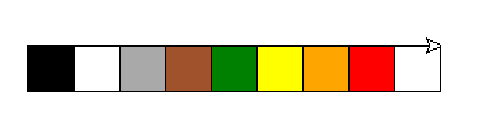

1. Add a function to your drawings module that uses a loop to prompt the user to enter color strings. For each string that the user enters, use the function that you wrote in the previous activity to draw the corresponding sequence of colored pixels. You should always move to the start of the next row after drawing a string of pixels. Your function should continue prompting the user until:

a.) an invalid color is entered, or

b.) the user enters an empty string.

***Hint***: Manually test your function with small sequences of pixels to start. Once you are confident that it is working, copy and paste the contents of the provided *drawingXX.txt* files into the prompt and compare your results with the images below.

***Note****: You* **do not** *need to type colors into the prompt manually. Each of the images below was created by opening the corresponding text file, selecting all of the text (CTRL-A), copying all of the text (CTRL-C), and then pasting all of the text into the prompt (CTRL-V).*

|  |  |
| --- | --- |
| drawing01.txt | drawing02.txt |
|  | *This image is larger than 20x20 and will not be centered on the turtle’s canvas.* |
|  |  |
| drawing03.txt | drawing04.txt |
|  |  |

**Challenge:** refactor your production code to prompt the user for the name of the text file, read the content of the text file and generate the image.

## Submission Instructions

* + - 1. Include the appropriate internal-documentation (i.e. comments & docstring)
      2. Upload **ALL the file (including the provided text files)** to the MyCourses Assignment box as (Activity02.zip) (only one team-member needs to submit to MyCourses)
      3. Be sure that you have pushed **ALL the file (including the provided text files)** to your GitHub repository (**for each team-member**). Link to Assignment: [add link here]