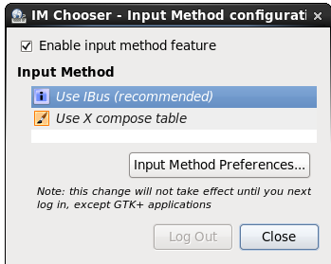

1. 检查ibus
2. 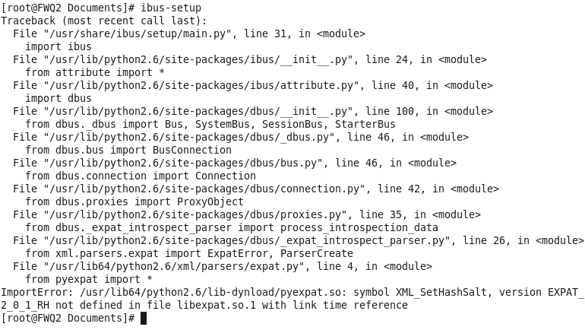将找不到的库添加进环境变量

# vi /etc/profile

export LD_LIBRARY_PATH=/usr/lib64/python2.6/lib-dynload

# source /etc/profile

1. Input Method --> chines -->pinyin -->Add -->close

Ctrl +空格 切换输入法.

测试搞定！

# gnome-screenshot -a 可以任意截屏.

System -->Preference -->Keyboard Shortcuts -->Add,

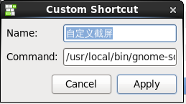

Apply 发现是全屏截图

解决：# touch /usr/local/bin/gnome-screenshot

写下以下内容.

#!/bin/bash

sleep 0.3

exec /usr/bin/gnome-screenshot -a

将/usr/local/bin/gnome-screenshot 填入Command. -->Apply

测试可以任意截屏.