武汉纺织大学

Java应用开发课程设计

**EMS物流下单程序**

**学 院： 数学与计算机学院**

**班 级： 物联网11801**

**姓 名： 刘广川**

**学 号： 1814260214**

**指导老师： 聂刚**

**成 绩：**

**完成日期： 2020年6月14日**

目录

1 需求分析 1

2 系统设计 1

3 系统实现 1

3.2 配置文件 2

3.2.1 订单文件 2

3.3 用户界面Driver.java 2

3.4 ExpressWaybill.java 6

3.5 MatrixToImageWriter.java 8

4 系统测试 9

11

5 系统总结 11

# 1 需求分析

从Excel文件中读取订单数据，生成如下样式的EMS物流面单图片文件（程序生成订单号，规则yyyyMMddhhmmssSSS+三位随机号），并将图片文件转换为pdf文件。



**2 系统设计**

ExpressWayBill

(物流单类)

makeQRCode

(生成二维码JPG)

expList

(物流单集合)

jpgToPdf

(将二维码jpg转为pdf)

crearOrderNum

(产生订单号)

ReadExc

(读取Excel文件)

Driver

Excel文件

(订单文件)

**3 系统实现**

3.1 项目结构

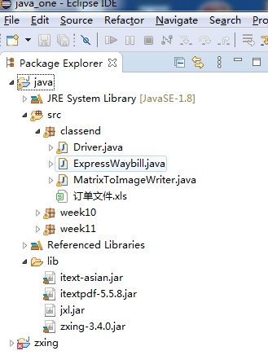

## 3.2 配置文件

在java项目下新建classend Folder，名为classend

### 3.2.1 订单文件

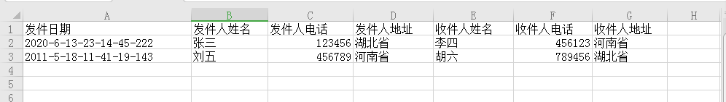

## 3.3 用户界面Driver.java

描述该文件作用，并对里面的关键代码进行解释

**package** classend;

**import** java.io.File;

**import** java.io.FileNotFoundException;

**import** java.io.FileOutputStream;

**import** java.io.IOException;

**import** java.net.MalformedURLException;

**import** java.util.ArrayList;

**import** java.util.HashMap;

**import** java.util.Map;

**import** java.util.regex.Matcher;

**import** java.util.regex.Pattern;

**import** javax.swing.event.DocumentListener;

**import** javax.swing.event.UndoableEditListener;

**import** javax.swing.text.AttributeSet;

**import** javax.swing.text.BadLocationException;

**import** javax.swing.text.Document;

**import** javax.swing.text.Element;

**import** javax.swing.text.Position;

**import** javax.swing.text.Segment;

**import** com.google.zxing.BarcodeFormat;

**import** com.google.zxing.EncodeHintType;

**import** com.google.zxing.MultiFormatWriter;

**import** com.google.zxing.WriterException;

**import** com.google.zxing.common.BitMatrix;

**import** com.itextpdf.text.DocumentException;

**import** com.itextpdf.text.Image;

**import** com.itextpdf.text.PageSize;

**import** com.itextpdf.text.pdf.PdfWriter;

**import** jxl.Cell;

**import** jxl.Sheet;

**import** jxl.Workbook;

**import** jxl.read.biff.BiffException;

**public** **class** Driver {

**public** **static** **void** main (String[] args) **throws** BiffException, IOException, WriterException, DocumentException{

ArrayList<ExpressWaybill> expList = **new** ArrayList<ExpressWaybill>();//创建快递单集

expList = *getExpList*();

*creatOrderNum*(expList);

*makeAll*(expList);

System.***out***.println(expList);

}

**public** **static** ArrayList<String> readExc() **throws** BiffException, IOException{//读取exc信息

//创建workbook

Workbook workbook = Workbook.*getWorkbook*(**new** File("C:\\Users\\Administrator\\eclipse-workspace\\java_one\\java\\src\\classend\\订单文件.xls"));

//获取第一个工作表

Sheet sheet = workbook.getSheet(0);

ArrayList<String> infList = **new** ArrayList<String>();//创建物流字符串集

String inf = "";//单个物流信息

**for** (**int** i = 1; i < sheet.getRows(); i++) { //行

**for** (**int** j = 0; j < sheet.getColumns(); j++) { //列

Cell cell = sheet.getCell(j,i);

inf += cell.getContents()+"\n";

}

infList.add(inf);

inf = "";

}

workbook.close();

**return** infList;

}

**public** **static** ArrayList<ExpressWaybill> getExpList() **throws** BiffException, IOException {//得到全部快递单集

ArrayList<String> infList = **new** ArrayList<String>();//创建物流字符串集

ArrayList<ExpressWaybill> expList = **new** ArrayList<ExpressWaybill>();//创建快递单集

infList = *readExc*();

**for** (**int** i = 0; i < infList.size(); i++) {

expList.add(*getExpressWaybill*(infList.get(i)));

}

**return** expList;

}

**public** **static** ExpressWaybill getExpressWaybill(String inf) {//得到单个快递单信息

ExpressWaybill exp = **null**;

Pattern pattern = Pattern.*compile*("(.*)\\n(.*)\\n(.*)\\n(.*)\\n(.*)\\n(.*)\\n(.*)");

Matcher matcher = pattern.matcher(inf);

**if** (matcher.find()) {

exp = **new** ExpressWaybill(matcher.group(1), matcher.group(2), matcher.group(3), matcher.group(4), matcher.group(5), matcher.group(6), matcher.group(7));

}

**return** exp;

}

**public** **static** **void** creatOrderNum(ArrayList<ExpressWaybill> expList) {//产生订单号

**for** (**int** i = 0; i < expList.size(); i++) {

String randomNum = "";//随机数

**for** (**int** j = 0; j < 3; j++) {

**int** num = (**int**)(Math.*random*()*10);

randomNum += num+"";

}

Pattern pattern = Pattern.*compile*("-");

Matcher matcher = pattern.matcher(expList.get(i).getDate());

String orderNum = matcher.replaceAll("")+randomNum;//订单号

expList.get(i).setOrderNum(orderNum);

}

}

**public** **static** File makeQRCode(ExpressWaybill exp) **throws** WriterException, IOException {

String content = ""; //二维码内容

String path = "C:\\Users\\Administrator\\eclipse-workspace\\java_one\\java\\src\\classend";//存放地址

MultiFormatWriter multiFormatWriter = **new** MultiFormatWriter();

Map hints = **new** HashMap();

hints.put(EncodeHintType.***CHARACTER_SET***, "UTF-8");

content = exp.toString();

String fileName = exp.getOrderNum()+".jpg";

BitMatrix bitMatrix = multiFormatWriter.encode(content, BarcodeFormat.***QR_CODE***, 200, 200,hints);

File file = **new** File(path,fileName);

MatrixToImageWriter.*writeToFile*(bitMatrix, "jpg", file);

**return** file;

}

**public** **static** **void** makeAll(ArrayList<ExpressWaybill> expList) **throws** WriterException, IOException, DocumentException {

**for** (**int** i = 0; i < expList.size(); i++) {

*jpgToPdf*(*makeQRCode*(expList.get(i)));

//makeQRCode(expList.get(i));

}

}

**public** **static** **void** jpgToPdf(File file) **throws** DocumentException, MalformedURLException, IOException {

com.itextpdf.text.Document document = **new** com.itextpdf.text.Document(PageSize.***A4***, 50, 50, 50, 50);

String fileName = file.getName();

fileName = fileName.replaceAll(".jpg", "");

String path = "C:\\Users\\Administrator\\eclipse-workspace\\java_one\\java\\src\\classend\\"+fileName+".pdf";

PdfWriter writer = PdfWriter.*getInstance*(document,**new** FileOutputStream(path));

document.open();

Image image = Image.*getInstance*(file.getPath());

document.add(image);

document.close();

writer.close();

}

}

document.add(image);

document.close();

writer.close();

}

}

## 

## 3.4 ExpressWaybill.java

**package** classend;

**public** **class** ExpressWaybill {

**private** String date; //发件日期

**private** String consignerName; //发件人姓名

**private** String consignerTel; //发件人电话

**private** String consignerAddress; //发件人地址

**private** String recipientName; //收件人姓名

**private** String recipientTel; //收件人电话

**private** String recipientAddress; //收件人地址

**private** String orderNum; //订单号

**public** ExpressWaybill(String date, String consignerName, String consignerTel, String consignerAddress, String recipientName, String recipientTel, String recipientAddress) {

setDate(date);

setConsignerName(consignerName);

setConsignerTel(consignerTel);

setConsignerAddress(consignerAddress);

setRecipientName(recipientName);

setRecipientTel(recipientTel);

setRecipientAddress(recipientAddress);

**this**.orderNum = **null**;

}

**public** String toString() {

**return** "ExpressWaybill [date=" + date + ",\n consignerName=" + consignerName + ",\n consignerTel=" + consignerTel

+ ",\n consignerAddress=" + consignerAddress + ",\n recipientName=" + recipientName + ",\n recipientTel="

+ recipientTel + ",\n recipientAddress=" + recipientAddress + ",\n orderNum=" + orderNum + "]\n";

}

**public** String getDate() {

**return** date;

}

**public** **void** setDate(String date) {

**this**.date = date;

}

**public** String getConsignerName() {

**return** consignerName;

}

**public** **void** setConsignerName(String consignerName) {

**this**.consignerName = consignerName;

}

**public** String getConsignerTel() {

**return** consignerTel;

}

**public** **void** setConsignerTel(String consignerTel) {

**this**.consignerTel = consignerTel;

}

**public** String getConsignerAddress() {

**return** consignerAddress;

}

**public** **void** setConsignerAddress(String consignerAddress) {

**this**.consignerAddress = consignerAddress;

}

**public** String getRecipientName() {

**return** recipientName;

}

**public** **void** setRecipientName(String recipientName) {

**this**.recipientName = recipientName;

}

**public** String getRecipientTel() {

**return** recipientTel;

}

**public** **void** setRecipientTel(String recipientTel) {

**this**.recipientTel = recipientTel;

}

**public** String getRecipientAddress() {

**return** recipientAddress;

}

**public** **void** setRecipientAddress(String recipientAddress) {

**this**.recipientAddress = recipientAddress;

}

**public** String getOrderNum() {

**return** orderNum;

}

**public** **void** setOrderNum(String orderNum) {

**this**.orderNum = orderNum;

}

}

## 3.5 MatrixToImageWriter.java

**package** classend;

**import** com.google.zxing.common.BitMatrix;

**import** javax.imageio.ImageIO;

**import** java.io.File;

**import** java.io.OutputStream;

**import** java.io.IOException;

**import** java.awt.image.BufferedImage;

**public** **final** **class** MatrixToImageWriter {

**private** **static** **final** **int** ***black*** = 0xFF000000;

**private** **static** **final** **int** ***white*** = 0xFFFFFFFF;

**private** MatrixToImageWriter() {}

**public** **static** BufferedImage toBufferedImage(BitMatrix matrix) {

**int** width = matrix.getWidth();

**int** height = matrix.getHeight();

BufferedImage image = **new** BufferedImage(width, height, BufferedImage.***TYPE_INT_RGB***);

**for** (**int** x = 0; x < width; x++) {

**for** (**int** y = 0; y < height; y++) {

image.setRGB(x, y, matrix.get(x, y) ? ***black*** : ***white***);

}

}

**return** image;

}

**public** **static** **void** writeToFile(BitMatrix matrix, String format, File file) **throws** IOException {

BufferedImage image = *toBufferedImage*(matrix);

**if** (!ImageIO.*write*(image, format, file)) {

**throw** **new** IOException("Could not write an image of format " + format + " to " + file);

}

}

}

# 

# **4 系统测试**

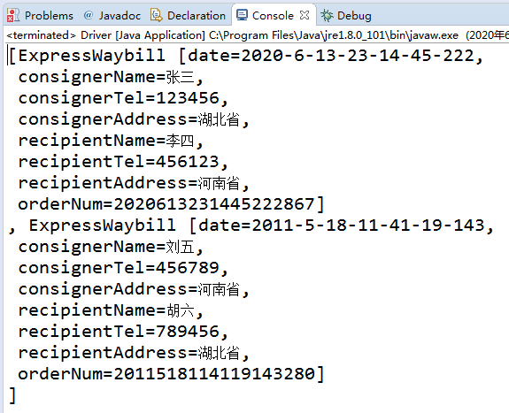

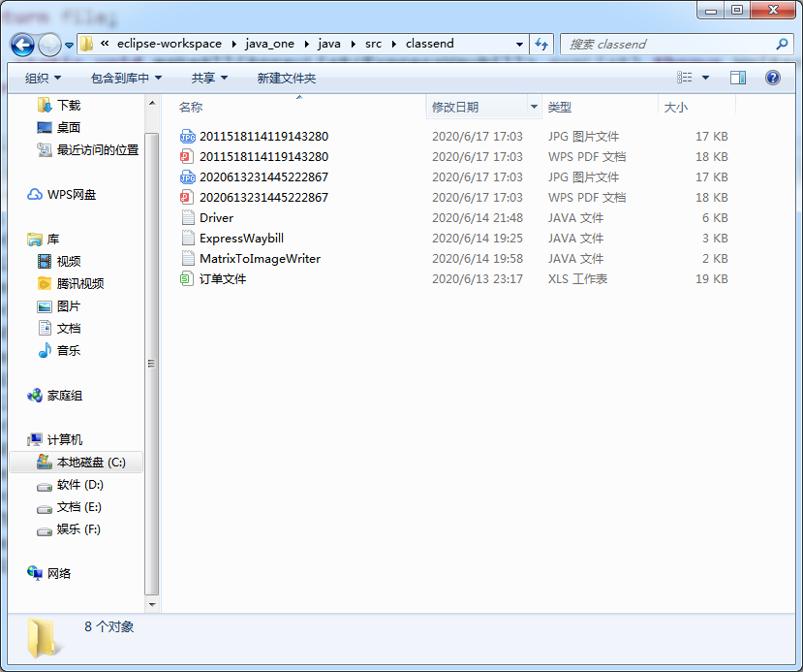

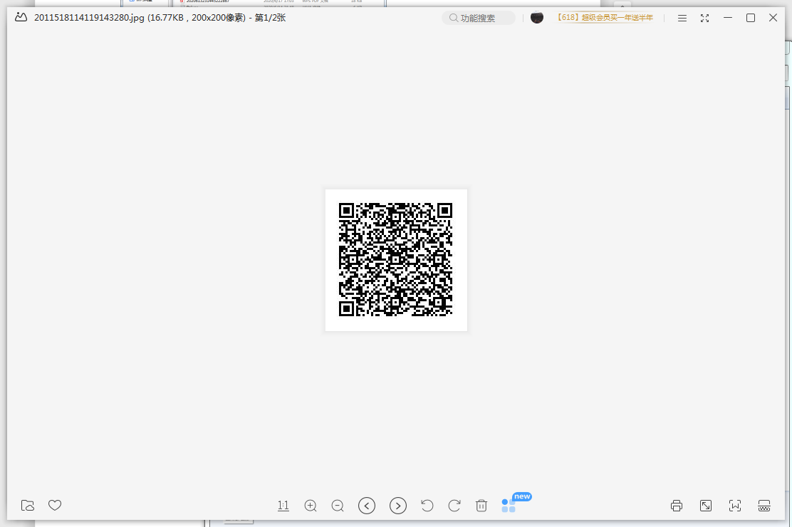

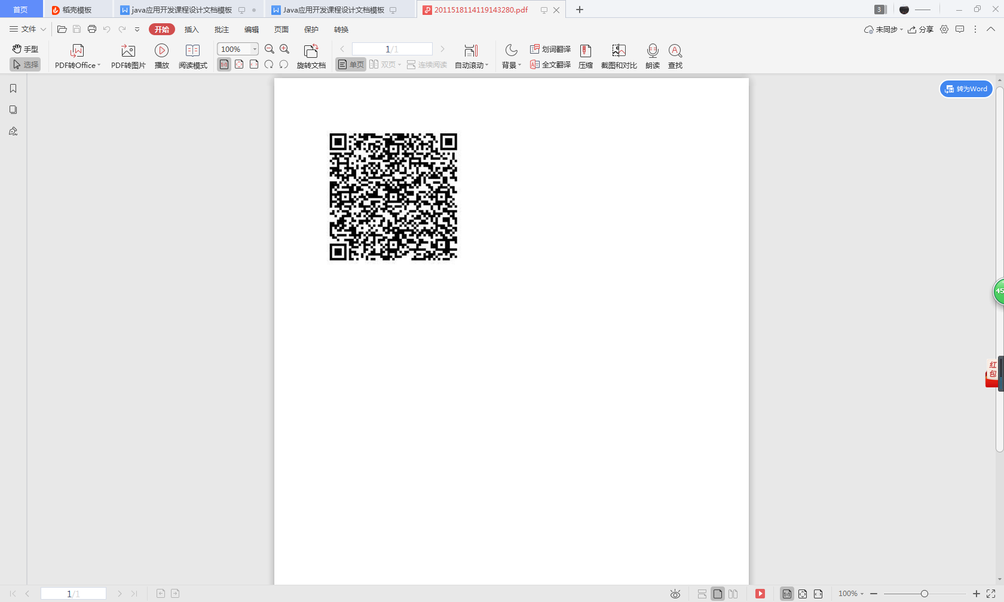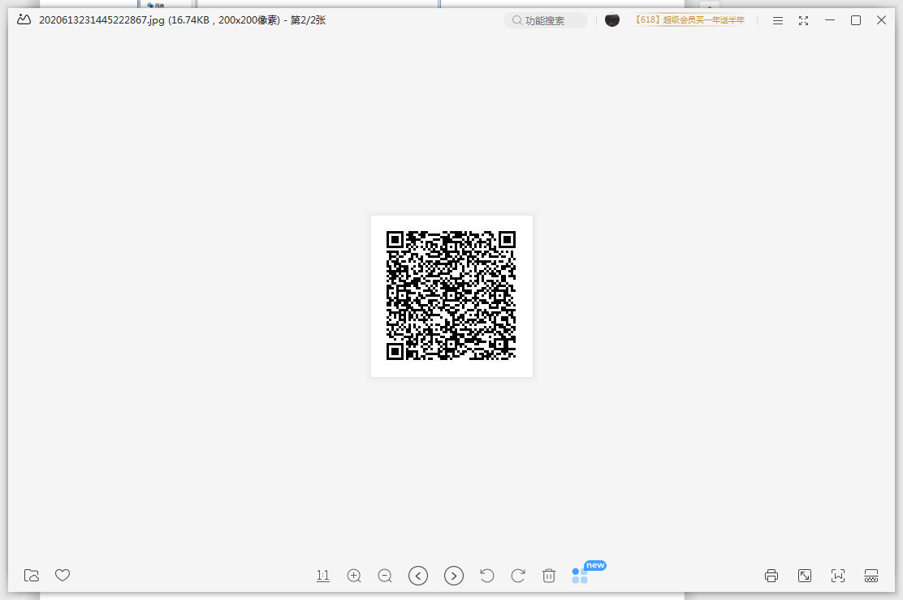

# 

# **5 系统总结**

掌握了java通过Excel文件数据创造二维码的技巧,同时也掌握了JPG文件转为PDF文件.

自评成绩:85.