# Welcome to the Esri Shortlist template

Introduction 2

1. Create the ArcGIS web map for your Shortlist application 3

2. Install the application 10

3. Configure the application 11

Samples folder 15

Tips 16

## Introduction

This template enables you to publish a web map as an easy-to-use, attractive map application that enables people to discover a small number of places of interest in an area. Users can browse the places in a series of tabs next to the map, each showing a particular set of places based on a theme. Places are listed with images to make the browsing experience fun and attractive. When users see a place they are interested in, they can click (or tap) on the place in the tab, and a popup will show its location on the map. Users also click or tap on a place directly on the map to get the popup about it. As users navigate around the map, the list of places shown in the tab updates to show them places in the current map extent, so the experience is similar to travelling around in the real world and discovering new places. So if a user navigates to a particular location, the tabs just show places in that location. Here's an example, the [San Diego Shortlist](http://storymaps.esri.com/stories/shortlist-sandiego/).

Potential uses of this template include: displaying a selection places that you recommend in an area, like a state or a city, a city agency can showcase the location of planning initiatives, a state tourism agency can highlight key activities and attractions, an environmental agency can display its projects and show off its successes and places where there are still issues.

Have a look at some examples of shortlists that have been created by other authors to get some ideas for your shortlist. You can filter the gallery of Esri story maps: <http://storymaps.esri.com> and the Community story map gallery: <http://storymaps.esri.com/partnerstories/> to just view shortlists by typing 'shortlist' into the 'search box' on those pages. To see more examples, the following query in ArcGIS Online returns all the web mapping application entries that have 'shortlist' in their metadata, sorted by date with the most recent first, so it provides a useful list of some of the latest shortlist apps that authors have created: <http://www.arcgis.com/home/search.html?q=shortlist&t=content&sortField=modified&sortOrder=desc&focus=applications-web>

The template is designed to be used in any web browser. It fits nicely on the iPad and iPad Mini when they are held in landscape (lengthways) orientation but doesn't work well on smartphones or on tablets held in portrait orientation. We would like to enhance the template in the future to add support for those.

This template can be deployed by anyone who has access to a website or web server on which they can install the template. (We do provide a [limited generic hosted version of the template](http://storymaps.esri.com/templates/shortlist/?webmap=8504932f183c4b8699dc6ba28235e398) that can be used to display a shortlist but as it doesn't support customization its main use is for testing, teaching or demos).

The web map you use in the application is created and hosted on ArcGIS Online. You author this map using ArcGIS Online, Esri's online GIS and mapping system. There's no software to install. You can access ArcGIS Online at <http://www.arcgis.com/home/> with either a free public account (for use by individuals, small non-profits, in education, etc.) or an ArcGIS organizational subscription (commercial and government use). To create your web map that will be displayed using the Shortlist template, you have to upload the point features that represent your places into your web map as files. You can use shapefiles or text files (such as CSV, TXT and GPX files). In other words, you use the standard, functionality available in ArcGIS Online for uploading file-based features into your web map. The only other ArcGIS software that is recommended to make a Shortlist map is ArcGIS Desktop, which makes it easy to create and manage shapefiles. But ArcGIS Desktop isn't required because you could upload your point feature data as text files instead of as shapefiles. This means that is very easy for anyone to create a Shortlist map.

## 1. Create the ArcGIS web map for your Shortlist application

You use the standard ArcGIS Online functionality to create the web map that will be used in your shortlist. Assembling your content in the required format, writing your descriptive text and organizing the photos is likely to be the most time consuming part of creating your Shortlist. You can continue refining your content after you've made your web map and after your Shortlist is up and running but it is easier if you can assemble and proof read your content first before you upload your data into your web map, so you only have to do it once.

The Shortlist template will use whatever **basemap** you use in your web map. The Shortlist app depends on users being able to easily see the numbered points so it is best to choose a basemap that doesn't overwhelm them. In the [San Diego Shortlist](http://storymaps.esri.com/stories/shortlist-sandiego) we use the light grey basemap (actually we just wanted the light grey base but without the reference overlay of dark text labels so we used the Light Gray Base map service as our basemap, rather than simply choosing the Light Gray Basemap from the basemap gallery). The light grey basemap works nicely for the San Diego area because the coastline is easily recognizable. In the [Palm Springs Shortlist](http://storymaps.esri.com/stories/shortlist-palmsprings/) we use the World Topographic basemap with transparency applied to it, so that people can see the striking terrain in the area. If the basemap you want to use is a bit too dark, don't forget that in your web map you can apply transparency to the basemap to dim it and make your places pop out more.

The following sections describe what to put in your web map so that the Shortlist template can use it.

### Add point layers containing the places that will appear in the tabs and on the map as numbered points.

Each point layer in your map becomes one tab in your shortlist. Your shortlist can contain one or more tabs. There's no limit to how many tabs you have but we normally recommend either 3 or 4 tabs. Some apps use more, such as the [Geography of Horror](http://mediamaps.esri.com/geography-of-horror/) app which uses 7 tabs, one for each decade's production of horror movies.

Each layer's name is used as the name for the tab, and the drawing order of your layers becomes the tab order, so the top-most point layer in your map becomes the top-most tab.

Each point layer is a feature layer created by uploading a shapefile or text file (i.e CSV, TXT or GPX). Each layer can contain up to 99 features. *Feature services and map services are currently not supported as point layers by this template.*

Your layer names need to be short enough to fit in the available space in the Shortlist template's tabs. The tabs don't automatically expand to fit the length of your layer names, although you can alter the shortlist code to control the tab widths (described later in this document)

In your web map you don't need to **specify symbology** for these point layers, because the Shortlist template automatically applies its own built-in symbology (numbered symbols) to the data in the layers. So it doesn't matter what symbology you apply to these point layers in your web map.

In your web map you don't need to **configure the popups** for these layers, because the Shortlist template automatically applies its own built-in popup configuration to the data in the layers. So it doesn't matter whether you configure popups or not for these point layers.

Each point layer is expected to contain certain set fields (or 'schema') in addition to the standard required fields used by the file the layer is based on, such as FID and Shape in the case of shapefiles, and the Lat, Long or Address fields in the case of text files). The easiest way to assemble layers for use in the Shortlist with the correct schema is to use one of the sample datasets that you'll find in the Samples folder in the Shortlist template download. This folder contains the complete set of shapefiles we use for the Palm Springs Shortlist, the MXD file, and a CSV file for one of the layers. You can use these as the basis for your shapefiles or your CSV files. They use the schema described above. For convenience and consistency, all of the text fields in the shapefiles are formatted as being 254 characters wide in the shapefiles, even if the content of the field, as in the case of the Title field, shouldn't use that full length. If you are going to use CSV files to upload your point features, there is no limit to the number of characters you can use for your text fields. See the section later in this document that describes what is in the Samples folder.

The following section details each of the fields that the Shortlist expects to find in your layers. The field names have to match the names in English shown below but this match is case in-sensitive. All of the fields listed below have to be present in each of your point layers except where noted. The fields can be in any order. Additional fields not listed above are allowed to be present in the data but are ignored by the application.

*NUMBER* An integer field containing a unique number between 1 and 99 assigned to the features in the layer. This is the number each place is given that identifies it on the map. Places are listed in this numeric order in each tabs. Places don't have unique numbers across the layers (so in other words each point layer's features are numbered 1-99). Which places on your map you start your numbering scheme at your places on the map is up to you, but you will most likely want to ensure that the initial map extent that the user sees when the open your map includes the first set of places in the first tab, so the user immediately sees a consecutive set of places starting at number 1. For example, the San Diego Shortlist opens up to show the downtown area, so we started the place numbering for each layer in that area. *This field must be present and must be populated for each feature.*

*TITLE* A text field containing the name of the place. This appears in the tab below each photo, as a map tip when the user hovers their cursor over the place on the map, in the title bar of the popup that the user sees on the map if they click or tap the place on the map or in the list, and in the title bar of the Details panel that they see if they click or tap the 'Details' link in the popup for a place. The main constraint on name length is that it has to fit into the available space underneath the photo in the tab, which is roughly a limit of 40 characters, but as the font is proportional this will depend on your text. *This field must be present and must be populated for each feature.*

*ADDRESS* A text field containing the address of the place. This appears in the left hand column of the Details panel that appears if the user clicks or taps the 'Details' link in the popup for a place. This address field is only used to give the user useful information: the Shortlist app doesn't use this field to locate the places on the map because it gets the locations of your places from the layers in your web map. So this doesn't have to be a street address. For example you could tell the user roughly where a particular neighborhood or area is located. *This field can be left empty if you don't want to provide this information for some or all of your places. This field can also be omitted completely if it doesn't apply to any of the places in your layer.* (Note: if you are uploading your places into your web map using a text file instead of a shapefile, and the location of the places in your file is specified by their street address as opposed to latitude and longitude, then you can either use this Address field to store the full address of each feature, or use a different set of address fields: either way the geocoding isn't performed by the Shortlist template: it is performed when you add your file into your web map.)

*HOURS* A text field containing the opening hours of the place. This appears in the left hand column of the Details panel that appears if the user clicks or taps the 'Details' link in the popup for a place. *This field can be left empty if you don't want to provide this information for some or all of your places. This field can also be omitted completely if it doesn't apply to any of the places in your layer.*

*SHORT_DESC* A text field containing a short description of the place. This appears in the popup that the user sees on the map if they click or tap the place on the map or in the list. These are best kept short, and are easiest to read if they aren't complete sentences. We do not display this field in the Details panel. This is on purpose so that the user doesn't have to read the same text twice. *This field must be present and must be populated for each feature.*

*DESC1* This is the first of five text fields containing the long description of the place. Each of these fields contains the text for one paragraph of the description. This description appears in the right hand column of the Details panel that appears if the user clicks or taps the 'Details' link in the popup for a place. We support up to five description fields. *This field can be empty for some or all of your places, and can also be omitted completely from your layer. However you would be unlikely to omit the Desc1 field because if you did there would be no additional descriptive text in the Details panel for your places, and the whole point of the Details panel is to give people more information.*

*DESC2* Text field containing the second paragraph of the long description. *This field can be empty for some or all of your places, and can also be omitted completely from your layer.*

*DESC3* Text field containing the third paragraph of the long description. *This field can be empty for some or all of your places, and can also be omitted completely from your layer.*

*DESC4* Text field containing the fourth paragraph of the long description. *This field can be empty for some or all of your places, and can also be omitted completely from your layer.*

*DESC5* Text field containing the fifth paragraph of the long description. *This field can be empty for some or all of your places, and can also be omitted completely from your layer.*

Note: why do we provide five Description fields? Firstly in a shapefile the maximum length of a text field is 254 characters, so this enables a description longer than that to be displayed. Secondly, in the Details panel we automatically format the contents of each Description field into separate paragraphs, to improve the readability of long descriptions. If the right hand column of the Details panel exceeds the height of the panel because of the amount of text in these description fields, then the user can scroll down to read all the text. The text in each description field should be a self-contained paragraph. The text must be plain text and HTML formatting is not supported. If you are using a text file instead of a shapefile to upload your features into your web map, there is not a 254 character limit on each of these fields, so each of these fields can contain a lot of text. For example, if you have a 2000 character description for each place in your layer, you could put all of that text into Desc1 and omit the other fields. That text will be displayed in a single paragraph in the Details panel. This may be easier than manually dividing up existing text into separate paragraphs, and, in the case of a shapefile, trying to keep the length of each paragraph to below 254 characters.

*WEBSITE* A text field containing the full URL of a website or web page about the place. This appears at the bottom of the left hand column of the Details panel that appears if the user clicks or taps the 'Details' link in the popup for a place. When the user follows this link, it gets launched in a new tab in their web browser. This field has to be populated for each place. This URL can't be longer than 254 characters for shapefile based point layers. If you can, it is a good idea to use redirectable URLs in this field. In this way, if the target URL of a place's website or a web page about it changes, you can redirect the URL that is stored in this field to point at that target URL without having to make an edit to the data in the web map. *This field can be left empty for some or all of your places if they don't have a corresponding web URL giving useful further information about them that you want to give to users. This field can also be omitted completely if it doesn't apply to any of the places in your layer.*

*IMAGE_URL* A text field containing the full URL of a graphic representing the place. This graphic appears in the tabs to the left of the map and in the top of the left column of the Details panel. The image will usually be a photograph of the place but could also be a graphic such as a logo. (See the Food tab in the San Diego Shortlist for how using a mixture of photos and logos adds interest to a tab). Each photograph needs to be in either PNG or JPG format and should be 200 pixels wide by 150 pixels tall. This small size ensures speedy loading of the graphics, and this aspect ratio means that the graphics fit perfectly into the space available for them in the template UI. (This size is also generally the recommended size for images in popups in web maps). The graphics can reside on any web server (ArcGIS Online doesn't provide graphic hosting). *This field must be present and must be populated for each feature.*

### Optionally, add line or polygon layers to provide clickable supporting features

In addition to the point layers, your web map can optionally also contain supporting layers containing line or polygon features that the user can click on to get more information in a popup and get extended information in a Details panel. Users can also hover their cursor over these features to get a map tip.

For example the San Diego Shortlist uses these supporting layers to indicate some recommended neighborhoods and beach areas, and also to show users the ferry routes over San Diego Bay. The Palm Springs Shortlist uses supporting layers to show neighborhoods, trails and the route of the tramway up San Jacinto Mountain.

These supporting features are not listed in the tabs as places, and they appear on your map all the time. However, just like the point places on the map, users can hover the cursor over your supporting line and polygon features to find out their title, and they can click or tap on them to get a popup and details about them. These layers are totally optional, so you can have no supporting layers, just one, or multiple. You can't have a supporting layer containing point features, because file-based layers containing point features are automatically treated as being places in the tabs.

Each clickable supporting layer is a feature layer created by uploading a shapefile. Text files aren’t supported for supporting layers because text files can't (currently) be uploaded into a web map to define line or polygon features. You'll probably be unlikely to want to have more than a handful of features in your supporting layers.

As we said above, the features in your supporting layers are not listed in the tabs, but if you want you can of course have point features in your places layers next to or inside your supporting features to represent them in the tabs. For example in the San Diego Shortlist we show the Gaslamp Quarter, Little Italy and Balboa Park as areas using supporting layers, but we also have point features representing them in the 'Fun' tab because we want users to be able to see entries for them in that tab when they open the app. This gives you a lot of flexibility. For example in the [San Diego Shortlist](http://storymaps.esri.com/stories/shortlist-sandiego/) we have a supporting layer showing the three ferry routes across the bay, but we just have one place point, located at the departure point for the most frequently used ferry, in the 'Fun' tab to represent going over the bay in a ferry, because it seemed like overkill to include all three ferry rides as separate 'Fun' entries.

Unlike with the point layers that contain your places, the **symbology** you choose for your supporting layers in your web map is used as-is by the Shortlist template. So be sure to symbolize your supporting layers the way you want them to appear in the map. But just like the point layers that contain your places, you don't need to **configure the popups** for the supporting layers, because the Shortlist template automatically applies its own built-in popup configuration to the data in the layers. So it doesn't matter whether you configure popups or not for these supporting layers.

The names of the supporting line or polygon layers aren’t displayed in the Shortlist template, so any name can be used for these layers in your web map

*Each supporting layer is expected to have the same fields that are listed above for the places point layers, with the only difference being that the Number field is not required for supporting features because these features are not numbered on the map.* All the shapefile-based line and polygon layers in your web map are automatically treated as supporting layers, and they have to contain the set of fields described above. But be sure to specify all the attributes for your supporting layers. It's a common issue in shortlists we see that authors have added shapefile-based supporting layers but have not populated the full set of attributes for them, so for example, the Details panel can be partially or fully empty for them. See the Samples folder (described in a section below) for ready-to-use line and polygon shapefiles you can use as templates for your supporting clickable layers.

**Note:** You may also notice if you use the San Diego Shortlist or Palm Springs Shortlist app, or look at the sample shapefiles, that for supporting features that represent areas, like the Gaslamp Quarter and Little Italy neighborhoods, we actually use **line features instead of polygon features**. This is by design to maximize usability. In these maps, a lot of the places fall inside these areas. If we used polygons for these areas, the user would get the map tip when they hover the cursor anywhere inside these areas and the popup if they clicked or tapped anywhere inside these areas. We wanted to avoid that, so that when the user interacts with the places inside the areas they don't accidentally get the information about the area when they are trying to get information about a place that falls inside it. So in this way, if you move the cursor around inside one of these areas, the only map tips you see are for the places in the area. You only see the map tip for the Gaslamp Quarter if you click on the boundary of the Gaslamp Quarter itself. Similarly, if you are using the San Diego Shortlist app on an iPad and you tap inside the Gaslamp Quarter and miss the restaurant you were trying to hit, you don't keep getting the popup for the Gaslamp Quarter (which you would then have to dismiss) like you would if that area was handled using a polygon. PS: Using line features to represent areas also improves the usability of these Shortlist web maps when they are accessed in standard clients like the ArcGIS.com map viewer and the ArcGIS for iOS app. In those clients if you click or tap on a point feature that is drawn on top of a polygon feature, the popup that appears gives you access to the popups for both features, which is usually not what you want.

### Optionally, add any additional non-clickable background layers you want your map to have

In addition to the shapefile-based clickable layers described above, your web map can optionally also contain additional layers to enhance your map display that the user can't click on. The Shortlist treats any layers in your web map that are based on services (such as map services or feature services) or map notes drawn on top of the web map, as being non-clickable background layers.

For example, if your web map is using the Imagery or Imagery With Labels basemap, and you also want your web map to contain roads, road labels. and street names, you can add the [World Transportation map service](http://www.arcgis.com/home/item.html?id=94f838a535334cf1aa061846514b77c7) from ArcGIS Online into your map. The Shortlist template supports any type of service based layer as a background layer, including map services, image services and feature services. Another example would be a set of additional boundaries, such as planning districts or geological areas, that you want the map to contain but you don’t want to make clickable

The **symbology** for these additional services you add into your map is used as-is in the Shortlist template. **Popups** are not supported on these background services (because the Shortlist template has its own built in popup format and only supports these for the file-based point layers and supporting line and polygon layers). So you don't need to configure popups to service-based layers you add into your web map. The names of these additional background layers are not displayed in the map, nor is the legend.

Adding map notes to your map can be a quick easy way to put additional non-clickable features or annotation into your shortlist.

### Choose the initial extent of your map

The initial extent of a web map is simply the spatial extent it shows when it is opened. This extent is whatever extent was being displayed the last time that the map's author saved the map. When a user opens a Shortlist app, the first extent they see is the initial extent of the web map. After they've navigated around the map, they can also return to this initial extent by using the Home button (the house icon) on the map. This provides a nice way for people to get back to base after they've been somewhere else.

Your initial extent is an important information design choice for your Shortlist application. As the tabs only show places that are inside the extent that the user is currently viewing in the app, if your initial extent doesn't cover the entire area of your map that contains your places, people will only see a subset of the places in your map when they first launch the app and they may not realize that there are other places in the map. So we recommend that your initial extent cover all of your shortlist points. The user can then browse through the tabs to see all the places, and they can also zoom in on the map if they want to focus just on what is in one area.

### Optionally, add some bookmarks to your map

Your web map can optionally contain some bookmarks. When your web map contains some bookmarks, they appear in a dropdown menu in the top right hand corner of the Shortlist. By default, this menu is called 'Zoom' but you can change this name easily (see later in this document for how). For example, for a city Shortlist where you've defined bookmarks for key neighborhoods you might want to change this to Neighborhoods. If you choose not to have any bookmarks, the menu is automatically hidden in the Shortlist.

This menu is an important way for you to guide your users around the areas on the map you want them to look at. Some users might navigate around your Shortlist map primarily using this menu. For the San Diego and Palm Springs Shortlist maps, we treated the bookmarks as part of the set of recommendations we want to give users. So instead of trying to list every neighborhood in town, we chose the ones that we wanted to recommend people visit. As described above, we also included a bookmark called Overview that covers the entire city. We avoided bookmarks for areas that would give the user no places, especially in the first tab 'Fun', so that the user always gets something in their tabs if they visit each of the places in the bookmarks dropdown.

Your bookmarks should have fairly short names. You can add bookmarks to a web map in either the ArcGIS.com map viewer or the ArcGIS Explorer Online client. The Shortlist template doesn't sort the bookmarks alphabetically. It simply uses the same order in which they occur in your map. The ArcGIS.com map viewer doesn't let you change the order of existing bookmarks but the ArcGIS Explorer Online client does, so use that client if you want to change the bookmark order.

### Specify the name and summary for your web map

The Shortlist template automatically uses the name of your web map as the title of the Shortlist application and uses the summary text of your web map as the subtitle in the application. To edit the title and summary of your map in ArcGIS Online go to the Details page for your map. The other information on the Details page, such as Description, Access Constraints and Tags is not used by the Shortlist template. For example, here's the [Details page](http://www.arcgis.com/home/item.html?id=1966ef409a344d089b001df85332608f) for the web map used in the San Diego Shortlist app. The only things on the page that appear on the Shortlist app is the title and summary.

### Finally save your map and share it

You need to share your web map publicly, via your web map's Details page. This is the usual configuration (because you want everyone in the world to see your nice story map right!).

You are done with the web map part of the process! That's the hard part done. Now you just need to install the Shortlist template on your website or web server and configure it so that it uses your web map.

## 2. Install the application

Now you've created your web map and shared it publicly, you are ready to deploy the application. You will normally do this by putting the files for the Shortlist application (i.e. the files that were in the shortlist template.zip file you downloaded) onto your website or web server.

We don't mean installing the application onto ArcGIS Server. ArcGIS Server is a product that allows organizations to create and serve web services that use GIS data. ArcGIS Server is not needed in order to use this template. By 'web server' we mean the standard web server that you use for your website or web pages. This might be a web server that you or your organization maintains. Or it may simply be a folder on a shared or hosted web server that you use for your website or web pages. In an enterprise situation you may give the Shortlist template files for someone with administration rights to load onto your server server. Or if you are an individual or small organization you may simply log in to a system like iPage™ where your website is hosted and copy the files onto your website, in the same way that you or they would put HTML, PNG, and other files if you were adding a new web page.

When you copy the contents of the Shortlist template zip file into a folder on your website or web server.m the location of the template's Index.html file defines the URL that will be used to access your shortlist. For example if your website is using a web server like Internet Information Services(IIS) you can create a folder in its root file structure (C:\inetpub\wwwroot) and copy the contents of the template zip file into it. So if you created a folder called:

C:\inetpub\wwwroot\shortlist

and your website's domain is http://www.example.com then the URL of your shortlist will be:

http://www.example.com/shortlist

That's it!

**Tip:** We don't recommend installing the template in a file sharing system like Dropbox™. We have noticed that story map templates installed on a Dropbox account sometimes don't load when opened in certain browsers because of how they handle Dropbox security.

**Tip:** If you don't have access to a website or web server, you can use the [generic hosted instance of the Shortlist template](http://storymaps.esri.com/templates/shortlist/?webmap=8504932f183c4b8699dc6ba28235e398) that resides on the storymaps.esri.com server to display your shortlist. This can be useful in some situations, but as this instance can't be customized - for example you can't switch the Esri logo with your own logo - it isn't recommended for deploying production applications and its main use is for testing, reviewing or demoing. If you do want to use the generic hosted shortlist instance, jump to the heading in the next section called 'Using the generic hosted shortlist option'.

## 3. Configure the application

To configure the application, the only one of the Shortlist source code files you have to edit is **index.html**. Open this file in the editor of your choice.

(1) In the Config section of the index.html file you'll see the following variables

/******************************************************

******************** config section ******************

*******************************************************/

var WEBMAP_ID = "1966ef409a344d089b001df85332608f";

var BOOKMARKS_ALIAS = "Zoom";

var COLOR_ORDER = "green,red,blue,purple";

var BINGMAPS_KEY = "";

(2) Update the WEBMAP_ID variable to be the ID of your ArcGIS Online web map. This tells the Shortlist app which web map to use. For example, our Palm Springs Shortlist web map has this URL: [http://www.arcgis.com/home/webmap/viewer.html?webmap=**88b187a860934d8491bdff591d0b1e1a**](http://www.arcgis.com/home/webmap/viewer.html?webmap=88b187a860934d8491bdff591d0b1e1a)

and the ID of this map is the last part 88b187a860934d8491bdff591d0b1e1a

(3) Update the BOOKMARKS_ALIAS variable if you want to specify a different name for the bookmarks menu in the top right corner of your Shortlist app. By default, this name is "Zoom".

(4) Update the COLOR_ORDER variable to specify a different color ordering for the four colors that the Shortlist template supports for the places in each of your tabs. The default order is green, red, blue, purple, so green is used for the points in the first tab, red for the points in the second tab, etc. If your application has less than four tabs, you don't need to specify all the colors.

(5) If your web base is using one of the Bing Maps basemap, enter your [Bing Maps Key](http://help.arcgis.com/en/webapi/javascript/arcgis/help/jshelp_start.htm#jshelp/ve_getting_started.htm) in the BINGMAP_KEY variable

(6) In the "social" section of the index.html file you'll see the following lines. These control the links that you see in the top right hand corner of your Shortlist app:

<div id="social"><a id="msLink" href="http://storymaps.esri.com" target="_blank">A story map </a><span class='st_facebook' ></span><span class='st_twitter' ></span>

</div>

If you want to have a different link and target where we currently have 'A story map', modify that line.

(7) In the "logo" section of the index.html file you'll see the following lines. These specify the graphic logo that you see in the top right hand corner of your Shortlist app:

<div id="logo"><a id="logoLink" href="http://www.esri.com" target="_blank"><img id="logoImg" src="images/Logo.png" alt="Esri - Home"></a>

</div>

If you want to use your own logo graphic, update the images/Logo.png file in the source code with your own design. We recommend using the same size graphic to keep the same layout. Update the URL target as well to where you want the user to be taken if they click the logo.

You are done!

### Add a 'web mapping application' entry into ArcGIS Online to represent your shortlist

Now you've deployed your shortlist, we recommend that you add a 'web mapping application' entry, like this one: <http://www.arcgis.com/home/item.html?id=203ccf638aaf461ea9464de27a597e1c>, to represent your application in ArcGIS Online. You've already got an entry in ArcGIS Online for the web map you are using in your shortlist, but you don't have an entry in ArcGIS Online for the application itself. Although you aren't required to add a 'web mapping application' entry into ArcGIS Online for your app, it is highly recommended because:

a) It enables people who search in ArcGIS Online to discover and launch your application. Without one of these entries, people can find your web map but won't be able to find your app.

b) It enables Esri staff to discover your application when they look for interesting examples and creative work by the user community.

c) It enables your application to be added into an ArcGIS Online gallery, such as your organization's web app gallery, ArcGIS Online home page, or into the Story Maps community gallery. These galleries reference the

To add a 'web mapping application' entry, go to My Content in ArcGIS Online, and click the Add Item button, and then in the dialog that appears choose 'The item is an application', enter the URL of your shortlist and other information, including tags.

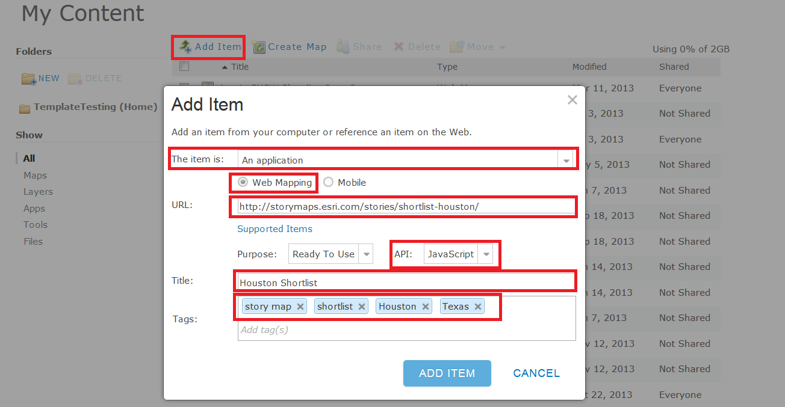

Be sure to include 'story map' and 'shortlist' in the Tags you add so that your entry can be found easily when people search for examples using those keywords. You should also include tags such as the name of the city, state or province, and country the shortlist covers, plus additional Tags to reflect the theme or content of the shortlist. This all helps people find your work if they search ArcGIS Online and makes it show up in the Shortlist search we showed you in the Introduction part of this document.

After you've added the entry, you can edit it directly in ArcGIS Online to give it a nice looking thumbnail image, like a little screenshot of the app or one of the pictures from it, and specify credits, etc.

Finally, be sure to share your web mapping application entry publicly.

### Making additional customizations to your shortlist

You can of course edit and customize the code in any way you want! That's why we freely provide the complete code for the template. It can also be a good way to start learning JavaScript.

You can find some nice examples of customized shortlists by running this query in ArcGIS Online:

<http://www.arcgis.com/home/search.html?q=shortlist&t=content&sortField=modified&sortOrder=desc&focus=applications-web>

For example, you can add graphic headers to the shortlist, and also tailor the color schemes, like in T[he Geography of Horror](http://mediamaps.esri.com/geography-of-horror/) and our [Visit Mississippi](http://storymaps.esri.com/stories/visit-mississippi/) demo.

* Here's a blog post with some information about how to get started customizing your Shortlist:

<http://blogs.esri.com/esri/esri-insider/2013/10/30/creating-and-customizing-a-story-map-from-a-non-giser/>

* A common customization that authors do to their shortlist is to change the width of the tab controls, normally to make them wider so that a longer name will fit in there, but sometimes like in the Geography of Horror the tab controls were made narrower so they didn't occupy too much space. To change the width of the tab control, edit the /css/style.css file and in the .tab class, change the width setting. The default value is 96 pixels:

.tab {

                float:left;

                background-color:#444;

                padding-top:4px;

                padding-left:10px;

                margin-top:10px;

                height:21px;

**width:96px;**

                margin-left:7px;

                color:#d8d8d8;

                cursor:pointer;

                font-family:Arial, Helvetica, sans-serif;

                font-weight:bold;

}

### Using the generic hosted shortlist option

As we stated above, this generic hosted option may be useful because you don't need to install anything on your own website or web server, and there's no index.html file to edit to configure the application: you just launch the existing installation of the application on our server with your web map. However the template can't be customized to replace the Esri logo with your logo, and you can't customize the code to do additional tweaks like making the tab controls wider to fit longer names. So it is most useful for testing, teaching, demos and temporary deployments, and not recommended for production deployments.

To use this option, simply replace the web map ID in the URL below with the web map ID of your web map. (The web map ID that is already in the URL below is for the web map used in our Phoenix Shortlist, so if you click the link below, that Shortlist will open):

[http://storymaps.esri.com/templates/shortlist/?webmap=**8504932f183c4b8699dc6ba28235e398**](http://storymaps.esri.com/templates/shortlist/?webmap=8504932f183c4b8699dc6ba28235e398)

The hosted shortlist does support two additional parameters in the URL to control its appearance.

You can use the bookmarks_alias parameter to change the name of the bookmarks menu:

[http://storymaps.esri.com/templates/shortlist/?webmap=8504932f183c4b8699dc6ba28235e398&**bookmarks_alias=Areas**](http://storymaps.esri.com/templates/shortlist/?webmap=8504932f183c4b8699dc6ba28235e398&bookmarks_alias=Areas)

You can use the color_order parameter to specify which of the 4 default colors you want each tab to use:

[http://storymaps.esri.com/templates/shortlist/?webmap=8504932f183c4b8699dc6ba28235e398&**color_order=red,red,red**](http://storymaps.esri.com/templates/shortlist/?webmap=8504932f183c4b8699dc6ba28235e398&color_order=red,red,red)

You can use both of these parameters in the same URL:

[http://storymaps.esri.com/templates/shortlist/?webmap=8504932f183c4b8699dc6ba28235e398&**color_order=red,red,red**&**bookmarks_alias=Areas**](http://storymaps.esri.com/templates/shortlist/?webmap=8504932f183c4b8699dc6ba28235e398&color_order=red,red,red&bookmarks_alias=Areas)

## Samples folder

Irrespective of which option you choose for assembling your shortlist point layers (shapefiles, CSV files created manually in Excel, CSV files created by exporting a feature class from ArcMap), its attributes need to follow the schema that the template expects. The easiest way to assemble your shortlist point layers is to use one of the ready-to-use sample files that you can find in the \samples folder in this template download. These files already use the shortlist template, so you can simply fill in your own information in place of what is there.

The following three folders contain some ready-made CSV and Excel files in each of the common geocoding styles. If you want to use Excel to assemble the point data, use the XLSX file and then export it to a CSV file using the Save As command in Excel:

\samples\csv_file__lat_long

Points.csv

Points.xlsx

\samples\csv_file__address__one_field

*(this file uses the Address field in the Shortlist schema as the field with which the points are geolocated)*

Points.csv

Points.xlsx

\samples\csv_file__address__four_fields

*(this file stores the address with which the points are geolocated in four fields: Address2, city, state and zip. It*

*still contains the Address field in which the full address of the place can be stored for display in the Shortlist*

Points.csv

Points.xlsx

The following folder contains a point shapefile layer for defining the places in one tab in a shortlist. There are also optional line and polygon shapefiles for defining clickable supporting layers in a shortlist. There's an 10.1 MXD file too that references these shapefiles to make it easy to edit them.

\samples\shapefiles

Points

Lines

Polygons

Shapefiles for Shortlist.mxd

The following folder contains a geodatabase point feature class for defining the places in one tab in a shortlist. It is provided both in a geodatabase and as a layer package. You can use this feature class to edit a shortlist point layer in ArcMap and then export it to a CSV file from ArcMap. This is a good way to create your Shortlist point layers because it doesn't impose the 254 character limit on your text fields that using a shapefile does. Before you export the layer to a CSV file, be sure to recalculate the LONG and LAT fields in the layer, so the locations of your map tour points are captured in the layer's attribute table before you export it. There's a 10.1 MXD file that references the feature class to make it easy to edit it.

\samples\feature_class

Geodatabase (containing Points feature class)

Feature class for Shortlist.mxd

Points.lpk

## Tips

* After you've uploaded shapefiles into your web map, if you want to make changes to the information, or add or remove features, don't forget that you can make edits to the layers in the web map. You don't need to reload the data. However, making the updates to the original source data and then reloading the data might be easier, and makes it easier if you want to use that source data in multiple maps.
* Don't put too much information in the Address and Hours fields, such as detailed directions in the Address tab. In the Details panel, the left hand column isn't scrollable, so if those fields are too long, and the user is viewing the Shortlist in a small browser window, the bottom of the left hand column may be clipped.
* If you add additional line or polygon layers into your web map using shapefiles, these are always clickable by the user of your shortlist, so be sure to give the features in those layers the full range of shortlist attributes. It's a common issue we see in shortlists that authors have added shapefile-based layers into their web map to show boundaries or other supporting features but have not given them the full set of attributes, including a picture, so when the user clicks on those features they get empty or half-empty popups. If you want to add additional layers into your shortlist that are not clickable, add them as map services, feature services, or map notes.
* If you customize the application, avoid making the height of the title area (i.e. the black strip across the top of the app) any taller than it currently is. (It is currently 96 pixels tall). We chose that height so that the application fits nicely in landscape mode on an iPad when it is displayed in Safari with the browser's Bookmarks bar turned on (the default Safari configuration on the iPad). At this size, the user can completely see the first 9 places and also a few pixels of the next row of places underneath those 9, which helps the user see that more places are available. If you make the title area any taller you will lose that nice effect:

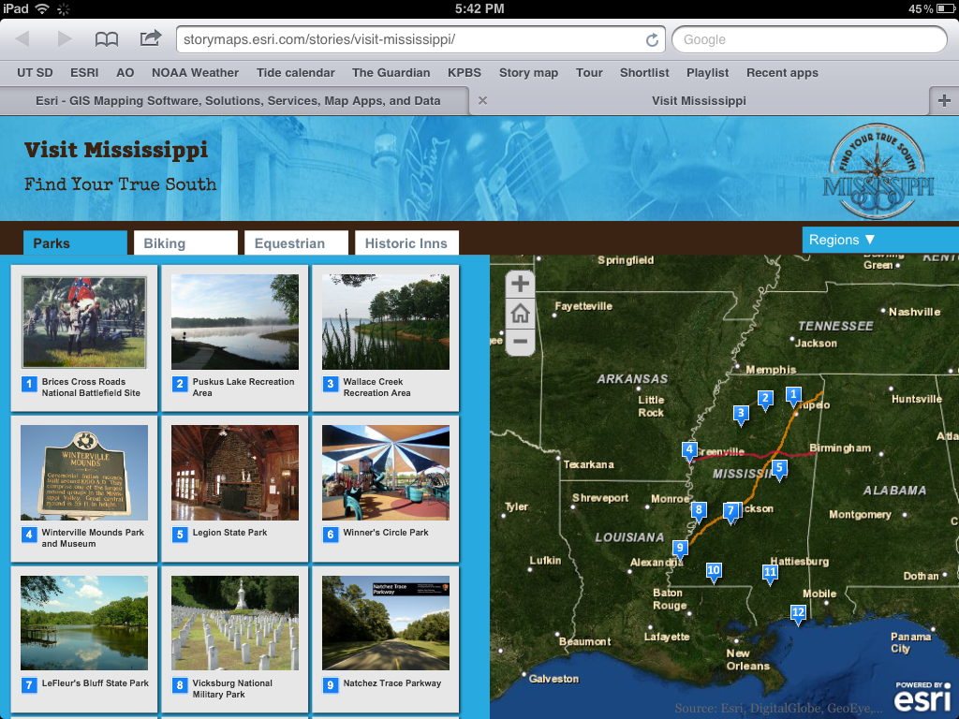

* We don’t have a specific field for photo credits but you can always use the last paragraph of the description to give a credit. It would be a nice enhancement to the template to have a specific, but optional Photo Credit field that appears in small text under the photo in the Details tab.
* How about if you want to have some clickable point features appear only as supporting features in your map, rather than as number places that appear in the tabs? Currently the template doesn't support clickable supporting point features. We've kept the configuration of the template as simple as possible, so we’ve just told it to treat all point feature layers in the map as being places that will be displayed in the tabs. So this precludes having supporting point features in your web map.

This issue came up in the [Phoenix Shortlist](http://links.esri.com/phoenix_shortlist) we have been working on, which at the time of writing isn't finished or announced yet. This shows the METRO light rail system and each of the stations as supporting features. In order to show the stations I actually buffered the station point features in ArcMap to create a set of tiny polygons, which I then added to the [underlying web map](http://www.arcgis.com/home/webmap/viewer.html?webmap=8504932f183c4b8699dc6ba28235e398) to represent the stations. I used a buffer distance of 60 feet. This seems to work OK and also has the nice effect that as you zoom in the stations get bigger on the map, so if you zoom to the neighborhood level you see quite big spots where the stations are so that you are aware they are there. I also applied a scale dependency to the Light Rail Stations layer so that when you zoom a long way out, they don't get drawn at all. Anyway, that is one way to handle supporting point features that you want to look like points.

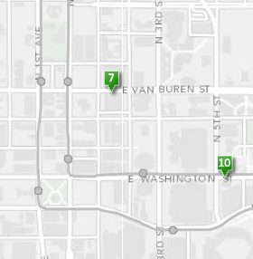

Another example is where there is a particular place you want to add onto the map, which you would perhaps normally add as a point feature. This came up in the [Palm Springs Shortlist](http://storymaps.esri.com/stories/shortlist-palmsprings/) where we wanted to add the Convention Center as a supporting feature, so that if someone is visiting Palm Springs to attend a convention or meeting there they'll be able to see it on the map. But we didn't want to make it too prominent because it's not an important location for the typical recreational visitor. So we added it as a supporting polygon feature and symbolized it quite subtly so that looks like it is part of the basemap. As a polygon feature the user can hover their cursor anywhere over the feature to see a map tip with its name, or click or tap anywhere on the feature to get its popup. This also looks better than using a point feature because as the user zooms in on the Convention Center it gets bigger on the map showing the footprint of the building.

