Importing Libraries

In [5]:**import** numpy **as** np

**import** pandas **as** pd

**import** seaborn **as** sns

**import** matplotlib.pyplot **as** plt

**from** scipy.stats **import** pearsonr, spearmanr

**from** scipy.stats **import** poisson,binom

Correlation

In [10]:*# Ravi -->*

heights **=** np**.**array([68, 62, 64, 61, 70, 66, 61, 65, 71, 72]) *# inches*

weights **=** np**.**array([72, 58, 67, 72, 79, 61, 68, 64, 80, 79]) *# kgs*

sns**.**scatterplot(x**=**heights, y**=**weights)

plt**.**axvline(heights**.**mean(),color**=**"green",linestyle**=**"--")

plt**.**axhline(weights**.**mean(),color**=**"green",linestyle**=**"--")

plt**.**xlabel("Heights (inches)")

plt**.**ylabel("Weights (Kgs)")

plt**.**show()

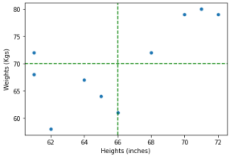

In [11]:covariance**=**(((heights**-**heights**.**mean())**\***(weights**-**weights**.**mean()))**.**sum())**/**len(heights) print("Covariance : ",covariance)

Covariance : 20.4

In [12]:*# Rishav --> USA*

heights1 **=** np**.**array([68, 62, 64, 61, 70, 66, 61, 65, 71, 72])**\***2.54 *# cms*

weights1 **=** np**.**array([72, 58, 67, 72, 79, 61, 68, 64, 80, 79])**\***1000 *# gms*

sns**.**scatterplot(x**=**heights1, y**=**weights1)

plt**.**axvline(heights1**.**mean(),color**=**"green",linestyle**=**"--")

plt**.**axhline(weights1**.**mean(),color**=**"green",linestyle**=**"--")

plt**.**xlabel("Heights1 (cms)")

plt**.**ylabel("Weights1 (gms)")

plt**.**show()

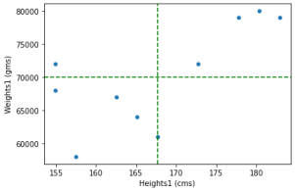

In [13]:covariance1**=**(((heights1**-**heights1**.**mean())**\***(weights1**-**weights1**.**mean()))**.**sum())**/**len(heights1) print("Covariance : ",covariance1)

Covariance : 51816.00000000001

In [14]:covariance**/**(heights**.**std()**\***weights**.**std())

Out[14]:

0.7094289771951879

In [15]:covariance1**/**(heights1**.**std()**\***weights1**.**std())

Out[15]:

0.7094289771951878

In [18]:np**.**corrcoef(weights,heights)

Out[18]:

array([[1. , 0.70942898], [0.70942898, 1. ]])

In [19]:np**.**corrcoef(weights,heights)[0,1]

Out[19]:

0.7094289771951878

In [20]:pearsonr(weights,heights)

Out[20]:

(0.7094289771951878, 0.021575164034828447)

In [38]:spearmanr(weights,heights)

Out[38]:

SpearmanrResult(correlation=0.6024493002399199, pvalue=0.06529313205986141)

In [23]:df**=**pd**.**DataFrame([heights,weights])**.**transpose() df

Out[23]:

**0 1**

**0** 68 72 **1** 62 58 **2** 64 67 **3** 61 72 **4** 70 79 **5** 66 61 **6** 61 68 **7** 65 64 **8** 71 80 **9** 72 79

In [30]:heights_ranks**=**df[0]**.**rank() weights_ranks**=**df[1]**.**rank()

In [31]:heights_ranks

Out[31]:

0 7.0

1 3.0

2 4.0

3 1.5

4 8.0

5 6.0

6 1.5

7 5.0

8 9.0

9 10.0

Name: 0, dtype: float64

In [32]:weights_ranks

Out[32]:

0 6.5

1 1.0

2 4.0

3 6.5

4 8.5

5 2.0

6 5.0

7 3.0

8 10.0

9 8.5

Name: 1, dtype: float64

In [35]:sns**.**scatterplot(x**=**heights_ranks, y**=**weights_ranks) plt**.**axvline(weights_ranks**.**mean(),color**=**"green",linestyle**=**"--") plt**.**axhline(weights_ranks**.**mean(),color**=**"green",linestyle**=**"--")

plt**.**xlabel("heights_ranks ")

plt**.**ylabel("weights_ranks ")

plt**.**show()

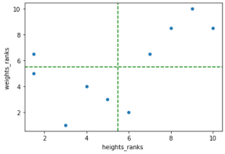

In [37]:pearsonr(heights_ranks,weights_ranks)

Out[37]:

(0.6024493002399198, 0.06529313205986152)

In [39]:df**=**pd**.**read_csv("Sachin_ODI.csv") df

Out[39]:

**runs NotOut mins bf fours sixes sr Inns Opp Ground Date Winner Won century 0** 13 0 30 15 3 0 86.66 1 New Zealand Napier 1995-02-16 New Zealand False False **1** 37 0 75 51 3 1 72.54 2 South Africa Hamilton 1995-02-18 South Africa False False **2** 47 0 65 40 7 0 117.50 2 Australia Dunedin 1995-02-22 India True False **3** 48 0 37 30 9 1 160.00 2 Bangladesh Sharjah 1995-04-05 India True False **4** 4 0 13 9 1 0 44.44 2 Pakistan Sharjah 1995-04-07 Pakistan False False **...** ... ... ... ... ... ... ... ... ... ... ... ... ... ...

**355** 14 0 34 15 2 0 93.33 2 Australia Sydney 2012-02-26 Australia False False **356** 39 0 45 30 5 0 130.00 2 Sri Lanka Hobart 2012-02-28 India True False **357** 6 0 25 19 1 0 31.57 1 Sri Lanka Dhaka 2012-03-13 India True False **358** 114 0 205 147 12 1 77.55 1 Bangladesh Dhaka 2012-03-16 Bangladesh False True **359** 52 0 93 48 5 1 108.33 2 Pakistan Dhaka 2012-03-18 India True False

360 rows × 14 columns

In [40]:df**.**info()

<class 'pandas.core.frame.DataFrame'>

RangeIndex: 360 entries, 0 to 359

Data columns (total 14 columns):

# Column Non-Null Count Dtype

--- ------ -------------- -----

0 runs 360 non-null int64

1 NotOut 360 non-null int64

2 mins 360 non-null object

3 bf 360 non-null int64

4 fours 360 non-null int64

5 sixes 360 non-null int64

6 sr 360 non-null float64

7 Inns 360 non-null int64

8 Opp 360 non-null object

9 Ground 360 non-null object

10 Date 360 non-null object

11 Winner 360 non-null object

12 Won 360 non-null bool

13 century 360 non-null bool

dtypes: bool(2), float64(1), int64(6), object(5) memory usage: 34.6+ KB

In [41]:df**.**corr()

Out[41]:

**runs NotOut bf fours sixes sr Inns Won century runs** 1.000000 0.377869 0.953558 0.907861 0.604078 0.576354 -0.076998 0.188319 0.751176 **NotOut** 0.377869 1.000000 0.324253 0.360667 0.266437 0.210590 0.104015 0.214461 0.336174 **bf** 0.953558 0.324253 1.000000 0.841240 0.487939 0.419307 -0.114803 0.153881 0.696394 **fours** 0.907861 0.360667 0.841240 1.000000 0.414766 0.613975 -0.014255 0.225120 0.591924 **sixes** 0.604078 0.266437 0.487939 0.414766 1.000000 0.415239 -0.045657 0.063837 0.547777 **sr** 0.576354 0.210590 0.419307 0.613975 0.415239 1.000000 0.058539 0.174703 0.292648 **Inns** -0.076998 0.104015 -0.114803 -0.014255 -0.045657 0.058539 1.000000 0.043287 -0.137966 **Won** 0.188319 0.214461 0.153881 0.225120 0.063837 0.174703 0.043287 1.000000 0.108010 **century** 0.751176 0.336174 0.696394 0.591924 0.547777 0.292648 -0.137966 0.108010 1.000000

In [44]:sns**.**heatmap(df**.**corr(),annot**=True**,cmap**=**"coolwarm")

Out[44]:

<AxesSubplot:>

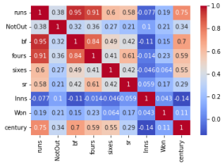

In [46]:sns**.**heatmap(df**.**corr(method**=**"spearman"),annot**=True**,cmap**=**"coolwarm")

Out[46]:

<AxesSubplot:>

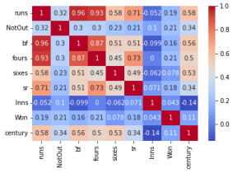

In [45]:df_mpg**=**sns**.**load_dataset('mpg')

df_mpg

Out[45]:

**mpg cylinders displacement horsepower weight acceleration model_year origin name 0** 18.0 8 307.0 130.0 3504 12.0 70 usa chevrolet chevelle malibu **1** 15.0 8 350.0 165.0 3693 11.5 70 usa buick skylark 320 **2** 18.0 8 318.0 150.0 3436 11.0 70 usa plymouth satellite **3** 16.0 8 304.0 150.0 3433 12.0 70 usa amc rebel sst **4** 17.0 8 302.0 140.0 3449 10.5 70 usa ford torino **...** ... ... ... ... ... ... ... ... ...

**393** 27.0 4 140.0 86.0 2790 15.6 82 usa ford mustang gl **394** 44.0 4 97.0 52.0 2130 24.6 82 europe vw pickup **395** 32.0 4 135.0 84.0 2295 11.6 82 usa dodge rampage **396** 28.0 4 120.0 79.0 2625 18.6 82 usa ford ranger **397** 31.0 4 119.0 82.0 2720 19.4 82 usa chevy s-10

398 rows × 9 columns

In [47]:sns**.**heatmap(df_mpg**.**corr(),annot**=True**,cmap**=**"coolwarm")

Out[47]:

<AxesSubplot:>

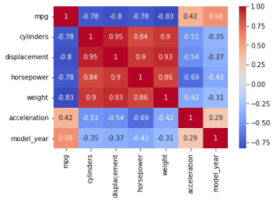In [48]:sns**.**pairplot(df_mpg)

Out[48]:

<seaborn.axisgrid.PairGrid at 0x7f9288017f70>

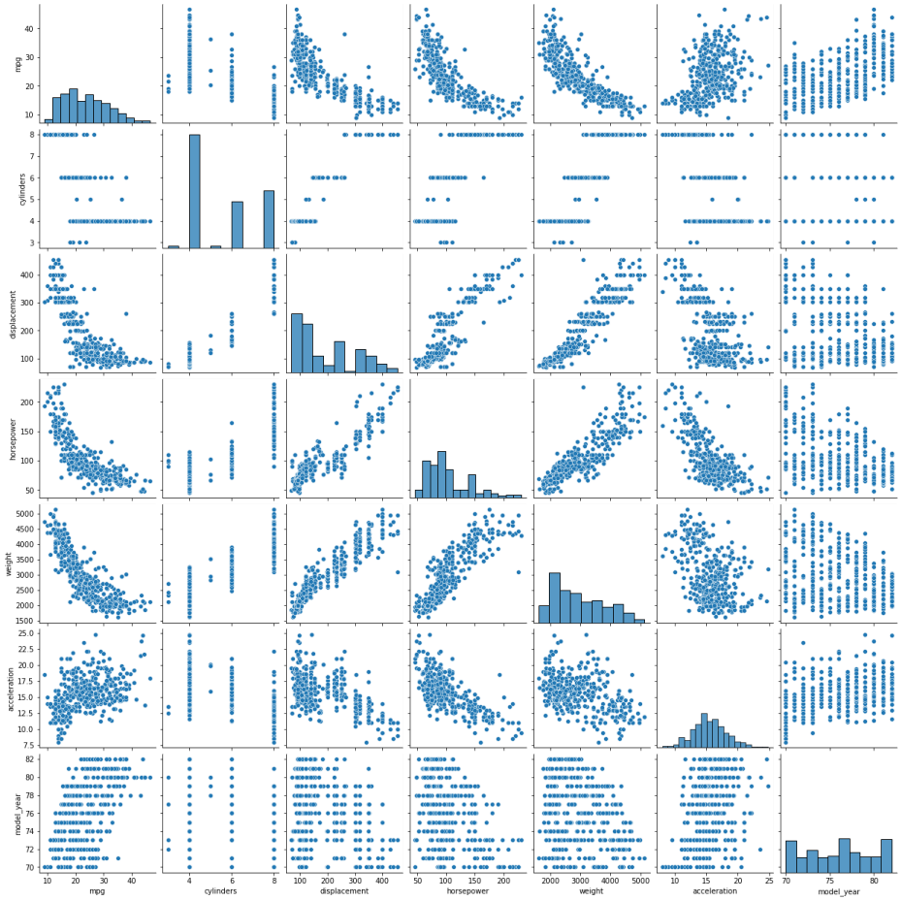In [49]:df_mpg**.**isnull()**.**sum()

Out[49]:

mpg 0 cylinders 0 displacement 0 horsepower 6 weight 0 acceleration 0 model_year 0 origin 0 name 0 dtype: int64

In [50]:pearsonr(df_mpg["displacement"],df_mpg["mpg"])

Out[50]:

(-0.8042028248058989, 1.6558889101912744e-91)

In [51]:spearmanr(df_mpg["displacement"],df_mpg["mpg"])

Out[51]: In [ ]: In [ ]: In [ ]: In [ ]: In [ ]:

SpearmanrResult(correlation=-0.8556920118178749, pvalue=2.3646353779685863e-115) Poisson Distribution

In [60]:**import** math

**def** calc_poisson(k,mu):

**return** ((mu**\*\***k)**\***((math**.**exp(**-**1**\***mu))))**/**math**.**factorial(k) In [61]:calc_poisson(5,3)

Out[61]:

0.10081881344492448

In [67]:calc_poisson(2,3)

Out[67]:

0.22404180765538775

In [68]:calc_poisson(3,3)

Out[68]:

0.22404180765538775

In [80]:calc_poisson(1,3)**+**calc_poisson(0,3)

Out[80]:

0.19914827347145578

In [81]:poisson**.**pmf(k**=**1,mu**=**3)**+**poisson**.**pmf(k**=**0,mu**=**3)

Out[81]:

0.1991482734714558

In [82]:poisson**.**cdf(k**=**1,mu**=**3)

Out[82]: In [ ]:

0.1991482734714558

In [62]:poisson**.**pmf(k**=**5,mu**=**3)

Out[62]:

0.10081881344492458

In [63]:poisson**.**pmf(k**=**3,mu**=**3)

Out[63]:

0.22404180765538775

In [65]:poisson**.**pmf(k**=**2,mu**=**3)

Out[65]:

0.22404180765538775

In [64]:mu **=** 3

x_values **=** np**.**arange(0, 10)

y_values **=** poisson**.**pmf(x_values, mu**=**mu) sns**.**barplot(x**=**x_values, y**=**y_values)

Out[64]:

<AxesSubplot:>

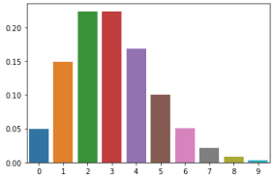In [69]:mu **=** 1

x_values **=** np**.**arange(0, 10)

y_values **=** poisson**.**pmf(x_values, mu**=**mu)

sns**.**barplot(x**=**x_values, y**=**y_values)

Out[69]:

<AxesSubplot:>

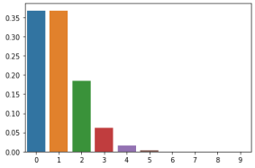In [70]:mu **=** 2

x_values **=** np**.**arange(0, 10)

y_values **=** poisson**.**pmf(x_values, mu**=**mu)

sns**.**barplot(x**=**x_values, y**=**y_values)

Out[70]:

<AxesSubplot:>

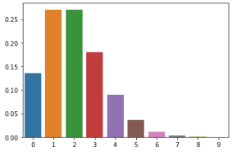In [71]:mu **=** 3

x_values **=** np**.**arange(0, 10)

y_values **=** poisson**.**pmf(x_values, mu**=**mu)

sns**.**barplot(x**=**x_values, y**=**y_values)

Out[71]:

<AxesSubplot:>

In [72]:mu **=** 4

x_values **=** np**.**arange(0, 10)

y_values **=** poisson**.**pmf(x_values, mu**=**mu)

sns**.**barplot(x**=**x_values, y**=**y_values)

Out[72]:

<AxesSubplot:>

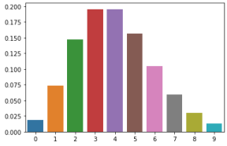In [73]:mu **=**5

x_values **=** np**.**arange(0, 10)

y_values **=** poisson**.**pmf(x_values, mu**=**mu)

sns**.**barplot(x**=**x_values, y**=**y_values)

Out[73]:

<AxesSubplot:>

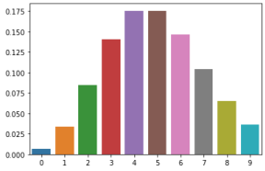In [74]:mu **=** 6

x_values **=** np**.**arange(0, 10)

y_values **=** poisson**.**pmf(x_values, mu**=**mu)

sns**.**barplot(x**=**x_values, y**=**y_values)

Out[74]:

<AxesSubplot:>

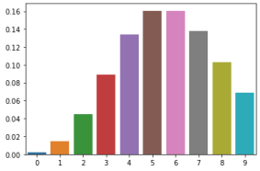In [75]:mu **=** 7

x_values **=** np**.**arange(0, 10)

y_values **=** poisson**.**pmf(x_values, mu**=**mu)

sns**.**barplot(x**=**x_values, y**=**y_values)

Out[75]:

<AxesSubplot:>

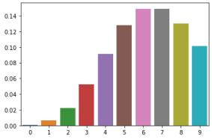In [76]:mu **=** 8

x_values **=** np**.**arange(0, 10)

y_values **=** poisson**.**pmf(x_values, mu**=**mu)

sns**.**barplot(x**=**x_values, y**=**y_values)

Out[76]:

<AxesSubplot:>

In [77]:mu **=** 9

x_values **=** np**.**arange(0, 10)

y_values **=** poisson**.**pmf(x_values, mu**=**mu)

sns**.**barplot(x**=**x_values, y**=**y_values)

Out[77]:

<AxesSubplot:>

In [ ]: