Global Framework for Responsible AI (GCRAI)
Architecture Overview
Version 0.8 · Architecture brief
The GCRAI framework is a meta-framework: it does not replace the EU AI Act, NIST AI RMF, ISO/IEC 42001, or OECD principles, but sits above them as a common reference point that maps into each. That single decision shapes the whole design — it is why every pillar carries a harmonization mapping and why evidence collected once can be reused across regulatory regimes. The architecture is built to translate between governance regimes rather than compete with them.
The architecture in one sentence
Six principles (intent) are expressed through seven pillars (operational domains), grouped into four layers that form a closed loop — govern → purpose → execute → assure → govern. Two design commitments — proportionality and harmonization — run through every layer, and progress is demonstrated through three assurance tiers.

Four structural components
At the top level the framework declares four integrated components. In plain terms: why it exists, what the words mean, what you actually do, and how you prove it.
- Core Principles & Objectives — governance intent and boundaries (the why).
- Definitions & Architecture — shared vocabulary and the layering logic (what the words mean).
- The Seven Pillars — the operational domains, each with an identical internal structure (what you do).
- Implementation & Assurance Pathway — the three-tier adoption, verification, and certification model (how you prove it).

The governance loop: four layers, seven pillars
The seven pillars are not a flat list. They are grouped into four functional layers that form a closed loop: governance defines authority, purpose defines intent, execution operationalizes controls, and assurance verifies — with assurance findings feeding back into governance. The layers are the grouping logic; the pillars are their operational expression.
Layer | Role in the loop | Expressed through pillars
Governance | Defines authority, accountability, and decision rights | Ethical Leadership; Data Governance & Integrity
Purpose | Defines intended use and impact boundaries | Purpose-Driven Innovation; Human-Centric Use
Execution | Translates governance and purpose into practice | Responsible Implementation; AI Literacy & Workforce Readiness
Assurance | Verifies performance and documentation integrity | Transparency & Auditability; the three-tier model
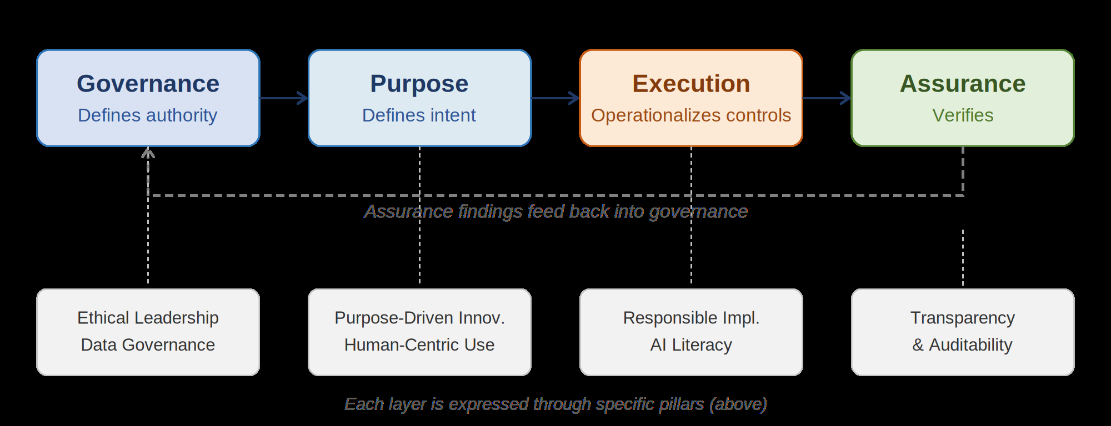
Figure 1. The four-layer governance loop and the pillars expressing each layer.
Every pillar shares the same internal structure — Definition → Core Principles → Strategic Keywords → Key Questions → Implementation Pathways → Harmonization Mapping → Governance Artifacts → Expected Outcomes. That uniformity is deliberate: the Key Questions become assessable control questions and the Governance Artifacts become document requests, so a controls catalogue plugs into each pillar mechanically. The pillar structure is the socket that turns concept into audit.

The assurance pathway: three tiers of depth
Running across all seven pillars is a three-tier assurance model. Critically, the tiers represent progressive assurance depth, not a risk classification. An organization can sit at different tiers for different systems at the same time. This is the dimension a controls catalogue keys off — each control carries a tier objective, which lets one catalogue serve both a light self-assessment and a full external certification.
Tier | What it demonstrates | Review type
Tier 1 — Foundational Alignment | Governance structures and accountability exist; baseline controls and capability gaps identified via self-assessment | Structured self-assessment
Tier 2 — Verified Implementation | A specific system was designed, deployed, monitored, and documented per pillar requirements, with evidence | Internal verification
Tier 3 — Independent Certification | Evidence evaluated for completeness, accuracy, and alignment by an accredited external reviewer | Independent external review

Two cross-cutting design commitments
- Proportionality — governance depth, documentation, and assurance intensity scale to a system's impact, complexity, and risk. This is why controls can be scoped (All / SMB / Large & Complex) and why the framework fits both a start-up and a multinational.
- Harmonization — because it is a meta-framework, every pillar maps to the EU AI Act, NIST AI RMF, ISO/IEC 42001, and OECD principles, so evidence collected once is reusable across regulatory contexts.

How the layers connect: one traceable thread
The architecture's value is that the chain is complete and bidirectional at every hop. A single example, end to end:
Principle (Accountability & Governance) → Pillar (Ethical Leadership) → Key Question (“Has the organization defined formal executive accountability for AI governance?”) → Control (executive accountability is documented in policy or charter) → Evidence (Governance Charter; Leadership Accountability Registry) → External mapping (EU AI Act Art. 9 & 17; NIST GOVERN 1.1/1.2; ISO 42001 Clause 5.1/5.3; OECD 1.5).
An auditor can start from a regulatory article and walk backwards to the governing principle, or start from a principle and walk forwards to the exact document to request — without a gap in the trace.
Implementation note
The assurance layer's coherence depends on a Section 5 that defines the tier objectives and requirements (T1-O1, T2-R4, and so on) referenced by the controls. Until that section is populated, the assurance layer is architecturally specified but not yet operationally complete.

