**Multicontact Capturability. Studying the coplanar case in 3D.**

Gabriel Garcia

1. Convexness for the forces allowed for a fixed CoM.

Suppose there are two force configuration $f_{i1}$ and $f_{i2}$ being applied at the contact points $i$ holding:

$$μn_{i}^{T}f_{i1}≥\left\|\left(I-n_{i}n_{i}^{T}\right)f_{i1}\right\|$$

$$n_{i}^{T}f_{i1}>0$$

$${f_{i}}_{max}≥\left\|f_{i1}\right\|$$

$$\sum_{i}{(r_{i}-r_{CoM})×f_{i1}}=τ_{1}=0$$

$$\sum_{i}{f_{i1}}=F_{ext1}$$

$$μn_{i}^{T}f_{i2}≥\left\|\left(I-n_{i}n_{i}^{T}\right)f_{i2}\right\|$$

$$n_{i}^{T}f_{i2}>0$$

$${f_{i}}_{max}≥\left\|f_{i2}\right\|$$

$$\sum_{i}{(r_{i}-r_{CoM})×f_{i2}}=τ_{2}=0$$

$$\sum_{i}{f_{i2}}=F_{ext2}$$

Let’s see that the forces $f_{i3}=λf_{i1}+\left(1-λ\right)f_{i2}$ hold the same constraints for $1>λ>0$. For the nonlinear restrictions we are using the triangular inequality.

$$\left\|\left(I-n_{i}n_{i}^{T}\right)f_{i3}\right\|≤\left\|\left(I-n_{i}n_{i}^{T}\right)λf_{i1}\right\|+\left\|\left(I-n_{i}n_{i}^{T}\right)\left(1-λ\right)f_{i2}\right\|≤μn_{i}^{T}f_{i3}$$

$$n_{i}^{T}f_{i3}=n_{i}^{T}λf_{i1}+n_{i}^{T}\left(1-λ\right)f_{i1}>0$$

$${f_{i}}_{max}=λ{f_{i}}_{max}+\left(1-λ\right){f_{i}}_{max}≥\left\|λf_{i1}\right\|+\left\|\left(1-λ\right)f_{i2}\right\|≥\left\|f_{i3}\right\|$$

$$\sum_{i}{(r_{i}-r_{CoM})×f_{i3}}=λτ_{1}+\left(1-λ\right)τ_{2}=0$$

So we can apply the force $f_{i3}$ in each contact. The resulting force on the CoM is:

$$\sum_{i}{f_{i3}}=λF_{ext1}+\left(1-λ\right)F_{ext2}$$

So, if we can apply any two forces $F_{ext1}$ and $F_{ext2}$ to the CoM, then we can apply any force between them. The direct consequence is the convexity of the applicable force to a given CoM.

1. For a fixed force, the set of the possible CoM where you can apply zero torque is convex.

Suppose there are two force configuration $f_{i1}$ and $f_{i2}$, and two respective CoMs $r_{CoM1}$ and $r_{CoM2}$ being applied at the contact points $i$ holding:

$$μn_{i}^{T}f_{i1}≥\left\|\left(I-n_{i}n_{i}^{T}\right)f_{i1}\right\|$$

$$n_{i}^{T}f_{i1}>0$$

$${f_{i}}_{max}≥\left\|f_{i1}\right\|$$

$$\sum_{i}{(r_{i}-r_{CoM1})×f_{i1}}=τ_{1}=0$$

$$\sum_{i}{f_{i1}}=F_{ext}$$

$$μn_{i}^{T}f_{i2}≥\left\|\left(I-n_{i}n_{i}^{T}\right)f_{i2}\right\|$$

$$n_{i}^{T}f_{i2}>0$$

$${f_{i}}_{max}≥\left\|f_{i2}\right\|$$

$$\sum_{i}{(r_{i}-r_{CoM2})×f_{i2}}=τ_{2}=0$$

$$\sum_{i}{f_{i2}}=F_{ext}$$

Let’s see that the forces $f_{i3}=λf_{i1}+\left(1-λ\right)f_{i2}$ hold the following constraints for $1>λ>0$.

$$μn_{i}^{T}f_{i3}≥\left\|\left(I-n_{i}n_{i}^{T}\right)λf_{i1}\right\|+\left\|\left(I-n_{i}n_{i}^{T}\right)\left(1-λ\right)f_{i2}\right\|≥\left\|\left(I-n_{i}n_{i}^{T}\right)f_{i3}\right\|$$

$$n_{i}^{T}f_{i3}=n_{i}^{T}λf_{i1}+n_{i}^{T}\left(1-λ\right)f_{i1}>0$$

$${f_{i}}_{max}=λ{f_{i}}_{max}+\left(1-λ\right){f_{i}}_{max}≥\left\|λf_{i1}\right\|+\left\|\left(1-λ\right)f_{i2}\right\|≥\left\|f_{i3}\right\|$$

The resultant torque around CoM $r_{CoM3}=λr_{CoM1}+\left(1-λ\right)r_{CoM2}$ is:

$$τ_{3}=\sum_{i}{(r_{i}-r_{CoM3})×f_{i3}}$$

$$τ_{3}=\sum_{i}{\left(r_{i}-\left(λr_{CoM1}+\left(1-λ\right)r_{CoM2}\right)\right)×f_{i3}}=\sum_{i}{\left(λr_{i}+\left(1-λ\right)r_{i}-\left(λr_{CoM1}+\left(1-λ\right)r_{CoM2}\right)\right)×f_{i3}}$$

$$τ_{3}=λ\sum_{i}{\left(r_{i}-r_{CoM1}\right)×f_{i3}}+\left(1-λ\right)\sum_{i}{\left(r_{i}-r_{CoM2}\right)×f_{i3}}=λ\sum_{i}{\left(r_{i}-r_{CoM1}\right)×\left(1-λ\right)f_{i2}}+(1-λ)\sum_{i}{\left(r_{i}-r_{CoM2}\right)×λf_{i1}}$$

$$τ_{3}=λ\left(1-λ\right)\left(\sum_{i}{\left(r_{i}-r_{CoM1}\right)×f_{i2}}+\sum_{i}{\left(r_{i}-r_{CoM2}\right)×f_{i1}}\right)$$

Let’s rearrange the torque equalities from $τ_{1}$ and $τ_{2}$ as follows and replace those in $τ_{3}$:

$$\sum_{i}{(r_{i}-r_{CoM1})×f_{i1}}=0→\sum_{i}{r_{i}×f_{i1}}=\sum_{i}{r_{CoM1}×f_{i1}}$$

$$\sum_{i}{(r_{i}-r_{CoM2})×f_{i2}}=0→\sum_{i}{r_{i}×f_{i2}}=\sum_{i}{r_{CoM2}×f_{i2}}$$

$$τ_{3}=λ\left(1-λ\right)\left(\sum_{i}{\left(r_{CoM2}-r_{CoM1}\right)×f_{i2}}+\sum_{i}{\left(r_{CoM1}-r_{CoM2}\right)×f_{i1}}\right)$$

$$τ_{3}=λ\left(1-λ\right)\left(\left(r_{CoM2}-r_{CoM1}\right)×\left(\sum_{i}{\left(f_{i2}-f_{i1}\right)}\right)\right)=0$$

$$τ_{3}=λ\left(1-λ\right)\left(\left(r_{CoM2}-r_{CoM1}\right)×\left(F_{ext}-F_{ext}\right)\right)=0$$

We can apply the force $f_{i3}$ in each contact and it produces torque 0 at the CoM $λr_{CoM1}+\left(1-λ\right)r_{CoM2}$. The resulting force on the CoM is:

$$\sum_{i}{f_{i3}}=λF_{ext}+\left(1-λ\right)F_{ext}=F_{ext}$$

So, if we can apply any force $F_{ext}$ and $F_{ext}$ at two different CoMs, then we can apply the same force at any CoM between the two initial different CoMs. The direct consequence is the convexity of the applicable force to a given CoM.

1. If we can apply a force $F_{ext}$ to a CoM $r_{CoM}$, then we can apply the same force to any CoM along the line $r_{CoM}+λ{\hat{F}}_{ext}, ∀λ∈R$ by applying the same forces $f_{i}$ at each contact.

Let’s make the following observation:

$$\sum_{i}{(r_{i}-r_{CoM})×f_{i}}=0$$

$$\sum_{i}{\left(r_{i}-\left(r_{CoM}+λ{\hat{F}}_{ext}\right)\right)×f_{i}}=-λ\sum_{i}{{\hat{F}}_{ext}×f_{i}}=-λ{\hat{F}}_{ext}×\sum_{i}{f_{i}}=0$$

1. Developed and simulated a new walking strategy based on 3D DCM piecewise-LIP for rough terrain using "hybrid control" instead of precomputed trajectories.

In “Three-Dimensional Bipedal Walking Control Based on Divergent Component of Motion” the authors suggest the use of a constant stiffness for the reaction force on the ground. The resultant system is the same as the 3D-LIP, with the difference that you can remove the assumption $\dot{z}=0$. The main problem here is that the stiffness is *permanent* along the whole walking, and in consequence, long-term planning or continuous re-computing trajectories is compulsory to avoid falling. If you change the value of the stiffness, then the whole system will change, and in particular, the DCM will be instantaneously repositioned (given that $ξ=r+b\dot{r}$ and b is a function of the stiffness). Note that if the stiffness is variable at will, then the system becomes the 3D VHIP. Here we relax partially the assumption of permanent stiffness: We change the value of the stiffness only in each step, and with this, we can have more dynamic behaviors: in particular, we no longer need long-term planning, we just need the coordinates of 2 future foot placements (in 3D, roughly terrain), and the values of the stiffness are directly defined by those coordinates and the current states of the system.

DCM Dynamics under constant stiffness

$$\dot{ξ}=\sqrt{u_{0}}\left(ξ-r_{vrp}\right)$$

$$r_{vrp}=r_{CoP}+\frac{g}{u_{0}}{\hat{e}}_{z}$$

New DCM after switching stiffness value:

$$ξ^{+}=r+\frac{1}{\sqrt{u_{0}}}\dot{r}$$

Deadbeat value for $u_{0}$ to keep the height constant of DCM:

$$z_{CoP}+\frac{g}{u_{0}}=z+\frac{1}{\sqrt{u_{0}}}\dot{z}→u_{0}=\frac{1}{{\left(\frac{\dot{z}+\sqrt{{\dot{z}}^{2}+4g\left(z-z_{CoP}\right)}}{2g}\right)}^{2}}$$

Note that the solution of the equation is restricted. In particular $z_{CoP}<z+\frac{{\dot{z}}^{2}}{4g}$. We we’ll keep instead $z_{CoP}<z$ because the model considering unilaterality should be redefined when $z_{CoP}≥z$.

That stiffness should be applied at the beginning of the new step. When to switch between steps? When the new DCM $ξ^{+}$ lies on a line defined by 2 future foot placements that can also be found in closed form because the deadbeat value $u_{0}$ and the new DCM $ξ^{+}$ have close form solution.

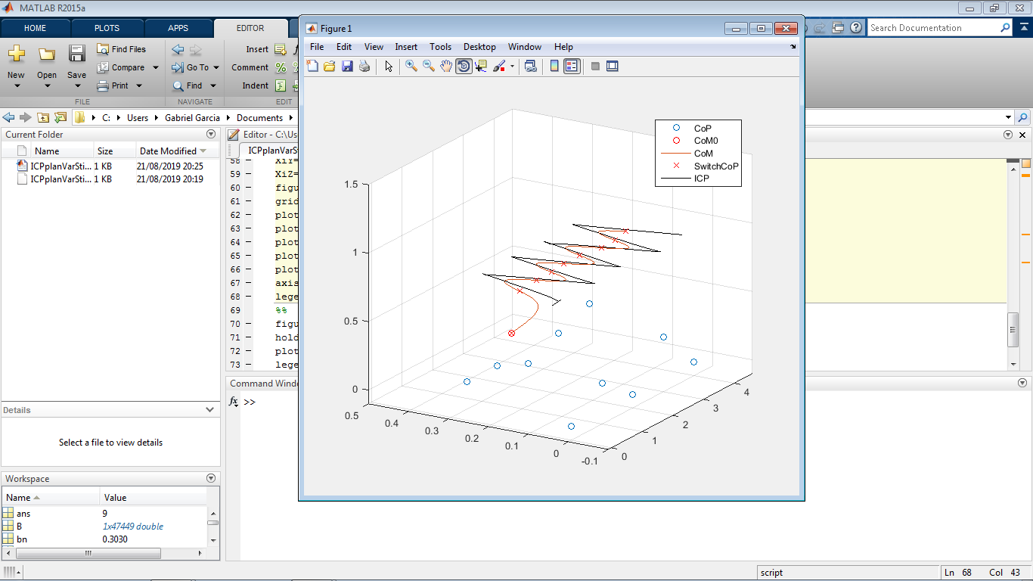

The direct consequence is that you can step *almost* *anywhere* in the space below the CoM because it’s a control based on states as long as your kinematic limits and “friction angle” allows you, and the robot will always find the value of the stiffness that stabilizes the system, in particular, keep the height of the DCM at a constant value, in some kind of “deadbeat control”. The limitation is exactly that: Constant height DCM is (in long term) constant height CoM. Research can be improved by using linear-piecewise DCM in order to keep the height difference between the CoM and the CoP at an average constant value.

Note also that we are using only a Fixed CoP. When using a Variable CoP (Planar foot instead of point foot) our control authority increases.

1. Defined the problem of "The possible forces allowed to apply to the CoM given the contact points" as a Linear optimization program with Quadratic restrictions in 3D. Linearized the problem and reduced it to a LP Optimization.

Slides shows the LP programs.

1. Understanding graphically and analytically the implications of Multicontact and frictions in 2D. Connected the 2D multi-contact case with Capturability and obtained the region of attraction for a very particular case (point foot and point hand in 2D, w. friction, without limits on actuation). Main paper:

“Computation and Graphical Characterization of Robust Multiple-Contact Postures in 2D Gravitational Environments”

<https://ieeexplore.ieee.org/abstract/document/1570127>

Generalization to 3D was done in:

<https://pdfs.semanticscholar.org/7ce9/7ec86ae094212f1f60fd636488cfbd086c7b.pdf?_ga=2.118913033.1090864858.1566513978-26913049.1566312813>

Interestingly, those works were done 4 years before “Testing Static Equilibrium for Legged Robots”- Bretl et. al., and also the paper deals with the case of *any* direction of force.

Some extra state of art: Multicontact Capturability

*“ZMP Analysis for Arm/Leg Coordination”*

Uses an extension of ZMP belonging to the projection to the ground of the convex hull of contact arm/foot as the stability criterion. That could be sufficient under certain circumstances but is not necessary. (Human flag is a counterexample)

*“A Universal Stability Criterion of the Foot Contact of Legged Robots - Adios ZMP*”

Gives specific conditions of the forces that can be applied to a CoM for given contact points

*“FSW (Feasible Solution of Wrench) for Multi-legged Robots”*

*“Leveraging Cone Double Description for Multi-contact Stability of Humanoids with Applications to Statics and Dynamics”*

*“Stability of surface contacts for humanoid robots: Closed-form formulae of the Contact Wrench Cone for rectangular support areas”*

Proof of reduction of Contact surfaces using wrench on vertices instead of polygonal surface. Reduces the forces of a rectangle foot (coplanar) to a CWC in closed analytical solution considering friction.

“*CROC: Convex Resolution of Centroidal Dynamics Trajectories to Provide a Feasibility Criterion for the Multi Contact Planning Problem*”

*“Strong Recursive Feasibility in Model Predictive Control of Biped Walking”*

They show that a particular MPC setting (CoM with jerk input + restrictions) for a 3D LIP Variable CoP is “StrongRecursive Feasible”: If in the next iteration you plan to take a step or to stop, there exist still a solution in any case. Solved numerically in the whole space of prediction (inputs and states) with LP. Get inspiration for vertex-finder program for dynamic stability.