FINTRACE Project Details
  - Technical project brief and hackathon handoff
Prepared for VENTURE 2026 | 16 September 2026 | Two member team
FINTRACE is a local-first transaction investigation workspace for analysts with authorised transaction records. It prioritises accounts, traces chronological paths through a bounded graph, shows linked evidence, replays what was visible at a chosen cutoff, and exports the selected case as JSON.
The current repository contains a working React and Vite prototype. The analysis route can run as a stateless Vercel Function, with a local engine fallback. Supabase Auth and Postgres row-level security are prepared for private saves after the project values and SQL schema are configured.

Project at a glance
Area | Current decision
Product | FINTRACE
Tagline | Follow the money. Explain the risk.
Event | VENTURE 2026 on 18 September 2026
Target user | Fraud analyst with authorised transaction records
Core pattern | Collection burst followed by rapid outward payments and split reconvergence
Frontend | React, Vite, TypeScript, CSS Modules
Analysis | POST /api/analyze with fintrace-graph-v2 and local fallback
Data | Three synthetic examples, validated CSV intake, and JSON case snapshots
Authentication | Supabase Auth with profiles and owner-scoped investigation saves
Current verification | 25 of 25 accuracy scenarios, 58 tests, typecheck, lint, and Vite build pass

Implementation status. The local demo is ready. Vercel configuration and the Supabase SQL migration are prepared but require an authorised project setup before real private accounts and saved cases work.

Product overview
FINTRACE helps an analyst answer a narrower and more defensible question than a generic fraud classifier: what transaction pattern is visible in the supplied records, in what order did it occur, and which rows support the review priority?

Target user and job
The intended user is a fraud analyst or investigator working with authorised transaction records. The analyst needs to move from a queue entry to a focal account, inspect connected transfers, rewind the observation time, and export a snapshot that another reviewer can understand.

Scope boundary
The prototype focuses on one collection-led pattern family. It does not claim to identify every type of fraud, prove criminal intent, identify beneficial ownership, recover money, block an account, or replace a production detection system. The score is a review-priority score, not a calibrated fraud probability.
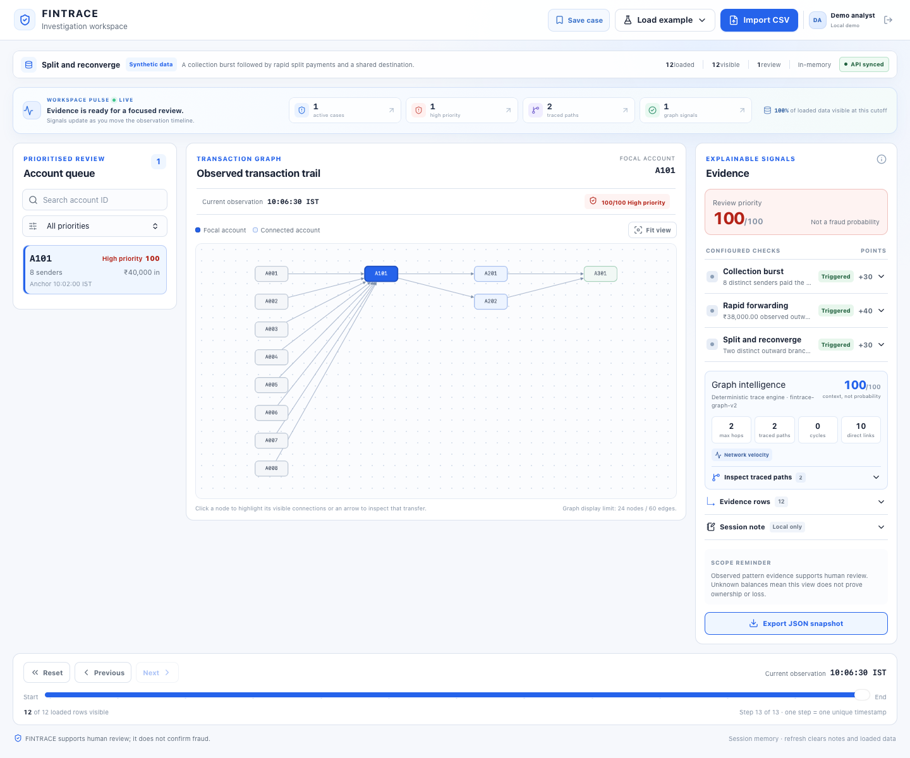
Figure 1. Working FINTRACE investigation workspace for the canonical split and reconverge scenario

What makes the product useful
- It keeps the account queue, graph, evidence panel, replay cutoff, and export on one analysis snapshot.
- It links each signal to transaction IDs, so the reviewer can inspect the records behind the points.
- It shows how a case changes as new timestamps become visible instead of assuming the final dataset was known from the start.
- It displays graph context such as chronological paths, bottleneck values, fan-out, layering, circular re-entry, and network velocity.

User journey
1. Load the Split and reconverge example or import a compatible CSV file.
2. Validate and normalize the records before analysis. Invalid imports cannot replace the active dataset.
3. Review the account queue, which keeps one representative episode per focal account and sorts by priority.
4. Select an account and inspect the same case in the graph, evidence panel, and transaction table.
5. Use Reset, Previous, Next, or the timestamp slider to replay only the records visible at a chosen cutoff.
6. Add a session note and export the selected investigation snapshot as versioned JSON. Authenticated users can save a private case after Supabase configuration.

Working screens and interactions
Surface | Purpose | Important interaction
Empty state | Start with no fabricated data | Load demo, import CSV, or download the CSV template
Example picker | Replace the active dataset with one of three synthetic scenarios | Split and reconverge, Merchant collection, or Ambiguous settlement
Account queue | Prioritise one representative case per focal account | Search by account ID and filter by Monitor, Review, or High priority
Transaction graph | Show observed account-to-account relationships | Select a node or edge to inspect linked transfers without changing the focal case
Evidence panel | Explain points and show supporting records | Expand a signal, open evidence rows, add a contextual session note
Replay controls | Recompute the snapshot at a timestamp cutoff | Reset, Previous, Next, and labelled slider
Export and save | Create a portable handoff | Download JSON locally or save an authenticated private investigation

Canonical demo path
Load Split and reconverge, select A101, expand the evidence rows, press Reset, and advance with Next. The focal case moves from 30 points after collection to 70 points after rapid forwarding and 100 points after both branches reach A301. The graph, evidence, queue, and export all use the same cutoff.

System architecture
The application separates input validation, analysis logic, and presentation. This keeps the frontend from silently becoming a second detector and makes the local and server-side paths share the same normalized contract.
CSV or demo data
|
parse and validate
|
normalized INR transactions
|
cutoff filter
|
deterministic rules plus graph intelligence
|
analysis snapshot
|-- account queue
|-- investigation graph
|-- evidence and notes
|-- replay controls
|-- JSON export
Layer | Repository location | Responsibility
UI | src/components, src/pages, src/App.tsx | Analyst surfaces, accessible controls, and layout
State | src/hooks/useInvestigation.ts | Dataset replacement, selection, replay, notes, and snapshot orchestration
Validation | src/engine/validate.ts, src/engine/money.ts | CSV parsing, field checks, exact paise normalization, limits, and warnings
Core detector | src/engine/analyze.ts, src/config/detector.ts | Collection, forwarding, reconvergence, scoring, deduplication, and evidence
Graph intelligence | src/engine/intelligentAnalyze.ts | Chronological path tracing, bottlenecks, cycles, velocity, fan-out, and layering
Graph view | src/graph/buildGraphModel.ts | Cutoff-aware nodes, one edge per transaction, deterministic positions, and display truncation
API | api/analyze.ts, src/services/analysisService.ts | Re-validating stateless analysis contract with local fallback
Persistence | src/auth, src/lib/supabase.ts, src/services/workspaceService.ts, supabase/schema.sql | Supabase Auth, owner-scoped saved investigations, and SQL policies

Detection model
FINTRACE uses deterministic rules for its core score. Each analysis first filters transactions to timestampMs less than or equal to the selected cutoff. It then builds incoming and outgoing indexes from visible records only. Candidate episodes are evaluated per account and deduplicated to one representative episode per focal account.

Core signals
Signal | Exact condition | Points | Evidence shown
Collection burst | At least 6 distinct senders pay the focal account inside the inclusive 10 minute window ending at an incoming anchor. | +30 | Incoming transaction IDs, sender count, window, and observed incoming amount
Rapid forwarding | After the anchor and within 5 minutes, observed outward volume reaches at least 80 percent of observed collection volume. | +40 | Relevant incoming and outgoing IDs, both totals, ratio, and window
Split and reconverge | Two distinct first-hop recipients each send to one common destination in strict chronological order within the hop window. | +30 | Two first-hop IDs, two onward IDs, destination, and timing witness

Scoring ladder
Observed signals | Score | Queue label | Interpretation
Collection only | 30 | Monitor | A collection burst is visible. No qualifying rapid forwarding is observed.
Collection plus forwarding | 70 | Review | Observed outward movement reaches the configured volume threshold.
All three core signals | 100 | High priority | Two outward branches reach one common destination in time order.

Important distinction. A score of 100 means that all configured prototype checks triggered. It does not mean that fraud is confirmed. The engine does not perform FIFO allocation or claim that the smallest edge on a path represents an exact stolen amount.

Candidate selection and deduplication
The detector considers each qualifying incoming timestamp as an anchor. It keeps one representative case per focal account by preferring the highest score, then the latest qualifying anchor, then a deterministic account or anchor tie-break. Evidence IDs are deduplicated and sorted chronologically. The queue is therefore a review queue, not a complete historical case-management system.

Graph intelligence
The server-side graph pass adds context after the core case has been identified. It traverses only visible transactions, requires strictly increasing timestamps, prevents repeated account visits except for explicit cycle detection, and returns linked paths rather than an opaque label.
Output | Meaning in the current implementation
Chronological paths | Transaction-by-transaction paths discovered from the focal account after the representative anchor
Bottleneck amount | The smallest observed edge on a path. It is a display measure, not exact fund attribution
Direct counterparties | Distinct accounts directly connected to the focal account in visible records
Path depth | Number of transactions in the path, with a five-hop maximum
Cycle count | Chronological paths that return to the focal account
Network velocity | Count of relevant transfers around the collection anchor
Fan-out | Three or more distinct first-hop recipients after the anchor
Layering | A path of at least three chronological hops inside the trace window
Trace truncation | A flag when bounded branch or retained-path limits prevent complete graph display

Trace bounds. The graph engine uses a 5-hop maximum, a 30 minute total trace window, and a 10 minute maximum between hops. The UI limits display to 24 nodes and 60 edges for readability. Those display limits do not reduce the detector's input records.

Data intake and CSV contract
The importer accepts six logical columns in any order. It uses Papa Parse for CSV tokenization, preserves IDs as strings, rejects incomplete or ambiguous records, and normalizes amounts into integer paise before the detector runs.
transaction_id,timestamp,from_account,to_account,amount,currency
T001,2026-09-18T10:00:00+05:30,A001,A101,5000.00,INR
Column | Contract | Example
transaction_id | 1 to 40 characters using letters, digits, underscore, or hyphen. Must be unique. | T001
timestamp | ISO 8601 with explicit Z or numeric offset. Display timezone is Asia/Kolkata. | 2026-09-18T10:00:00+05:30
from_account | Opaque account ID using the same ID pattern as transaction IDs. | A001
to_account | Opaque account ID. Self-transfers are rejected in this prototype. | A101
amount | Positive rupee decimal with zero, one, or two fractional digits. Stored as integer paise. | 5000.00
currency | Must be INR after trimming and uppercasing. | INR

Import limits and validation behavior
Control | Current value | Behavior
File size | 2 MiB | Reject the attempted import if it exceeds the limit
Data rows | 2,000 | Reject the attempted import if it exceeds the limit
Amount | Up to INR 100,000,000.00 per row | Reject signs, scientific notation, separators, symbols, excess decimals, and unsafe totals
Currency | INR only | Reject mixed or unsupported currencies
Record identity | Unique IDs and no self-transfers | Show row-level errors and keep the current dataset unchanged
Validation mode | All or nothing | Do not analyze a silently incomplete subset

- Required headers are normalized for whitespace and a UTF-8 byte order mark. Duplicate logical headers are rejected.
- Unsorted valid input can be normalized into deterministic timestamp and transaction ID order.
- Extra fields are ignored only with an explicit warning. They do not enter the engine, graph, evidence, or export.
- At most five detailed errors are shown in the import dialog, with the total error count preserved.

API and persistence

Analysis endpoint
The route at POST /api/analyze re-validates the normalized transaction payload at the server boundary. It rejects invalid methods, oversized JSON requests, malformed transactions, duplicate IDs, unsafe amounts, invalid cutoffs, and invalid focal account IDs. Responses use no-store caching.
Part | Current contract
Request | transactions: normalized INR records, asOfMs: finite number or null, optional focalAccountId
Success | ok, engineVersion, processedAt, asOfMs, snapshot, and intelligenceByAccount
Engine version | fintrace-graph-v2
Error response | ok false, a readable error, and up to 20 issues
Fallback | The browser uses local analysis when the same-origin endpoint is unavailable

Supabase data model
Table | Fields and purpose | Access boundary
public.profiles | User ID linked to auth.users, display name, optional organization and avatar fields, timestamps | Authenticated users can read and update their own profile
public.investigations | Owner ID, title, source metadata, selected account, cutoff, score, JSONB payload, timestamps | Authenticated users can read, insert, update, and delete only rows where owner_id equals auth.uid()
private functions | Trigger helpers for updated_at and profile creation after signup | Schema is not exposed to anon or authenticated client roles

The browser reads only VITE_SUPABASE_URL and VITE_SUPABASE_PUBLISHABLE_KEY. A service role key must never be placed in Vite or Vercel client-visible variables. Demo sessions remain local-only until the project values are added and supabase/schema.sql is applied by an authorised project owner.

Configuration sequence
1. Create a Supabase project and copy its project URL and publishable key into .env.local.
2. Run supabase/schema.sql once in the intended Supabase SQL Editor.
3. Restart the Vite server so the environment values load.
4. Verify signup, sign-in, password recovery, Save case, and owner-scoped investigation reads.
5. Add the same VITE_SUPABASE_* values to the Vercel environment before a production deployment.

Testing and verification
The project uses layered verification. Pure engine tests cover rule semantics, API tests cover the request boundary, integration tests cover replay and export behavior, and headed browser checks cover the real interaction path.
Check | Command or method | Current result
Type safety | npm run typecheck | Pass
Lint | npm run lint | Pass
Full test suite | npm test -- --run | 58 tests passed
Focused accuracy matrix | npm test -- --run src/tests/accuracy.test.ts | 25 of 25 scenarios passed
Production build | npm run build | Pass
Browser flow | Headed Playwright on the local Vite app | Auth gate, demo login, dataset load, replay, evidence, save messaging, sign out, and recovery validation checked
Responsive check | 390 pixel viewport browser check | No horizontal overflow or offender elements found
Console check | Fresh WebKit sessions | No errors or warnings observed

Accuracy matrix coverage
The 25 synthetic scenarios cover threshold edges, cutoff replay, future-record exclusion, reconvergence witnesses, layering, fan-out, cycles, network velocity, over-attribution warnings, and bounded deep tracing. The matrix uses isolated account namespaces and calls the same validating analysis handler used by the local UI and the Vercel route.

Canonical replay checkpoints
Cutoff in IST | Score | Visible interpretation
10:02:00 | 30 | Collection observed
10:04:00 | 30 | Forwarding window has just started
10:04:30 | 70 | 95 percent outward volume observed
10:06:00 | 70 | One reconvergence branch visible
10:06:30 | 100 | Two branch common recipient witnessed

Hackathon demo script
1. Start at the auth screen and choose the local demo path when Supabase is not configured.
2. Load Split and reconverge. Point out that A101 is the highest-priority representative case.
3. Open one signal row and Evidence rows. Show that the explanation contains observed values and linked transaction IDs.
4. Press Reset and advance with Next. Pause at 10:04:30 to show the 70 point review state.
5. Advance to 10:06:30. Show the two chronological paths from A101 through A201 and A202 to A301.
6. Open Ambiguous settlement and explain that the same observed structure can be legitimate. The product supports review rather than accusation.
7. Optionally import an invalid CSV to show all-or-nothing validation, then export the current JSON snapshot.

Judge talking points
What to show | What it proves
The timeline changes the score | The engine respects what was visible at each cutoff
Two branches reach A301 | The graph pass produces an inspectable witness, not only a label
Evidence rows open from a signal | Every point can be connected back to records
Ambiguous settlement example | The team understands false positives and responsible use
25 of 25 boundary scenarios | The team tests inclusions and exclusions rather than only the happy path
Vercel and Supabase path | The prototype has a practical route from local demo to private deployment

Implementation status
Area | Status | What remains
Local investigation workspace | Working | Use npm run dev or npm run preview for the local demo
Graph analysis endpoint | Implemented | Deploy api/analyze.ts through the Vercel project
CSV validation and JSON export | Working | Add any desired organization-specific schema after the hackathon
Supabase Auth and private saves | Code and SQL prepared | Configure environment values, run the SQL schema, and verify live reads and writes
Production fraud accuracy | Not measured | Calibrate against authorised labelled data and monitor false positives
Live banking or UPI integration | Not included | Add a reviewed connector and a data-access agreement before implementation

Limitations and responsible use
FINTRACE analyzes only the records supplied in the current session. It does not know account balances, beneficial ownership, off-platform activity, reversals, authorization status, or the reason for a transfer. Observed incoming and outgoing volumes can support a review, but they do not prove that the same rupees moved through every edge.
The bundled examples are synthetic. A passing test matrix proves that the configured rules behave as designed. It does not establish production accuracy, fairness, or a fraud rate. The prototype never blocks, freezes, reports, or takes action on an account.

Roadmap
Stage | Focus | Guardrail
Current prototype | Synthetic and CSV intake, deterministic review score, bounded graph intelligence, evidence, replay, and JSON handoff | Human review remains required
Next build | Private saved cases, organisation workspaces, audit history, redaction controls, and richer case notes | Owner-scoped access and retention policy
Production research | Calibrated models, labelled evaluation data, approved connectors, and analyst feedback loops | Measure precision, recall, drift, and false-positive cost before actioning

Source references
This brief is grounded in the implemented FINTRACE repository, the local browser verification outputs, the shared FINTRACE project specification, and the checked-in SQL schema. The main source files are listed above so a teammate or reviewer can trace each project claim to its implementation.

Team handoff
Owner | Primary responsibility | Handoff evidence
Member 1 | Engine, API boundary, detector rules, graph intelligence, accuracy matrix | src/engine, api/analyze.ts, src/config, src/tests
Member 2 | UI composition, Cytoscape graph surface, auth states, evidence interactions, demo flow | src/components, src/auth, src/graph, src/App.tsx
Shared | Browser QA, demo data, pitch, SQL and Vercel configuration, final readback | README.md, supabase/schema.sql, output/playwright

Pre-demo checklist
- Run npm run typecheck, npm run lint, npm test -- --run, and npm run build.
- Run npm run preview and verify the canonical demo path against the production build.
- Keep a known-good Split and reconverge dataset available for the live explanation.
- If using real signup or saves, verify the Supabase environment values and SQL schema before the event.
- Keep the responsible-use language visible when presenting the 100 point score.
- Do not claim that a synthetic passing matrix represents production fraud accuracy.

Repository map
Path | Role
README.md | Quick start, demo path, detection contract, architecture, authentication, Vercel, and responsible-use notes
src/data/examples.ts | Three bundled synthetic datasets and CSV template
src/engine/analyze.ts | Core collection, forwarding, reconvergence, scoring, and representative case selection
src/engine/intelligentAnalyze.ts | Bounded chronological graph traversal and advanced intelligence signals
src/engine/validate.ts | CSV header, row, timestamp, amount, currency, duplicate, and self-transfer validation
api/analyze.ts | Stateless re-validating Vercel Function contract
src/export/buildCaseExport.ts | Versioned JSON case snapshot builder and download
src/auth and src/services | Supabase configuration, session mapping, and private investigation saves
supabase/schema.sql | Profiles, investigations, triggers, grants, and RLS policies
src/tests/accuracyScenarios.ts | 25 scenario expectations for threshold and graph behavior

