程式編譯完使用時將argv[1]環境變數帶入要輸入的raw檔案，就會自動輸出Q1-Q5（Bonus）的結果raw檔案。

因為Q1-Q4使用的DCT&IDCT與Q5的Block-DCT&Block-IDCT演算法相同，差別只在Block大小，因此Q1-Q4使用Block Size 64x64進行計算，而Q5則使用Block Size 8x8運算，只要設定DCT&IDCT Function第三個參數即可。

程式執行硬體環境：

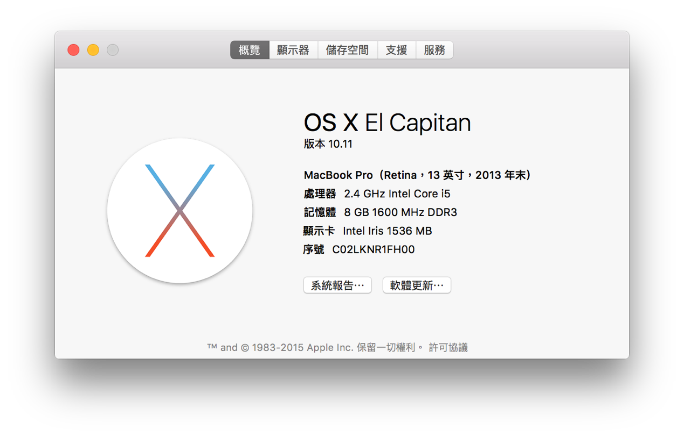

1. Q1&Q2

|  |  |  |  |  |  |
| --- | --- | --- | --- | --- | --- |
| Name | Lena64 | pepper64 | baboon64 | gra1 | gra2 |
| Origin Image | lena64/lena64.png | pepper64/pepper64.png | baboon64/baboon64.png | gra1/gra1.png | gra2/gra2.png |
| 2D-DCT | lena64/lena64.raw_2d_dct.png | pepper64/pepper64.raw_2d_dct.png | baboon64/baboon64.raw_2d_dct.png | gra1/gra1.raw_2d_dct.png | gra2/gra2.raw_2d_dct.png |
| Time | 1.14205s | 1.1372s | 1.16301s | 1.1667s | 1.19388s |
| 2D-IDCT | lena64/lena64.raw_2d_idct.png | pepper64/pepper64.raw_2d_idct.png | baboon64/baboon64.raw_2d_idct.png | gra1/gra1.raw_2d_idct.png | gra2/gra2.raw_2d_idct.png |
| Time | 1.21806s | 1.16037s | 1.15805s | 1.19827s | 1.23471s |
| PSNR | MSE = 0 | MSE = 0 | MSE = 0 | MSE = 0 | MSE = 0 |
| 1D-DCT | lena64/lena64.raw_1d_dct.png | pepper64/pepper64.raw_1d_dct.png | baboon64/baboon64.raw_1d_dct.png | gra1/gra1.raw_1d_dct.png | gra2/gra2.raw_1d_dct.png |
| Time | 0.013858s | 0.014021s | 0.013914s | 0.013486s | 0.015114s |
| 1D-IDCT | lena64/lena64.raw_1d_idct.png | pepper64/pepper64.raw_1d_idct.png | baboon64/baboon64.raw_1d_idct.png | gra1/gra1.raw_1d_idct.png | gra2/gra2.raw_1d_idct.png |
| Time | 0.013918s | 0.017057s | 0.015691s | 0.01414s | 0.013935s |
| PSNR | MSE = 0 | MSE = 0 | MSE = 0 | MSE = 0 | MSE = 0 |
|  | | | | | |
| Name | wildcard | triangle | circle1 | circle2 | Circle3 |
| Origin Image | wildcard/wildcard.png | triangle/triangle.png | circle1/circle1.png | circle2/circle2.png | circle3/circle3.png |
| 2D-DCT | wildcard/wildcard.raw_2d_dct.png | triangle/triangle.raw_2d_dct.png | circle1/circle1.raw_2d_dct.png | circle2/circle2.raw_2d_dct.png | circle3/circle3.raw_2d_dct.png |
| Time | 1.14736s | 1.15209s | 1.13428s | 1.14153s | 1.16579s |
| 2D-IDCT | wildcard/wildcard.raw_2d_idct.png | triangle/triangle.raw_2d_idct.png | circle1/circle1.raw_2d_idct.png | circle2/circle2.raw_2d_idct.png | circle3/circle3.raw_2d_idct.png |
| Time | 1.19901s | 1.18947s | 1.16016s | 1.18848s | 1.17925s |
| PSNR | MSE = 0 | MSE = 0 | MSE = 0 | MSE = 0 | MSE = 0 |
| 1D-DCT | wildcard/wildcard.raw_1d_dct.png | triangle/triangle.raw_1d_dct.png | circle1/circle1.raw_1d_dct.png | circle2/circle2.raw_1d_dct.png | circle3/circle3.raw_1d_dct.png |
| Time | 0.01503s | 0.013118s | 0.0138s | 0.015453s | 0.013674s |
| 1D-IDCT | wildcard/wildcard.raw_1d_idct.png | triangle/triangle.raw_1d_idct.png | circle1/circle1.raw_1d_idct.png | circle2/circle2.raw_1d_idct.png | circle3/circle3.raw_1d_idct.png |
| Time | 0.014527s | 0.014479s | 0.014913s | 0.015861s | 0.014949s |
| PSNR | MSE = 0 | MSE = 0 | MSE = 0 | MSE = 0 | MSE = 0 |

首先在上表可以發現2D的DCT&IDCT相較於1D慢，因為2D所需的運算量為64\*64\*64\*64 = 16777216次，1D只需要64\*64\*64\*2 = 524288次，相差32倍的運算量。其次可以發現MSE的差值接近等於0，扣除浮點數誤差，可以發現其DCT&IDCT轉換結果與原圖相同。對於較複雜的圖片，可以發現使用DCT轉為頻域空間時可以很有效的將高低頻分離。

1. Q3-Q4

|  |  |  |  |  |  |
| --- | --- | --- | --- | --- | --- |
| Name | Lena64 | Pepper64 | Baboom64 | Gra1 | Gra2 |
| Origin Image | lena64/lena64.png | pepper64/pepper64.png | baboon64/baboon64.png | gra1/gra1.png | gra2/gra2.png |
| Dead Zone | 0~0 | 0~0 | 0~0 | 0~0 | 0~0 |
| Truncate (dc,ac) | (0,3) | (0,3) | (0,3) | (0,6) | (0,5) |
| Quantization | lena64/lena64.raw_quantization_0_0_idct.png | pepper64/pepper64.raw_quantization_0_0_idct.png | baboon64/baboon64.raw_quantization_0_0_idct.png | gra1/gra1.raw_quantization_0_0_idct.png | gra2/gra2.raw_quantization_0_0_idct.png |
| Required Bits | 32767 | 32767 | 32767 | 32767 | 32767 |
| PSNR | 36.1585dB | 36.172dB | 36.1448dB | 32.5046dB | 46.2638dB |
| Dead Zone | -7~7 | -7~7 | -7~7 | -7~7 | -7~7 |
| Truncate (dc,ac) | (0,3) | (0,3) | (0,3) | (0,6) | (0,5) |
| Quantization | lena64/lena64.raw_quantization__7_7_idct.png | pepper64/pepper64.raw_quantization__7_7_idct.png | baboon64/baboon64.raw_quantization__7_7_idct.png | gra1/gra1.raw_quantization__7_7_idct.png | gra2/gra2.raw_quantization__7_7_idct.png |
| Required Bits | 2007 | 2239 | 847 | 31 | 39 |
| PSNR | 24.3112dB | 24.0379dB | 25.5966 | 26.4092dB | 39.8252dB |

|  |  |  |  |  |  |
| --- | --- | --- | --- | --- | --- |
| Name | wildcard | triangle | Circle1 | Circle2 | Circle3 |
| Origin Image | wildcard/wildcard.png | triangle/triangle.png | circle1/circle1.png | circle2/circle2.png | circle3/circle3.png |
| Dead Zone | 0~0 | 0~0 | 0~0 | 0~0 | 0~0 |
| Truncate (dc,ac) | (0,4) | (0,6) | (0,5) | (0,5) | (0,4) |
| Quantization | wildcard/wildcard.raw_quantization_0_0_idct.png | triangle/triangle.raw_quantization_0_0_idct.png | circle1/circle1.raw_quantization_0_0_idct.png | circle2/circle2.raw_quantization_0_0_idct.png | circle3/circle3.raw_quantization_0_0_idct.png |
| Required Bits | 32767 | 32767 | 32767 | 32767 | 32767 |
| PSNR | 32.5945dB | 24.7378dB | 25.8255dB | 25.7357dB | 31.0865dB |
| Dead Zone | -7~7 | -7~7 | -7~7 | -7~7 | -7~7 |
| Truncate (dc,ac) | (0,4) | (0,6) | (0,5) | (0,5) | (0,4) |
| Quantization | wildcard/wildcard.raw_quantization__7_7_idct.png | triangle/triangle.raw_quantization__7_7_idct.png | circle1/circle1.raw_quantization__7_7_idct.png | circle2/circle2.raw_quantization__7_7_idct.png | circle3/circle3.raw_quantization__7_7_idct.png |
| Required Bits | 2135 | 183 | 423 | 231 | 2479 |
| PSNR | 23.3774dB | 18.4531dB | 16.9585 | 19.2867dB | 17.7563dB |

可以發現上表大多沒有Dead Zone的Quantization對於圖片還原後的改變PSNR都是在30dB以上，而有Dead Zone則會在20dB~30dB左右品質會下降但是Required Bits會變少很多，其次會發現若是圖片本身頻率分佈均勻，則Required Bits則較少，因為與DCT轉換為頻域的方式有關。

1. Q5

|  |  |  |  |  |  |
| --- | --- | --- | --- | --- | --- |
| Name | Lena64 | Pepper64 | Baboon64 | Gra1 | Gra2 |
| Origin Image | lena64/lena64.png | pepper64/pepper64.png | baboon64/baboon64.png | gra1/gra1.png | gra2/gra2.png |
| 2D-DCT | lena64/lena64.raw_2d_block_dct.png | pepper64/pepper64.raw_2d_block_dct.png | baboon64/baboon64.raw_2d_block_dct.png | gra1/gra1.raw_2d_block_dct.png | gra2/gra2.raw_2d_block_dct.png |
| Time | 0.016258s | 0.017584s | 0.014807s | 0.016681s | 0.018181s |
| 2D-IDCT | lena64/lena64.raw_2d_block_idct.png | pepper64/pepper64.raw_2d_block_idct.png | baboon64/baboon64.raw_2d_block_idct.png | gra1/gra1.raw_2d_block_idct.png | gra2/gra2.raw_2d_block_idct.png |
| Time | 0.016632s | 0.017191s | 0.016661s | 0.017275s | 0.017762s |
| PSNR | MSE = 0 | MSE = 0 | MSE = 0 | MSE = 0 | MSE = 0 |
| 1D-DCT | lena64/lena64.raw_1d_block_dct.png | pepper64/pepper64.raw_1d_block_dct.png | baboon64/baboon64.raw_1d_block_dct.png | gra1/gra1.raw_1d_block_dct.png | gra2/gra2.raw_1d_block_dct.png |
| Time | 0.001765s | 0.0017s | 0.001953s | 0.002101s | 0.001694s |
| 1D-IDCT | lena64/lena64.raw_1d_idct.png | pepper64/pepper64.raw_1d_block_idct.png | baboon64/baboon64.raw_1d_block_idct.png | gra1/gra1.raw_1d_block_idct.png | gra2/gra2.raw_1d_block_idct.png |
| Time | 0.001866s | 0.00189s | 0.001978s | 0.001701s | 0.001917s |
| PSNR | MSE = 0 | MSE = 0 | MSE = 0 | MSE = 0 | MSE = 0 |

|  |  |  |  |  |  |
| --- | --- | --- | --- | --- | --- |
| Name | wildcard | triangle | Circle1 | Circle2 | Circle3 |
| Origin Image | wildcard/wildcard.png | triangle/triangle.png | circle1/circle1.png | circle2/circle2.png | circle3/circle3.png |
| 2D-DCT | wildcard/wildcard.raw_2d_block_dct.png | triangle/triangle.raw_2d_block_dct.png | circle1/circle1.raw_2d_block_dct.png | circle2/circle2.raw_2d_block_dct.png | circle3/circle3.raw_2d_block_dct.png |
| Time | 0.017657s | 0.018502s | 0.015195s | 0.015392s | 0.015521s |
| 2D-IDCT | wildcard/wildcard.raw_2d_block_idct.png | triangle/triangle.raw_2d_block_idct.png | circle1/circle1.raw_2d_block_idct.png | circle2/circle2.raw_2d_block_idct.png | circle3/circle3.raw_2d_block_idct.png |
| Time | 0.019152s | 0.017392s | 0.017506s | 0.01659s | 0.017336s |
| PSNR | MSE = 0 | MSE = 0 | MSE = 0 | MSE = 0 | MSE = 0 |
| 1D-DCT | wildcard/wildcard.raw_1d_block_dct.png | triangle/triangle.raw_1d_block_dct.png | circle1/circle1.raw_1d_block_dct.png | circle2/circle2.raw_1d_block_dct.png | circle3/circle3.raw_1d_block_dct.png |
| Time | 0.002056s | 0.001661s | 0.001707s | 0.001661s | 0.001864s |
| 1D-IDCT | wildcard/wildcard.raw_1d_block_idct.png | triangle/triangle.raw_1d_block_idct.png | circle1/circle1.raw_1d_block_idct.png | circle2/circle2.raw_1d_block_idct.png | circle3/circle3.raw_1d_block_idct.png |
| Time | 0.001841s | 0.001665s | 0.001821s | 0.001662s | 0.001662s |
| PSNR | MSE = 0 | MSE = 0 | MSE = 0 | MSE = 0 | MSE = 0 |

與1.Q1&Q2的圖表相比，使用Block Size 8x8速度會比直接Block Size 64x64快，以2D-DCT&IDCT為例，64x64要運算64\*64\*64\*64 = 16777216次，而8x8 則只要8\*8\*8\*8\*8\*8 = 262144次，相差64倍，而若是1D-DCT&IDCT更是只要1ms左右的運算，因此8x8相較於64x64能夠有更好的執行時間與效率。