Chapter 4
Proposed work
4.1 Implementation
The course recommender is one of the most powerful tool a student can get his hands on it is one of the tools that is a game changer in terms of being effective and providing results to the student. One of the best things a student can do in his life is to use his time effectively and given proper guidance any student can shoot to the moon. Course recommendation is a special project taken into consideration the problems a student goes through his daily life by fixing it and can be used by any student with a keen interest to learn and grow. As a student we know how big the web really is and in this ocean of information finding the one we need is too tough going throw numerous pages to get what we need is not that effective approach so we tackled our this daily approach and created this product course recommendation system . So you want to learn some things okay anyone can name to so many websites udemy, coursera, etc. Where you can search the course you want that’s fine but how to know this one is the best you don’t know every website that is there you have not gone throw all the courses present at that website. Ratings can be deceiving and so many courses have so many ratings which among them is for you so we created this project who provides you with the best course for you in whole of the internet which will give you the best result there is.
Being a smart worker is always better than being a hard worker.The intended algorithm also consider how well versed the user is with the subject and also keeps in consideration their older courses taken to recommend the best course there is. The recommended courses can be paid or free.
But for the purpose of this project all courses considered are free courses as most students try to get the audited version for free to get the course material .The used algorithms can be discussed with fair brevity and can be understood from the documentation of the course files included in the project .Most algorithms are standard algorithms and can be implemented with fair ease by including libraries and adjusting their parameters .

4.2 K-means Algorithm
K-means clustering is a method of vector quantization, originally from signal processing, that is popular for cluster analysis in data mining. k-means clustering aims to partition n observations into k clusters in which each observation belongs to the cluster with the nearest mean, serving as a prototype of the cluster. This results in a partitioning of the data space into Voronoi cells.
The problem is computationally difficult (NP-hard); however, there are efficient heuristic algorithms that are commonly employed and converge quickly to a local optimum. These are usually similar to the expectation-maximization algorithm for mixtures of Gaussian distributions via an iterative refinement approach employed by both k-means and Gaussian mixture modeling. Additionally, they both use cluster centers to model the data; however, k-means clustering tends to find clusters of comparable spatial extent, while the expectation-maximization mechanism allows clusters to have different shapes.
The algorithm has a loose relationship to the k-nearest neighbor classifier, a popular machine learning technique for classification that is often confused with k-means due to the k in the name. One can apply the 1-nearest neighbor classifier on the cluster centers obtained by k-means to classify new data into the existing clusters. This is known as nearest centroid classifier or Rocchio algorithm.
This algorithm is so called k-means as it has k clusters and it is dependent on the two factors firstly the distance factor calculated from the neighbouring clusters and the clustering algorithm which decides which neighbour is the nearest to the data. The data is clustered into the existing cluster whichever is the nearest to it, this is decided by considering the lowest distance factor from all the existing clusters. This algorithm is considered to be one of the best data mining algorithm useful for finding the unseen patterns in the present data and predicting the properties of the new data encountered in the process.

The Flow of process for training the classifier to rate the courses based on the users intent and reviews.

Firstly the dataset for course review with name of each course and their review is included into the program .
Once the set of review has been added the next step is to preprocess the dataset and to remove any anomaly present in the data that could cause the system to give inaccurate ratings to the courses . Such as the language of text, null values etc.
The next step is to make feature set from given dataset to get the best features so that each review can be correlated to certain words that are important words and that define the intent of the user.
Once the featureset of the data has been made next step is to select the classifier to get he optimum result so here in the intended project naive bayes binary classifier has been used for initial purpose so as to rate the data as 1 fo bad and 5 for good .
Nlp library has the naive bayes function both multinomial and binary function included so the project used the inbuilt nail bayes function of nltk as the classifier .
Once the classifier has been chosen the next step is to divide the data into testing data and training data which can be done with the help of cross validations train test split . For the project the test set taken is divided based on the 4:1 ratio
Once the training of the data has been done the classifier was adjusted to achieve ans optimum accuracy with naive bayes and approx 70% was the result the algorithm of naive bayes was able to achieve in the specific case of this project .
The intention of the above process is to include as many reviews so that if a user gives a new review it can be labeled and the classifier could be adjusted further to give a adjusted score to each course for getting the best courses and the worst courses based on the selected features of the course
review given by the current user.

The above flow diagram represents the course of action for making a collaborative recommendation system once a dataset .of reviews and the users who gave them has been made available.
Firstly as the label for each course is available any user needs to login to the system to access his/her data .
Once a user registers by answering certain important questions which help the system form a knowledge base for initial recommendation to the new user he/ she can access the recommended courses.
Now coming to the backend part it functions based on the collaborative model of recommendation system .Where simlilar users recieve similar recommendations .
To achieve the proposed model a user item matrix is made using the data from the previously acquire user data where each user has given review for courses they have done or taken up earlier .
Certain key factors which influence the recommendation such as the length of curse needed and the year of study of the student have been taken as the crucial point for making the recommendation
Now the next step is to give a structure or score to each of such user who has given review which
has been done by employing the method of average score by giving each feature a score and taking average of all such features.
Once the score is caluculated a group or cluster of user has been made by help of kmeans clustering where k has been taken as the number of courses considered for the purpose of training the score classifier of linear regression.
A new user can be made to login and his /her score can be calculated based on the points or fatures question and recommendations can be considered based on the closeness to the mean points .
K means is as iterative algorithm which intends to group datests based on their closeness to one other or similarity to one another.
The recommendation user similarity so they are in true nature with the collaborative model and have been optimised by suggesting the top 5 courses or recommendations to ease the search .

Implementation and Results
5.1 Working Explanation
The working project involves the use of jupyter notebook for implementation of each module and the prerequisites mention above require nltk.download() to download the various libraries. The loading of dataset into python is helped by the use of pandas and also the numpy library has been used for ease of processing. The datasets after being loaded look like the figure 5.1. Where the reviews have a serial no and the text, and the course id .To deal with the preprocessing nltk library has been used.
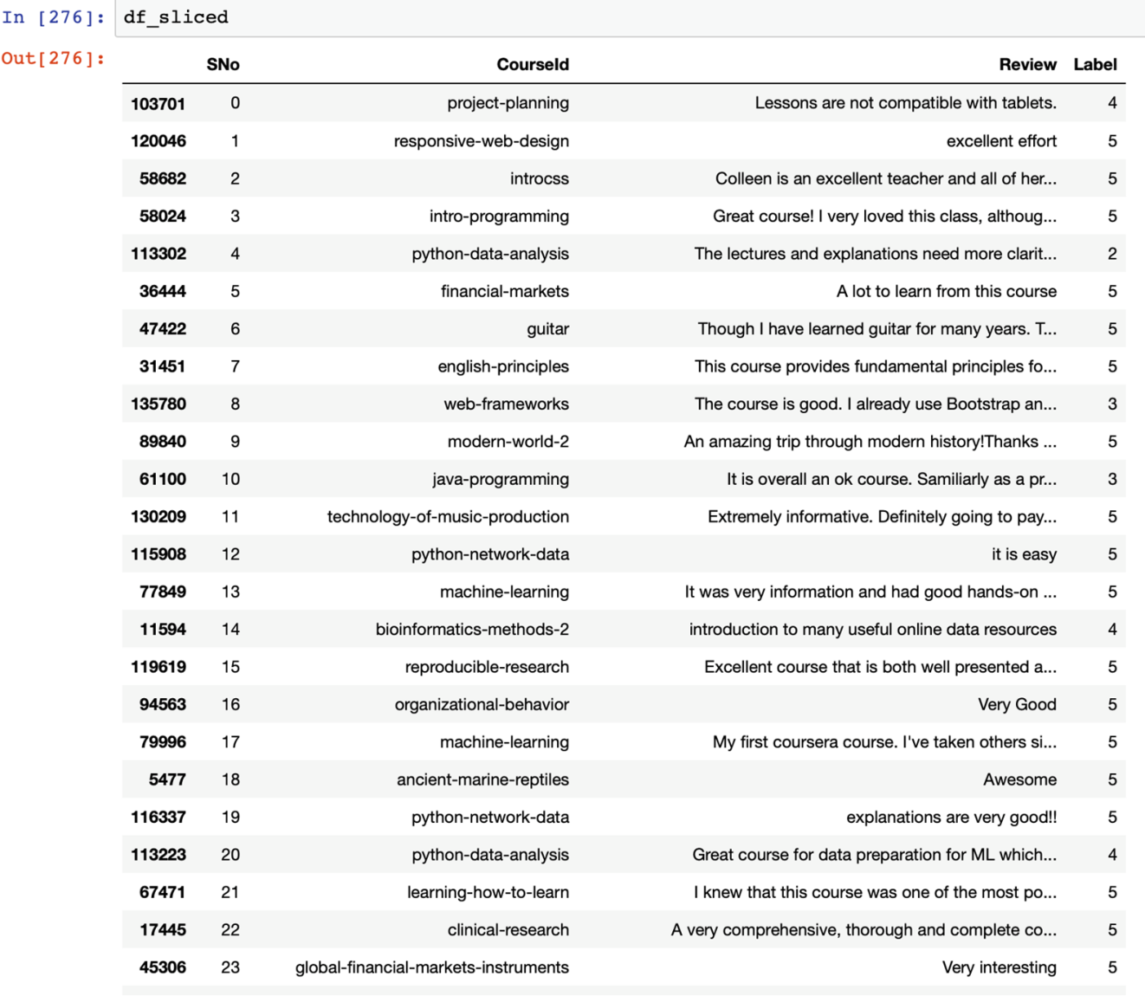
Figure 5.1 Set of reviews loaded into ipython notebook

5.2 Preprocessing of data
Once the Data has been loaded the next step involves the process of preprocessing the data. This step includes selecting only the English reviews which has been done with the help of enchant library where the first word of a set of 10000 reviews has been selected and checked using the enchant if it was not English then its index was stored in a array and the set was subtracted from 10000 to get new indexes which contained only English reviews. Preprocessing can be seen in the figure 5.2.
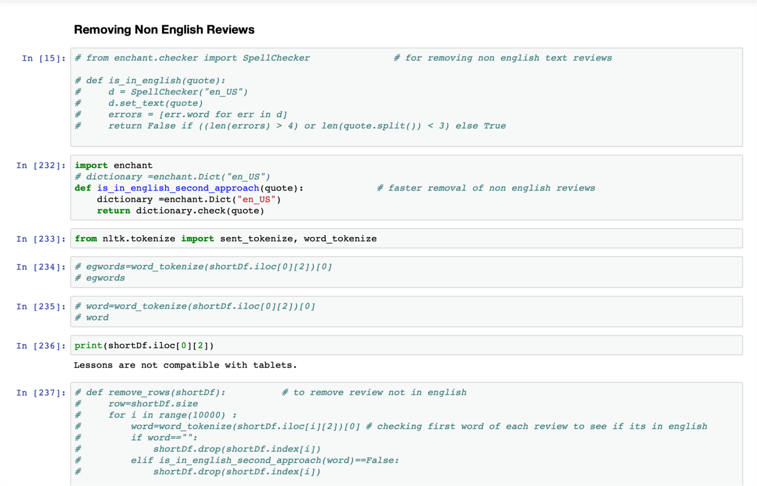
Figure 5.2: Function is_in_english_second_approach() which makes only English reviews available

The main feature of to use the enchant function rather than using the nltk library inbuilt function is to make a separate list of only english words and to do this faster with creating a new table of only such reviews instead of removing them form current table
words for reference is the array which has all the first words which are checked using enchant for getting the index of non english words and to remove them from the total sets .Which has been shown below

indexes to drop houses the index of the non english reviews

In this part the non english indexed reviews have been removed from all reviews and a new array of indexes to keep has been made.

5.3 Making the feature set
Once the preprocessing of data is done the next step involved making of the features so to select the features from reviews the most frequent 3000 words form the set of review words were selected as features. To select most common words nltk library inbuilt fuction most_common() and pandas inbuilt function unique() were used. This can be seen in figure 5.3 given below.
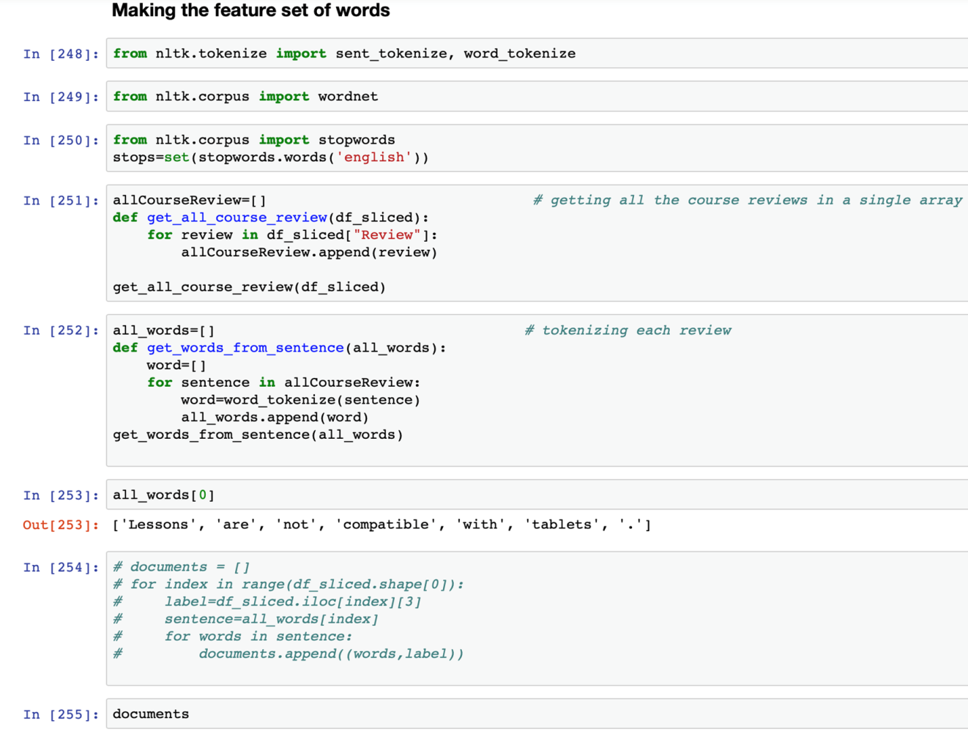
Figure 5.3: Process of making the features using the function the get_from_sentence()

The above function gets the names of the courses for which reviews have been considered after preprocessing the course reviews.

To tokenise each sentence and to get words from each sentence the above function get_words_from_sentence has been used which gets a review as an argument and divides it into words and then stores them into words[] python list.

once the words have been tokenised they have to be related to a label for the purpose of training to make a clasifer which understands to relate each word to a good or bad review context .
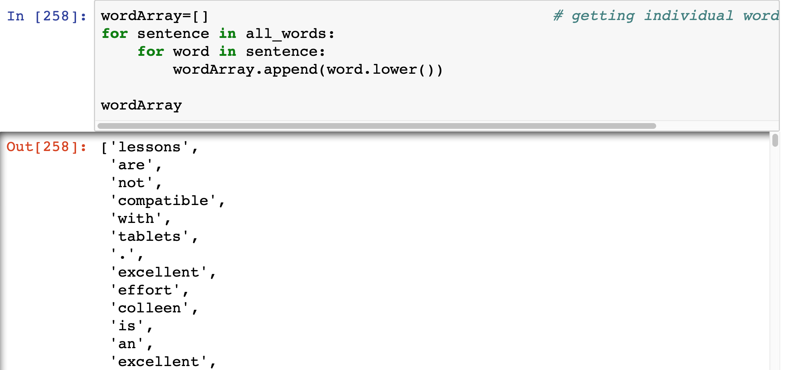

To optimize the process of training all the unnecessary words have to be removed which can be done using the nltk.stopwords which include a list of all unnneceary words that can be removed form the text .

This gives the list of most common words which occur in the selected review and also give an insight to which words to remove further for consideration .

Selecting 3000 words as the feature set where if any word one of these if present or not present can help identify the sentiment .

This function makes a 2D list or a key value dictionary where if a word is present in th ecurrent review it gets true for the corresponding word from the fetaureset pod words else false.
The complexity of this algorithm is O(n*m) where n is the size of review and m is the number of feature set words which in the considered case is 3000 .

5.4 Training process
Once the feature section is done the training process comes into the picture where naïve bayes has been used from the nltk library so that the reviews get clarified in a category of1 or 5. The cross validation has been used so as to divide the reviews into two sets of 80 % data for training and 20 % for testing . this has been done so as to avoid overfitting of data . The process of training involved 10 min approx . The input for prediction has to be a featureset where a true is there for each word of the features present in the current review and false otherwise. The classifier gives an accuracy score of 71% and the most informative features have been shown in figure 5.4.
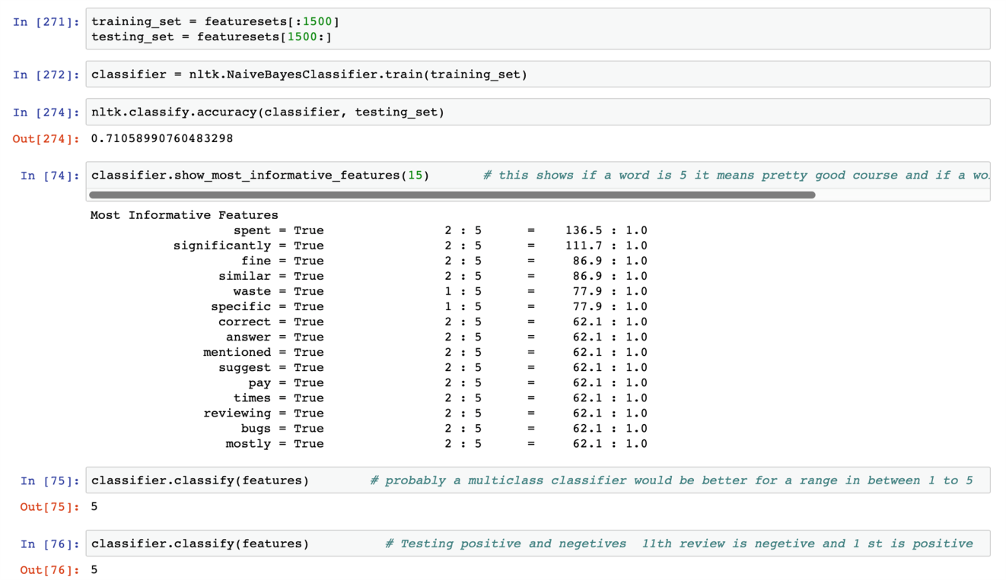
Figure 5.4: It shows the most informative features that were found during the training of the naïve bayes classifier
here the classifier used is the nltk’s inbuilt classifier naive bayes . This is a probabilistic classifier which works on the above made feature set.
Here for purpose for training and testing approximately 20 % of data has been kept for testing.

The above words are the most informative words which help differentiate a review from a good or bad based on the trained classifier.
The above code can be used to save the trained classifier for future purposes and to save time for further use. This includes saving the pickle file in write mode and then to open it in the read mode to get the saved classfier and use it.
5.5 User item matrix
After the reviews had been classified the next step was to get the user item matrix so as to get a novel model of collaborative recommendation into the picture. The user item matrix is a 2d matrix where the users are the reviewers and item in the intended case are the courses which the users have taken. This matrix helps classify a similar user to them and the process of recommendation get much simpler. This can be seen in the figure 5.5.
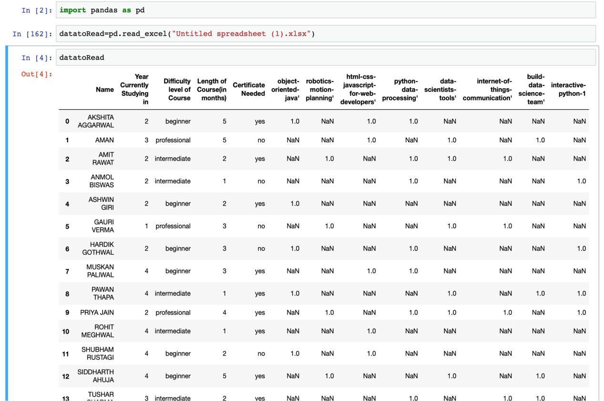
Figure 5.5: The above image depicts the user item matrix for collaborative filtering
To get the training of the classifier done it accepts numerical data so string data is converted into numerical values.
The score for each user is calculated so as to get a basis for clustering the user who have given the reviews .

5.6 Create a scoring mechanism
Once the user item matrix had been made the next step proposed was to make a set of scoring mechanism for the users but the purpose involved in this case was solved temporarily using the method of averages. The proposed system intended to use k-means clustering for users to make a group and the use kNN for classifying new users. The knowledge base for the new users was developed by overcoming the cold start problem by asking a set of question from the new users as shown in figure 5.6.
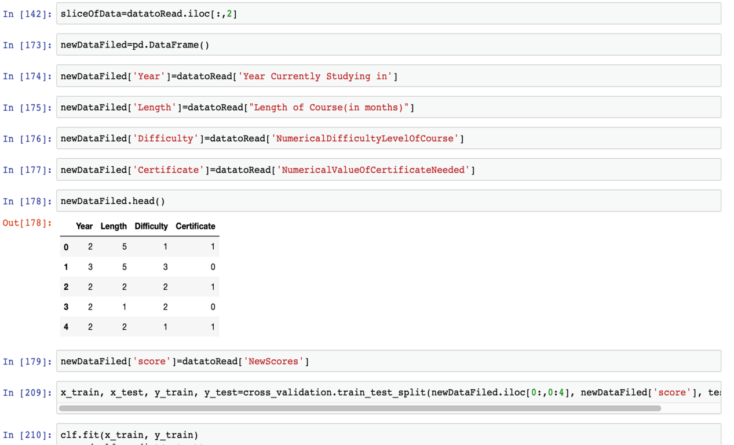
Figure 5.6: Set of questions asked from the new user so as to make a knowledge base

5.7 Results
The end result of the recommendation model is to get suggestion based on the aforementioned schema of the things which has been shown in below figure 5.7.
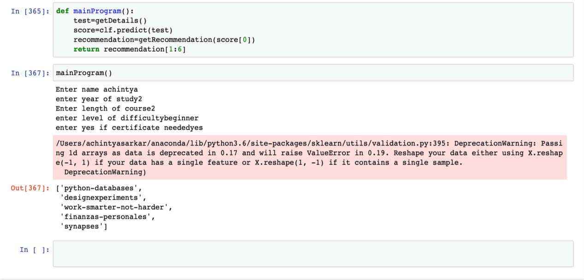

The details of the new user are used for getting the knowledge base and to get the recommendation

