Zad.1

Szkic grafu:

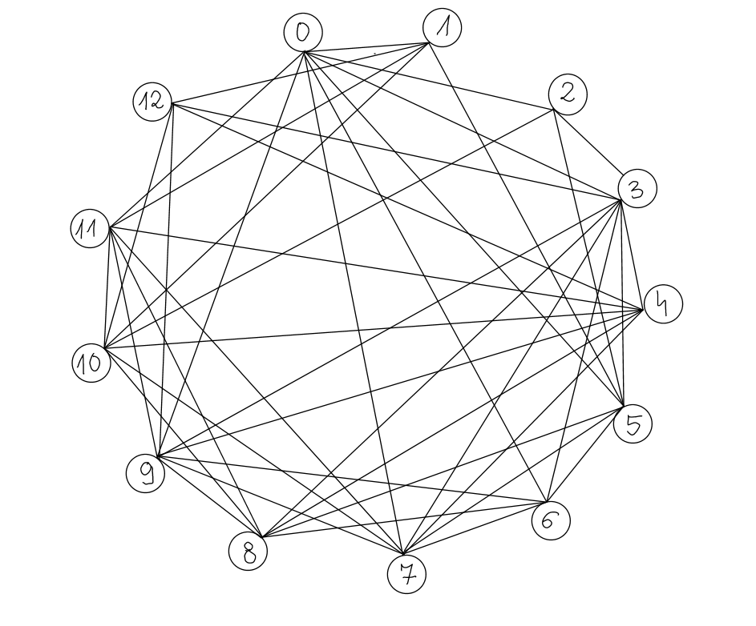

Zad.2

**MACIERZ INCYDENCJI**

|  |  |  |  |  |  |  |  |  |  |  |  |  |  |
| --- | --- | --- | --- | --- | --- | --- | --- | --- | --- | --- | --- | --- | --- |
|  | 0 | 1 | 2 | 3 | 4 | 5 | 6 | 7 | 8 | 9 | 10 | 11 | 12 |
| (0,1) | 1 | 1 | 0 | 0 | 0 | 0 | 0 | 0 | 0 | 0 | 0 | 0 | 0 |
| (0,2) | 1 | 0 | 1 | 0 | 0 | 0 | 0 | 0 | 0 | 0 | 0 | 0 | 0 |
| (0,3) | 1 | 0 | 0 | 1 | 0 | 0 | 0 | 0 | 0 | 0 | 0 | 0 | 0 |
| (0,5) | 1 | 0 | 0 | 0 | 0 | 1 | 0 | 0 | 0 | 0 | 0 | 0 | 0 |
| (0,6) | 1 | 0 | 0 | 0 | 0 | 0 | 1 | 0 | 0 | 0 | 0 | 0 | 0 |
| (0,7) | 1 | 0 | 0 | 0 | 0 | 0 | 0 | 1 | 0 | 0 | 0 | 0 | 0 |
| (0,9) | 1 | 0 | 0 | 0 | 0 | 0 | 0 | 0 | 0 | 1 | 0 | 0 | 0 |
| (0,11) | 1 | 0 | 0 | 0 | 0 | 0 | 0 | 0 | 0 | 0 | 0 | 1 | 0 |
| (1,5) | 0 | 1 | 0 | 0 | 0 | 1 | 0 | 0 | 0 | 0 | 0 | 0 | 0 |
| (1,10) | 0 | 1 | 0 | 0 | 0 | 0 | 0 | 0 | 0 | 0 | 1 | 0 | 0 |
| (1,11) | 0 | 1 | 0 | 0 | 0 | 0 | 0 | 0 | 0 | 0 | 0 | 1 | 0 |
| (1,12) | 0 | 1 | 0 | 0 | 0 | 0 | 0 | 0 | 0 | 0 | 0 | 0 | 1 |
| (2,3) | 0 | 0 | 1 | 1 | 0 | 0 | 0 | 0 | 0 | 0 | 0 | 0 | 0 |
| (2,5) | 0 | 0 | 1 | 0 | 0 | 1 | 0 | 0 | 0 | 0 | 0 | 0 | 0 |
| (2,10) | 0 | 0 | 1 | 0 | 0 | 0 | 0 | 0 | 0 | 0 | 1 | 0 | 0 |
| (3,4) | 0 | 0 | 0 | 1 | 1 | 0 | 0 | 0 | 0 | 0 | 0 | 0 | 0 |
| (3,5) | 0 | 0 | 0 | 1 | 0 | 1 | 0 | 0 | 0 | 0 | 0 | 0 | 0 |
| (3,6) | 0 | 0 | 0 | 1 | 0 | 0 | 1 | 0 | 0 | 0 | 0 | 0 | 0 |
| (3,7) | 0 | 0 | 0 | 1 | 0 | 0 | 0 | 1 | 0 | 0 | 0 | 0 | 0 |
| (3,8) | 0 | 0 | 0 | 1 | 0 | 0 | 0 | 0 | 1 | 0 | 0 | 0 | 0 |
| (3,9) | 0 | 0 | 0 | 1 | 0 | 0 | 0 | 0 | 0 | 1 | 0 | 0 | 0 |
| (3,12) | 0 | 0 | 0 | 1 | 0 | 0 | 0 | 0 | 0 | 0 | 0 | 0 | 1 |
| (4,7) | 0 | 0 | 0 | 0 | 1 | 0 | 0 | 1 | 0 | 0 | 0 | 0 | 0 |
| (4,8) | 0 | 0 | 0 | 0 | 1 | 0 | 0 | 0 | 1 | 0 | 0 | 0 | 0 |
| (4,9) | 0 | 0 | 0 | 0 | 1 | 0 | 0 | 0 | 0 | 1 | 0 | 0 | 0 |
| (4,10) | 0 | 0 | 0 | 0 | 1 | 0 | 0 | 0 | 0 | 0 | 1 | 0 | 0 |
| (4,11) | 0 | 0 | 0 | 0 | 1 | 0 | 0 | 0 | 0 | 0 | 0 | 1 | 0 |
| (4,12) | 0 | 0 | 0 | 0 | 1 | 0 | 0 | 0 | 0 | 0 | 0 | 0 | 1 |
| (5,6) | 0 | 0 | 0 | 0 | 0 | 1 | 1 | 0 | 0 | 0 | 0 | 0 | 0 |
| (5,7) | 0 | 0 | 0 | 0 | 0 | 1 | 0 | 1 | 0 | 0 | 0 | 0 | 0 |
| (5,8) | 0 | 0 | 0 | 0 | 0 | 1 | 0 | 0 | 1 | 0 | 0 | 0 | 0 |
| (6,7) | 0 | 0 | 0 | 0 | 0 | 0 | 1 | 1 | 0 | 0 | 0 | 0 | 0 |
| (6,8) | 0 | 0 | 0 | 0 | 0 | 0 | 1 | 0 | 1 | 0 | 0 | 0 | 0 |
| (6,9) | 0 | 0 | 0 | 0 | 0 | 0 | 1 | 0 | 0 | 1 | 0 | 0 | 0 |
| (7,9) | 0 | 0 | 0 | 0 | 0 | 0 | 0 | 1 | 0 | 1 | 0 | 0 | 0 |
| (7,10) | 0 | 0 | 0 | 0 | 0 | 0 | 0 | 1 | 0 | 0 | 1 | 0 | 0 |
| (7,11) | 0 | 0 | 0 | 0 | 0 | 0 | 0 | 1 | 0 | 0 | 0 | 1 | 0 |
| (8,9) | 0 | 0 | 0 | 0 | 0 | 0 | 0 | 0 | 1 | 1 | 0 | 0 | 0 |
| (8,10) | 0 | 0 | 0 | 0 | 0 | 0 | 0 | 0 | 1 | 0 | 1 | 0 | 0 |
| (8,11) | 0 | 0 | 0 | 0 | 0 | 0 | 0 | 0 | 1 | 0 | 0 | 1 | 0 |
| (9,11) | 0 | 0 | 0 | 0 | 0 | 0 | 0 | 0 | 0 | 1 | 0 | 1 | 0 |
| (9,12) | 0 | 0 | 0 | 0 | 0 | 0 | 0 | 0 | 0 | 1 | 0 | 0 | 1 |
| (10,11) | 0 | 0 | 0 | 0 | 0 | 0 | 0 | 0 | 0 | 0 | 1 | 1 | 0 |
| (10,12) | 0 | 0 | 0 | 0 | 0 | 0 | 0 | 0 | 0 | 0 | 1 | 0 | 1 |

1. **Jeśli krawędź nie jest incydentna z wierzchołkiem**
2. **Jeśli krawędź jest incydentna z wierzchołkiem**

--------------------------------------------------------------------------------------------------------------------------------------

Zad.3

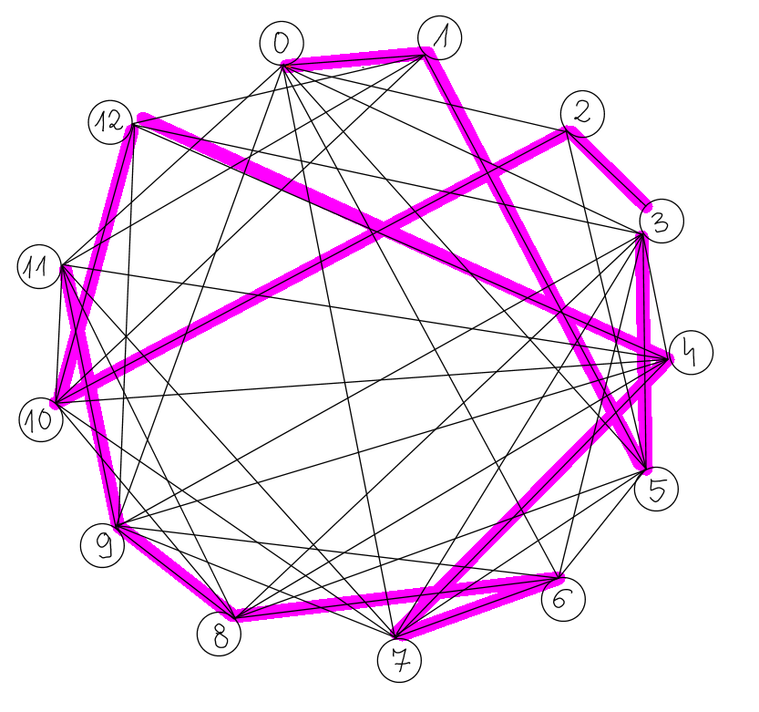

Graf jest Hamiltonowski.

Cykl Hamiltona = [0,1,5,3,2,10,12,4,7,6,8,9,11]

--------------------------------------------------------------------------------------------------------------------------------------

Zad.4

**Graf eulerowski** ⬄ gdy wszystkie wierzchołki mają parzyste stopnie. NIE SPEŁNIONE, czyli graf nie jest eulerowski.

**Graf półeulerowski** ⬄ gdzy wszystkie wierzchołki mają parzyste stopnie poza początkiem i końcem. np.:

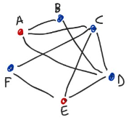

Czyli analizowany graf NIE JEST również półeulerowski.

--------------------------------------------------------------------------------------------------------------------------------------

Zad. 5 i 6

**Kolorowanie krawędziowe:**

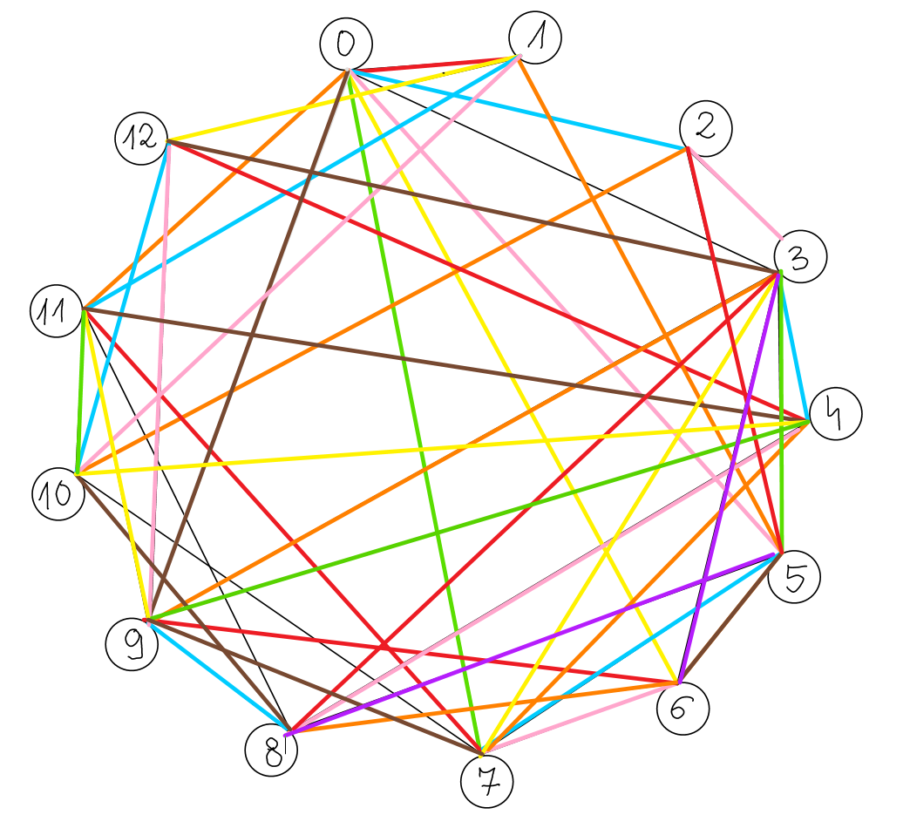

Indeks chromatyczny: 9

**Kolorowanie wierzchołkowe:**

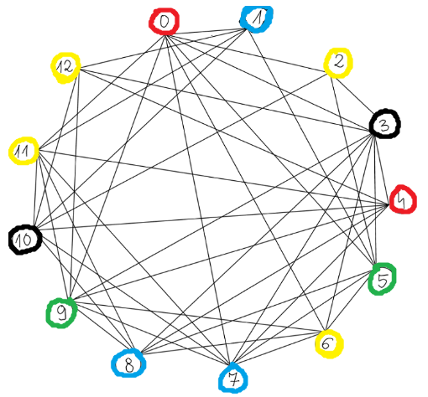

Dowód:

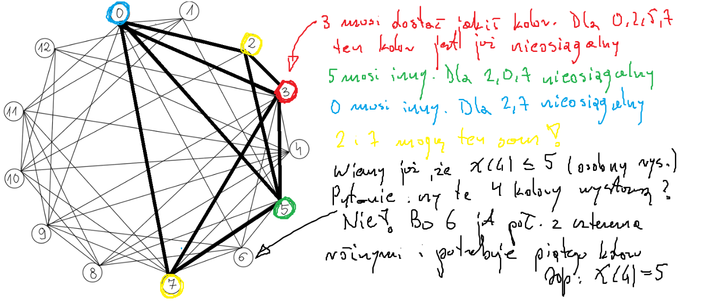

Liczba chromatyczna: 5

--------------------------------------------------------------------------------------------------------------------------------------

Zad.7

Nadane wagi do zadania nr.7

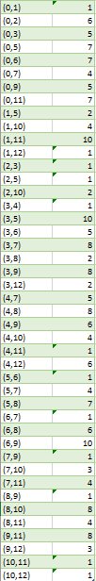

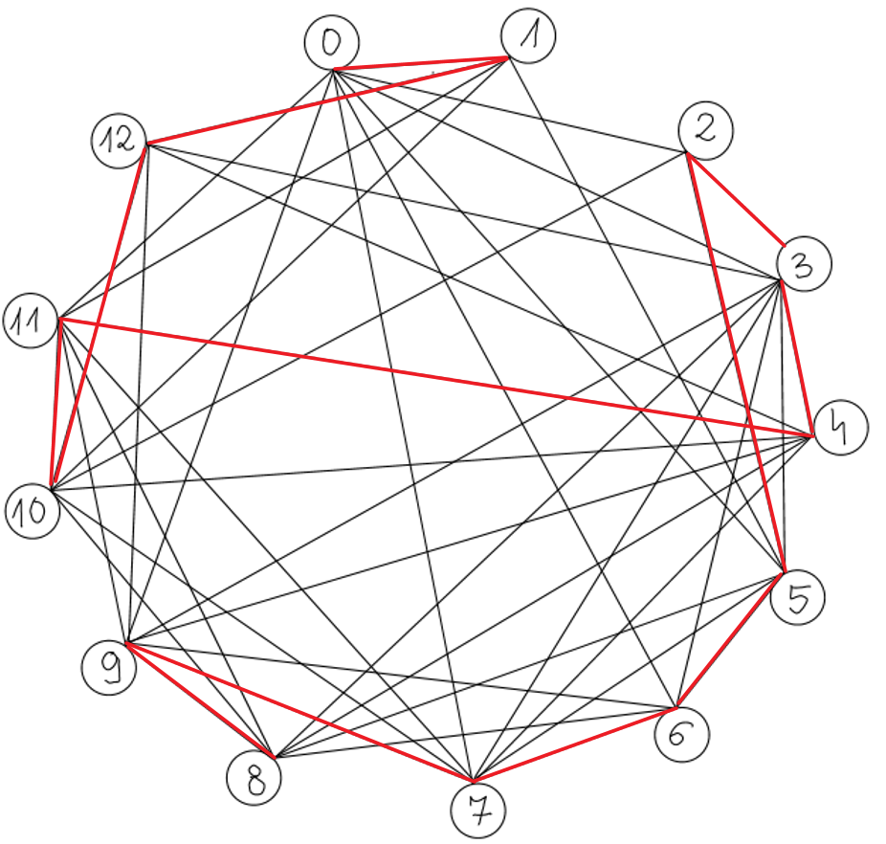

----------------------------------------------------------------------------------------------------------------------------

Zad.8

Czy rysunek tego grafu jest planarny? **NIE**

Jeśli nie, to czy da się go przedstawić jako planarny? **NIE DA SIĘ**

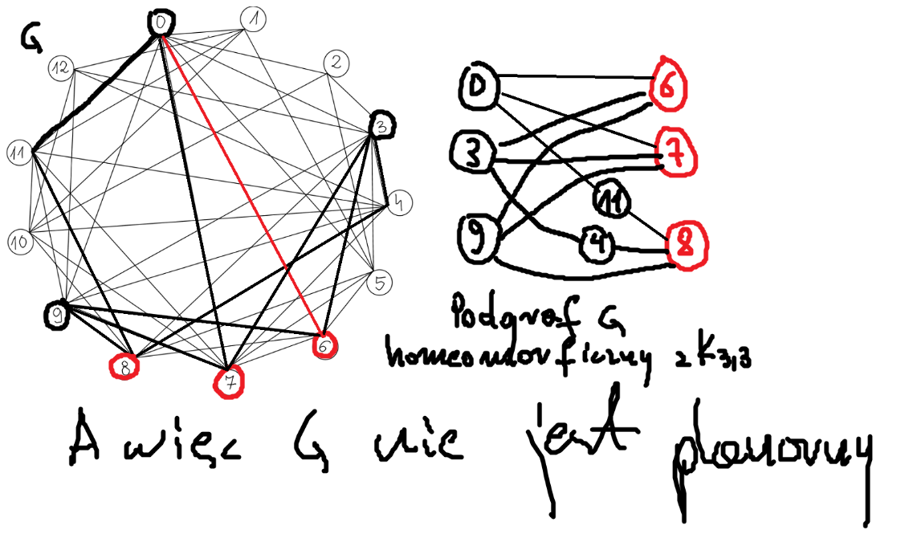

Graf G jest planarny ⬄ gdy nie zawiera podgrafu HOMEOMORFICZNEGO z  *K5*  ani z *K3,3*.

Na obrazku powyżej pokazałam, że analizowany przeze mnie graf jest homeomorficzny z *K3,3*, więc graf ten nie jest planarny.

----------------------------------------------------------------------------------------------------------------------------