代理服务器搭建教程
我们使用阿里云的服务器来搭建这个代理服务器，首先进入阿里云的官网：https://www.aliyun.com/product/ecs
提示：
如果搭建机场就可以使用这个搭建方法，不可以使用ssh的动态端口转发，之所以无法使用ssh，是因为ssh不具备高并发特性，如果想要搭建机场需要使用v2ray，这个文档就是专门使用v2ray来搭建VPN节点，本文档中使用了ansilble+v2ray进行搭建VPN节点
下面这个方法也可以来搭建ip代理池，进行上网代理，但是IP代理池的搭建方法这里不做详细讲解，后续会在GitHub仓库里面进行开源IP代理池的搭建方法，大家可以静候佳音
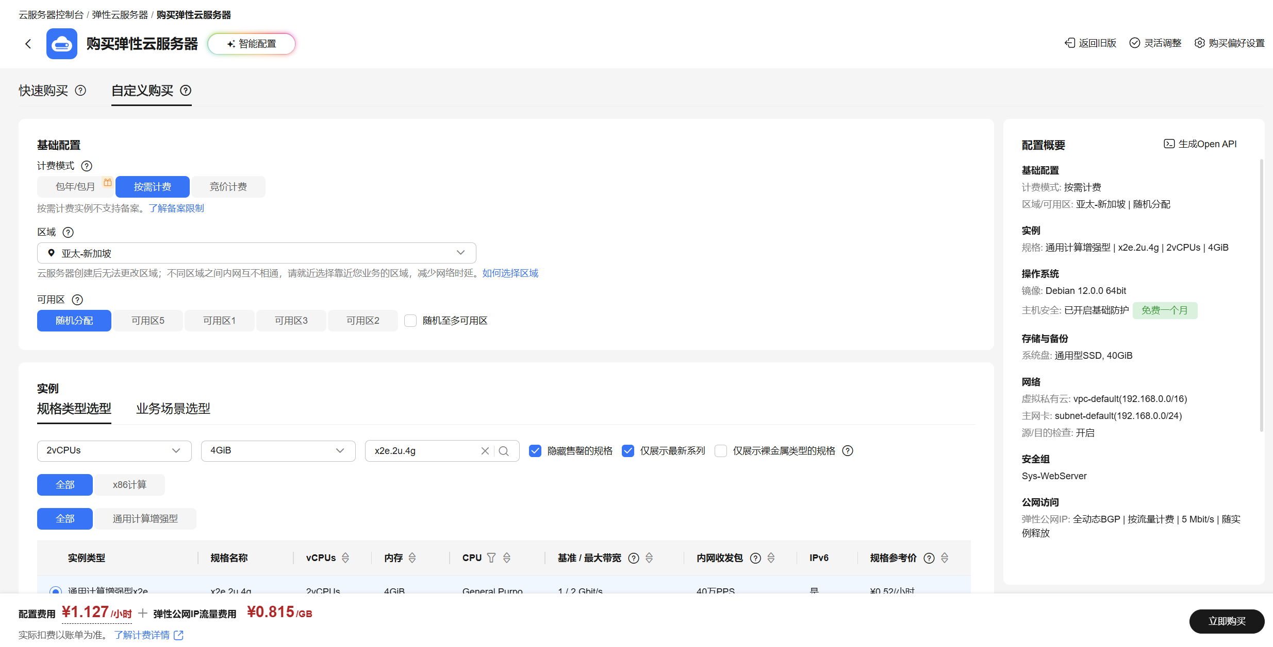
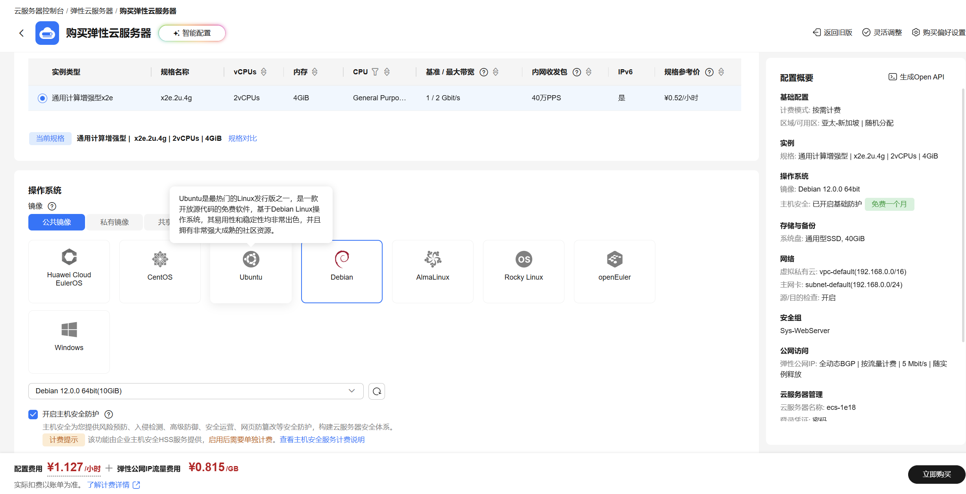
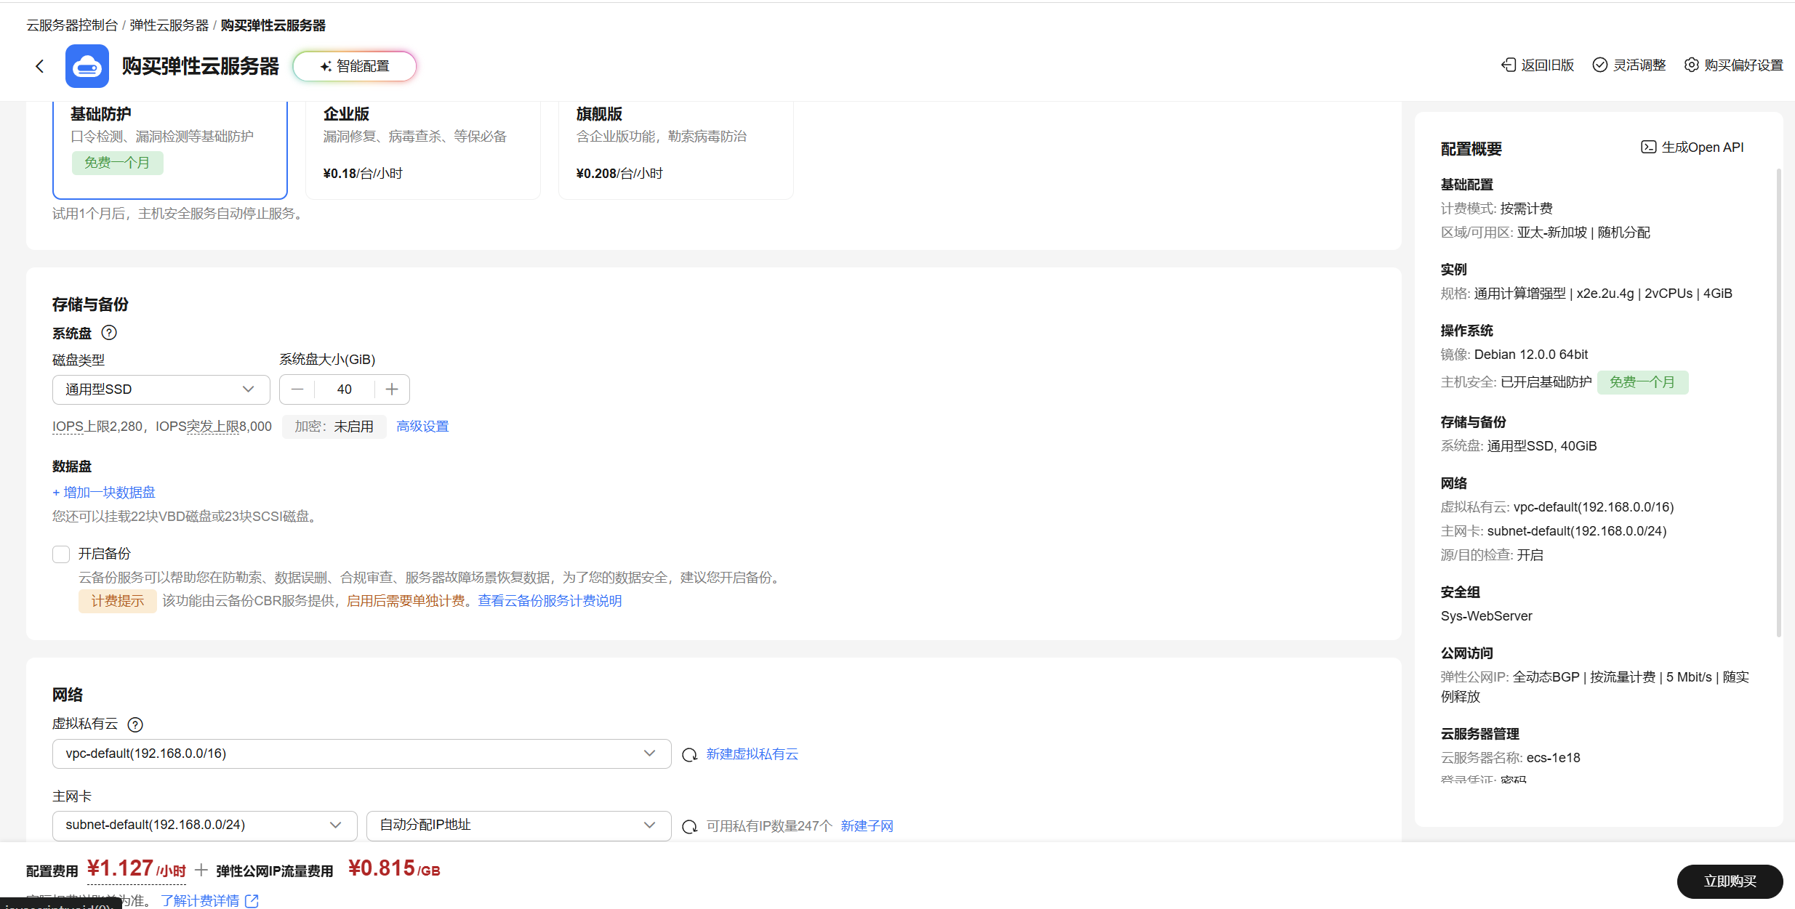
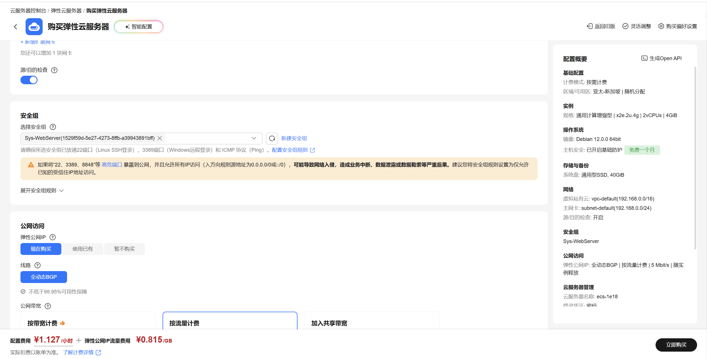
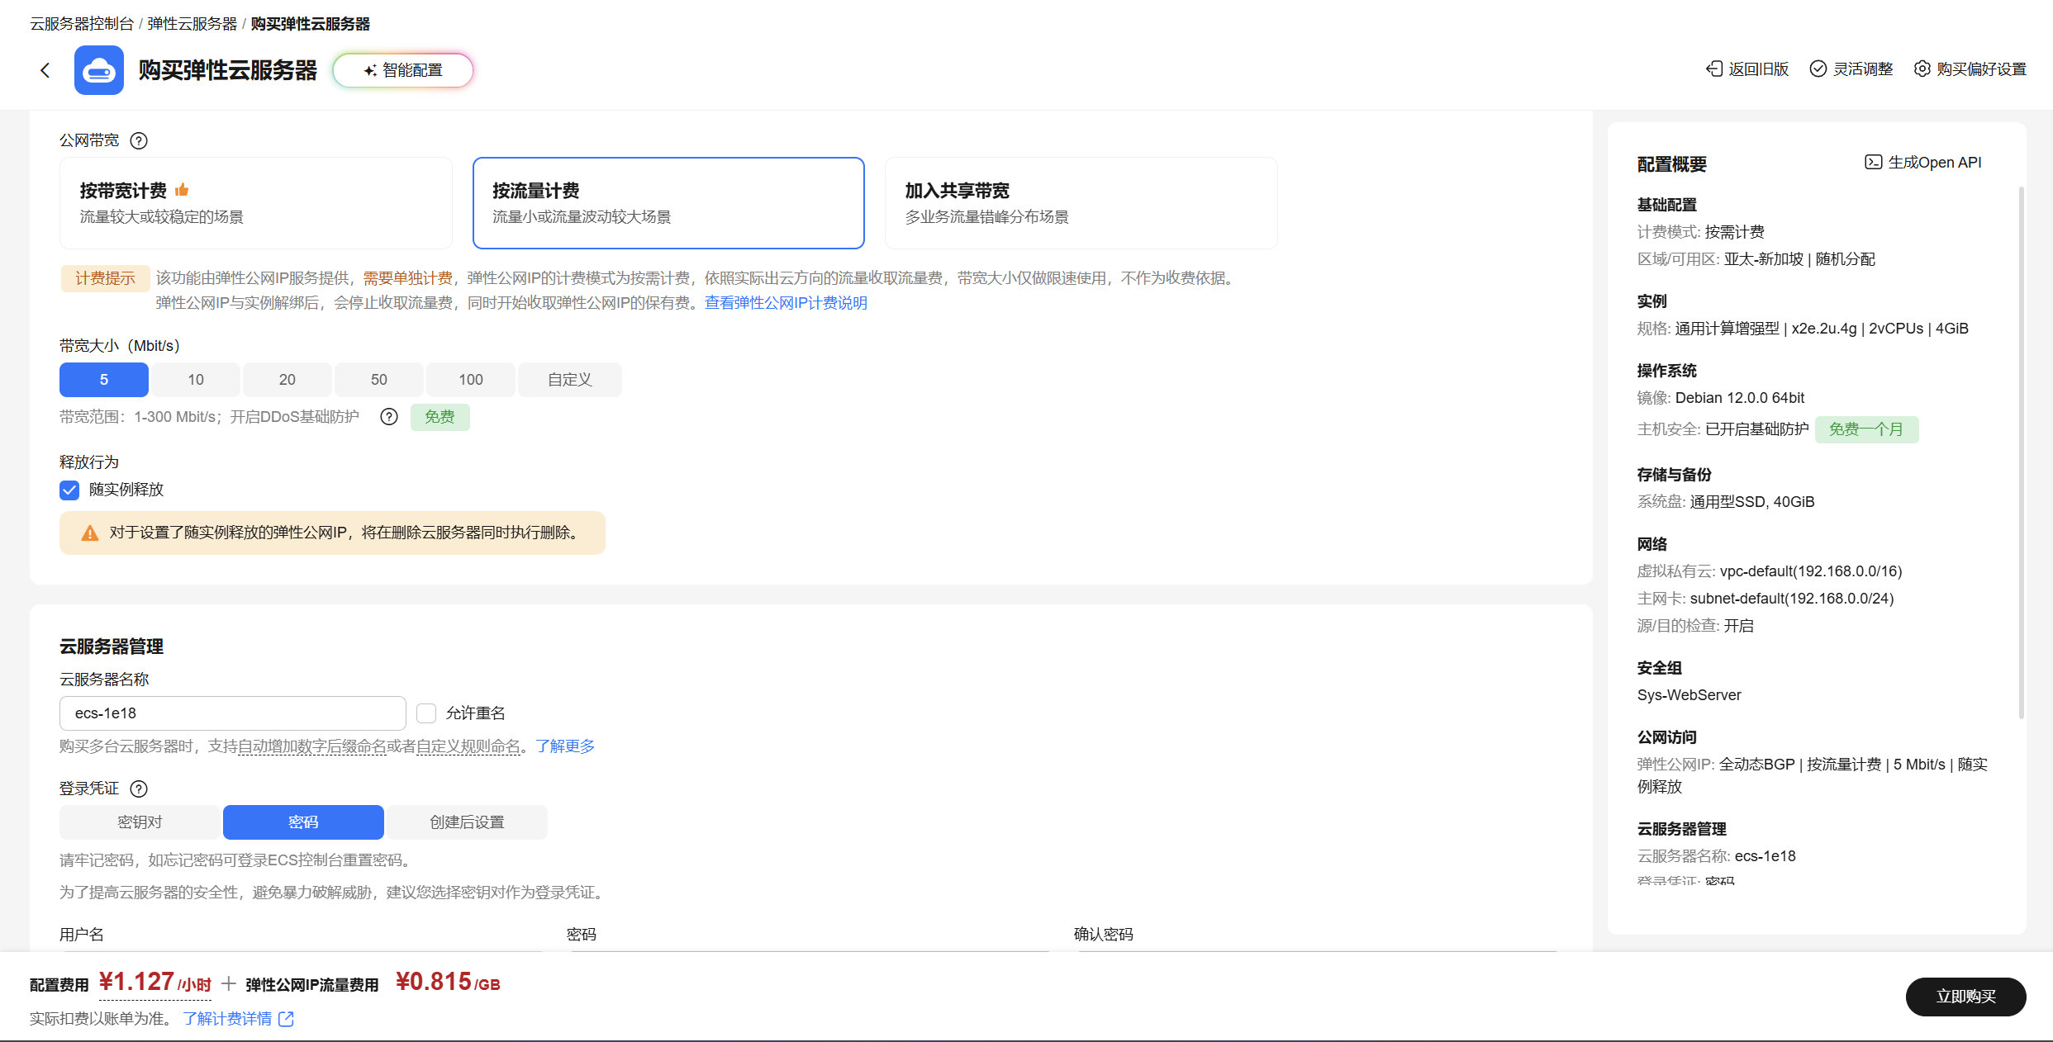
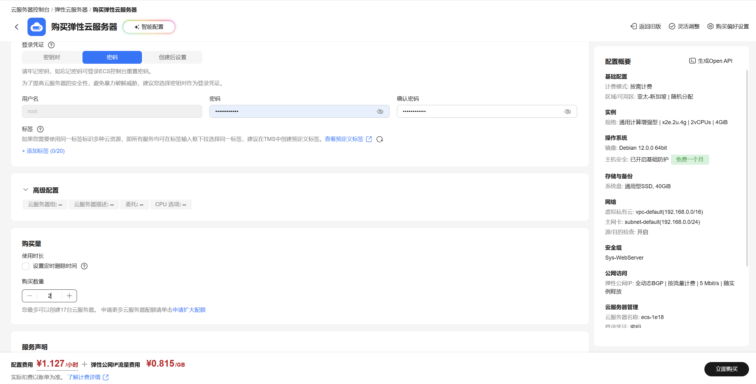
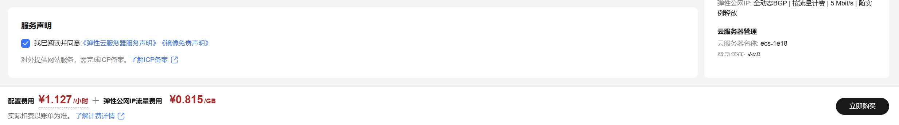
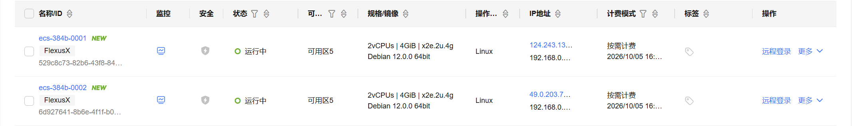
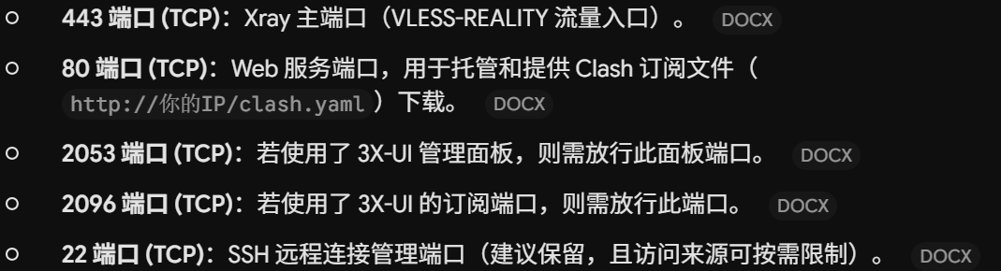
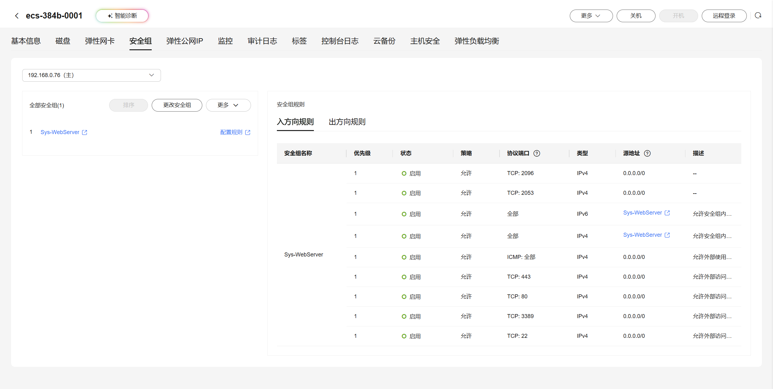
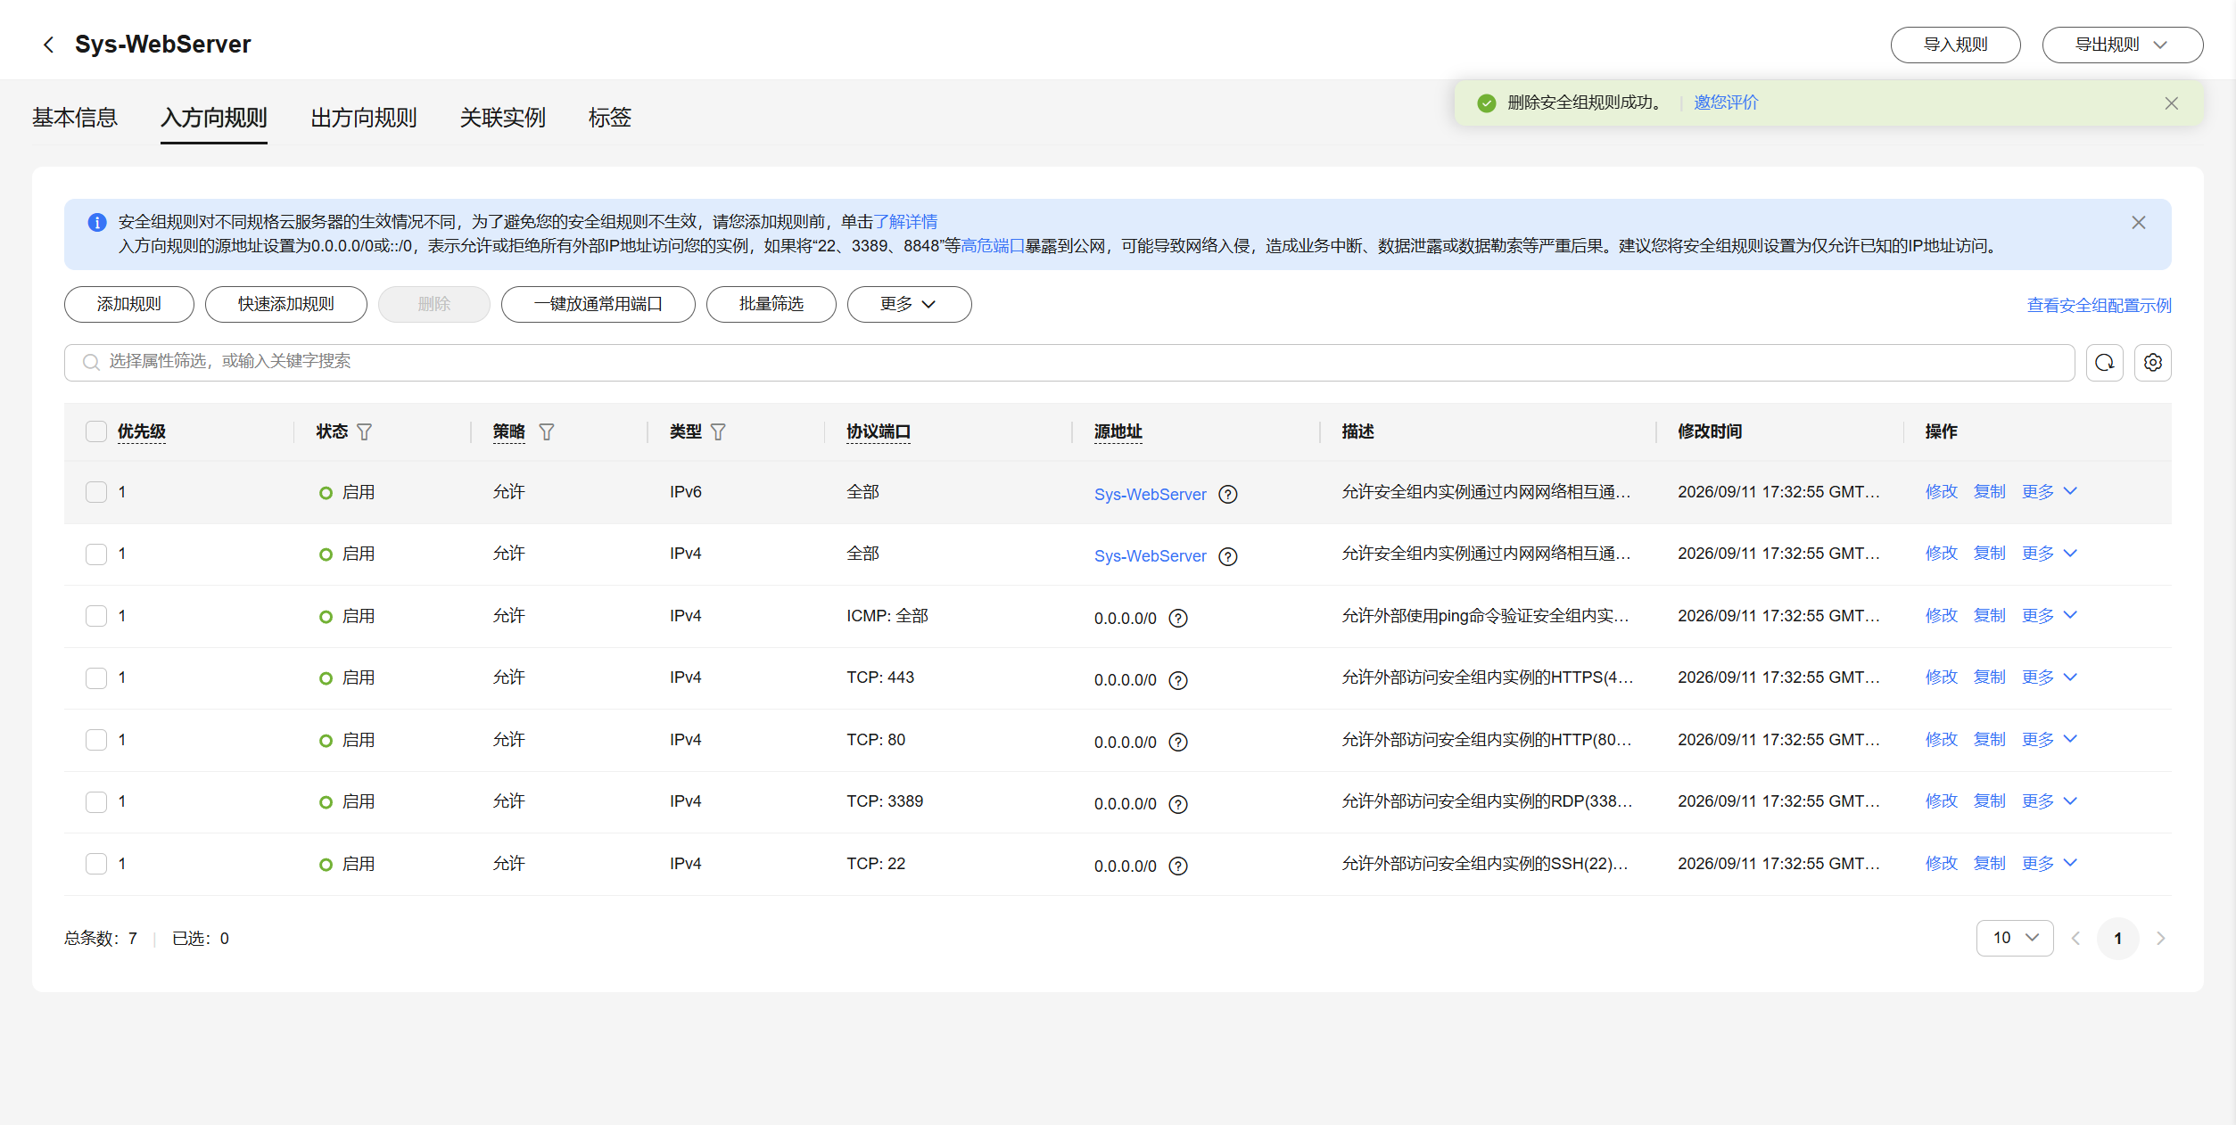
[root@server ~]# cd /etc/yum.repos.d/
[root@server yum.repos.d]# ll
total 0
[root@server yum.repos.d]# touch rhel.repo
[root@server yum.repos.d]# vim rhel.repo
[root@server yum.repos.d]# cat rhel.repo
[base]
name=baseos
baseurl=file:///run/media/root/RHEL-9-3-0-BaseOS-x86_64/BaseOS
enabled=1
gpgcheck=1
gpgkey=file:///run/media/root/RHEL-9-3-0-BaseOS-x86_64/RPM-GPG-KEY-redhat-release

[appstream]
name=appstream
baseurl=file:///run/media/root/RHEL-9-3-0-BaseOS-x86_64/AppStream
enabled=1
gpgcheck=1
gpgkey=file:///run/media/root/RHEL-9-3-0-BaseOS-x86_64/RPM-GPG-KEY-redhat-release

[root@server yum.repos.d]# yum clean all
Updating Subscription Management repositories.
Unable to read consumer identity

This system is not registered with an entitlement server. You can use subscription-manager to register.

0 files removed
[root@server yum.repos.d]# yum makecache
Updating Subscription Management repositories.
Unable to read consumer identity

This system is not registered with an entitlement server. You can use subscription-manager to register.

baseos 95 MB/s | 2.0 MB 00:00
appstream 265 MB/s | 6.5 MB 00:00
Metadata cache created.
[root@server yum.repos.d]# yum repolist all
Updating Subscription Management repositories.
Unable to read consumer identity

This system is not registered with an entitlement server. You can use subscription-manager to register.

repo id repo name status
appstream appstream enabled
base baseos enabled
[root@server yum.repos.d]#

[root@server yum.repos.d]# cd
[root@server ~]#
安装ansible工具
[root@server ~]# yum install ansible-core.x86_64 -y
Updating Subscription Management repositories.
Unable to read consumer identity
....
Installed:
ansible-core-1:2.14.9-1.el9.x86_64 git-core-2.39.3-1.el9_2.x86_64 python3-cffi-1.14.5-5.el9.x86_64 python3-cryptography-36.0.1-4.el9.x86_64
python3-packaging-20.9-5.el9.noarch python3-ply-3.11-14.el9.noarch python3-pycparser-2.20-6.el9.noarch python3-pyparsing-2.4.7-9.el9.noarch
python3-resolvelib-0.5.4-5.el9.noarch sshpass-1.09-4.el9.x86_64

Complete!
[root@server ~]#
安装ansible导航器
导航器的命令工具默认叫做navigator，但是这个命令默认在本地仓库是没有的，需要有红帽的订阅，注册到红帽的订阅，连接到红帽的网络仓库才可以，如果自己的红帽账号有开发者订阅就可以使用，虽然是可以使用红帽的网络仓库，但是比较慢
所以在仓库中就提供了对应的iso镜像文件，这个镜像文件就是包含了ansible的navigator的rpm包还有执行环境，这个执行环境不是专门去拉个镜像就可以了，这个是有专门的容器镜像
您也可以选择不使用导航器，可以直接使用ansible-playbook来执行playbook也可以，这个ISO包含ansible-navigator的rpm包，同时也包含导航器的执行环境
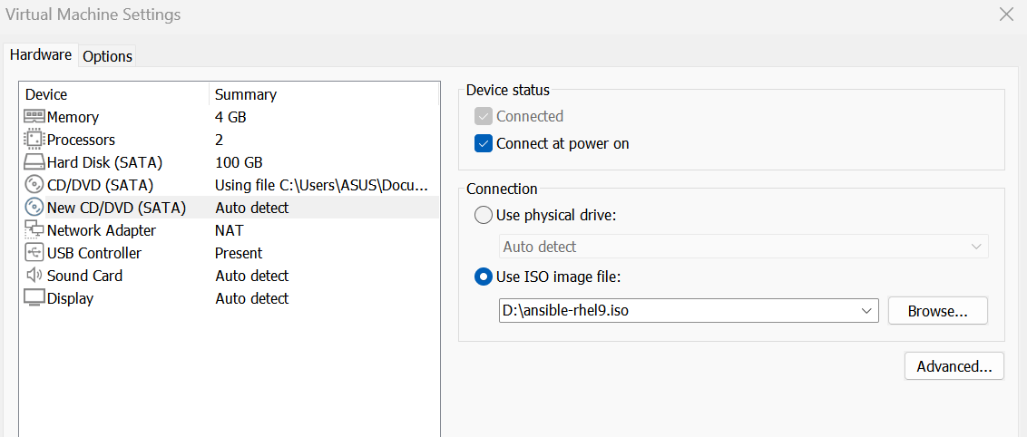
将这个镜像挂载到VMware虚拟机中
[root@server ~]# lsblk
NAME MAJ:MIN RM SIZE RO TYPE MOUNTPOINTS
sda 8:0 0 100G 0 disk
├─sda1 8:1 0 512M 0 part /boot
└─sda2 8:2 0 99.5G 0 part /
sr0 11:0 1 9.8G 0 rom /run/media/root/RHEL-9-3-0-BaseOS-x86_64
sr1 11:1 1 1.6G 0 rom /run/media/root/ansible
[root@server ~]#
[root@server ~]# cd /etc/yum.repos.d/
[root@server yum.repos.d]# ll
total 8
-rw-r--r--. 1 root root 358 Sep 29 18:51 redhat.repo
-rw-r--r--. 1 root root 387 Sep 29 18:51 rhel.repo
[root@server yum.repos.d]# touch ansible.repo
[root@server yum.repos.d]# vim ansible.repo
[root@server yum.repos.d]# cat ansible.repo
[ansible]
name=ansible
baseurl=file:///run/media/root/ansible/
gpgcheck=0
enabled=1

[root@server yum.repos.d]# yum clean all
Updating Subscription Management repositories.
Unable to read consumer identity

This system is not registered with an entitlement server. You can use subscription-manager to register.

13 files removed
[root@server yum.repos.d]# yum makecache
Updating Subscription Management repositories.
Unable to read consumer identity

This system is not registered with an entitlement server. You can use subscription-manager to register.

ansible 3.2 MB/s | 37 kB 00:00
baseos 272 MB/s | 2.0 MB 00:00
appstream 303 MB/s | 6.5 MB 00:00
Metadata cache created.
[root@server yum.repos.d]# yum repolist all
Updating Subscription Management repositories.
Unable to read consumer identity

This system is not registered with an entitlement server. You can use subscription-manager to register.

repo id repo name status
ansible ansible enabled
appstream appstream enabled
base baseos enabled
[root@server yum.repos.d]#
配置好了ansible的软件仓库，现在开始安装navigator导航器
[root@server ~]# yum install ansible-navigator.noarch -y
Updating Subscription Management repositories.
Unable to read consumer identity
....
Installed:
ansible-builder-1.1.0-3.el9ap.noarch ansible-navigator-2.1.0-1.el9ap.noarch ansible-runner-2.2.2-1.el9ap.noarch
python3-ansible-runner-2.2.2-1.el9ap.noarch python3-attrs-21.4.0-2.el9pc.noarch python3-bindep-2.10.2-3.el9ap.noarch
python3-daemon-2.3.0-4.el9ap.noarch python3-docutils-0.16-4.el9ap.noarch python3-importlib-metadata-4.10.1-2.el9pc.noarch
python3-jinja2-3.0.3-2.el9pc.noarch python3-jsonschema-4.6.0-1.el9pc.noarch python3-lockfile-1:0.12.2-1.el9ap.noarch
python3-markupsafe-2.1.0-2.el9ap.x86_64 python3-onigurumacffi-1.1.0-2.el9ap.x86_64 python3-parsley-1.3-2.el9pc.noarch
python3-pbr-5.8.1-2.el9ap.noarch python3-pyrsistent-0.17.3-8.el9.x86_64 python3-requirements-parser-0.2.0-4.el9ap.noarch
python3-typing-extensions-3.10.0.2-2.el9pc.noarch python3-zipp-3.4.0-4.el9pc.noarch

Complete!
[root@server ~]#
导入导航器执行环境
[root@server ansible]# podman load -i /run/media/root/ansible/rhaap22.tar
Getting image source signatures
Copying blob 9d77e7418812 done
Copying blob 0de48c98fba3 done
Copying blob 1053d00b8e29 done
Copying blob 73895dd4b0ef done
Copying config 39a93719fc done
Writing manifest to image destination
Loaded image: registry.redhat.io/ansible-automation-platform-22/ee-supported-rhel8:latest
[root@server ansible]# podman images
REPOSITORY TAG IMAGE ID CREATED SIZE
registry.redhat.io/ansible-automation-platform-22/ee-supported-rhel8 latest 39a93719fc25 2 years ago 1.66 GB
[root@server ansible]#
修改默认的拉去策略，将拉取策略定义为不要每次执行的时候都去红帽的容器镜像的仓库中拉取，执行导航器的时候一定要保证当前目录下有ansible.cfg配置文件，如果当前目录下没有ansible.cfg配置文件，那么导航器执行任务的时候就无法得到ansible.cfg的配置信息了，比如说：远程链接用户是什么，远程链接被控节点的方式，角色搜索的路径....
查看导航器生效的配置
[root@server ~]# ansible-navigator settings --pp missing --effective -m stdout
---
ansible-navigator:
ansible:
config:
help: false
doc:
help: false
plugin:
type: module
inventory:
help: false
playbook:
help: false
ansible-builder:
help: false
workdir: /root
app: settings
collection-doc-cache-path: /root/.cache/ansible-navigator/collection_doc_cache.db
color:
enable: true
osc4: true
editor:
command: vi +{line_number} {filename}
console: true
exec:
command: /bin/bash
shell: true
execution-environment:
container-engine: podman
enabled: true
image: registry.redhat.io/ansible-automation-platform-22/ee-supported-rhel8:latest
pull:
policy: missing
images:
details:
- everything
logging:
append: true
file: /root/ansible-navigator.log
level: warning
mode: stdout
playbook-artifact:
enable: true
save-as: '{playbook_dir}/{playbook_name}-artifact-{time_stamp}.json'
settings:
effective: true
sample: false
schema: json
sources: false
time-zone: UTC

[root@server ~]#
[root@server ~]# cd /etc/ansible/
[root@server ansible]# ll
total 8
-rw-r--r--. 1 root root 614 Aug 17 2023 ansible.cfg
-rw-r--r--. 1 root root 1175 Aug 17 2023 hosts
drwxr-xr-x. 2 root root 6 Aug 17 2023 roles
[root@server ansible]#
[root@server ansible]# vim /root/.ansible-navigator.yml
[root@server ansible]# cat /root/.ansible-navigator.yml
ansible-navigator:
execution-environment:
container-engine: podman
enabled: true
image: registry.redhat.io/ansible-automation-platform-22/ee-supported-rhel8:latest
pull:
policy: missing

[root@server ansible]#

[root@server ansible]# ansible-navigator settings --effective -m stdout
---
ansible-navigator:
ansible:
config:
help: false
doc:
help: false
plugin:
type: module
inventory:
help: false
playbook:
help: false
ansible-builder:
help: false
workdir: /etc/ansible
app: settings
collection-doc-cache-path: /root/.cache/ansible-navigator/collection_doc_cache.db
color:
enable: true
osc4: true
editor:
command: vi +{line_number} {filename}
console: true
exec:
command: /bin/bash
shell: true
execution-environment:
container-engine: podman
enabled: true
image: registry.redhat.io/ansible-automation-platform-22/ee-supported-rhel8:latest
pull:
policy: missing
images:
details:
- everything
logging:
append: true
file: /etc/ansible/ansible-navigator.log
level: warning
mode: stdout
playbook-artifact:
enable: true
save-as: '{playbook_dir}/{playbook_name}-artifact-{time_stamp}.json'
settings:
effective: true
sample: false
schema: json
sources: false
time-zone: UTC

[root@server ansible]#
发现现在运行可以直接打印当前的配置信息，不需要使用--pp missing
[root@server ansible]# ansible --version
ansible [core 2.14.9]
config file = /etc/ansible/ansible.cfg
configured module search path = ['/root/.ansible/plugins/modules', '/usr/share/ansible/plugins/modules']
ansible python module location = /usr/lib/python3.9/site-packages/ansible
ansible collection location = /root/.ansible/collections:/usr/share/ansible/collections
executable location = /usr/bin/ansible
python version = 3.9.18 (main, Sep 7 2023, 00:00:00) [GCC 11.4.1 20230605 (Red Hat 11.4.1-2)] (/usr/bin/python3)
jinja version = 3.1.2
libyaml = True
[root@server ansible]# ansible-navigator --version
ansible-navigator 2.1.0
[root@server ansible]#

另一台云服务器进行同样的方形操作
[root@server ~]# ping 124.243.135.106
PING 124.243.135.106 (124.243.135.106) 56(84) bytes of data.
64 bytes from 124.243.135.106: icmp_seq=1 ttl=128 time=201 ms
64 bytes from 124.243.135.106: icmp_seq=2 ttl=128 time=164 ms
64 bytes from 124.243.135.106: icmp_seq=4 ttl=128 time=87.6 ms
64 bytes from 124.243.135.106: icmp_seq=5 ttl=128 time=215 ms
^C
--- 124.243.135.106 ping statistics ---
5 packets transmitted, 4 received, 20% packet loss, time 4024ms
rtt min/avg/max/mdev = 87.574/166.912/215.472/49.564 ms
[root@server ~]#
[root@server ~]# ping 49.0.203.74
PING 49.0.203.74 (49.0.203.74) 56(84) bytes of data.
64 bytes from 49.0.203.74: icmp_seq=4 ttl=128 time=224 ms
64 bytes from 49.0.203.74: icmp_seq=5 ttl=128 time=328 ms
64 bytes from 49.0.203.74: icmp_seq=6 ttl=128 time=288 ms
64 bytes from 49.0.203.74: icmp_seq=7 ttl=128 time=532 ms
64 bytes from 49.0.203.74: icmp_seq=8 ttl=128 time=114 ms
64 bytes from 49.0.203.74: icmp_seq=9 ttl=128 time=288 ms
^C
--- 49.0.203.74 ping statistics ---
9 packets transmitted, 6 received, 33.3333% packet loss, time 8111ms
rtt min/avg/max/mdev = 114.264/295.803/531.857/125.826 ms
[root@server ~]#
[root@server ~]# cd /etc/ansible/
[root@server ansible]# cat hosts
node1
node2
[root@server ansible]#
[root@server ansible]# cd roles/
[root@server roles]# ll
total 0
drwxr-xr-x. 10 root root 135 Oct 2 19:00 v2ray
[root@server roles]#
[root@server roles]# cd v2ray/
[root@server v2ray]# tree
.
├── defaults
│ └── main.yml
├── files
├── handlers
│ └── main.yml
├── meta
│ └── main.yml
├── README.md
├── tasks
│ └── main.yml
├── templates
│ ├── clash.yaml.j2
│ └── config.json.j2
├── tests
│ ├── inventory
│ └── test.yml
└── vars
└── main.yml

8 directories, 10 files
[root@server v2ray]#

[root@server v2ray]# vim tasks/main.yml
[root@server v2ray]# cat tasks/main.yml
---
# tasks file for v2ray
- name: update cache and upgrade packages
ansible.builtin.apt:
update_cache: yes
upgrade: safe
- name: install pkg
ansible.builtin.apt:
name: "{{ item }}"
state: present
loop:
- curl
- wget
- unzip
- tar
- openssl
- apache2
- ufw
- name: Execute Xray installation script
ansible.builtin.get_url:
url: https://github.com/XTLS/Xray-install/raw/main/install-release.sh
dest: /tmp/install-release.sh
mode: '0755'
- name: install Xray
ansible.builtin.shell: bash /tmp/install-release.sh install
args:
executable: /bin/bash
register: xray_install_out
changed_when: "'Installed' in xray_install_out.stdout or 'Upgraded' in xray_install_out.stdout or xray_install_out.rc == 0"
- name: Get Xray version
ansible.builtin.shell: /usr/local/bin/xray version
args:
executable: /bin/bash
register: xray_version_raw
changed_when: false
- name: Generate Xray UUID
ansible.builtin.shell: /usr/local/bin/xray uuid
args:
executable: /bin/bash
register: xray_uuid_raw
changed_when: false
- name: Generate x25519 key pair
ansible.builtin.shell: /usr/local/bin/xray x25519
args:
executable: /bin/bash
register: xray_x25519_raw
changed_when: false
- name: Generate ShortID
ansible.builtin.shell: openssl rand -hex 8
args:
executable: /bin/bash
register: xray_shortid_raw
changed_when: false
# 获取服务器真实公网 IP
- name: Get server public IP
ansible.builtin.shell: curl -s https://api.ipify.org || curl -s https://ifconfig.me
args:
executable: /bin/bash
register: server_public_ip_raw
changed_when: false
# 变量解析
- name: Parse and set facts
ansible.builtin.set_fact:
xray_version: "{{ xray_version_raw.stdout_lines[0] if xray_version_raw.stdout_lines else 'Unknown' }}"
xray_uuid: "{{ xray_uuid_raw.stdout | trim }}"
xray_private_key: "{{ ((xray_x25519_raw.stdout_lines | select('match', '(?i).*private.*') | list | first | default('')) .split(':') | last | trim) .split(' ') | first }}"
xray_public_key: "{{ ((xray_x25519_raw.stdout_lines | select('match', '(?i).*public.*') | list | first | default('')) .split(':') | last | trim) .split(' ') | first }}"
xray_shortid: "{{ xray_shortid_raw.stdout | trim }}"
server_public_ip: "{{ server_public_ip_raw.stdout | trim }}"
# 打印信息与 Clash 订阅地址
- name: Print generated variables
ansible.builtin.debug:
msg:
- "Xray 版本: {{ xray_version }}"
- "公网 IP: {{ server_public_ip }}"
- "UUID: {{ xray_uuid }}"
- "私钥 (填服务端): {{ xray_private_key }}"
- "公钥 (填客户端): {{ xray_public_key }}"
- "ShortID: {{ xray_shortid }}"
- "Clash 订阅地址: http://{{ server_public_ip }}/clash.yaml"
- name: Ensure /usr/local/etc/xray directory exists
ansible.builtin.file:
path: /usr/local/etc/xray
state: directory
mode: '0755'
- name: Render Xray config.json from template
ansible.builtin.template:
src: config.json.j2
dest: /usr/local/etc/xray/config.json
mode: '0644'
notify: restart xray
- name: Render Clash YAML config from template
ansible.builtin.template:
src: clash.yaml.j2
dest: /var/www/html/clash.yaml
mode: '0644'
- name: systemd
systemd:
daemon_reload: true
name: "{{ item }}"
state: started
enabled: true
loop:
- apache2
- ufw
- xray
- name: ufw allow ports

community.general.ufw:
rule: allow
port: "{{ item | split('/') | first }}"
proto: "{{ item | split('/') | last }}"
loop:
- 80/tcp
- 443/tcp
- name: Ensure ufw is enabled
community.general.ufw:
state: enabled
- name: Create auto IP update script for clash.yaml
ansible.builtin.copy:
dest: /usr/local/bin/update-clash-ip.sh
mode: '0755'
content: |
#!/bin/bash
# 循环尝试最多 30 次（每次间隔 2 秒），防止开机瞬间网络尚未完全通畅
NEW_IP=""
for i in {1..30}; do
NEW_IP=$(curl -s --connect-timeout 3 https://api.ipify.org || curl -s --connect-timeout 3 https://ifconfig.me)
if [ -n "$NEW_IP" ]; then
break
fi
sleep 2
done
if [ -n "$NEW_IP" ] && [ -f /var/www/html/clash.yaml ]; then
# 自动把 clash.yaml 里的旧 IP 替换成今天的最新 IP（兼容带引号与不带引号）
sed -i -E "s/server:[[:space:]]*\"?[0-9]+\.[0-9]+\.[0-9]+\.[0-9]+\"?/server: $NEW_IP/g" /var/www/html/clash.yaml
fi
- name: Create systemd service for auto IP update
ansible.builtin.copy:
dest: /etc/systemd/system/update-clash-ip.service
mode: '0644'
content: |
[Unit]
Description=Update Clash YAML Server IP on Boot
After=network-online.target
Wants=network-online.target
[Service]
Type=oneshot
RemainAfterExit=yes
ExecStart=/usr/local/bin/update-clash-ip.sh
[Install]
WantedBy=multi-user.target
- name: Enable update-clash-ip service
systemd:
name: update-clash-ip
enabled: true
daemon_reload: true
[root@server v2ray]#

[root@server v2ray]# vim handlers/main.yml
[root@server v2ray]# cat handlers/main.yml
---
# handlers file for v2ray

- name: restart xray
ansible.builtin.systemd:
name: xray
state: restarted
[root@server v2ray]#
[root@server v2ray]# vim templates/config.json.j2
[root@server v2ray]# cat templates/config.json.j2
{
"log": {
"loglevel": "warning"
},
"inbounds": [
{
"listen": "0.0.0.0",
"port": 443,
"protocol": "vless",
"settings": {
"clients": [
{
"id": "{{ xray_uuid }}",
"flow": "xtls-rprx-vision"
}
],
"decryption": "none"
},
"streamSettings": {
"network": "tcp",
"security": "reality",
"realitySettings": {
"show": false,
"dest": "dl.google.com:443",
"xver": 0,
"serverNames": [
"dl.google.com"
],
"privateKey": "{{ xray_private_key }}",
"shortIds": [
"{{ xray_shortid }}"
]
}
},
"sniffing": {
"enabled": true,
"destOverride": [
"http",
"tls",
"quic"
]
}
}
],
"outbounds": [
{
"protocol": "freedom",
"tag": "direct"
},
{
"protocol": "blackhole",
"tag": "block"
}
]
}
[root@server v2ray]#

[root@server v2ray]# vim templates/clash.yaml.j2
[root@server v2ray]# cat templates/clash.yaml.j2
# =========================================================
# Mihomo / Clash Meta 配置文件
# =========================================================
port: 7890
socks-port: 7891
mixed-port: 7890
allow-lan: true
mode: rule
log-level: info
ipv6: false
# DNS 配置
dns:
enable: true
listen: 0.0.0.0:1053
enhanced-mode: fake-ip
nameserver:
- 223.5.5.5
- 119.29.29.29
fallback:
- https://1.1.1.1/dns-query
- https://8.8.8.8/dns-query
# ---------------------------------------------------------
# 节点配置 (Proxies)
# ---------------------------------------------------------
proxies:
- name: "REALITY-节点"
type: vless
server: "{{ server_public_ip }}"
port: 443
uuid: "{{ xray_uuid }}"
network: tcp
udp: true
tls: true
flow: xtls-rprx-vision
servername: dl.google.com
client-fingerprint: chrome
reality-opts:
public-key: "{{ xray_public_key }}"
short-id: "{{ xray_shortid }}"
# ---------------------------------------------------------
# 节点策略组 (Proxy Groups)
# ---------------------------------------------------------
proxy-groups:
- name: 🚀 节点选择
type: select
proxies:
- REALITY-节点
- 🎯 节点直连
- name: 🎯 节点直连
type: select
proxies:
- DIRECT
# ---------------------------------------------------------
# 路由规则 (Rules)
# ---------------------------------------------------------
rules:
# 局域网/私有 IP 直连
- GEOIP,lan,🎯 节点直连,no-resolve
# 中国大陆 IP/域名 直连
- GEOIP,CN,🎯 节点直连
# 其它未匹配到的流量走代理组
- MATCH,🚀 节点选择
[root@server v2ray]#
[root@server v2ray]# cd ../../
[root@server ansible]#

[root@server ansible]# vim ansible.cfg
[root@server ansible]# cat ansible.cfg
[defaults]
inventory=/etc/ansible/hosts
collections_path={{ ANSIBLE_HOME ~ "/collections:/usr/share/ansible/collections" }}
roles_path={{ ANSIBLE_HOME ~ "/roles:/usr/share/ansible/roles:/etc/ansible/roles" }}
ask_pass=False
host_key_checking=False
# remote_user=devops

remote_user=root

[privilege_escalation]
become=True
become_ask_pass=False
become_method=sudo
become_user=root
[root@server ~]# ssh-keygen
Generating public/private rsa key pair.
Enter file in which to save the key (/root/.ssh/id_rsa):
Created directory '/root/.ssh'.
Enter passphrase (empty for no passphrase):
Enter same passphrase again:
Your identification has been saved in /root/.ssh/id_rsa
Your public key has been saved in /root/.ssh/id_rsa.pub
The key fingerprint is:
SHA256:Y7kyFQPLww54X/hgjZEKH+qYbTb+JKwWXgq+YnCCK6o root@server.example.com
The key's randomart image is:
+---[RSA 3072]----+
| o. |
| ...o.B |
| .+ooX = |
| ..o= = + |
|.= o S |
|BoB. o o |
|=B*.. o . |
|+B.o o |
|E.... |
+----[SHA256]-----+
[root@server ~]# ssh-copy-id -i /root/.ssh/id_rsa.pub root@124.243.135.106
/usr/bin/ssh-copy-id: INFO: Source of key(s) to be installed: "/root/.ssh/id_rsa.pub"
The authenticity of host '124.243.135.106 (124.243.135.106)' can't be established.
ED25519 key fingerprint is SHA256:YkqfYo5x6akIvDLyCJsKCfDVKVi24o+xt2a8N4UeeqM.
This key is not known by any other names
Are you sure you want to continue connecting (yes/no/[fingerprint])? yes
/usr/bin/ssh-copy-id: INFO: attempting to log in with the new key(s), to filter out any that are already installed
/usr/bin/ssh-copy-id: INFO: 1 key(s) remain to be installed -- if you are prompted now it is to install the new keys
root@124.243.135.106's password:

Number of key(s) added: 1

Now try logging into the machine, with: "ssh 'root@124.243.135.106'"
and check to make sure that only the key(s) you wanted were added.

[root@server ~]# ssh-copy-id -i /root/.ssh/id_rsa.pub root@49.0.203.74
/usr/bin/ssh-copy-id: INFO: Source of key(s) to be installed: "/root/.ssh/id_rsa.pub"
The authenticity of host '49.0.203.74 (49.0.203.74)' can't be established.
ED25519 key fingerprint is SHA256:GaER6Aauvcf9lsx9mCvDTROdZHnLG2Qun+hFVIZGHBE.
This key is not known by any other names
Are you sure you want to continue connecting (yes/no/[fingerprint])? yes
/usr/bin/ssh-copy-id: INFO: attempting to log in with the new key(s), to filter out any that are already installed
/usr/bin/ssh-copy-id: INFO: 1 key(s) remain to be installed -- if you are prompted now it is to install the new keys
root@49.0.203.74's password:

Number of key(s) added: 1

Now try logging into the machine, with: "ssh 'root@49.0.203.74'"
and check to make sure that only the key(s) you wanted were added.

[root@server ~]#
[root@server ~]# ansible all -m ping
node2 | SUCCESS => {
"ansible_facts": {
"discovered_interpreter_python": "/usr/bin/python3"
},
"changed": false,
"ping": "pong"
}
node1 | SUCCESS => {
"ansible_facts": {
"discovered_interpreter_python": "/usr/bin/python3"
},
"changed": false,
"ping": "pong"
}
[root@server ~]#

[root@server ~]# ansible all -m shell -a 'useradd devops'
node1 | CHANGED | rc=0 >>

node2 | CHANGED | rc=0 >>

[root@server ~]# ansible all -m shell -a 'echo "devops:1" | chpasswd'
node1 | CHANGED | rc=0 >>

node2 | CHANGED | rc=0 >>

[root@server ~]#

[root@server ~]# ansible all -m shell -a 'id devops'
node1 | CHANGED | rc=0 >>
uid=1000(devops) gid=1000(devops) groups=1000(devops)
node2 | CHANGED | rc=0 >>
uid=1000(devops) gid=1000(devops) groups=1000(devops)
[root@server ~]# ansible all -m shell -a 'grep devops /etc/shadow'
node2 | CHANGED | rc=0 >>
devops:$y$j9T$o8bfdiZDScSoMOSXQlLcu0$.vzb7mJZ6k7D0TIUxowwo.YZOZRhPMZ5oQI4vJa/GM/:20731:0:99999:7:::
node1 | CHANGED | rc=0 >>
devops:$y$j9T$EuAWH6CiFeGnDe8Ek.Zvm1$f.zXRkazsIw4RBbhgQbhg0znBY3TOlcnzd5KVT4nNNB:20731:0:99999:7:::
[root@server ~]#

[root@server ~]# ansible all -m shell -a 'mkdir -p /home/devops && chown -R devops:devops /home/devops && chmod 700 /home/devops'
node2 | CHANGED | rc=0 >>

node1 | CHANGED | rc=0 >>

[root@server ~]#

[root@server ~]# ssh-copy-id -i /root/.ssh/id_rsa.pub devops@124.243.135.106
/usr/bin/ssh-copy-id: INFO: Source of key(s) to be installed: "/root/.ssh/id_rsa.pub"
/usr/bin/ssh-copy-id: INFO: attempting to log in with the new key(s), to filter out any that are already installed
/usr/bin/ssh-copy-id: INFO: 1 key(s) remain to be installed -- if you are prompted now it is to install the new keys
devops@124.243.135.106's password:

Number of key(s) added: 1

Now try logging into the machine, with: "ssh 'devops@124.243.135.106'"
and check to make sure that only the key(s) you wanted were added.

[root@server ~]# ssh-copy-id -i /root/.ssh/id_rsa.pub devops@49.0.203.74
/usr/bin/ssh-copy-id: INFO: Source of key(s) to be installed: "/root/.ssh/id_rsa.pub"
/usr/bin/ssh-copy-id: INFO: attempting to log in with the new key(s), to filter out any that are already installed
/usr/bin/ssh-copy-id: INFO: 1 key(s) remain to be installed -- if you are prompted now it is to install the new keys
devops@49.0.203.74's password:

Number of key(s) added: 1

Now try logging into the machine, with: "ssh 'devops@49.0.203.74'"
and check to make sure that only the key(s) you wanted were added.

[root@server ~]#
[root@server ansible]# ansible all -m shell -a 'echo "devops ALL=(ALL) NOPASSWD:ALL" > /etc/sudoers.d/devops && chmod 440 /etc/sudoers.d/devops'
node2 | CHANGED | rc=0 >>

node1 | CHANGED | rc=0 >>

[root@server ansible]#

[root@server ~]# cd /etc/ansible/
[root@server ansible]# vim ansible.cfg
[root@server ansible]# cat ansible.cfg
[defaults]
inventory=/etc/ansible/hosts
collections_path={{ ANSIBLE_HOME ~ "/collections:/usr/share/ansible/collections" }}
roles_path={{ ANSIBLE_HOME ~ "/roles:/usr/share/ansible/roles:/etc/ansible/roles" }}
ask_pass=False
host_key_checking=False
remote_user=devops

# remote_user=root

[privilege_escalation]
become=True
become_ask_pass=False
become_method=sudo
become_user=root
[root@server ansible]#
[root@server ansible]# ansible all -m ping
node2 | SUCCESS => {
"ansible_facts": {
"discovered_interpreter_python": "/usr/bin/python3"
},
"changed": false,
"ping": "pong"
}
node1 | SUCCESS => {
"ansible_facts": {
"discovered_interpreter_python": "/usr/bin/python3"
},
"changed": false,
"ping": "pong"
}
[root@server ansible]#
[root@server ansible]# ansible all -m shell -a 'whoami'
node2 | CHANGED | rc=0 >>
root
node1 | CHANGED | rc=0 >>
root
[root@server ansible]#

[root@server ansible]# cat v2ray.yaml
- name: v2ray
hosts: all
roles:
- v2ray
[root@server ansible]# ll roles/
total 0
drwxr-xr-x. 10 root root 135 Oct 5 17:17 v2ray
[root@server ansible]#

[root@server ansible]# ansible-navigator run v2ray.yaml -m stdout
[WARNING]: Collection community.general does not support Ansible version
2.13.10

PLAY [v2ray] *******************************************************************

TASK [Gathering Facts] *********************************************************
ok: [node2]
ok: [node1]

TASK [v2ray : update cache and upgrade packages] *******************************
ok: [node2]
ok: [node1]

TASK [v2ray : install pkg] *****************************************************
ok: [node2] => (item=curl)
ok: [node1] => (item=curl)
ok: [node2] => (item=wget)
ok: [node1] => (item=wget)
ok: [node2] => (item=unzip)
ok: [node1] => (item=unzip)
ok: [node2] => (item=tar)
ok: [node1] => (item=tar)
ok: [node1] => (item=openssl)
ok: [node2] => (item=openssl)
ok: [node1] => (item=apache2)
ok: [node2] => (item=apache2)
changed: [node1] => (item=ufw)
changed: [node2] => (item=ufw)

TASK [v2ray : Execute Xray installation script] ********************************
ok: [node1]
ok: [node2]

TASK [v2ray : install Xray] ****************************************************
changed: [node1]
changed: [node2]

TASK [v2ray : Get Xray version] ************************************************
ok: [node2]
ok: [node1]

TASK [v2ray : Generate Xray UUID] **********************************************
ok: [node1]
ok: [node2]

TASK [v2ray : Generate x25519 key pair] ****************************************
ok: [node1]
ok: [node2]

TASK [v2ray : Generate ShortID] ************************************************
ok: [node1]
ok: [node2]

TASK [v2ray : Get server public IP] ********************************************
ok: [node2]
ok: [node1]

TASK [v2ray : Parse and set facts] *********************************************
ok: [node1]
ok: [node2]

TASK [v2ray : Print generated variables] ***************************************
ok: [node1] => {
"msg": [
"Xray 版本: Xray 26.3.27 (Xray, Penetrates Everything.) d2758a0 (go1.26.1 linux/amd64)",
"公网 IP: 124.243.135.106",
"UUID: 19cb1f42-bb05-48f2-a59d-7ce3d898400a",
"私钥 (填服务端): iGhL3EamgRO5GhN6n9m-PFEOpjQxGLoXZ9XHQVeSmnw",
"公钥 (填客户端): JjLFBVNSbHQ0iV8GjyllzEONRGQYqk2KYxeROQSmb2w",
"ShortID: 69dbed4c155328ac",
"Clash 订阅地址: http://124.243.135.106/clash.yaml"
]
}
ok: [node2] => {
"msg": [
"Xray 版本: Xray 26.3.27 (Xray, Penetrates Everything.) d2758a0 (go1.26.1 linux/amd64)",
"公网 IP: 49.0.203.74",
"UUID: 043cb461-30f8-4c56-a6d2-82dac0bcf534",
"私钥 (填服务端): aOBZNe893gQWVGEntl6XK44bAfByvuLpvLSh-hvya1s",
"公钥 (填客户端): 0kOfshh6Pryhzv30tnbltgBfmt50dYy0-pqRcUXcBSw",
"ShortID: a957d9574f818d3a",
"Clash 订阅地址: http://49.0.203.74/clash.yaml"
]
}

TASK [v2ray : Ensure /usr/local/etc/xray directory exists] *********************
ok: [node1]
ok: [node2]

TASK [v2ray : Render Xray config.json from template] ***************************
changed: [node2]
changed: [node1]

TASK [v2ray : Render Clash YAML config from template] **************************
changed: [node1]
changed: [node2]

TASK [v2ray : systemd] *********************************************************
ok: [node2] => (item=apache2)
ok: [node1] => (item=apache2)
changed: [node2] => (item=ufw)
changed: [node1] => (item=ufw)
ok: [node2] => (item=xray)
ok: [node1] => (item=xray)

TASK [v2ray : ufw allow ports] *************************************************
changed: [node2] => (item=80/tcp)
changed: [node1] => (item=80/tcp)
changed: [node2] => (item=443/tcp)
changed: [node1] => (item=443/tcp)

TASK [v2ray : Ensure ufw is enabled] *******************************************
changed: [node1]
changed: [node2]

TASK [v2ray : Create auto IP update script for clash.yaml] *********************
changed: [node1]
changed: [node2]

TASK [v2ray : Create systemd service for auto IP update] ***********************
changed: [node1]
changed: [node2]

TASK [v2ray : Enable update-clash-ip service] **********************************
changed: [node1]
changed: [node2]

RUNNING HANDLER [v2ray : restart xray] *****************************************
changed: [node1]
changed: [node2]

PLAY RECAP *********************************************************************
node1 : ok=22 changed=11 unreachable=0 failed=0 skipped=0 rescued=0 ignored=0
node2 : ok=22 changed=11 unreachable=0 failed=0 skipped=0 rescued=0 ignored=0
[root@server ansible]#

