代理服务器搭建教程
我们使用华为云的服务器来搭建这个代理服务器，首先进入华为云的官网：https://www.huaweicloud.com/product/ecs.html

提示：
如果搭建机场就可以使用这个搭建方法，不可以使用ssh的动态端口转发，之所以无法使用ssh，是因为ssh不具备高并发特性，如果想要搭建机场需要使用v2ray，这个文档就是专门使用v2ray来搭建VPN节点，本文档中使用了shell+v2ray进行搭建VPN节点，直接将shell脚本上传到服务端就可以进行自动化部署，目前仅仅开源RHEL系列操作系统的搭建教程，并没有对Debian系列的操作系统进行搭建，大家有兴趣可以自行尝试搭建，请大家搭建完成之后将教程开源到GitHub上面，为开源贡献一份力量

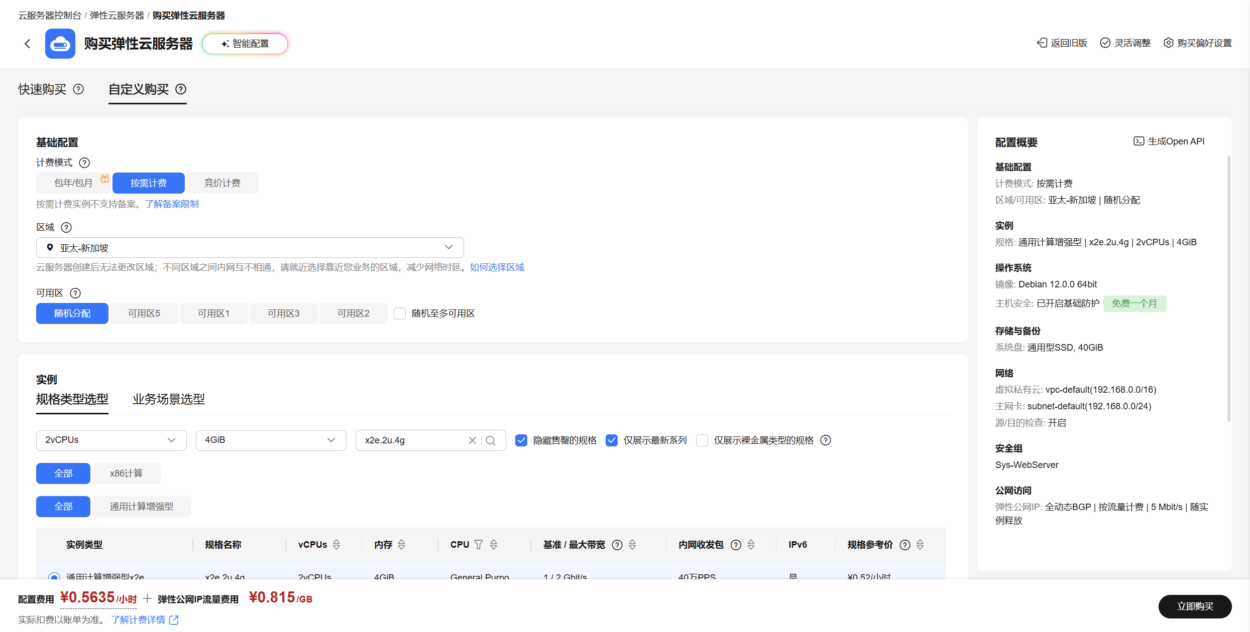
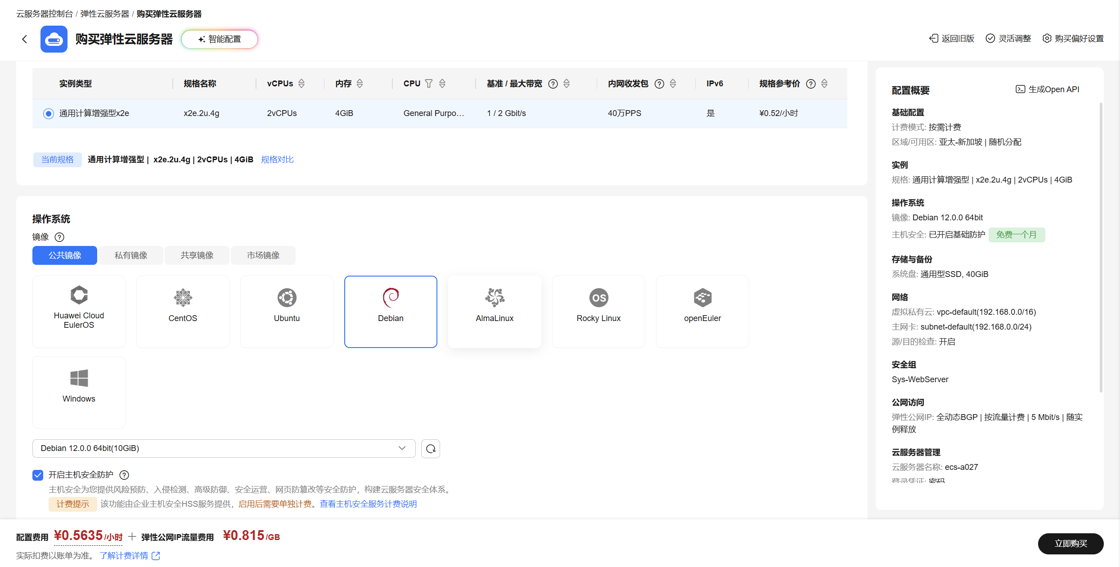
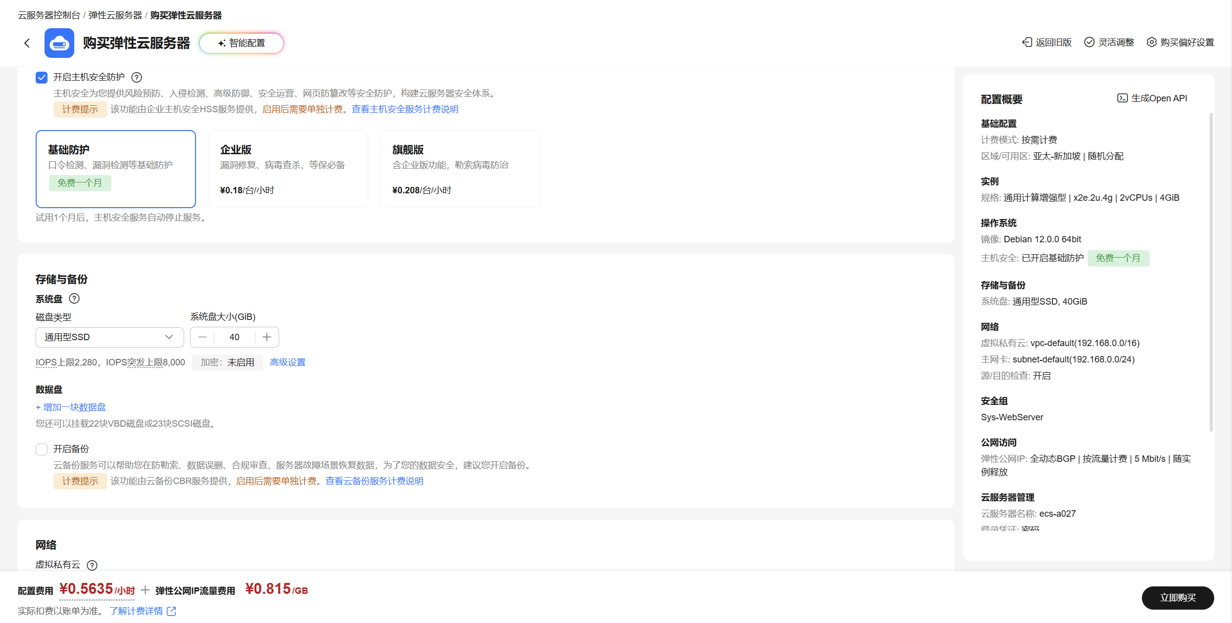
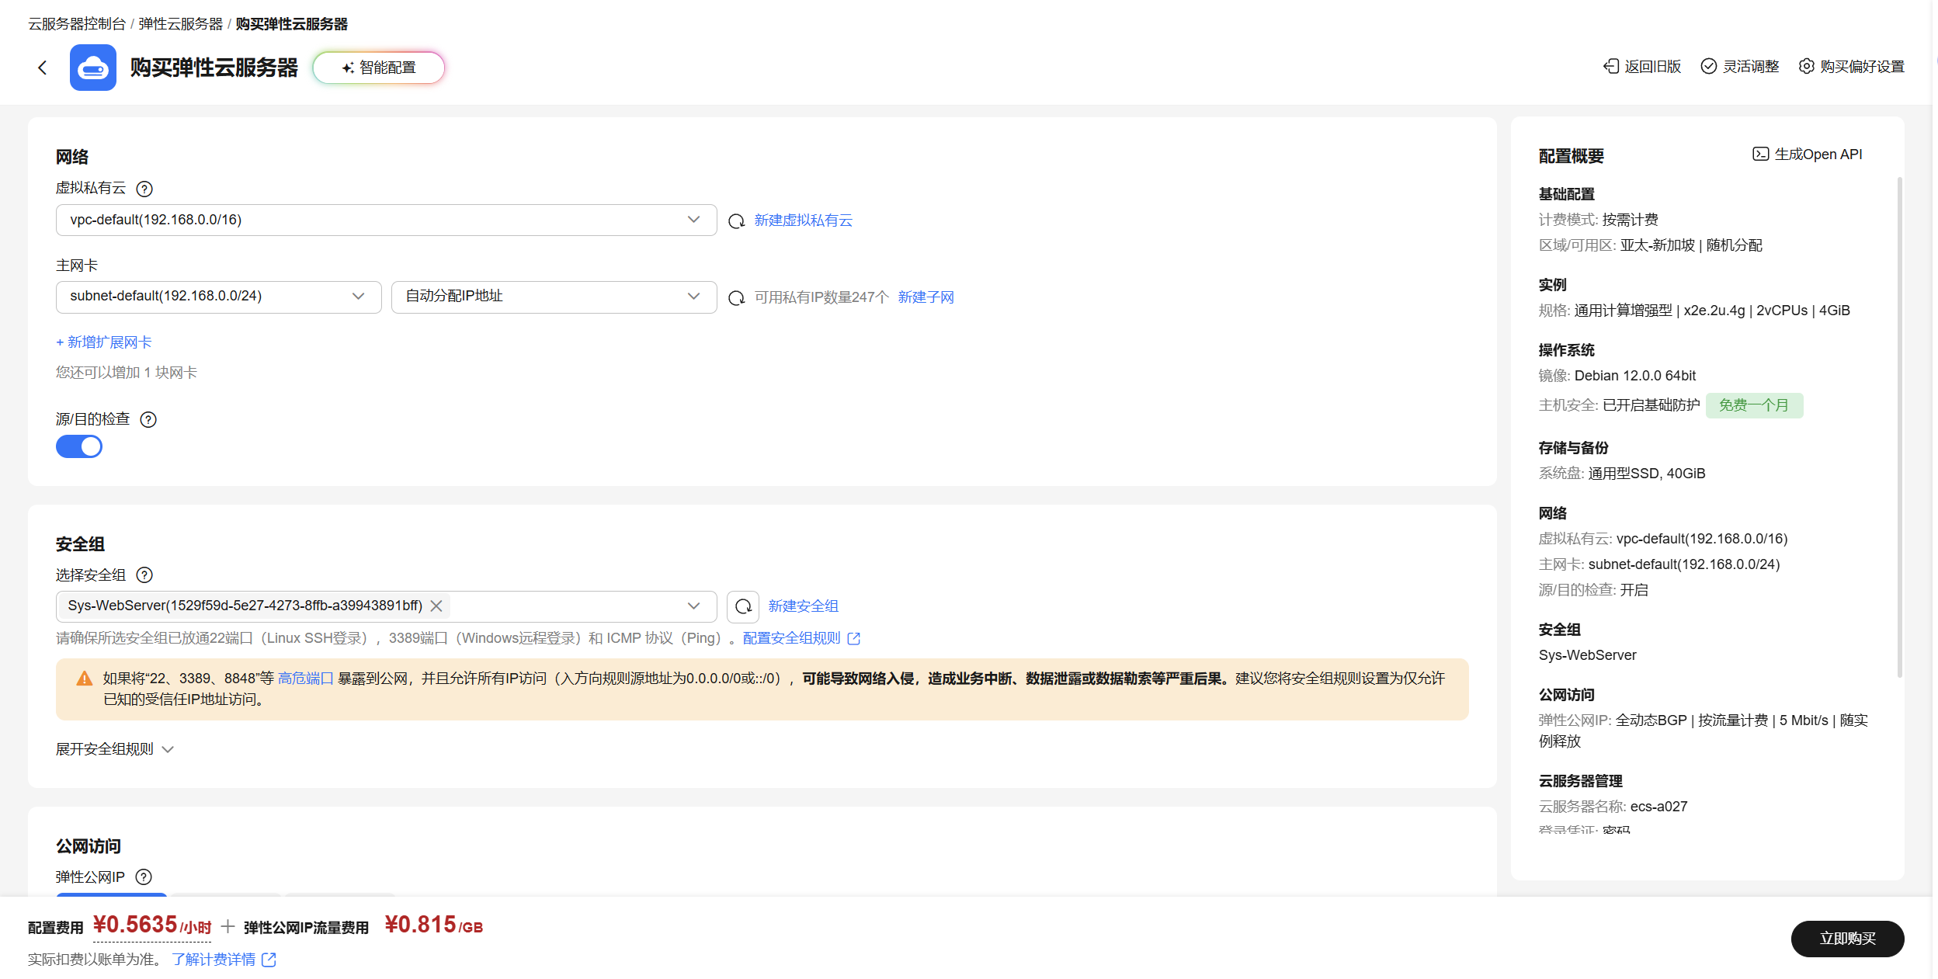
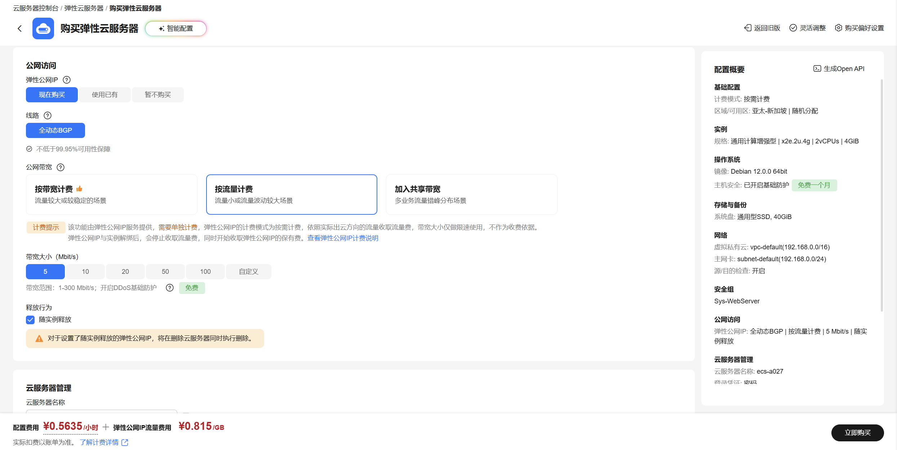
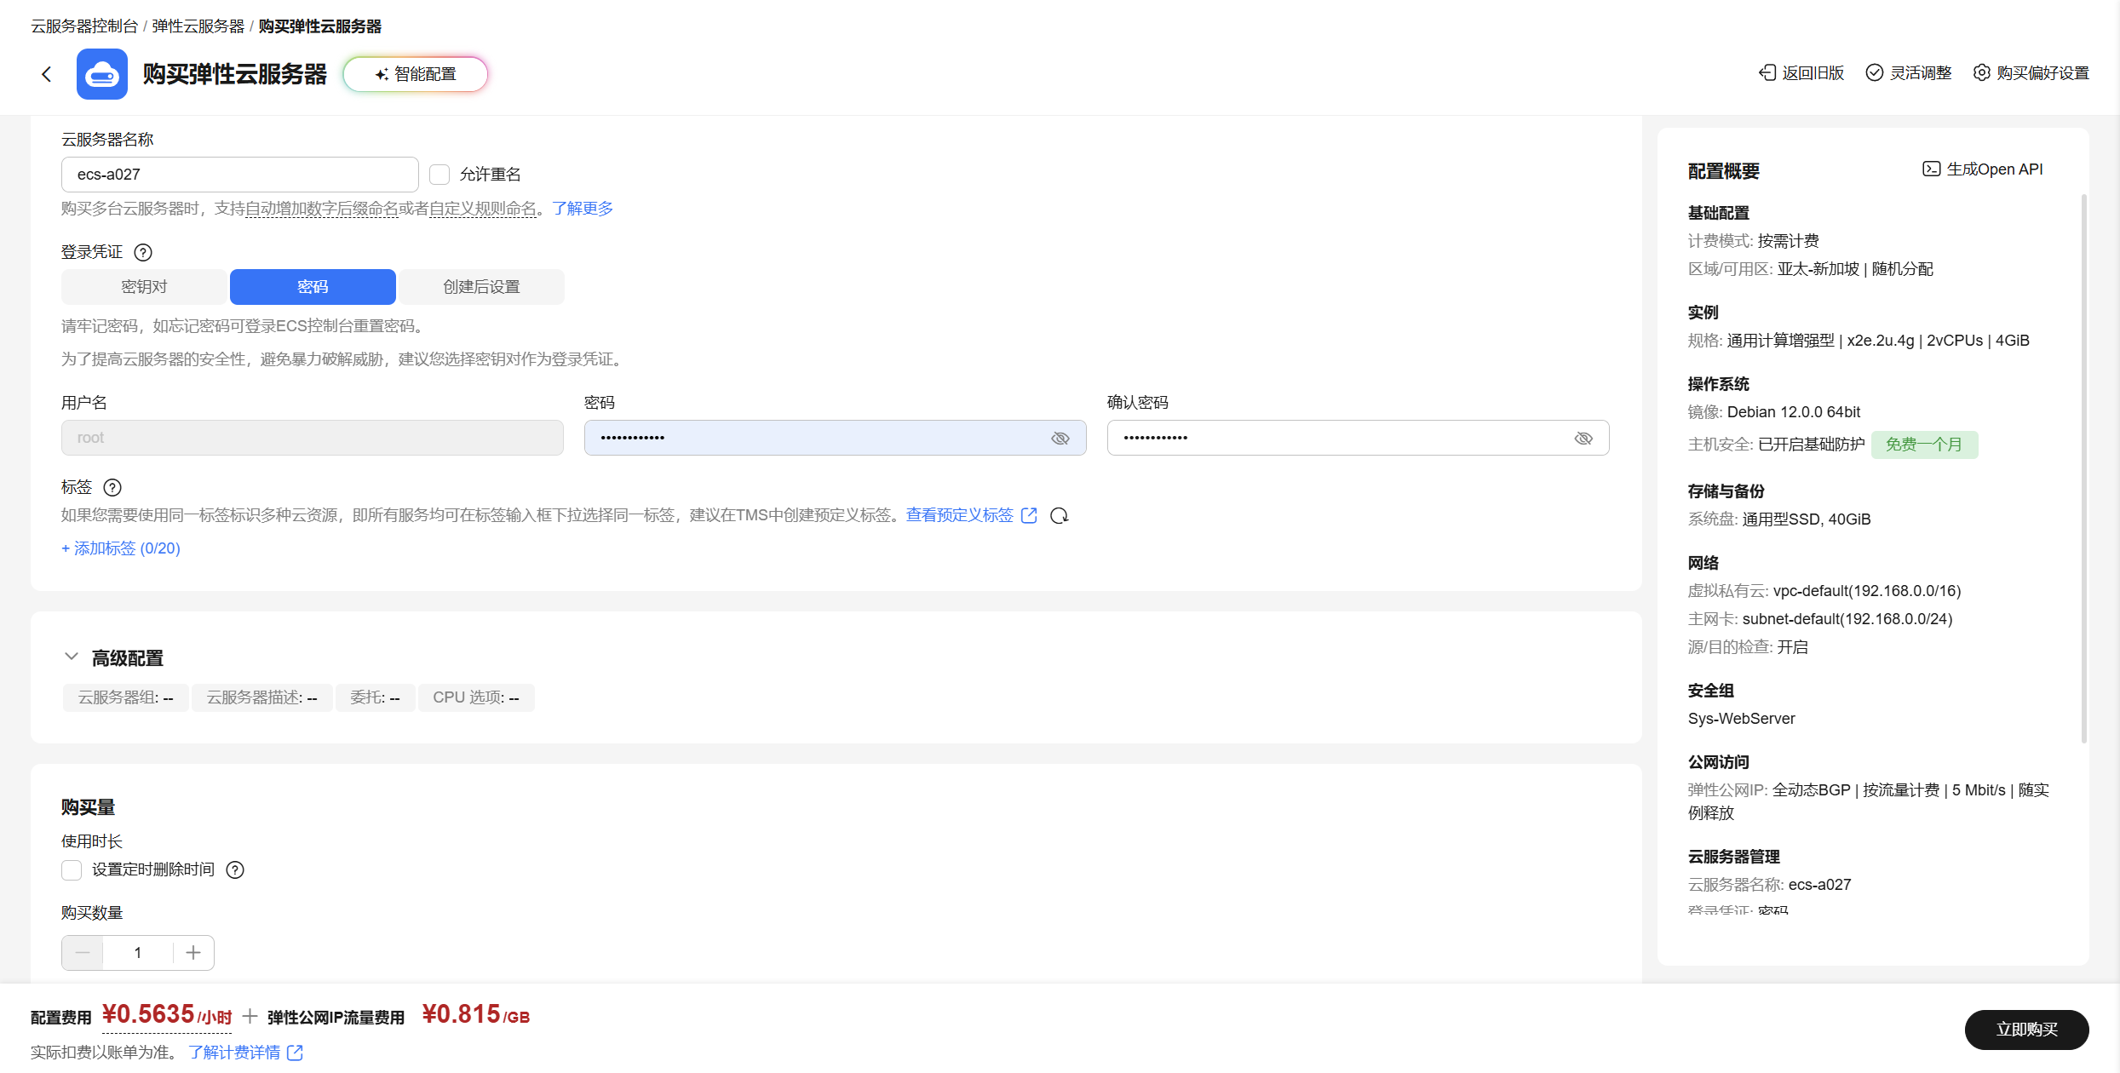


root@ecs-a027:~# ll
total 16
-rwxr-xr-x 1 root root 679 Oct 3 22:55 v2ray_clash.sh
-rwxr-xr-x 1 root root 6803 Oct 5 19:05 v2ray.sh
-rwxr-xr-x 1 root root 594 Oct 3 22:53 v2ray_xray.sh
root@ecs-a027:~# vim v2ray.sh
root@ecs-a027:~# cat v2ray.sh
#!/bin/bash
if apt update -y && apt install -y curl wget unzip tar openssl apache2 ufw;then
echo "开始搭建翻墙服务器，服务器使用的是v2ray软件进行搭建"
echo "开始执行任务..."

systemctl enable --now apache2
systemctl enable --now ufw
firewalld_enabled=$(systemctl is-enabled ufw.service)
firewalld_active=$(systemctl is-active ufw.service)
httpd_enabled=$(systemctl is-enabled apache2.service)
httpd_active=$(systemctl is-active apache2.service)
if [ "${firewalld_enabled}" = 'enabled' -a "${firewalld_active}" = 'active' -a "${httpd_enabled}" = 'enabled' -a "${httpd_active}" = 'active' ];then
ufw allow 80/tcp
ufw allow 443/tcp
ufw --force reload
else
echo "防火墙或者apache服务没有安装，出现问题，检查环境之后重试"
exit 2
fi

# 1. 检查是否为 root 用户
if [ "$EUID" -ne 0 ]; then
echo "错误：请使用 sudo 或 root 权限运行此脚本！"
exit 3
fi

# 2. 检查并安装 curl (Rocky Linux 默认使用 dnf)
if ! command -v curl &> /dev/null; then
echo "正在安装 curl..."
apt install -y curl
fi

# 3. 下载官方脚本
echo "正在下载 Xray 安装脚本..."
curl -L https://github.com/XTLS/Xray-install/raw/main/install-release.sh -o install-release.sh

# 4. 判断下载是否成功（文件是否存在且不为空）
if [ ! -s install-release.sh ]; then
echo "下载失败，请检查网络或 GitHub 连通性！"
rm -f install-release.sh
exit 4
fi

# 5. 赋予执行权限并运行安装
echo "开始安装 Xray..."
chmod +x install-release.sh
./install-release.sh install

# 6. 清理临时文件
rm -f install-release.sh
echo "安装完成，临时文件已清理！"

# 生成参数（自动赋值）
export MY_UUID=$(/usr/local/bin/xray uuid)
export KEYS=$(/usr/local/bin/xray x25519)
export MY_PRIVATE_KEY=$(echo "$KEYS" | grep -i "Private" | awk -F': ' '{print $2}' | tr -d ' ')
export MY_PUBLIC_KEY=$(echo "$KEYS" | grep -i "Public" | awk -F': ' '{print $2}' | tr -d ' ')
export MY_SHORT_ID=$(openssl rand -hex 8)
export MY_IP=$(curl -s https://api.ipify.org || curl -s https://ifconfig.me)
if [ -n "${MY_UUID}" -a -n "${KEYS}" -a -n "${MY_PRIVATE_KEY}" -a -n "${MY_PUBLIC_KEY}" -a -n "${MY_SHORT_ID}" -a -n "${MY_IP}" ];then

echo "=========================================="
echo "服务器IP : $MY_IP"
echo "UUID : $MY_UUID"
echo "Public Key : $MY_PUBLIC_KEY"
echo "Short ID : $MY_SHORT_ID"
echo "=========================================="

else
echo "部分变量渲染失败，请重新审查代码或者是操作环境..."
exit 5
fi
# 写入 Xray 配置并启动
mkdir -p /usr/local/etc/xray
if [ -d "/usr/local/etc/xray" ]; then
echo "/usr/local/etc/xray目录存在,继续执行程序..."
chmod a+x /root/v2ray_xray.sh
/root/v2ray_xray.sh
/usr/local/bin/xray run -test -config /usr/local/etc/xray/config.json
systemctl daemon-reload
systemctl enable --now xray
systemctl restart xray
xray_enabled=$(systemctl is-enabled xray)
xray_active=$(systemctl is-active xray)
if [ "${xray_enabled}" = 'enabled' -a "${xray_active}" = 'active' ];then
echo "成功启动xray，并成功实现xray开机自启"
else
echo "启动失败，脚本停止执行..."
exit 7
fi
else
echo "/usr/local/etc/xray目录不存在，中断程序的执行..."
exit 6
fi

if [ -f "/root/v2ray_clash.sh" ]; then
chmod a+x /root/v2ray_clash.sh
/root/v2ray_clash.sh

if [ -f "/var/www/html/clash.yaml" ]; then
chmod 644 /var/www/html/clash.yaml
restorecon -v /var/www/html/clash.yaml 2>/dev/null || true
chcon -R -t httpd_sys_content_t /var/www/html/ 2>/dev/null || true
echo "=========================================="
echo "Clash 订阅地址: http://${MY_IP}/clash.yaml"
echo "=========================================="
else
echo "执行失败..."
exit 8
fi
else
echo "文件不存在，无法执行..."
fi

# =================================================================
# 【新增功能】：创建开机自动更新 Clash 订阅文件中 IP 地址的服务
# =================================================================
echo "正在配置开机自动更新公网 IP 的服务..."

# 1. 创建更新 IP 的脚本文件
cat > /usr/local/bin/update-clash-ip.sh << 'EOF'
#!/bin/bash
NEW_IP=""
# 循环尝试获取公网 IP，最多重试 30 次（防止开机网络未就绪）
for i in {1..30}; do
NEW_IP=$(curl -s --connect-timeout 5 https://api.ipify.org || curl -s --connect-timeout 5 https://ifconfig.me)
if [ -n "$NEW_IP" ]; then
break
fi
sleep 2
done

# 如果成功获取到了新 IP 且 clash.yaml 文件存在，则自动替换其中的 server IP
if [ -n "$NEW_IP" ] && [ -f "/var/www/html/clash.yaml" ]; then
sed -i -E "s/(server:[[:space:]]*[\"']).*([\"'])/\1${NEW_IP}\2/g; t; s/(server:[[:space:]]*)[^\"'].*/\1${NEW_IP}/g" /var/www/html/clash.yaml
fi
EOF

# 赋予脚本执行权限
chmod +x /usr/local/bin/update-clash-ip.sh

# 2. 创建 systemd 服务文件
cat > /etc/systemd/system/update-clash-ip.service << 'EOF'
[Unit]
Description=Auto Update Clash IP on Boot
After=network-online.target
Wants=network-online.target

[Service]
Type=oneshot
ExecStart=/usr/local/bin/update-clash-ip.sh

[Install]
WantedBy=multi-user.target
EOF

# 3. 启用并加载开机自启服务
systemctl daemon-reload
systemctl enable update-clash-ip.service
echo "开机自动更新 IP 服务配置成功！"

else
echo "基础依赖软件安装失败，停止程序的执行..."
exit 1
fi
root@ecs-a027:~#

root@ecs-a027:~# ll
total 16
-rwxr-xr-x 1 root root 679 Oct 3 22:55 v2ray_clash.sh
-rwxr-xr-x 1 root root 6800 Oct 5 19:16 v2ray.sh
-rwxr-xr-x 1 root root 594 Oct 3 22:53 v2ray_xray.sh
root@ecs-a027:~# cat v2ray_clash.sh
#!/bin/bash
cat > /var/www/html/clash.yaml << EOF
port: 7890
socks-port: 7891
mixed-port: 7890
allow-lan: true
mode: rule
log-level: info
ipv6: false
dns:
enable: true
enhanced-mode: fake-ip
nameserver:
- 223.5.5.5
- 119.29.29.29
fallback:
- https://1.1.1.1/dns-query
- https://8.8.8.8/dns-query
proxies:
- name: "VMESS-节点"
type: vmess
server: "${MY_IP}"
port: 443
uuid: "${MY_UUID}"
alterId: 0
cipher: auto
network: ws
ws-opts:
path: "/ray"
proxy-groups:
- name: "🚀 节点选择"
type: select
proxies:
- VMESS-节点
- DIRECT
rules:
- GEOIP,CN,DIRECT
- MATCH,🚀 节点选择
EOF
root@ecs-a027:~# cat v2ray_xray.sh
#!/bin/bash
cat > /usr/local/etc/xray/config.json << EOF
{
"log": {
"loglevel": "warning"
},
"inbounds": [
{
"port": 443,
"protocol": "vmess",
"settings": {
"clients": [
{
"id": "${MY_UUID}",
"alterId": 0
}
]
},
"streamSettings": {
"network": "ws",
"wsSettings": {
"path": "/ray"
}
}
}
],
"outbounds": [
{
"protocol": "freedom",
"tag": "direct"
},
{
"protocol": "blackhole",
"tag": "block"
}
]
}
EOF
root@ecs-a027:~#

root@ecs-a027:~# ./v2ray.sh
Hit:1 http://repo.huaweicloud.com/debian bookworm InRelease
Hit:2 http://repo.huaweicloud.com/debian bookworm-updates InRelease
Hit:3 http://repo.huaweicloud.com/debian bookworm-proposed-updates InRelease
Hit:4 http://repo.huaweicloud.com/debian bookworm-backports InRelease
Hit:5 http://repo.huaweicloud.com/debian-security bookworm-security InRelease
Reading package lists... Done
Building dependency tree... Done
Reading state information... Done
131 packages can be upgraded. Run 'apt list --upgradable' to see them.
Reading package lists... Done
Building dependency tree... Done
Reading state information... Done
curl is already the newest version (7.88.1-10+deb12u15).
wget is already the newest version (1.21.3-1+deb12u1).
unzip is already the newest version (6.0-28+deb12u1).
tar is already the newest version (1.34+dfsg-1.2+deb12u1).
openssl is already the newest version (3.0.22-1~deb12u1).
apache2 is already the newest version (2.4.68-1~deb12u1).
ufw is already the newest version (0.36.2-1).
0 upgraded, 0 newly installed, 0 to remove and 131 not upgraded.
开始搭建翻墙服务器，服务器使用的是v2ray软件进行搭建
开始执行任务...
Synchronizing state of apache2.service with SysV service script with /lib/systemd/systemd-sysv-install.
Executing: /lib/systemd/systemd-sysv-install enable apache2
Synchronizing state of ufw.service with SysV service script with /lib/systemd/systemd-sysv-install.
Executing: /lib/systemd/systemd-sysv-install enable ufw
Skipping adding existing rule
Skipping adding existing rule (v6)
Skipping adding existing rule
Skipping adding existing rule (v6)
Firewall not enabled (skipping reload)
正在下载 Xray 安装脚本...
% Total % Received % Xferd Average Speed Time Time Time Current
Dload Upload Total Spent Left Speed
0 0 0 0 0 0 0 0 --:--:-- --:--:-- --:--:-- 0
100 31219 100 31219 0 0 91674 0 --:--:-- --:--:-- --:--:-- 91674
开始安装 Xray...
get release list success
get release list success
info: No new version. The current version of Xray is v26.3.27.
安装完成，临时文件已清理！
==========================================
服务器IP : 119.8.170.133
UUID : 9183e405-65a9-44ad-b3ef-76c47f6e1915
Public Key : mLGOIrALXEtqtYtjs1eNUkDWBviTakecBAnkUV-7CHo
Short ID : f29ff8e06c6db4f0
==========================================
/usr/local/etc/xray目录存在,继续执行程序...
Xray 26.3.27 (Xray, Penetrates Everything.) d2758a0 (go1.26.1 linux/amd64)
A unified platform for anti-censorship.
2026/10/05 19:18:22.301398 [Info] infra/conf/serial: Reading config: &{Name:/usr/local/etc/xray/config.json Format:json}
2026/10/05 19:18:22.301971 [Warning] common/errors: The feature WebSocket transport (with ALPN http/1.1, etc.) is deprecated, not recommended for using and might be removed. Please migrate to XHTTP H2 & H3 as soon as possible.
2026/10/05 19:18:22.302041 [Warning] common/errors: The feature VMess (with no Forward Secrecy, etc.) is deprecated, not recommended for using and might be removed. Please migrate to VLESS Encryption as soon as possible.
Configuration OK.
成功启动xray，并成功实现xray开机自启
==========================================
Clash 订阅地址: http://119.8.170.133/clash.yaml
==========================================
正在配置开机自动更新公网 IP 的服务...
开机自动更新 IP 服务配置成功！
root@ecs-a027:~#

