使用Xray在云服务器上搭建VPS翻墙服务器
VPS服务器也称为梯子服务器，也称为代理服务器，也称为翻墙服务器，本文档中我们统一称该服务器为VPS服务器，从0到1搭建VPS翻墙服务器，来实现科学上网，VPS服务器必须是国外的服务器，可以连接到国外的网站，搭建VPS翻墙服务器的方法有很多种，ssh的动态端口转发也可以实现VPS服务器的搭建，但是性能十分拉跨，本文档中我们使用最常用的开源软件xray来部署VPS服务器

准备工作：
· 一台外网的服务器，推荐购买华为云的服务器
· 服务器可以链接到外部网络

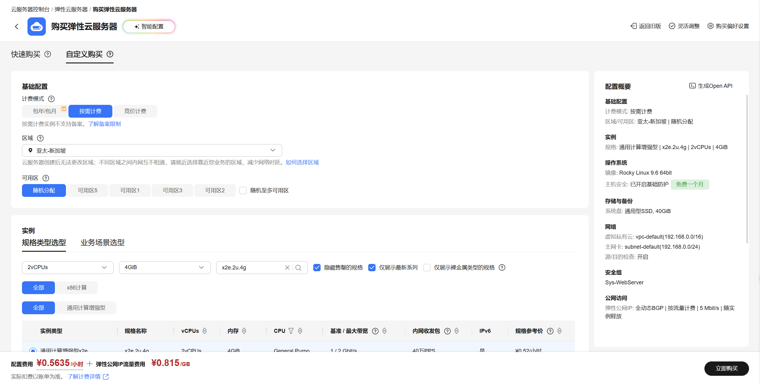
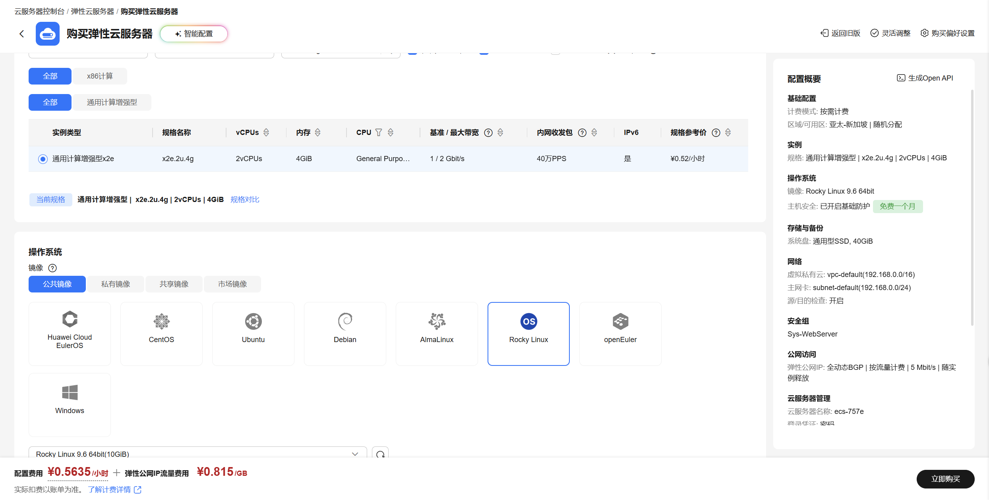
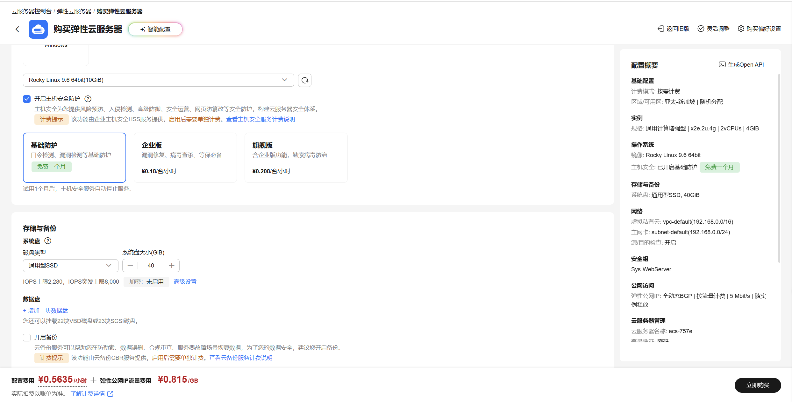
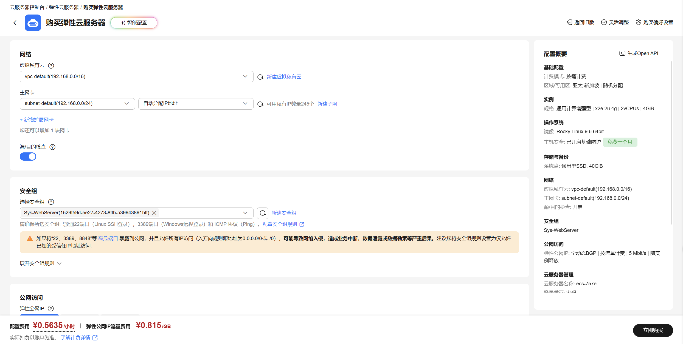
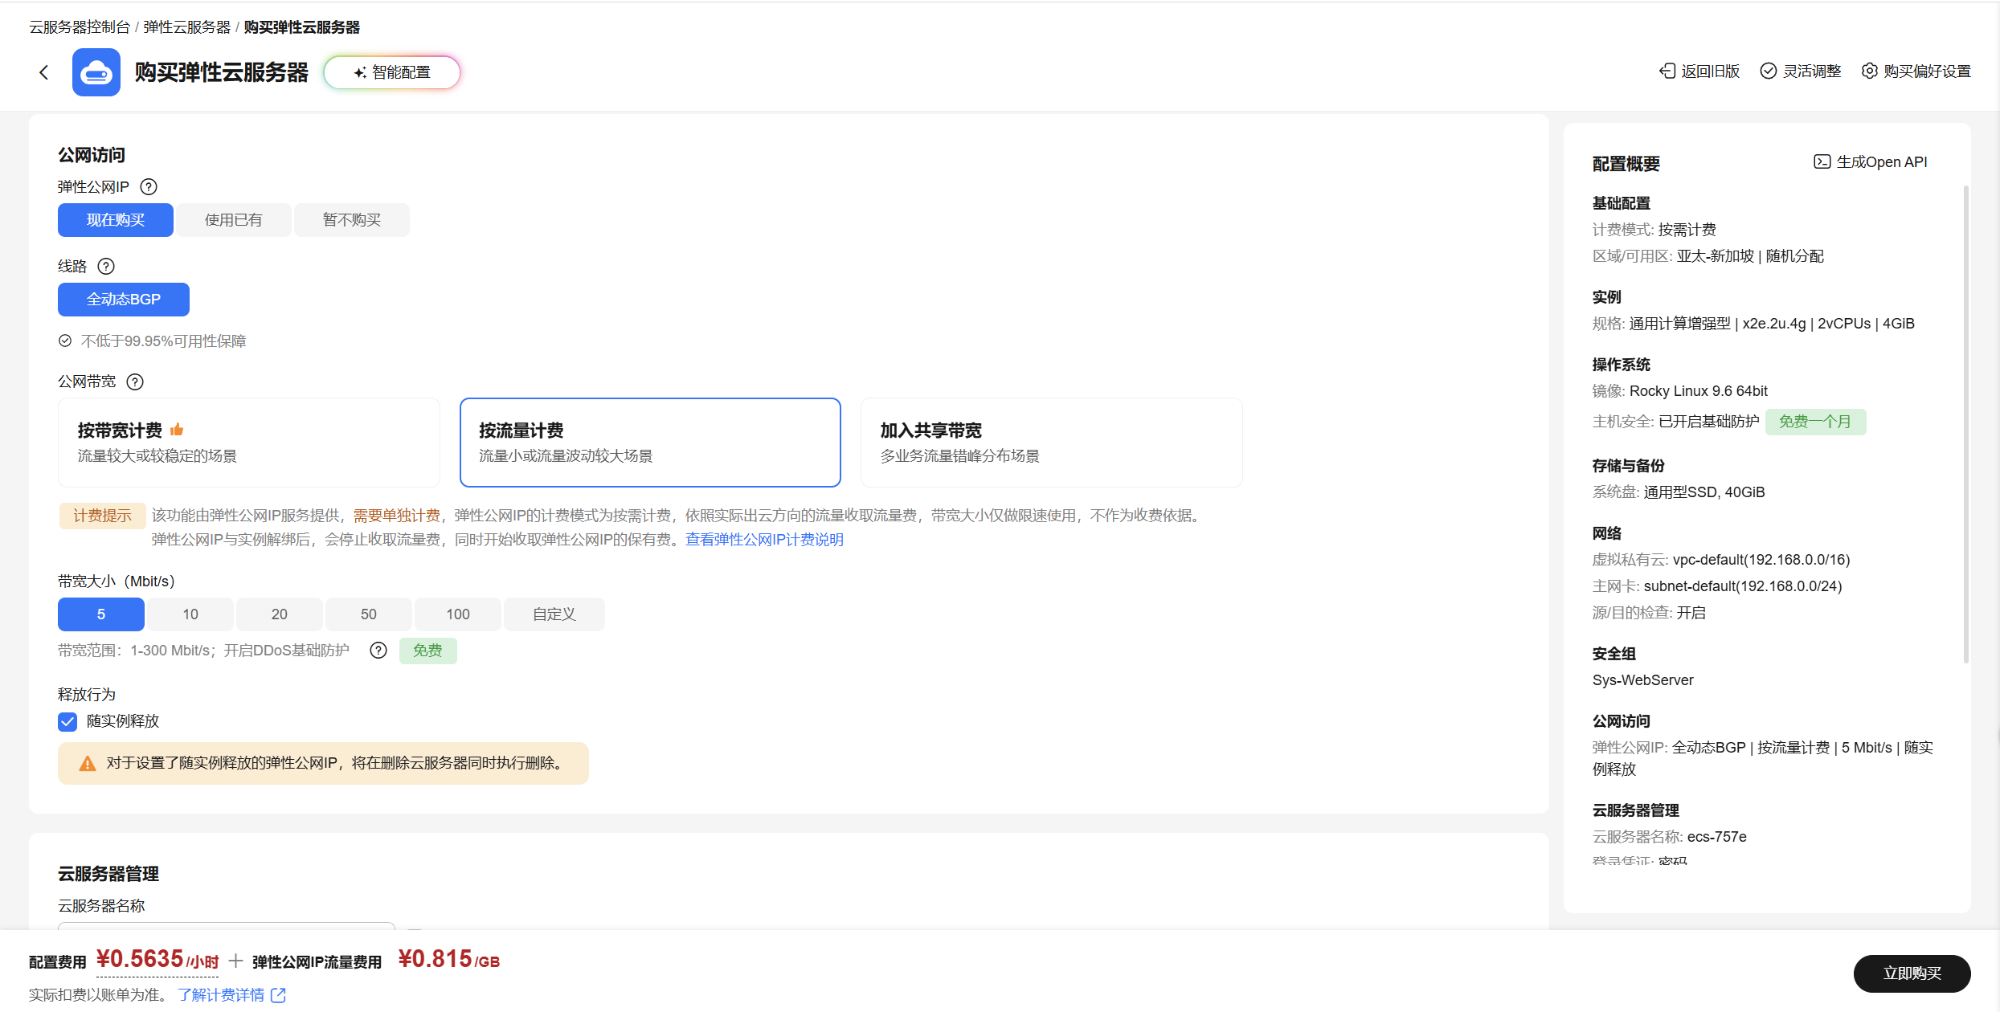
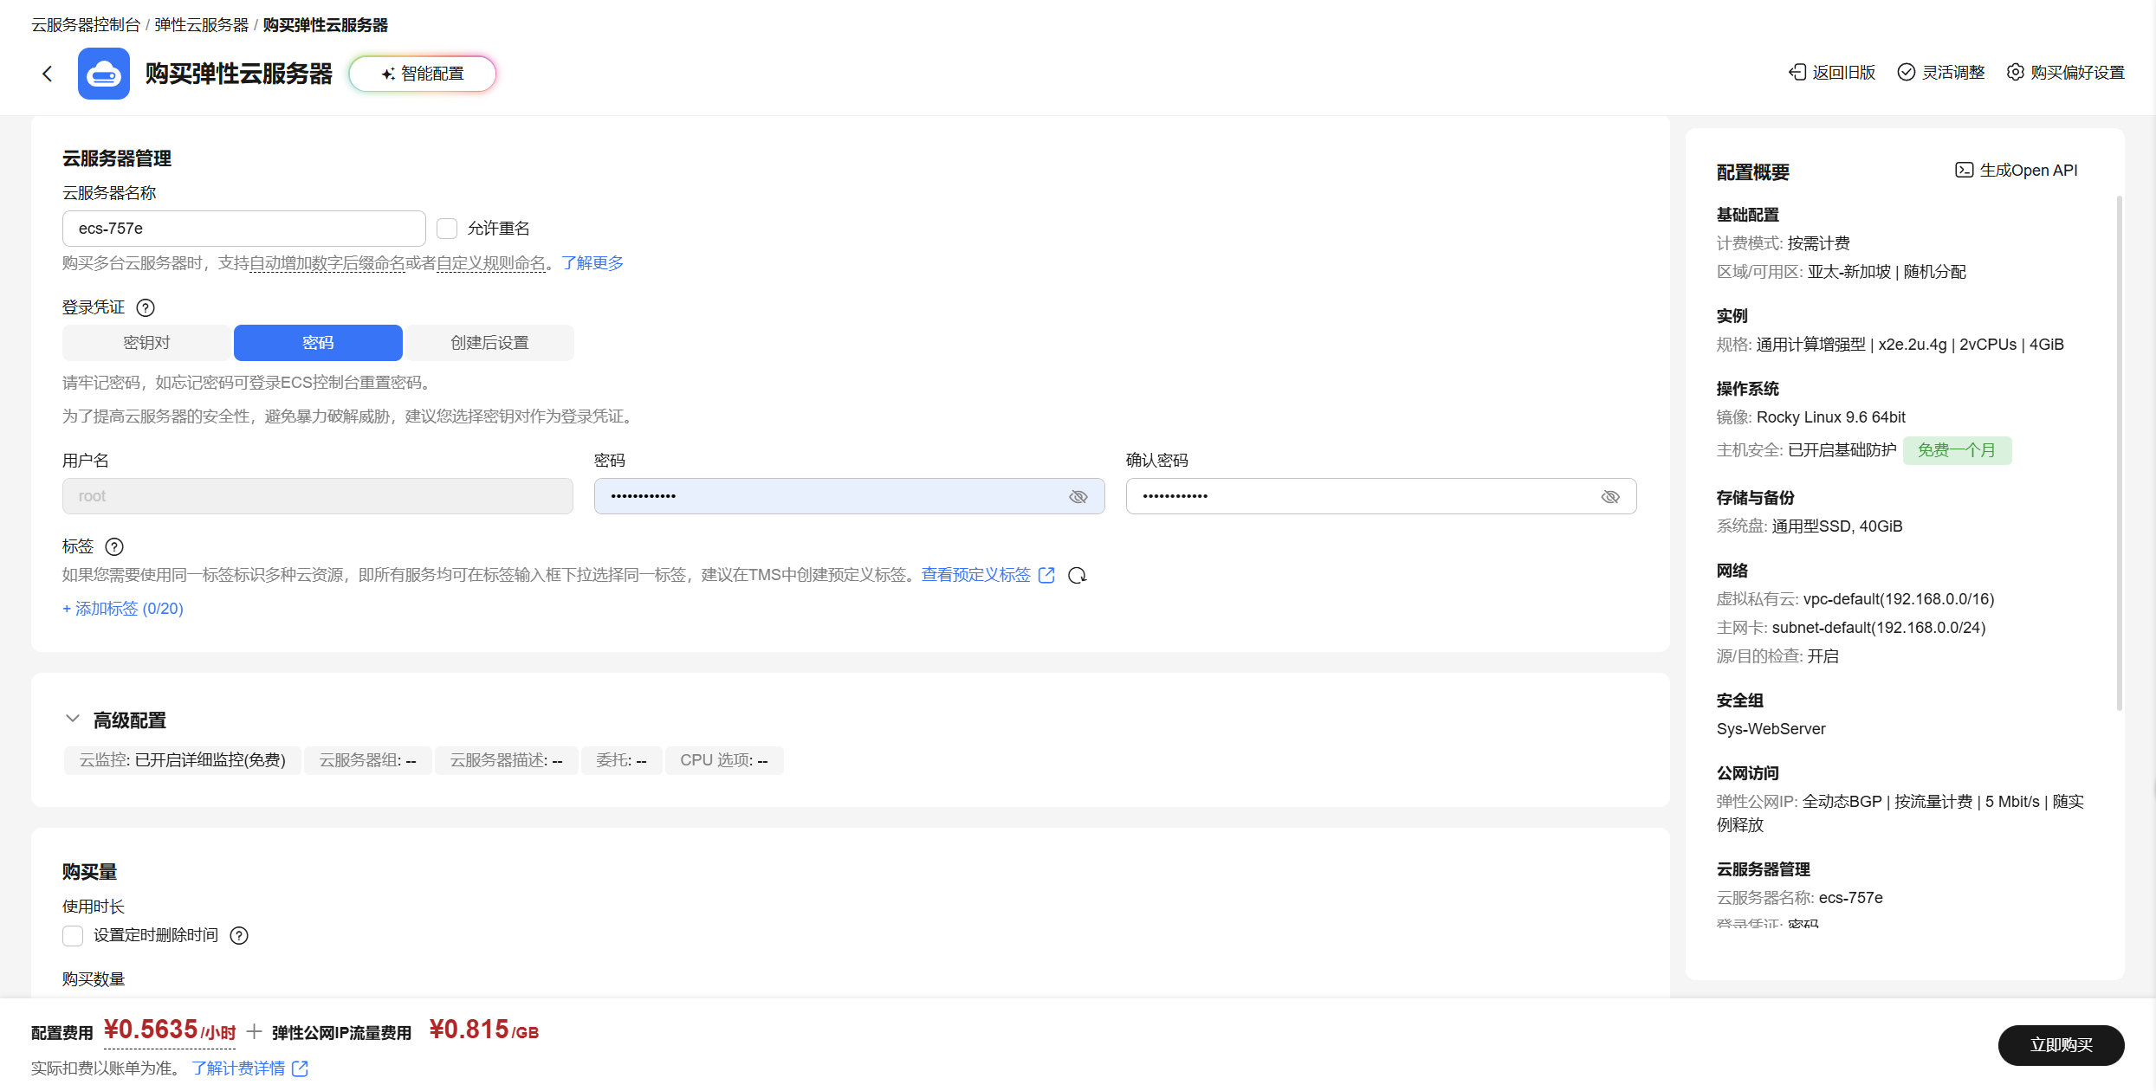
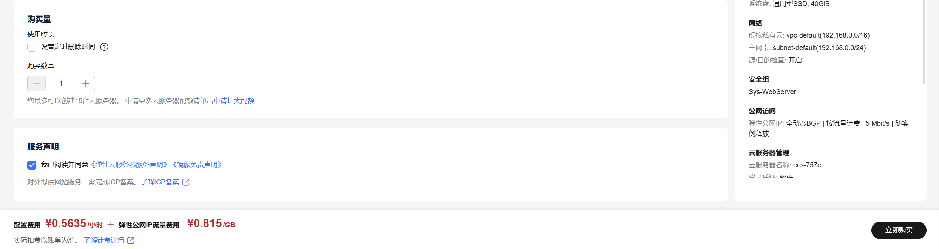

[root@ecs-cb20 ~]# yum update -y;yum install -y curl wget unzip tar openssl httpd firewalld
Extra Packages for Enterprise Linux 9 - x86_64 136 MB/s | 20 MB 00:00
Extra Packages for Enterprise Linux 9 openh264 (From Cisco) - x86_64 981 B/s | 2.5 kB 00:02
Rocky Linux 9 - BaseOS 1.3 MB/s | 37 MB 00:27
.....
Installed:
apr-1.7.0-12.el9_3.x86_64 apr-util-1.6.1-23.el9_8.1.x86_64 apr-util-bdb-1.6.1-23.el9_8.1.x86_64 apr-util-openssl-1.6.1-23.el9_8.1.x86_64
httpd-2.4.62-13.el9_8.6.x86_64 httpd-core-2.4.62-13.el9_8.6.x86_64 httpd-filesystem-2.4.62-13.el9_8.6.noarch httpd-tools-2.4.62-13.el9_8.6.x86_64
mailcap-2.1.49-5.el9.0.2.noarch mod_http2-2.0.26-6.el9_8.2.x86_64 mod_lua-2.4.62-13.el9_8.6.x86_64 rocky-logos-httpd-90.17-1.el9.noarch

Complete!
[root@ecs-cb20 ~]#

[root@ecs-cb20 ~]# systemctl enable --now httpd
Created symlink /etc/systemd/system/multi-user.target.wants/httpd.service → /usr/lib/systemd/system/httpd.service.
[root@ecs-cb20 ~]# systemctl is-active httpd
active
[root@ecs-cb20 ~]# systemctl is-enabled httpd
enabled
[root@ecs-cb20 ~]#

[root@ecs-cb20 ~]# systemctl enable --now firewalld
Created symlink /etc/systemd/system/dbus-org.fedoraproject.FirewallD1.service → /usr/lib/systemd/system/firewalld.service.
Created symlink /etc/systemd/system/multi-user.target.wants/firewalld.service → /usr/lib/systemd/system/firewalld.service.
[root@ecs-cb20 ~]# systemctl is-active firewalld
active
[root@ecs-cb20 ~]# systemctl is-enabled firewalld
enabled
[root@ecs-cb20 ~]#

[root@ecs-cb20 ~]# firewall-cmd --permanent --add-port=80/tcp
success
[root@ecs-cb20 ~]# firewall-cmd --permanent --add-port=443/tcp
success
[root@ecs-cb20 ~]# firewall-cmd --reload
success
[root@ecs-cb20 ~]# firewall-cmd --list-all
public (active)
target: default
icmp-block-inversion: no
interfaces: eth0
sources:
services: cockpit dhcpv6-client ssh
ports: 80/tcp 443/tcp
protocols:
forward: yes
masquerade: no
forward-ports:
source-ports:
icmp-blocks:
rich rules:
[root@ecs-cb20 ~]#

[root@ecs-cb20 ~]# bash -c "$(curl -L https://github.com/XTLS/Xray-install/raw/main/install-release.sh)" @ install
% Total % Received % Xferd Average Speed Time Time Time Current
Dload Upload Total Spent Left Speed
0 0 0 0 0 0 0 0 --:--:-- --:--:-- --:--:-- 0
100 31219 100 31219 0 0 73284 0 --:--:-- --:--:-- --:--:-- 73284
get release list success
get release list success
info: Installing Xray v26.3.27 for x86_64
Downloading Xray archive: https://github.com/XTLS/Xray-core/releases/download/v26.3.27/Xray-linux-64.zip
% Total % Received % Xferd Average Speed Time Time Time Current
Dload Upload Total Spent Left Speed
0 0 0 0 0 0 0 0 --:--:-- --:--:-- --:--:-- 0
100 20.1M 100 20.1M 0 0 1304k 0 0:00:15 0:00:15 --:--:-- 1313k
ok.
Downloading verification file for Xray archive: https://github.com/XTLS/Xray-core/releases/download/v26.3.27/Xray-linux-64.zip.dgst
ok.
info: Extract the Xray package to /tmp/tmp.fsMIOZCGbH and prepare it for installation.
rm: cannot remove '/etc/systemd/system/xray.service.d/10-donot_touch_multi_conf.conf': No such file or directory
rm: cannot remove '/etc/systemd/system/xray@.service.d/10-donot_touch_multi_conf.conf': No such file or directory
info: Systemd service files have been installed successfully!
warning: The following are the actual parameters for the xray service startup.
warning: Please make sure the configuration file path is correctly set.
# /etc/systemd/system/xray.service
[Unit]
Description=Xray Service
Documentation=https://github.com/xtls
After=network.target nss-lookup.target

[Service]
User=nobody
CapabilityBoundingSet=CAP_NET_ADMIN CAP_NET_BIND_SERVICE
AmbientCapabilities=CAP_NET_ADMIN CAP_NET_BIND_SERVICE
NoNewPrivileges=true
ExecStart=/usr/local/bin/xray run -config /usr/local/etc/xray/config.json
Restart=on-failure
RestartPreventExitStatus=23
LimitNPROC=10000
LimitNOFILE=1000000
RuntimeDirectory=xray
RuntimeDirectoryMode=0755

[Install]
WantedBy=multi-user.target

# /etc/systemd/system/xray.service.d/10-donot_touch_single_conf.conf
# In case you have a good reason to do so, duplicate this file in the same directory and make your customizes there.
# Or all changes you made will be lost! # Refer: https://www.freedesktop.org/software/systemd/man/systemd.unit.html
[Service]
ExecStart=
ExecStart=/usr/local/bin/xray run -config /usr/local/etc/xray/config.json

installed: /usr/local/bin/xray
installed: /usr/local/share/xray/geoip.dat
installed: /usr/local/share/xray/geosite.dat
installed: /usr/local/etc/xray/config.json
installed: /var/log/xray/
installed: /var/log/xray/access.log
installed: /var/log/xray/error.log
installed: /etc/systemd/system/xray.service
installed: /etc/systemd/system/xray@.service
removed: /tmp/tmp.fsMIOZCGbH
info: Xray v26.3.27 is installed.
You may need to execute a command to remove dependent software: dnf remove curl unzip
Created symlink /etc/systemd/system/multi-user.target.wants/xray.service → /etc/systemd/system/xray.service.
info: Enable and start the Xray service
[root@ecs-cb20 ~]#

[root@ecs-cb20 ~]# export MY_UUID=$(/usr/local/bin/xray uuid)
export KEYS=$(/usr/local/bin/xray x25519)
export MY_PRIVATE_KEY=$(echo "$KEYS" | grep -i "Private" | awk -F': ' '{print $2}' | tr -d ' ')
export MY_PUBLIC_KEY=$(echo "$KEYS" | grep -i "Public" | awk -F': ' '{print $2}' | tr -d ' ')
export MY_SHORT_ID=$(openssl rand -hex 8)
export MY_IP=$(curl -s https://api.ipify.org || curl -s https://ifconfig.me)
echo "=========================================="
echo "服务器IP : $MY_IP"
echo "UUID : $MY_UUID"
echo "Private Key : $MY_PRIVATE_KEY"
echo "Public Key : $MY_PUBLIC_KEY"
echo "Short ID : $MY_SHORT_ID"
echo "=========================================="
==========================================
服务器IP : 159.138.92.253
UUID : 29ff3bc5-5a3a-4c65-90bd-99ae0eb7a00d
Private Key : 0Lur_SomuIwMVsSpc0-hK22sojbRs_UliSPr67AyI3M
Public Key : OxwYo2A9I7l_YCNMKvAdI7AiitCGLdUyiZXl_3doxSs
Short ID : 426dc80e6bf70069
==========================================
[root@ecs-cb20 ~]#

[root@ecs-cb20 ~]# mkdir -p /usr/local/etc/xray
[root@ecs-cb20 ~]# cat > /usr/local/etc/xray/config.json << EOF
{
"log": {
"loglevel": "warning"
},
"inbounds": [
{
"port": 443,
"protocol": "vmess",
"settings": {
"clients": [
{
"id": "${MY_UUID}",
"alterId": 0
}
]
},
"streamSettings": {
"network": "ws",
"wsSettings": {
"path": "/ray"
}
}
}
],
"outbounds": [
{
"protocol": "freedom",
"tag": "direct"
},
{
"protocol": "blackhole",
"tag": "block"
}
]
}
EOF
[root@ecs-cb20 ~]# cat /usr/local/etc/xray/config.json
{
"log": {
"loglevel": "warning"
},
"inbounds": [
{
"port": 443,
"protocol": "vmess",
"settings": {
"clients": [
{
"id": "29ff3bc5-5a3a-4c65-90bd-99ae0eb7a00d",
"alterId": 0
}
]
},
"streamSettings": {
"network": "ws",
"wsSettings": {
"path": "/ray"
}
}
}
],
"outbounds": [
{
"protocol": "freedom",
"tag": "direct"
},
{
"protocol": "blackhole",
"tag": "block"
}
]
}
[root@ecs-cb20 ~]#

[root@ecs-cb20 ~]# /usr/local/bin/xray run -test -config /usr/local/etc/xray/config.json
Xray 26.3.27 (Xray, Penetrates Everything.) d2758a0 (go1.26.1 linux/amd64)
A unified platform for anti-censorship.
2026/10/08 21:20:15.071728 [Info] infra/conf/serial: Reading config: &{Name:/usr/local/etc/xray/config.json Format:json}
2026/10/08 21:20:15.072296 [Warning] common/errors: The feature WebSocket transport (with ALPN http/1.1, etc.) is deprecated, not recommended for using and might be removed. Please migrate to XHTTP H2 & H3 as soon as possible.
2026/10/08 21:20:15.072362 [Warning] common/errors: The feature VMess (with no Forward Secrecy, etc.) is deprecated, not recommended for using and might be removed. Please migrate to VLESS Encryption as soon as possible.
Configuration OK.
[root@ecs-cb20 ~]#

[root@ecs-cb20 ~]# systemctl daemon-reload
[root@ecs-cb20 ~]# systemctl enable --now xray
[root@ecs-cb20 ~]# systemctl restart xray
[root@ecs-cb20 ~]# systemctl status xray
● xray.service - Xray Service
Loaded: loaded (/etc/systemd/system/xray.service; enabled; preset: disabled)
Drop-In: /etc/systemd/system/xray.service.d
└─10-donot_touch_single_conf.conf
Active: active (running) since Thu 2026-10-08 21:20:56 CST; 7s ago
Docs: https://github.com/xtls
Main PID: 61841 (xray)
Tasks: 8 (limit: 22360)
Memory: 8.3M (peak: 8.7M)
CPU: 13ms
CGroup: /system.slice/xray.service
└─61841 /usr/local/bin/xray run -config /usr/local/etc/xray/config.json

Oct 08 21:20:56 ecs-cb20 systemd[1]: Started Xray Service.
Oct 08 21:20:56 ecs-cb20 xray[61841]: Xray 26.3.27 (Xray, Penetrates Everything.) d2758a0 (go1.26.1 linux/amd64)
Oct 08 21:20:56 ecs-cb20 xray[61841]: A unified platform for anti-censorship.
Oct 08 21:20:56 ecs-cb20 xray[61841]: 2026/10/08 21:20:56.285632 [Info] infra/conf/serial: Reading config: &{Name:/usr/local/etc/xray/config.json Format:json}
Oct 08 21:20:56 ecs-cb20 xray[61841]: 2026/10/08 21:20:56.286371 [Warning] common/errors: The feature WebSocket transport (with ALPN http/1.1, etc.) is deprecated, no>
Oct 08 21:20:56 ecs-cb20 xray[61841]: 2026/10/08 21:20:56.286421 [Warning] common/errors: The feature VMess (with no Forward Secrecy, etc.) is deprecated, not recomme>
Oct 08 21:20:56 ecs-cb20 xray[61841]: 2026/10/08 21:20:56.286900 [Warning] core: Xray 26.3.27 started
[root@ecs-cb20 ~]#

[root@ecs-cb20 ~]# cat > /var/www/html/clash.yaml << EOF
port: 7890
socks-port: 7891
mixed-port: 7890
allow-lan: true
mode: rule
log-level: info
ipv6: false
dns:
enable: true
enhanced-mode: fake-ip
nameserver:
- 223.5.5.5
- 119.29.29.29
fallback:
- https://1.1.1.1/dns-query
- https://8.8.8.8/dns-query
proxies:
- name: "VMESS-节点"
type: vmess
server: "${MY_IP}"
port: 443
uuid: "${MY_UUID}"
alterId: 0
cipher: auto
network: ws
ws-opts:
path: "/ray"
proxy-groups:
- name: "🚀 节点选择"
type: select
proxies:
- VMESS-节点
- DIRECT
rules:
- GEOIP,CN,DIRECT
- MATCH,🚀 节点选择
EOF
[root@ecs-cb20 ~]# cat /var/www/html/clash.yaml
port: 7890
socks-port: 7891
mixed-port: 7890
allow-lan: true
mode: rule
log-level: info
ipv6: false
dns:
enable: true
enhanced-mode: fake-ip
nameserver:
- 223.5.5.5
- 119.29.29.29
fallback:
- https://1.1.1.1/dns-query
- https://8.8.8.8/dns-query
proxies:
- name: "VMESS-节点"
type: vmess
server: "159.138.92.253"
port: 443
uuid: "29ff3bc5-5a3a-4c65-90bd-99ae0eb7a00d"
alterId: 0
cipher: auto
network: ws
ws-opts:
path: "/ray"
proxy-groups:
- name: "🚀 节点选择"
type: select
proxies:
- VMESS-节点
- DIRECT
rules:
- GEOIP,CN,DIRECT
- MATCH,🚀 节点选择
[root@ecs-cb20 ~]#

[root@ecs-cb20 ~]# chmod 644 /var/www/html/clash.yaml
[root@ecs-cb20 ~]# restorecon -v /var/www/html/clash.yaml 2>/dev/null || true
[root@ecs-cb20 ~]# chcon -R -t httpd_sys_content_t /var/www/html/ 2>/dev/null || true
[root@ecs-cb20 ~]#

[root@ecs-cb20 ~]# cat > /usr/local/bin/update-clash-ip.sh << 'EOF'
#!/bin/bash
NEW_IP=""
# 循环尝试获取公网 IP，最多重试 30 次（防止开机网络未就绪）
for i in {1..30}; do
NEW_IP=$(curl -s --connect-timeout 5 https://api.ipify.org || curl -s --connect-timeout 5 https://ifconfig.me)
if [ -n "$NEW_IP" ]; then
break
fi
sleep 2
done

# 如果成功获取到了新 IP 且 clash.yaml 文件存在，则自动替换其中的 server IP
if [ -n "$NEW_IP" ] && [ -f "/var/www/html/clash.yaml" ]; then
sed -i -E "s/(server:[[:space:]]*[\"']).*([\"'])/\1${NEW_IP}\2/g; t; s/(server:[[:space:]]*)[^\"'].*/\1${NEW_IP}/g" /var/www/html/clash.yaml
fi
EOF
[root@ecs-cb20 ~]# cat /usr/local/bin/update-clash-ip.sh
#!/bin/bash
NEW_IP=""
# 循环尝试获取公网 IP，最多重试 30 次（防止开机网络未就绪）
for i in {1..30}; do
NEW_IP=$(curl -s --connect-timeout 5 https://api.ipify.org || curl -s --connect-timeout 5 https://ifconfig.me)
if [ -n "$NEW_IP" ]; then
break
fi
sleep 2
done

# 如果成功获取到了新 IP 且 clash.yaml 文件存在，则自动替换其中的 server IP
if [ -n "$NEW_IP" ] && [ -f "/var/www/html/clash.yaml" ]; then
sed -i -E "s/(server:[[:space:]]*[\"']).*([\"'])/\1${NEW_IP}\2/g; t; s/(server:[[:space:]]*)[^\"'].*/\1${NEW_IP}/g" /var/www/html/clash.yaml
fi
[root@ecs-cb20 ~]#

[root@ecs-cb20 ~]# chmod +x /usr/local/bin/update-clash-ip.sh

[root@ecs-cb20 ~]# cat > /etc/systemd/system/update-clash-ip.service << 'EOF'
[Unit]
Description=Auto Update Clash IP on Boot
After=network-online.target
Wants=network-online.target

[Service]
Type=oneshot
ExecStart=/usr/local/bin/update-clash-ip.sh

[Install]
WantedBy=multi-user.target
EOF
[root@ecs-cb20 ~]# cat /etc/systemd/system/update-clash-ip.service
[Unit]
Description=Auto Update Clash IP on Boot
After=network-online.target
Wants=network-online.target

[Service]
Type=oneshot
ExecStart=/usr/local/bin/update-clash-ip.sh

[Install]
WantedBy=multi-user.target
[root@ecs-cb20 ~]#

[root@ecs-cb20 ~]# systemctl daemon-reload
[root@ecs-cb20 ~]# systemctl enable update-clash-ip.service
Created symlink /etc/systemd/system/multi-user.target.wants/update-clash-ip.service → /etc/systemd/system/update-clash-ip.service.
[root@ecs-cb20 ~]#

http://你的服务器IP/clash.yaml
Clash / FlClash 直接添加此地址即可使用

服务器重启更换 IP 后：
在 Clash / FlClash 客户端将原有的订阅链接 http://旧IP/clash.yaml 修改为 http://新IP/clash.yaml。
重新拉取/刷新订阅即可直接正常连接。

