代理服务器搭建教程
我们使用阿里云的服务器来搭建这个代理服务器，首先进入阿里云的官网：https://www.aliyun.com/product/ecs
提示：
如果搭建机场就无法使用这个搭建方法发，不可以使用ssh的动态端口转发，之所以无法使用ssh，是因为ssh不具备高并发特性，如果想要搭建机场需要使用openvpn这里不做详细讲解
下面这个方法也可以来搭建ip代理池，进行上网代理


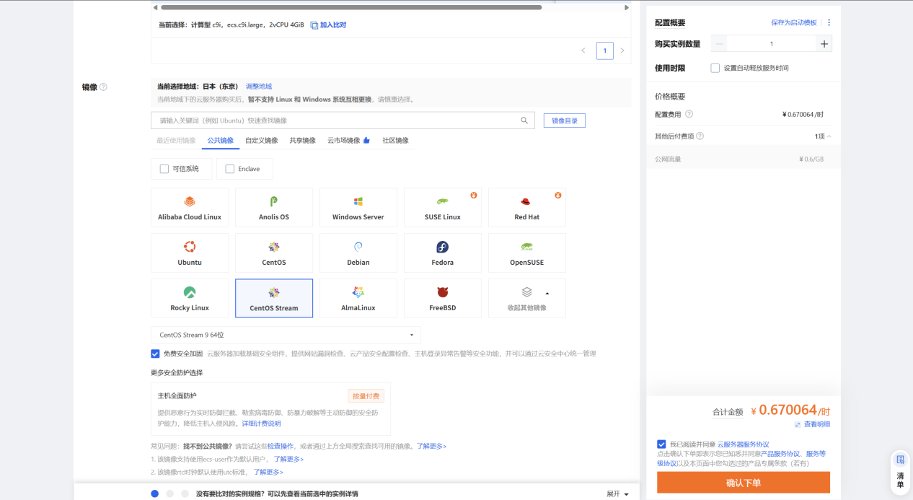


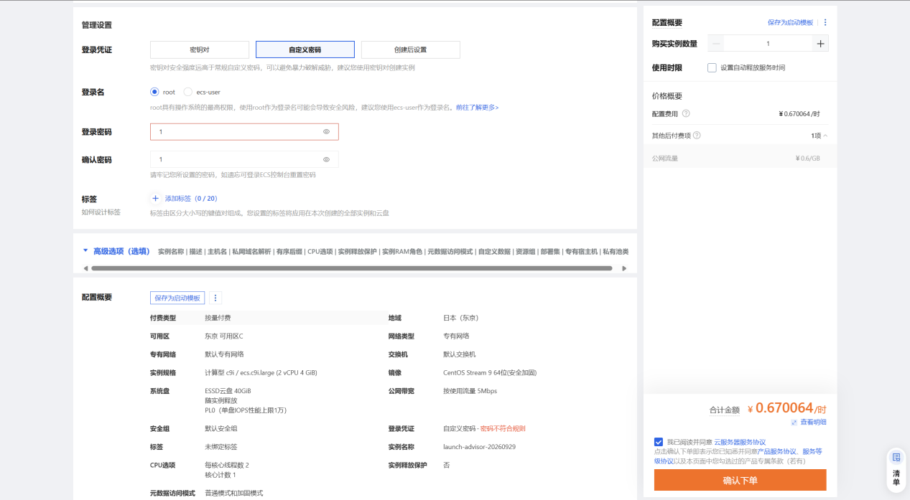
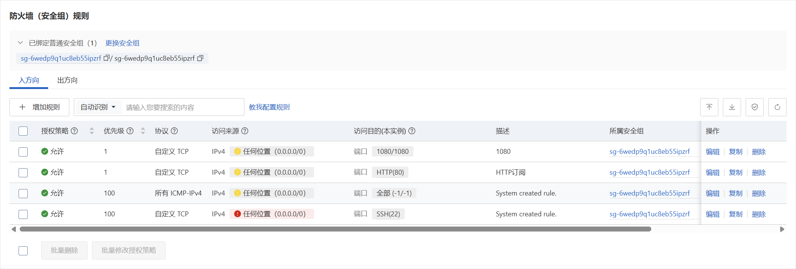

[root@server ~]# cd /etc/yum.repos.d/
[root@server yum.repos.d]# ll
total 0
[root@server yum.repos.d]# touch rhel.repo
[root@server yum.repos.d]# vim rhel.repo
[root@server yum.repos.d]# cat rhel.repo
[base]
name=baseos
baseurl=file:///run/media/root/RHEL-9-3-0-BaseOS-x86_64/BaseOS
enabled=1
gpgcheck=1
gpgkey=file:///run/media/root/RHEL-9-3-0-BaseOS-x86_64/RPM-GPG-KEY-redhat-release

[appstream]
name=appstream
baseurl=file:///run/media/root/RHEL-9-3-0-BaseOS-x86_64/AppStream
enabled=1
gpgcheck=1
gpgkey=file:///run/media/root/RHEL-9-3-0-BaseOS-x86_64/RPM-GPG-KEY-redhat-release

[root@server yum.repos.d]# yum clean all
Updating Subscription Management repositories.
Unable to read consumer identity

This system is not registered with an entitlement server. You can use subscription-manager to register.

0 files removed
[root@server yum.repos.d]# yum makecache
Updating Subscription Management repositories.
Unable to read consumer identity

This system is not registered with an entitlement server. You can use subscription-manager to register.

baseos 95 MB/s | 2.0 MB 00:00
appstream 265 MB/s | 6.5 MB 00:00
Metadata cache created.
[root@server yum.repos.d]# yum repolist all
Updating Subscription Management repositories.
Unable to read consumer identity

This system is not registered with an entitlement server. You can use subscription-manager to register.

repo id repo name status
appstream appstream enabled
base baseos enabled
[root@server yum.repos.d]#

[root@server yum.repos.d]# cd
[root@server ~]#
安装ansible工具
[root@server ~]# yum install ansible-core.x86_64 -y
Updating Subscription Management repositories.
Unable to read consumer identity
....
Installed:
ansible-core-1:2.14.9-1.el9.x86_64 git-core-2.39.3-1.el9_2.x86_64 python3-cffi-1.14.5-5.el9.x86_64 python3-cryptography-36.0.1-4.el9.x86_64
python3-packaging-20.9-5.el9.noarch python3-ply-3.11-14.el9.noarch python3-pycparser-2.20-6.el9.noarch python3-pyparsing-2.4.7-9.el9.noarch
python3-resolvelib-0.5.4-5.el9.noarch sshpass-1.09-4.el9.x86_64

Complete!
[root@server ~]#
安装ansible导航器
导航器的命令工具默认叫做navigator，但是这个命令默认在本地仓库是没有的，需要有红帽的订阅，注册到红帽的订阅，连接到红帽的网络仓库才可以，如果自己的红帽账号有开发者订阅就可以使用，虽然是可以使用红帽的网络仓库，但是比较慢
所以在仓库中就提供了对应的iso镜像文件，这个镜像文件就是包含了ansible的navigator的rpm包还有执行环境，这个执行环境不是专门去拉个镜像就可以了，这个是有专门的容器镜像
您也可以选择不使用导航器，可以直接使用ansible-playbook来执行playbook也可以，这个ISO包含ansible-navigator的rpm包，同时也包含导航器的执行环境
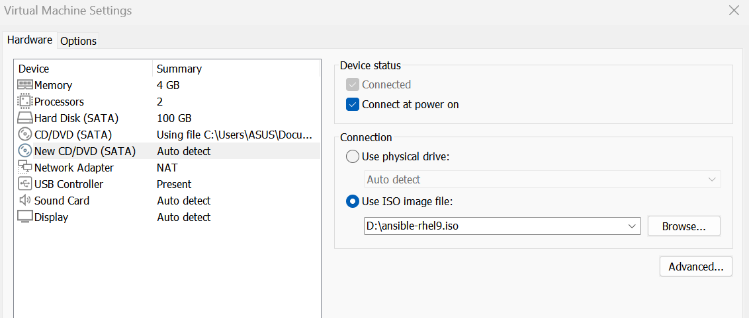
将这个镜像挂载到VMware虚拟机中
[root@server ~]# lsblk
NAME MAJ:MIN RM SIZE RO TYPE MOUNTPOINTS
sda 8:0 0 100G 0 disk
├─sda1 8:1 0 512M 0 part /boot
└─sda2 8:2 0 99.5G 0 part /
sr0 11:0 1 9.8G 0 rom /run/media/root/RHEL-9-3-0-BaseOS-x86_64
sr1 11:1 1 1.6G 0 rom /run/media/root/ansible
[root@server ~]#
[root@server ~]# cd /etc/yum.repos.d/
[root@server yum.repos.d]# ll
total 8
-rw-r--r--. 1 root root 358 Sep 29 18:51 redhat.repo
-rw-r--r--. 1 root root 387 Sep 29 18:51 rhel.repo
[root@server yum.repos.d]# touch ansible.repo
[root@server yum.repos.d]# vim ansible.repo
[root@server yum.repos.d]# cat ansible.repo
[ansible]
name=ansible
baseurl=file:///run/media/root/ansible/
gpgcheck=0
enabled=1

[root@server yum.repos.d]# yum clean all
Updating Subscription Management repositories.
Unable to read consumer identity

This system is not registered with an entitlement server. You can use subscription-manager to register.

13 files removed
[root@server yum.repos.d]# yum makecache
Updating Subscription Management repositories.
Unable to read consumer identity

This system is not registered with an entitlement server. You can use subscription-manager to register.

ansible 3.2 MB/s | 37 kB 00:00
baseos 272 MB/s | 2.0 MB 00:00
appstream 303 MB/s | 6.5 MB 00:00
Metadata cache created.
[root@server yum.repos.d]# yum repolist all
Updating Subscription Management repositories.
Unable to read consumer identity

This system is not registered with an entitlement server. You can use subscription-manager to register.

repo id repo name status
ansible ansible enabled
appstream appstream enabled
base baseos enabled
[root@server yum.repos.d]#
配置好了ansible的软件仓库，现在开始安装navigator导航器
[root@server ~]# yum install ansible-navigator.noarch -y
Updating Subscription Management repositories.
Unable to read consumer identity
....
Installed:
ansible-builder-1.1.0-3.el9ap.noarch ansible-navigator-2.1.0-1.el9ap.noarch ansible-runner-2.2.2-1.el9ap.noarch
python3-ansible-runner-2.2.2-1.el9ap.noarch python3-attrs-21.4.0-2.el9pc.noarch python3-bindep-2.10.2-3.el9ap.noarch
python3-daemon-2.3.0-4.el9ap.noarch python3-docutils-0.16-4.el9ap.noarch python3-importlib-metadata-4.10.1-2.el9pc.noarch
python3-jinja2-3.0.3-2.el9pc.noarch python3-jsonschema-4.6.0-1.el9pc.noarch python3-lockfile-1:0.12.2-1.el9ap.noarch
python3-markupsafe-2.1.0-2.el9ap.x86_64 python3-onigurumacffi-1.1.0-2.el9ap.x86_64 python3-parsley-1.3-2.el9pc.noarch
python3-pbr-5.8.1-2.el9ap.noarch python3-pyrsistent-0.17.3-8.el9.x86_64 python3-requirements-parser-0.2.0-4.el9ap.noarch
python3-typing-extensions-3.10.0.2-2.el9pc.noarch python3-zipp-3.4.0-4.el9pc.noarch

Complete!
[root@server ~]#
导入导航器执行环境
[root@server ansible]# podman load -i /run/media/root/ansible/rhaap22.tar
Getting image source signatures
Copying blob 9d77e7418812 done
Copying blob 0de48c98fba3 done
Copying blob 1053d00b8e29 done
Copying blob 73895dd4b0ef done
Copying config 39a93719fc done
Writing manifest to image destination
Loaded image: registry.redhat.io/ansible-automation-platform-22/ee-supported-rhel8:latest
[root@server ansible]# podman images
REPOSITORY TAG IMAGE ID CREATED SIZE
registry.redhat.io/ansible-automation-platform-22/ee-supported-rhel8 latest 39a93719fc25 2 years ago 1.66 GB
[root@server ansible]#
修改默认的拉去策略，将拉取策略定义为不要每次执行的时候都去红帽的容器镜像的仓库中拉取，执行导航器的时候一定要保证当前目录下有ansible.cfg配置文件，如果当前目录下没有ansible.cfg配置文件，那么导航器执行任务的时候就无法得到ansible.cfg的配置信息了，比如说：远程链接用户是什么，远程链接被控节点的方式，角色搜索的路径....
查看导航器生效的配置
[root@server ~]# ansible-navigator settings --pp missing --effective -m stdout
---
ansible-navigator:
ansible:
config:
help: false
doc:
help: false
plugin:
type: module
inventory:
help: false
playbook:
help: false
ansible-builder:
help: false
workdir: /root
app: settings
collection-doc-cache-path: /root/.cache/ansible-navigator/collection_doc_cache.db
color:
enable: true
osc4: true
editor:
command: vi +{line_number} {filename}
console: true
exec:
command: /bin/bash
shell: true
execution-environment:
container-engine: podman
enabled: true
image: registry.redhat.io/ansible-automation-platform-22/ee-supported-rhel8:latest
pull:
policy: missing
images:
details:
- everything
logging:
append: true
file: /root/ansible-navigator.log
level: warning
mode: stdout
playbook-artifact:
enable: true
save-as: '{playbook_dir}/{playbook_name}-artifact-{time_stamp}.json'
settings:
effective: true
sample: false
schema: json
sources: false
time-zone: UTC

[root@server ~]#
[root@server ~]# cd /etc/ansible/
[root@server ansible]# ll
total 8
-rw-r--r--. 1 root root 614 Aug 17 2023 ansible.cfg
-rw-r--r--. 1 root root 1175 Aug 17 2023 hosts
drwxr-xr-x. 2 root root 6 Aug 17 2023 roles
[root@server ansible]#
[root@server ansible]# vim /root/.ansible-navigator.yml
[root@server ansible]# cat /root/.ansible-navigator.yml
ansible-navigator:
execution-environment:
container-engine: podman
enabled: true
image: registry.redhat.io/ansible-automation-platform-22/ee-supported-rhel8:latest
pull:
policy: missing

[root@server ansible]#

[root@server ansible]# ansible-navigator settings --effective -m stdout
---
ansible-navigator:
ansible:
config:
help: false
doc:
help: false
plugin:
type: module
inventory:
help: false
playbook:
help: false
ansible-builder:
help: false
workdir: /etc/ansible
app: settings
collection-doc-cache-path: /root/.cache/ansible-navigator/collection_doc_cache.db
color:
enable: true
osc4: true
editor:
command: vi +{line_number} {filename}
console: true
exec:
command: /bin/bash
shell: true
execution-environment:
container-engine: podman
enabled: true
image: registry.redhat.io/ansible-automation-platform-22/ee-supported-rhel8:latest
pull:
policy: missing
images:
details:
- everything
logging:
append: true
file: /etc/ansible/ansible-navigator.log
level: warning
mode: stdout
playbook-artifact:
enable: true
save-as: '{playbook_dir}/{playbook_name}-artifact-{time_stamp}.json'
settings:
effective: true
sample: false
schema: json
sources: false
time-zone: UTC

[root@server ansible]#
发现现在运行可以直接打印当前的配置信息，不需要使用--pp missing
[root@server ansible]# ansible --version
ansible [core 2.14.9]
config file = /etc/ansible/ansible.cfg
configured module search path = ['/root/.ansible/plugins/modules', '/usr/share/ansible/plugins/modules']
ansible python module location = /usr/lib/python3.9/site-packages/ansible
ansible collection location = /root/.ansible/collections:/usr/share/ansible/collections
executable location = /usr/bin/ansible
python version = 3.9.18 (main, Sep 7 2023, 00:00:00) [GCC 11.4.1 20230605 (Red Hat 11.4.1-2)] (/usr/bin/python3)
jinja version = 3.1.2
libyaml = True
[root@server ansible]# ansible-navigator --version
ansible-navigator 2.1.0
[root@server ansible]#
配置ansible的配置文件
[root@server ansible]# ll
total 8
-rw-r--r--. 1 root root 614 Aug 17 2023 ansible.cfg
-rw-r--r--. 1 root root 0 Sep 29 19:28 ansible-navigator.log
-rw-r--r--. 1 root root 1175 Aug 17 2023 hosts
drwxr-xr-x. 2 root root 6 Aug 17 2023 roles
[root@server ansible]# vim ansible.cfg
[root@server ansible]# cat ansible.cfg
[defaults]
inventory=/etc/ansible/hosts
collections_path={{ ANSIBLE_HOME ~ "/collections:/usr/share/ansible/collections" }}
roles_path={{ ANSIBLE_HOME ~ "/roles:/usr/share/ansible/roles:/etc/ansible/roles" }}
ask_pass=False
host_key_checking=False
remote_user=root

[privilege_escalation]
become=True
become_ask_pass=False
become_method=sudo
become_user=root
[root@server ansible]#

进行ip地址与主机名之间的映射
[root@server ~]# vim /etc/hosts
[root@server ~]# cat /etc/hosts
127.0.0.1 localhost localhost.localdomain localhost4 localhost4.localdomain4
::1 localhost localhost.localdomain localhost6 localhost6.localdomain6

8.216.39.171 node1
8.216.43.96 node2

[root@server ~]#
[root@server ~]# ping 8.216.39.171
PING 8.216.39.171 (8.216.39.171) 56(84) bytes of data.
64 bytes from 8.216.39.171: icmp_seq=1 ttl=128 time=321 ms
64 bytes from 8.216.39.171: icmp_seq=2 ttl=128 time=209 ms
64 bytes from 8.216.39.171: icmp_seq=6 ttl=128 time=338 ms
64 bytes from 8.216.39.171: icmp_seq=7 ttl=128 time=447 ms
^C
--- 8.216.39.171 ping statistics ---
7 packets transmitted, 4 received, 42.8571% packet loss, time 6077ms
rtt min/avg/max/mdev = 208.985/328.886/447.091/84.392 ms
[root@server ~]# ping 8.216.43.96
PING 8.216.43.96 (8.216.43.96) 56(84) bytes of data.
64 bytes from 8.216.43.96: icmp_seq=2 ttl=128 time=98.0 ms
64 bytes from 8.216.43.96: icmp_seq=3 ttl=128 time=297 ms
64 bytes from 8.216.43.96: icmp_seq=4 ttl=128 time=366 ms
64 bytes from 8.216.43.96: icmp_seq=6 ttl=128 time=187 ms
^C
--- 8.216.43.96 ping statistics ---
7 packets transmitted, 4 received, 42.8571% packet loss, time 6074ms
rtt min/avg/max/mdev = 98.043/237.094/365.746/102.498 ms
[root@server ~]#

[root@server ansible]# vim hosts
[root@server ansible]# cat hosts
node1
node2
[root@server ansible]#
配置主控节点与被控节点之间的免密
[root@server ~]# ssh-keygen
Generating public/private rsa key pair.
Enter file in which to save the key (/root/.ssh/id_rsa):
Enter passphrase (empty for no passphrase):
Enter same passphrase again:
Your identification has been saved in /root/.ssh/id_rsa
Your public key has been saved in /root/.ssh/id_rsa.pub
The key fingerprint is:
SHA256:Ld6C607Zo9yMvz36jbkbHPJ1WxcXKxctyiNxO+SF6zE root@server.example.com
The key's randomart image is:
+---[RSA 3072]----+
| . o.|
| . + o =|
| * * =.|
| .. E o o|
| S oo.=. o|
| = * o.. o.|
| + = = . |
| o * +.= |
| oB.*+B+. |
+----[SHA256]-----+
[root@server ~]# ssh-copy-id -i /root/.ssh/id_rsa.pub root@8.216.39.171
/usr/bin/ssh-copy-id: INFO: Source of key(s) to be installed: "/root/.ssh/id_rsa.pub"
/usr/bin/ssh-copy-id: INFO: attempting to log in with the new key(s), to filter out any that are already installed
/usr/bin/ssh-copy-id: INFO: 1 key(s) remain to be installed -- if you are prompted now it is to install the new keys
root@8.216.39.171's password:

Number of key(s) added: 1

Now try logging into the machine, with: "ssh 'root@8.216.39.171'"
and check to make sure that only the key(s) you wanted were added.

[root@server ~]# ssh 'root@8.216.39.171'

Welcome to Alibaba Cloud Elastic Compute Service !

Last failed login: Tue Sep 29 19:55:11 CST 2026 from 77.239.124.31 on ssh:notty
There were 241 failed login attempts since the last successful login.
Last login: Tue Sep 29 18:49:43 2026 from 27.208.208.136
[root@iZ6wedp9q1uc8eb55nssblZ ~]#
logout
Connection to 8.216.39.171 closed.
[root@server ~]#
[root@server ~]# ssh-copy-id -i /root/.ssh/id_rsa.pub root@8.216.43.96
/usr/bin/ssh-copy-id: INFO: Source of key(s) to be installed: "/root/.ssh/id_rsa.pub"
The authenticity of host '8.216.43.96 (8.216.43.96)' can't be established.
ED25519 key fingerprint is SHA256:CLuSMmXcLMYvqnrInk9juBmhzur18O/sV4C7dyj8Yjo.
This key is not known by any other names
Are you sure you want to continue connecting (yes/no/[fingerprint])? yes
/usr/bin/ssh-copy-id: INFO: attempting to log in with the new key(s), to filter out any that are already installed
/usr/bin/ssh-copy-id: INFO: 1 key(s) remain to be installed -- if you are prompted now it is to install the new keys
root@8.216.43.96's password:

Number of key(s) added: 1

Now try logging into the machine, with: "ssh 'root@8.216.43.96'"
and check to make sure that only the key(s) you wanted were added.

[root@server ~]# ssh 'root@8.216.43.96'

Welcome to Alibaba Cloud Elastic Compute Service !

Last login: Tue Sep 29 18:37:31 2026 from 27.208.208.136
[root@iZ6wedp9q1uc8eb55nssbkZ ~]#
logout
Connection to 8.216.43.96 closed.
[root@server ~]#
[root@server ansible]# ansible all -m ping
node2 | SUCCESS => {
"ansible_facts": {
"discovered_interpreter_python": "/usr/bin/python3"
},
"changed": false,
"ping": "pong"
}
node1 | SUCCESS => {
"ansible_facts": {
"discovered_interpreter_python": "/usr/bin/python3"
},
"changed": false,
"ping": "pong"
}
[root@server ansible]# ansible all -m shell -a 'useradd devops'
node1 | CHANGED | rc=0 >>

node2 | CHANGED | rc=0 >>

[root@server ansible]# ansible all -m shell -a 'echo 1 | passwd --stdin devops'
node2 | CHANGED | rc=0 >>
Changing password for user devops.
passwd: all authentication tokens updated successfully.
node1 | CHANGED | rc=0 >>
Changing password for user devops.
passwd: all authentication tokens updated successfully.
[root@server ansible]#
由于长期使用受管节点的root用户不太安全，转而使用devops用户来提权到root
[root@server ansible]# ssh-copy-id -i /root/.ssh/id_rsa.pub devops@8.216.39.171
/usr/bin/ssh-copy-id: INFO: Source of key(s) to be installed: "/root/.ssh/id_rsa.pub"
/usr/bin/ssh-copy-id: INFO: attempting to log in with the new key(s), to filter out any that are already installed
/usr/bin/ssh-copy-id: INFO: 1 key(s) remain to be installed -- if you are prompted now it is to install the new keys
devops@8.216.39.171's password:

Number of key(s) added: 1

Now try logging into the machine, with: "ssh 'devops@8.216.39.171'"
and check to make sure that only the key(s) you wanted were added.

[root@server ansible]# ssh-copy-id -i /root/.ssh/id_rsa.pub devops@8.216.43.96
/usr/bin/ssh-copy-id: INFO: Source of key(s) to be installed: "/root/.ssh/id_rsa.pub"
/usr/bin/ssh-copy-id: INFO: attempting to log in with the new key(s), to filter out any that are already installed
/usr/bin/ssh-copy-id: INFO: 1 key(s) remain to be installed -- if you are prompted now it is to install the new keys
devops@8.216.43.96's password:

Number of key(s) added: 1

Now try logging into the machine, with: "ssh 'devops@8.216.43.96'"
and check to make sure that only the key(s) you wanted were added.

[root@server ansible]#
[root@server ansible]# ansible all -m shell -a "echo 'devops ALL=(ALL) NOPASSWD: ALL' > /etc/sudoers.d/devops"
node1 | CHANGED | rc=0 >>

node2 | CHANGED | rc=0 >>

[root@server ansible]# ansible all -m shell -a "chmod 0440 /etc/sudoers.d/devops"
node2 | CHANGED | rc=0 >>

node1 | CHANGED | rc=0 >>

[root@server ansible]#

[root@server ansible]# vim ansible.cfg
[root@server ansible]# cat ansible.cfg
[defaults]
inventory=/etc/ansible/hosts
collections_path={{ ANSIBLE_HOME ~ "/collections:/usr/share/ansible/collections" }}
roles_path={{ ANSIBLE_HOME ~ "/roles:/usr/share/ansible/roles:/etc/ansible/roles" }}
ask_pass=False
host_key_checking=False
remote_user=devops

[privilege_escalation]
become=True
become_ask_pass=False
become_method=sudo
become_user=root
[root@server ansible]# ansible all -m ping
node1 | SUCCESS => {
"ansible_facts": {
"discovered_interpreter_python": "/usr/bin/python3"
},
"changed": false,
"ping": "pong"
}
node2 | SUCCESS => {
"ansible_facts": {
"discovered_interpreter_python": "/usr/bin/python3"
},
"changed": false,
"ping": "pong"
}
[root@server ansible]#

开始配置ssh动态端口转发
[root@server ansible]# ll
total 48
-rw-r--r--. 1 root root 361 Sep 29 20:14 ansible.cfg
-rw-r--r--. 1 root root 39230 Sep 29 19:34 ansible.cfg.bak
-rw-r--r--. 1 root root 0 Sep 29 19:28 ansible-navigator.log
-rw-r--r--. 1 root root 12 Sep 29 19:48 hosts
drwxr-xr-x. 2 root root 6 Aug 17 2023 roles
[root@server ansible]#
安装集合
[root@server ~]# ansible-galaxy collection install ansible-posix-2.2.2.tar.gz
Starting galaxy collection install process
Process install dependency map
Starting collection install process
Installing 'ansible.posix:2.2.2' to '/etc/ansible/{{ ANSIBLE_HOME ~ "/collections/ansible_collections/ansible/posix'
ansible.posix:2.2.2 was installed successfully
[root@server ~]# ansible-galaxy collection install community-general-13.4.0.tar.gz
Starting galaxy collection install process
Process install dependency map
Starting collection install process
Installing 'community.general:13.4.0' to '/etc/ansible/{{ ANSIBLE_HOME ~ "/collections/ansible_collections/community/general'
Downloading https://galaxy.ansible.com/api/v3/plugin/ansible/content/published/collections/artifacts/community-library_inventory_filtering_v1-1.1.5.tar.gz to /root/.ansible/tmp/ansible-local-35358w8r20_ak/tmpfxqkok95/community-library_inventory_filtering_v1-1.1.5-hqy_fpae
community.general:13.4.0 was installed successfully
Downloading https://galaxy.ansible.com/api/v3/plugin/ansible/content/published/collections/artifacts/community-library_inventory_filtering_v1-1.1.5.tar.gz to /root/.ansible/tmp/ansible-local-35358w8r20_ak/tmpfxqkok95/community-library_inventory_filtering_v1-1.1.5-fh9x_68t
Downloading https://galaxy.ansible.com/api/v3/plugin/ansible/content/published/collections/artifacts/community-library_inventory_filtering_v1-1.1.5.tar.gz to /root/.ansible/tmp/ansible-local-35358w8r20_ak/tmpfxqkok95/community-library_inventory_filtering_v1-1.1.5-tkj1dekt
Downloading https://galaxy.ansible.com/api/v3/plugin/ansible/content/published/collections/artifacts/community-library_inventory_filtering_v1-1.1.5.tar.gz to /root/.ansible/tmp/ansible-local-35358w8r20_ak/tmpfxqkok95/community-library_inventory_filtering_v1-1.1.5-ikiyqcc1
Installing 'community.library_inventory_filtering_v1:1.1.5' to '/etc/ansible/{{ ANSIBLE_HOME ~ "/collections/ansible_collections/community/library_inventory_filtering_v1'
community.library_inventory_filtering_v1:1.1.5 was installed successfully
[root@server ~]#
[root@server ~]# ansible-galaxy collection list

# /etc/ansible/{{ ANSIBLE_HOME ~ "/collections/ansible_collections
Collection Version
---------------------------------------- -------
ansible.posix 2.2.2
community.general 13.4.0
community.library_inventory_filtering_v1 1.1.5
[root@server ~]#

二、服务器端完整配置（按顺序执行）

步骤 1：开启 SSH 公网代理权限（必须做）
检查当前配置
[root@server ansible]# ansible all -m shell -a "grep GatewayPorts /etc/ssh/sshd_config"
node2 | CHANGED | rc=0 >>
#GatewayPorts no
node1 | CHANGED | rc=0 >>
#GatewayPorts no
[root@server ansible]#

[root@server ansible]# ansible all -m shell -a "grep AllowTcpForwarding /etc/ssh/sshd_config"
node1 | CHANGED | rc=0 >>
#AllowTcpForwarding yes
# AllowTcpForwarding no
node2 | CHANGED | rc=0 >>
#AllowTcpForwarding yes
# AllowTcpForwarding no
[root@server ansible]#

追加配置
[root@server ansible]# ansible all -m shell -a "echo 'GatewayPorts yes' >> /etc/ssh/sshd_config"
node2 | CHANGED | rc=0 >>

node1 | CHANGED | rc=0 >>

[root@server ansible]#
[root@server ansible]# ansible all -m shell -a "echo 'AllowTcpForwarding yes' >> /etc/ssh/sshd_config"
node1 | CHANGED | rc=0 >>

node2 | CHANGED | rc=0 >>

[root@server ansible]#

重启sshd服务
[root@server ansible]# ansible all -m shell -a "systemctl restart sshd"
node1 | CHANGED | rc=0 >>

node2 | CHANGED | rc=0 >>

[root@server ansible]#

配置本机 SSH 免密登录（必须做，否则代理无法启动）
[root@server roles]# ansible-galaxy role init socket5
- Role socket5 was created successfully
[root@server roles]# ll
total 0
drwxr-xr-x. 10 root root 135 Sep 29 23:28 socket5
[root@server roles]# cd socket5/
[root@server socket5]# tree
.
├── defaults
│ └── main.yml
├── files
├── handlers
│ └── main.yml
├── meta
│ └── main.yml
├── README.md
├── tasks
│ └── main.yml
├── templates
├── tests
│ ├── inventory
│ └── test.yml
└── vars
└── main.yml

8 directories, 8 files
[root@server socket5]#

[root@server socket5]# cd files/
[root@server files]# pwd
/etc/ansible/roles/socket5/files
[root@server files]# sudo tee ssh-socks-proxy.service << 'EOF'
[Unit]
Description=SSH SOCKS5 Global Proxy
After=network-online.target sshd.service
Wants=network-online.target

[Service]
Type=simple
User=root
ExecStart=/usr/bin/ssh -gND 0.0.0.0:1080 localhost -o ServerAliveInterval=30 -o ServerAliveCountMax=5 -o ExitOnForwardFailure=yes -o ConnectTimeout=10 -o StrictHostKeyChecking=no
Restart=always
RestartSec=5

[Install]
WantedBy=multi-user.target

[root@server files]# ll
total 4
-rw-r--r--. 1 root root 486 Sep 30 17:34 ssh-socks-proxy.service
[root@server files]# cd ..
[root@server socket5]# tree
.
├── defaults
│ └── main.yml
├── files
│ └── ssh-socks-proxy.service
├── handlers
│ └── main.yml
├── meta
│ └── main.yml
├── README.md
├── tasks
│ └── main.yml
├── templates
├── tests
│ ├── inventory
│ └── test.yml
└── vars
└── main.yml

8 directories, 9 files
[root@server socket5]#

[root@server socket5]# cat files/ssh-socks-proxy.service
[Unit]
Description=SSH SOCKS5 Global Proxy
After=network-online.target sshd.service
Wants=network-online.target

[Service]
Type=simple
User=root
ExecStart=/usr/bin/ssh -gND 0.0.0.0:1080 localhost -o ServerAliveInterval=30 -o ServerAliveCountMax=5 -o ExitOnForwardFailure=yes -o ConnectTimeout=10 -o StrictHostKeyChecking=no
Restart=always
RestartSec=5

[Install]
WantedBy=multi-user.target
[root@server socket5]#

[root@server socket5]# cd templates/
[root@server templates]# cat > ssh_socks5.yaml << EOF
mixed-port: 7890
allow-lan: false
mode: rule
log-level: info
external-controller: 127.0.0.1:9090

proxies:
- name: "SSH-SOCKS5-1080"
type: socks5
server: {{ pub_ip.stdout }}
port: 1080
username: ""
password: ""
tls: false
skip-cert-verify: true

proxy-groups:
- name: "PROXY"
type: select
proxies:
- SSH-SOCKS5-1080
- DIRECT

rules:
- MATCH,PROXY
EOF
[root@server templates]# ll
total 4
-rw-r--r--. 1 root root 401 Sep 30 19:05 ssh_socks5.yaml
[root@server templates]# cat ssh_socks5.yaml
mixed-port: 7890
allow-lan: false
mode: rule
log-level: info
external-controller: 127.0.0.1:9090

proxies:
- name: "SSH-SOCKS5-1080"
type: socks5
server: {{ pub_ip.stdout }}
port: 1080
username: ""
password: ""
tls: false
skip-cert-verify: true

proxy-groups:
- name: "PROXY"
type: select
proxies:
- SSH-SOCKS5-1080
- DIRECT

rules:
- MATCH,PROXY
[root@server templates]#
[root@server templates]# ll
total 4
-rw-r--r--. 1 root root 401 Sep 30 19:05 ssh_socks5.yaml
[root@server templates]# mv ssh_socks5.yaml ssh_socks5.j2
[root@server templates]# ll
total 4
-rw-r--r--. 1 root root 401 Sep 30 19:05 ssh_socks5.j2
[root@server templates]#

[root@server socket5]# vim tasks/main.yml
[root@server socket5]# cat tasks/main.yml
---
# tasks file for socket5

- name: create root users SSH directory
file:
path: /root/.ssh
state: directory
owner: root
group: root
mode: '0700'

- name: for root users bir SSH key
openssh_keypair:
path: /root/.ssh/id_rsa
type: rsa
size: 4096
owner: root
group: root
mode: '0600'

- name: get pub root public key
slurp:
src: /root/.ssh/id_rsa.pub
register: root_public_key

- name: root can login root nopasswd
authorized_key:
user: root
state: present
key: "{{ root_public_key.content | b64decode }}"

- name: copy
copy:
src: ssh-socks-proxy.service
dest: /etc/systemd/system/

- name: systemd
systemd:
daemon_reload: true
name: ssh-socks-proxy
state: started
enabled: true

- name: start and enable firewalld
service:
name: firewalld
state: started
enabled: true

- name: firewalld allow port 1080/tcp and 80/tcp
firewalld:
port: "{{ item }}"
state: enabled
permanent: true
immediate: true
loop:
- 1080/tcp
- 80/tcp

- name: install httpd
yum:
name: httpd
state: present

- name: start httpd
systemd:
name: httpd
state: started
enabled: true

- name: get IP
shell: curl -s ifconfig.me
register: pub_ip
changed_when: false

- name: generate ssh_socks5 config file from jinja2 template
template:
src: ssh_socks5.j2
dest: /var/www/html/ssh_socks5.yaml
owner: root
group: root
mode: '0644'

[root@server socket5]#

[root@server socket5]# tree
.
├── defaults
│ └── main.yml
├── files
│ └── ssh-socks-proxy.service
├── handlers
│ └── main.yml
├── meta
│ └── main.yml
├── README.md
├── tasks
│ └── main.yml
├── templates
│ └── ssh_socks5.j2
├── tests
│ ├── inventory
│ └── test.yml
└── vars
└── main.yml

8 directories, 10 files
[root@server socket5]#

[root@server ansible]# touch ssh_socket.yml
[root@server ansible]# vim ssh_socket.yml
[root@server ansible]# cat ssh_socket.yml
- name: create socket
hosts: all
roles:
- socket5

[root@server ansible]#

[root@server ~]# ansible-galaxy collection install community-crypto-3.4.0.tar.gz
Starting galaxy collection install process
Process install dependency map
Starting collection install process
Installing 'community.crypto:3.4.0' to '/etc/ansible/{{ ANSIBLE_HOME ~ "/collections/ansible_collections/community/crypto'
community.crypto:3.4.0 was installed successfully
[root@server ~]#
[root@server ~]# ansible-galaxy collection list

# /etc/ansible/{{ ANSIBLE_HOME ~ "/collections/ansible_collections
Collection Version
---------------------------------------- -------
ansible.posix 2.2.2
community.crypto 3.4.0
community.general 13.4.0
community.library_inventory_filtering_v1 1.1.5
[root@server ~]#

[root@server ansible]# ansible-navigator run ssh_socket.yml -m stdout
[WARNING]: Collection community.crypto does not support Ansible version 2.13.10
[WARNING]: Collection ansible.posix does not support Ansible version 2.13.10

PLAY [create socket] ***********************************************************

TASK [Gathering Facts] *********************************************************
ok: [node1]
ok: [node2]

TASK [socket5 : create root users SSH directory] *******************************
ok: [node1]
ok: [node2]

TASK [socket5 : for root users bir SSH key] ************************************
ok: [node1]
ok: [node2]

TASK [socket5 : get pub root public key] ***************************************
ok: [node2]
ok: [node1]

TASK [socket5 : root can login root nopasswd] **********************************
ok: [node2]
ok: [node1]

TASK [socket5 : copy] **********************************************************
ok: [node2]
ok: [node1]

TASK [socket5 : systemd] *******************************************************
ok: [node2]
ok: [node1]

TASK [socket5 : start and enable firewalld] ************************************
changed: [node2]
changed: [node1]

TASK [socket5 : firewalld allow port 1080/tcp and 80/tcp] **********************
changed: [node2] => (item=1080/tcp)
changed: [node1] => (item=1080/tcp)
changed: [node2] => (item=80/tcp)
changed: [node1] => (item=80/tcp)

TASK [socket5 : install httpd] *************************************************
changed: [node2]
changed: [node1]

TASK [socket5 : start httpd] ***************************************************
changed: [node2]
changed: [node1]

TASK [socket5 : get IP] ********************************************************
ok: [node2]
ok: [node1]

TASK [socket5 : generate ssh_socks5 config file from jinja2 template] **********
changed: [node1]
changed: [node2]

PLAY RECAP *********************************************************************
node1 : ok=13 changed=5 unreachable=0 failed=0 skipped=0 rescued=0 ignored=0
node2 : ok=13 changed=5 unreachable=0 failed=0 skipped=0 rescued=0 ignored=0
[root@server ansible]#
[root@server ansible]# curl -I http://8.216.43.96/ssh_socks5.yaml
HTTP/1.1 200 OK
Date: Wed, 30 Sep 2026 12:46:25 GMT
Server: Apache/2.4.62 (CentOS Stream)
Last-Modified: Wed, 30 Sep 2026 12:04:09 GMT
ETag: "189-65cb218c22e86"
Accept-Ranges: bytes
Content-Length: 393

[root@server ansible]#

