CIS 430 Digital and Cyber Forensics
Lab 11 – Memory Forensics: an introduction

Please answer the questions in Answer Sheet at the bottom of this assignment and submit your work via Blackboard by the deadline to receive full credits for this assignment.

Please pay more attention to answer the questions. Incorrect answers won’t receive any credits. Details matter for digital forensics investigations.

Group

This lab can be a teamwork. If you work in a group, please name your team members on your lab report. The group size can be up to 5 people.

Educational Objectives

The educational objective of this lab project is for the students to:
- Gain hands-on experience Volatility framework for memory forensic investigation.
- Gain hands-on experience with strings utility for memory forensic investigation.

Lab Environment and Preparation

This lab will be conducted on the Kali Linux VM. The following instructions are given on the Kali Linux VM. If you use a different Linux distribution, commands may be different.

Do the following to prepare this lab:
- Log in to your Kali Linux VM.
- Create a folder for this lab:

mkdir -p cis430/lab11
cd cis430/lab11

- Download memory dumps from the following link:

https://gvsu.edu/s/2XG

If the short URL does not work for you, get the file from my web page:

https://faculty.computing.gvsu.edu/wangx/teaching/forensics/memdumps2.zip

- This will download a zip file, memdups2.zip. Save the file in the folder you just created.
- Unzip the file:

unzip memdumps2.zip

- Two files will be extracted:

  - cridex.vmem
  - memdump_casestudy.img

After testing, I realized that I don’t like the command names and settings of Volatility 3. Some plugins have not well integrated. We will use Volatility Framework 2.6.1 for this lab. Download it from the following link:

https://github.com/volatilityfoundation/volatility/releases/tag/2.6.1

Download the file volatility_2.6_lin64_standalone.zip

If the link does not work for you, download the file from my web page:

https://gvsu.edu/s/3C2
ls
Unzip it. The executable is volatility_2.6_lin64_standalone.zip in the folder volatility_2.6_lin64_standalone.zip.

For convenience, you can make a link to it with a shorter file name. For example,

sudo ln full_path_of_volatility_2.6_lin64_standalone /usr/bin/vol

Then, test the link:

vol -h

You will see the help page of volatility 2.6, as shown in the following screenshot.

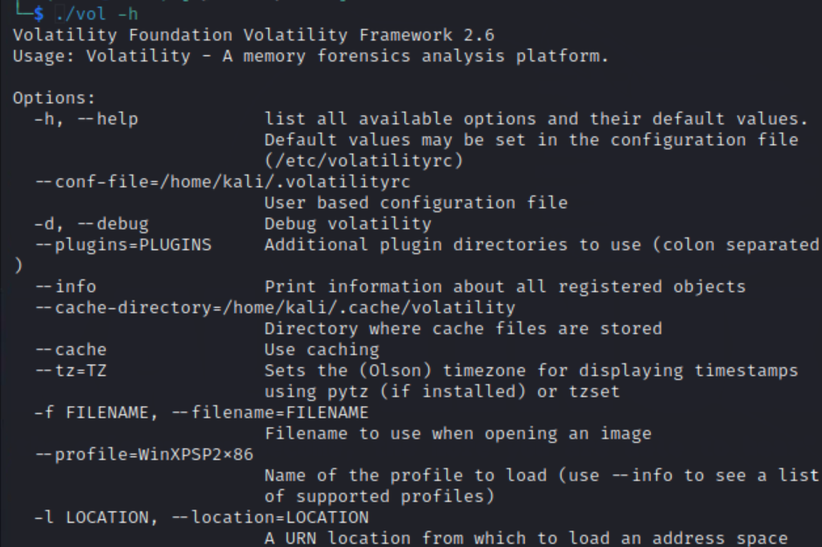

If you see this, you have all set to use volatility 2.6.

The rest of the lab is organized as follows: We first introduce the utility of strings in Section 1. Then, we introduce the Volatility Framework in Section 2. It includes a tutorial, exploration, and a mini case study. Finally, you can work on bonus part if you are interested in and have more time.

Section 1 Introduction to the strings Utility

The Linux utility strings prints the sequence of printable characters (strings) in files. You can use man page to learn how to use it. The following link gives a good introduction to the Linux strings command.

https://www.educba.com/linux-string-command/

By default, the results will be displayed on the screen (standard output). You can always redirect the results and save strings in a file.

For example, the following command will print all (with option -a) strings with a length equal or greater than 5 characters (with option -n 5) in file cridex.vmem and save the results in file strings1.

strings -a -n 5 cridex.vmem > strings1

Then, you can view this file with any text editor, such as vim, and look for any strings that may be interesting for you.

Question 01: How many times does the case-insensitive string "password" (or substring) appear in the memory dump file cridex.vmem? Attach a screenshot of your command/output to demonstrate your work.

Background / Hint:
Buffered credentials (user ID and password) are stored in plaintext within the memory dump file memdump_casestudy.img. Your task is to recover them.

Question 02: What is the credential pair (user ID and password) contained in the memory dump memdump_casestudy.img? Attach a screenshot of your command and output to demonstrate your work.

Question 03: After extracting strings from both memory dump files (cridex.vmem and memdump_casestudy.img) and examining the plaintext contents, what impressed you the most? Attach relevant screenshots to support your answer.

Section 2 Introduction to Volatility Framework

While many tools exist for examining memory snapshots, the Volatility Framework remains one of the most popular free and open-source solutions for memory forensics. It is actively maintained by the Volatility Foundation.

More information can be found here:

https://volatilityfoundation.org/

2.1 Volatility Tutorial

You will follow a tutorial in this subsection.

First steps to volatile memory analysis, posted on Jan 13, 2019:

https://medium.com/@zemelusa/first-steps-to-volatile-memory-analysis-dcbd4d2d56a1

Please use the image cridex.vmem and follow this tutorial to gain hands-on experience with Volatility framework.

Note:
The command volatility in the tutorial should be replaced with vol in our settings.

When finished, respond to the following questions.

Question04: What are the suggested profiles of the memory dump of cridex.vmem?

With the module connscan, we see two network connections, as shown below:

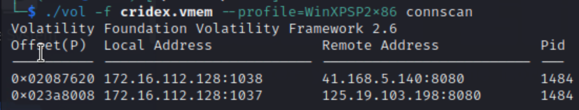

Both connections were created by the same process because the pid (process ID) was the same.

Question05: What was the name of the process (the name of the executable file) that created these TCP connections? (Hint: the option -p list_of_pids can be used with plugin pslist, where list_of_pids is a list of pids separated with a comma)

VirusTotal

https://www.virustotal.com/gui/home/upload

and Hybrid Analysis

https://www.hybrid-analysis.com/

Are two widely used free web-based malware scanners. Please use these two malware scanners to analyze the 1640.dmp file (which was extracted from the memory dump). Then, respond to the following question:

Question06: Briefly summarize the results of the analysis performed on these two web pages. Attach relevant screenshots to demonstrate your work.

Question07: During the investigation, when was the executable “KB00207877.exe” noticed suspicious for the first time and why? Would you be sure that it was malicious at this moment?

Question08: To erase the identified Trojan, why was the deletion of the “KB00207877.exe” needed to clean up an infected computer?

2.2: A Mini Case Study

An intrusion to a computer was caught by an IDS device. However, no details were given in the logs. Then, the IT staff dumped the memory of the attacked machine to investigate the case and answer the What, When, Who, How, Where and Why questions.

The memory dump for this mini case study is saved in the file memdump_casestudy.img. Please investigate this memory dump and respond to the following questions.

Useful Tips:
In addition to the plugins introduced in the tutorial, the following modules may also be helpful.
- Mutants can be helpful to identify the type of a malware program. Reference the article from the following link for details:

https://docs.velociraptor.app/blog/2020/2020-01-12_hunting-malware-using-mutants-ea08e86dfc19/

For example, the following command displays the Mutant owned by process 1640.

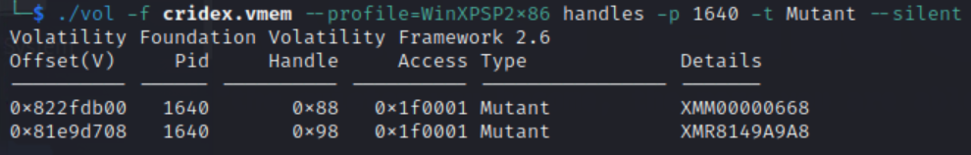

- Yarascan plugin can be useful to confirm a process contains a pattern. For example, the following command shows that the pattern “HTTP” occurred two times in process 1640.

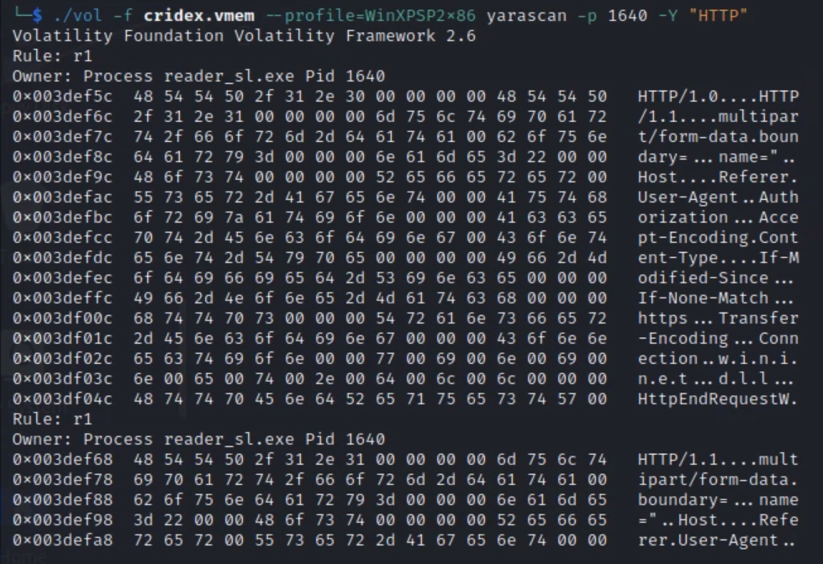

- Malfind module can scan a memory dump to identify injected malicious code. For example, the following command displays the malicious code injected in process 1640.

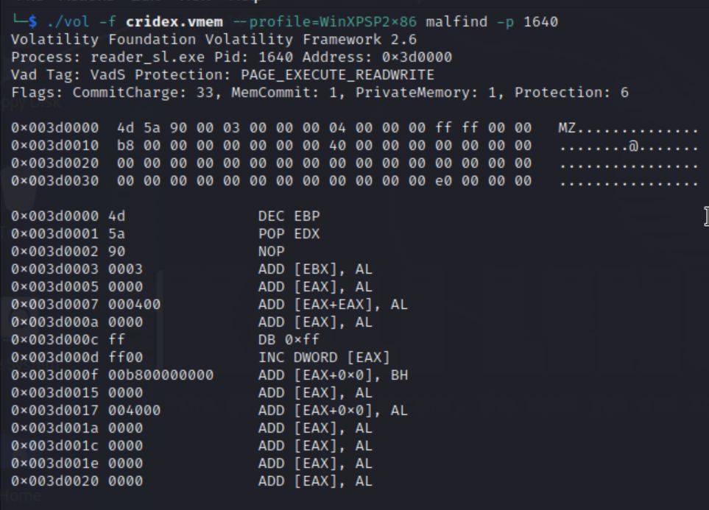

If you can retrieve malicious code from a process, you can convince yourself that malicious code has been injected to this process, or this process itself is malicious. If nothing can be retrieved, we can convince ourselves that no known malicious code is injected in this process.
- Filescan will display open files even if a rootkit is hiding the files on disk and if the rootkit hooks some API functions to hide the open handles on a live system.

Armed with the skills and knowledge you have gained through the tutorial, investigate the memory dump memdump_casestudy.img and respond to the following questions.

Briefly explain your answers to the questions with relevant screenshots to support your answers.

Question09: What are the suggested profiles of the memory dump of memdup_casestudy.img?

Question10: What was the IP address of the C2 (Control-and-Command) server? What protocol in the application layer was employed for this network connection? Explain your answer.

Question11: What process name and process ID (pid) was the backdoor running in? Explain.

Question 12: What was the time when the attack occurred?
Hint: Look at the timestamps of the file SWING-MECHANICS.DOC[1].EXE-0123CEA10.pf in the output of mftparser.

Question13: Where was the backdoor placed in the file system?
Hint:
- The executable was registered in registry for automatic execution.
- The executable was invoked by the process that maintained the C2 connection, which was explorer.exe.

Question14: What was the mutant the backdoor was using (hard coded)?
Hint: Existing hard-coded mutant by known malware can be found from the following link:
https://github.com/albertzsigovits/malware-mutex/blob/main/README.md

Question15: What level of privileges did the attacker finally obtain?
Hint: getsids and privs plugins will help.

Congratulations! You have completed this lab for the class. Hope you enjoyed working on this lab. Please let your instructor know if you have any comments.

Answer Sheet

========================== Required Questions ===========================

Question 01: How many times does the case-insensitive string "password" (or substring) appear in the memory dump file cridex.vmem? Attach a screenshot of your command/output to demonstrate your work.

Question 02: What is the credential pair (user ID and password) contained in the memory dump memdump_casestudy.img? Attach a screenshot of your command and output to demonstrate your work.

Question 03: After extracting strings from both memory dump files (cridex.vmem and memdump_casestudy.img) and examining the plaintext contents, what impressed you the most? Attach relevant screenshots to support your answer.

Question04: What are the suggested profiles of the memory dump of cridex.vmem?

Question05: What was the name of the process (the name of the executable file) that created these TCP connections? (Hint: the option -p list_of_pids can be used with plugin pslist, where list_of_pids is a list of pids separated with a comma)

Question06: Briefly summarize the results of the analysis performed on these two web pages. Attach relevant screenshots to demonstrate your work.

Question07: During the investigation, when was the executable “KB00207877.exe” noticed suspicious for the first time and why? Would you be sure that it was malicious at this moment?

Question08: To erase the identified Trojan, why was the deletion of the “KB00207877.exe” needed to clean up an infected computer?

Question09: What are the suggested profiles of the memory dump of memdup_casestudy.img?

Question10: What was the IP address of the C2 (Control-and-Command) server? What protocol in the application layer was employed for this network connection? Explain your answer.

Question11: What process name and process ID (pid) was the backdoor running in? Explain.

Question 12: What was the time when the attack occurred?
Hint: Look at the timestamps of the file SWING-MECHANICS.DOC[1].EXE-0123CEA10.pf in the output of mftparser.

Question13: Where was the backdoor placed in the file system?
Hint:
- The executable was registered in registry for automatic execution.
- The executable was invoked by the process that maintained the C2 connection, which was explorer.exe.

Question14: What was the mutant the backdoor was using (hard coded)?
Hint: Existing hard-coded mutant by known malware can be found from the following link:
https://github.com/albertzsigovits/malware-mutex/blob/main/README.md

Question15: What level of privileges did the attacker finally obtain?
Hint: getsids and privs plugins will help.

