**COURSEWORK SUBMISSION FORM**

|  |  |  |  |
| --- | --- | --- | --- |
| **STUDENT USE** | | **STAFF USE** | |
| Module Name | Developing Digital Enterprise | First Marker’s  (acts as signature) |  |
| Module Code | 6COSC013C-n - | Second Marker’s  (acts as signature) |  |
| Lecturer Name | Jakhongir Karimov | Agreed Mark |  |
| UoW Student IDs |  | **For Registrar’s office use only (hard copy submission)** | |
| WIUT Student IDs | 00010833 |
| Deadline Date | 24.10.2022 |
| Assignment Type | ☐ Group ☑ Individual |
| Word Count | 2756 |

**SUBMISSION INSTRUCTIONS**

**COURSEWORKS *must* be submitted in *both* HARD COPY (to the Registrar’s Office) *and* ELECTRONIC unless instructed otherwise.**

For hardcopy submission instructions refer to: <http://intranet.wiut.uz/Shared%20Documents/Forms/AllItems.aspx> - Coursework hard copy submission instructions.doc

For online submission instructions refer to: <http://intranet.wiut.uz/Shared%20Documents/Forms/AllItems.aspx> - Coursework online submission instructions.doc

|  |
| --- |
| **MARKERS FEEDBACK (Continued on the next page)** |
|  |

**Table of content**

Introduction2

Industrial market analysis 2

Competition in the industry2

Potential of new entrants into the industry4

Power of suppliers4

Power of customers 5

## Substitute items pose a risk6

Internal business process analysis6

Order fulfillment8

Material movement9

Warehousing9

Transportation9

New BIS development10

## The dispatch procedure and its major challenges10

New industrial and internal business environment analysis13

Conclusion13

Executive summary13

Reference list15

**Introduction**

One of any country's most important businesses has always been the logistics sector. Among the various things that the logistics sector typically manages are food, apparel, supplies for the medical field, and much more. Due to this, this sector is always searching for improvements to enable better performance of their duties. The science of collecting, manufacturing, and delivering goods to the right locations in the right amounts may be summed up as the logistics sector. Its definition also includes personnel mobility in a military context, where it has a more extensive use. The practice of organizing, putting into practice, and overseeing the protocols for the effective and efficient transfer and storage of commodities is referred to as logistics. From the point of origin through the point of consumption, this comprises all services and data linked to them that are provided with the intention of meeting and adhering to customer needs.

**Industrial market analysis**

The trucking industry alludes to the operation of road vehicles, such as tractor trailer and utility vehicles, to deliver goods over long distances. Although items are most typically transported from production plants to retail distribution hubs, other common uses include the delivery of constructing products and waste in the building projects. As Placek (2022) mentioned, trucking accounts for the majority of transcontinental freight transportation throughout in the United States, with the industry valued at 732.3 billion US dollars in 2020. There have been over 902,000 truck drivers working in the United States at the time, which was lower than the industry required. Driver expenses are the industry's most significant concern as a result of the driver scarcity. The trucking industry in the United States is broadly split into three major sectors: full truckload (FTL), less-than-truckload (LTL), and couriers.

## **Competition in the industry**

If to analyze this market according to Porter's criteria, then first of all it is worth mentioning the competition in this industry. According to Stasha (2022), as of February 2021, there have been 996,894 profit community operators, 813,440 private carriers, and 83,235 other federal motor carriers in the United States. The US transportation system transports around 50 million tons of cargo per day, valued at more than $53 billion. The majority of that freight is transported by vehicle. Today, the business is finally getting the national attention it deserves.

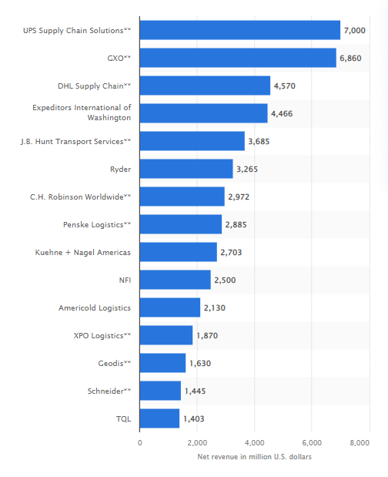

**Pic.1 - The leading logistics companies in the United States in 2021, based on North American net revenue\***

This statistic depicts a ranking of the top logistics businesses in North America by net revenue in 2021. UPS Supply Chain Logistics produced $7 billion in net revenue in North America that year, ranking first. Customers in US benefit from the variety of transportation options available in our globally interconnected society. Rail and highway transport, in addition to maritime transport and aircraft, are the most often used modes of haulage. When clients make an order for a product, they activate a plethora of services that extend beyond the mere delivery of goods. Logistics firms include information flow integration via supply chain automation systems, storage, manufacturing, and industrial equipment, as well as transportation, returned products management, and brokerage. The practical forwarding may be accomplished by utilizing numerous forms of transportation across multiple territories. As US Department of Industry stated trucking businesses, the financial enterprises, and facilities employ an approximate 8.9 million individuals in trucking-related jobs in the United States, including nearly 3.5 million truck drivers. UPS employs 60,000 people, with owner-operators accounting for 9%. Furthermore, LTL (less-than-truckload) shippers account for about 13.6% of the transportation industry in the United States.

## **Potential of new entrants into the industry**

Because of the COVID-19 epidemic, the US trucking business, like most sectors in the logistics area, faced additional hurdles. People began to rely on internet shopping, causing e-commerce to soar. Trucking companies began quickly expanding to meet the demand for critical consumer items. At the same time, firms supplying the commercial, non-essential commerce, or primary industries experienced a fall in business and are currently attempting to recover. As a result, every industry experienced turbulence in 2020.

Trucking companies will confront issues such as labor shortages and increased fuel prices, according to the study. However, container shipping demand will remain high, and economic fundamentals are likely to improve in 2022. Furthermore, transport sector volumes are showing signs of improvement as we approach the end of the year, after being low at the beginning of 2021.

## **Power of suppliers**

The regional cluster of logistics enterprises and operations is referred to as logistics agglomeration. The expanding tendency of logistical clustering in the United States has piqued the interest of both experts and politicians, and its advantages are universally acknowledged. However, knowledge of logistics congestion is still inadequate. The findings of the root test and the panel regression analysis suggest that there is a long-term equilibrium link among logistics agglomeration and logistics sector productivity, according to a study done by Li&Zhao (2018). The protracted flexibility was then estimated using a panel modified ordinary least squares regression, and the model estimate showed that the correlation between logistics concentration level and industrial productivity is 0.039.

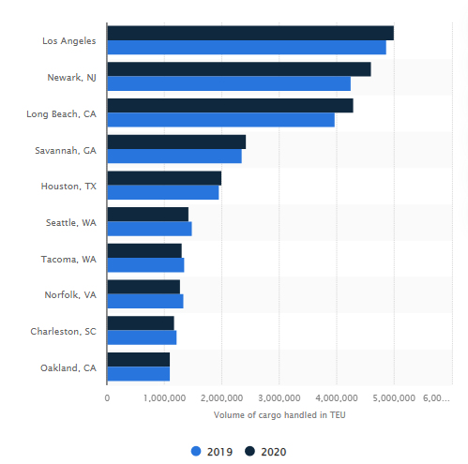

**Pic. 2 - Leading ports in the United States from 2019 to 2020, by cargo volume handled**

### Power of customers

That present economic agreements involving a variety of parties involved in freight transportation, such as load shareholders and consumers, series of recommendations and brokerage, shipping companies, large and small fleets, and owner/drivers, have a substantial impact on safety. Customer and consignor price, schedule, and loading/unloading requirements, as well as the atomistic and highly challenging nature of the industry, promote poor tendering processes, unaffordable shipping costs, and risky work methods. An excess of operators exacerbates the situation, which is exacerbated by the ease of entrance into the market (in both a financial and regulatory sense) and low-cost market's practices on the part of a considerable number of vendors. Possibly the most concerning symptoms are convincing evidence that several owners are economically unviable, and even huge corporations have had troubles in some periods.

## **Substitute items that pose a risk**

Companies would be well to explore implementing the most up-to-date technologies as technology still advancing in various sectors of the economy. The world is becoming more technological, and harnessing new technology can give numerous benefits, including increased organizational effectiveness and a strategic edge.

Delivering items from one to another location as quickly as able to deliver is the end objective of trucking specialists. However, achieving this is not without its difficulties. Concerns about safety, quality assurance, driver recruitment, and increasing unemployment are some of the challenges that businesses in the industry are attempting to tackle. Furthermore, vehicle operation concerns including such mechanical problems, electricity breakdowns, and tire spills result in more damage than benefit. According to Banks (2018), upwards of 70% of the country's goods are shipped from producers to retailers, and truck drivers encounter distinct challenges on the job.

Because of this, the following technologies are altering the trucking business and making processes more effective, more competitive, and safer for drivers:

- Electronic Management

- Fleet Software Solutions

- Fleet Software Solutions

- Accounting data analyze

- Electric Vehicles (EVs) - Trucking Applications

Integrating and maintaining these technologies for an industry lead is based on assisting this market, which in turn enhances the distribution network and economy.

**Internal business process analysis**

Physical Supply chain is another name for logistics. Several various companies engage in logistics for the distribution channels of commodities. FMCG, household appliances, and a variety of other businesses regularly produce goods. These commodities must be conveyed to carriers and brokers, and then to the end user. Logistics is the transportation of goods from a corporation to a middleman or the final customer.

Nevertheless, logistics does not solely refer to "transportation." A corporation may engage in a variety of logistical operations or functions of logistics.

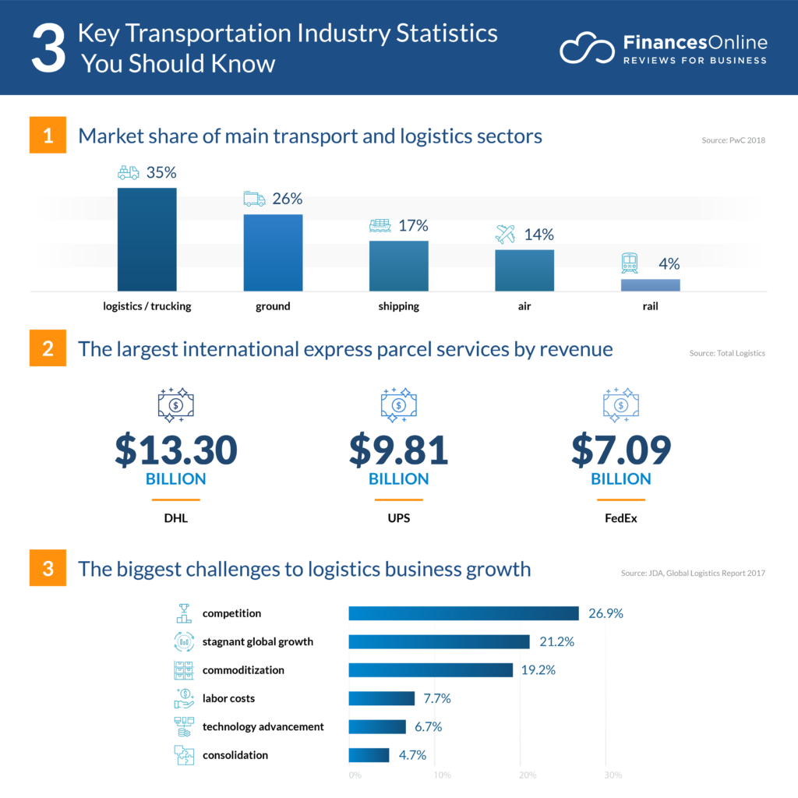

For illustration, if you are required to transport a product from your storage to a dealer, you must update the inventory in your warehouse. Furthermore, you must have entries indicating that the products have left the facility and arrived at the dealer. In the meantime, you must ensure that things are handled properly and arrive at the dealer in the target value. Whenever there are any vendor refunds, they must also be accounted for.

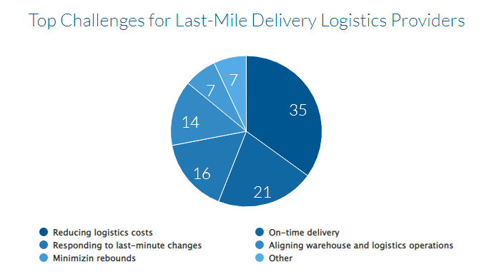

Transport breakage is responsible for 20% of all refunds. On general, the cost of replacing defective goods can indeed be equal to 17 times the cost of shipping. Surprisingly, according to (Supply & Demand Chain Executive, 2021), US consumers returned $428 billion in items in 2020. Steadily for the past delivery is responsible for the majority of delivery fees (53%), followed by collecting (37%), processing (6%), and straight carry (4%). Inside and external logistics services, in contrast side, represent for $1855.2 billion of the worldwide logistics business. Furthermore, the worldwide parcels market is valued at $349.89 billion, accounting for approximately 6% of the global logistics business. We can see from the preceding sentence that there are numerous logistics operations that must be managed. Here is the main six such logistics functions that practicing in this industry for a long period of time

## **Order fulfillment**

The distribution channels begin with transaction processing, which may be the responsibility of an organization's commercial department. The marketing division is in charge of ensuring that the billing and distribution terms are met before processing the order within the organization. Essentially, the procurement department acknowledges the purchase request and places it in the warehouse. If the consumer has paid, a company management enters the information into the system and informs the storage that the consumer has placed an order for ten items, and the warehouse must deliver ten units.

## **Material movement**

The transportation of products inside the facility is referred to as warehouse management. It entails arranging the stuff in such a method that the warehouse can process orders quickly. Although it may appear to be a routine task, it is vital and a constant activity in every warehouse. Organizing application of existing within the warehouse to enable for smooth transportation and shipment is an essential matter in logistics management. This becomes increasingly crucial as the warehouse expands in size. Amazon, for instance, uses a blend of robotics, artificial intelligence, and people for goods handling. Amazon is projected to dispatch 16 lakh packages per day. This equates to 70,000 packets per hour.

## **Warehousing**

The main thing to remember about warehousing is that the facility should be close to the dealership or distributor's location and should allow for easy shipment of goods. If a commodity from a recognized firm takes one week to provide, it may not shift as quickly on the industry as a goods from an inferior quality company that takes two days to deliver.

As a result, it stands to reason for the trademark company to have a nearby warehouse so that the goods can be delivered quickly.

## **Transportation**

# The practical conveyance of goods from the corporation to the wholesaler or dealership, as well as from dealer to the final client, is referred to as transportation. Companies are often only involved until the distributor or dealer receives the product. The supplier is then in charge of delivering the product to the end user. However, distribution is an expense to the dealer as well and diminishes his profit, so the corporation must offer the dealer more profits to offset his expenditures.

On this occasion, the best option to promote the idea of business information and maintain the quality of service by creating a platform in the form of a mobile application to provide a service of control and timely delivery of goods may be quite appropriate with the current status of the market and its leaky circumstances, which greatly affects the domestic economy of the country.

**New BIS development**

Trucking software is a form of freight forwarding technology that assists shipping companies in managing their regular operations and increasing efficiency by integrating all business components into a single system. Although such software is specifically built for carriers, some features can also be utilized by other relevant groups in the transport carrying process, such as brokers, shippers, manufacturers, and other associated workers.

Trucking system, like any other management systems, is designed to decrease manual efforts, optimize processes, integrate files, and decrease potential mistakes. Managing a trucking company entails the following processes: dispatching, routing, fuel management, safety and equipment control, and accountancy. The routine problems of the trucking industry are comparable for both large corporations with large fleets and owner-operators with a single truck. Nevertheless, each trucking company's unique circumstances may necessitate various methods and strategies. The issues that arise, and how technology addresses industry-specific concerns will be taken into account in report.

## **The dispatch procedure and its major challenges**

In this circumstance, the offered and related to tracking sphere idea included the entire functional system work that guide with periodic update and approval with all trucking divisions. One of the most significant departments is dispatch operations, which coordinates freight movement and organizes loads, clients, trucks, and drivers into a single timetable. Dispatching is intertwined with all other elements in some way.

Identifying freight channels, gathering all the facts and specifications on the loads, connecting shippers and receivers, organizing pickup and drop-off time frames, and so on are all components of planning and coordinating loading and delivery. However, in this profession, anything can happen at any time.

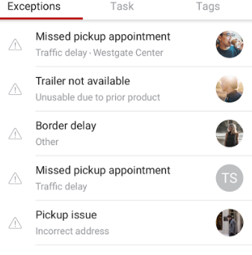  
  
  
  
  
  
  
  
  
  
  
  
  
Trucks break down and need to be serviced, loads are postponed or rescheduled, and road and weather cause delays. There are simply too many variables to keep track of with a document and a pen.  
  
  
  
  
  
  
  
  
  
  
Dealing with clients and maintaining contact with them is comparable to the preceding one in that it necessitates regular communication with all relevant parties. This includes contacting with ETAs, informing them of potential changes in the schedule, arranging for potential detainment, and so on. If you have a large fleet and don't use software, your dispatchers will most likely spend the majority of their time on the phone, trying to gather updates from drivers and telling customers about all of those changes.

Adding specific drivers entails constructing the most organizational skills possible, minimizing deadheads, ensuring that all drivers are working, taking into account their preferences, in addition to their vehicle model and possible house of service (HOS).

Managing paperwork including such payment approvals, trip papers, bills of lading, and even invoicing is an important element of a dispatcher's job that necessitates a high level of attention and precision. Manual data entry is always error-prone, and stacks of paper make it difficult much more. Furthermore, without a software program, gathering data from various sources to create required documentation is nearly impossible.



Paper documents while using this technology need to be printed; instead, they may be produced, e-signed, and forwarded directly from the system with a few mouse clicks. The development and exchange of digital documents saves time and reduces inaccuracies resulting from manual involvement.

Also, when selecting a trucking platform, ensure that dispatchers can readily identify the available vehicles that meet the specifications of the given cargo as well as their present location. This allows dispatchers to distribute vehicles based on the driver's HOS. Furthermore, some services advise the next load for the driver based on their location and accessible hours. Alternatively, based on how your organization functions, drivers will receive instant updates if company has a sufficient load near their location.

**New industrial and internal business environment analysis**

Trucking and logistics applications have the ability to make the trucking sector more productive than ever before by directly satisfying customer desires for packaged services. It removes the need for an intermediary between shippers and drivers while reducing related costs and the time required to transport and receive products.  Intelligent truck dispatch software offers a sophisticated transportation management platform to shippers, drivers, and carriers to optimize logistics and increase overall efficiency. It helps truckers and logistics companies, as well as startups, automate and scale their operations.

**Conclusion**

Global commerce and complexity characterize the logistics sector. Worldwide supply chains, the availability and timing of products, and the locations that companies select to locate their operations are all impacted by logistical factors. Every economy depends on it, and in the years to come, it is predicted to expand both in size and importance. Any business will continue to grow as long as logistics trends continue. Improvements in the logistics are already shaping the way we live and work for future generations. These factors are just one example of how logistics industry is essential to our global market and economy.

**Executive summary**

The term "logistics" describes the total process of controlling the acquisition, storage, and delivery of goods to their intended location. The logistics industry is divided into three types: air logistics, trucking logistics and water. In this report, the idea will be studied and substituted for trucking logistics. Choosing potential distributors and suppliers and evaluating their efficiency and availability are all part of logistics management. In the last decades, logistics industry has changed a lot. The logistics has advanced even further into the future, bringing with it a completely new perspective on how we transfer products and resources around the world. Artificial intelligence and machine learning are now having a significant impact on the field of logistics. These technologies are being used by several logistics companies to improve order management and precise forecast. Thanks to these and other technological developments, the supply chain has been able to flourish around the world. However, some difficulties also occur during the working process in this industry. Failures are inevitable in the logistics supply chain since it has so many components between production and transportation. Due to the numerous possible points where communication might fail, it can be challenging to identify and prevent potential problems. This problem can be solved with efficient software communication and control systems, frequently linked to warehouse management systems and connection with customers and other stakeholders. Problems are easier to fix before they turn into real trouble, when everyone engaged, even including clients waiting for a shipment, has access to the item as it progresses through the different phases of production and distribution. No matter how hard the logistic company try to keep the warehouses and distribution centers functioning without a hitch, errors can still happen. Simple mistakes may be expensive if they are not controlled, whether it be a misplaced product, picking, packaging, problems with delivery, missing orders, or damaged goods in the storage. Making sure that warehouse personnel are well-educated and that regulations clearly indicate where and how items should be treated, which also reduces the possibility of damage or mistake. In addition, having access to the appropriate technology is crucial when looking for solutions to typical logistical issues. To ensure the highest visibility, continual communication, real-time response, and efficient warehouse management, the logistics industry is constantly developing and implementing new kinds of technology and software The solution to practically any logistical issue is to apply various types of technology supervision.

**Reference List**

FutureLearn (2021). *Explore the logistics industry | How to get a job in logistics*. [online] FutureLearn. Available at: https://www.futurelearn.com/info/blog/explore-logistics-industry [Accessed 15 Oct. 2022].

Published by Statista Research Department and 15, J. (2022). Leading U.S. ports by TEU. *Statista*. Available from https://www.statista.com/statistics/1265024/leading-us-ports-by-teu/ [Accessed 15 October 2022].

Placek, M. (2022). Leading logistics companies in U.S. by net revenue 2021. *Statista*. Available from https://www.statista.com/statistics/184538/20-leading-us-logistics-companies-by-net-revenue/ [Accessed 15 October 2022].

How many trucking companies are in the US: Policy advice (no date). *How Many Trucking Companies Are In The US | Policy Advice | Policy Advice*. Available from https://policyadvice.net/insurance/insights/how-many-trucking-companies-in-the-us/ [Accessed 15 October 2022].

Placek, M. (2022). U.S. trucking industry: Total revenue 2014-2020. *Statista*. Available from https://www.statista.com/statistics/922817/trucking-industry-united-states-total-revenue/ [Accessed 15 October 2022].

Banks, M. (2021). Most common issues of semi trucks. *Modded*. Modded. Available from https://modded.com/most-common-issues-of-semi-trucks/ [Accessed 15 October 2022].

Working Party No. 2 on competition and regulation (no date). Available from https://www.ftc.gov/sites/default/files/attachments/us-submissions-oecd-and-other-international-competition-fora/1110excessivepricesus.pdf [Accessed 15 October 2022].

The benefits of Logistics Clustering Reivera Gligor sheffi (no date). Available from https://sheffi.mit.edu/sites/sheffi.mit.edu/files/2017-05/IJPDLM-10-2014-0243%20The%20Benefits%20of%20Logistics%20Clustering%20Reivera%20Gligor%20Sheffi_0.pdf [Accessed 15 October 2022].