**COURSEWORK SUBMISSION FORM** distribution of administration roles

|  |  |  |  |
| --- | --- | --- | --- |
| **STUDENT USE** | | **STAFF USE** | |
| Module Name | Developing Digital Enterprise | First Marker’s  (acts as signature) |  |
| Module Code | 6COSC013C-n - | Second Marker’s  (acts as signature) |  |
| Lecturer Name | Jakhongir Karimov | Agreed Mark |  |
| UoW Student IDs |  | **For Registrar’s office use only (hard copy submission)** | |
| WIUT Student IDs | 00010833 |
| Deadline Date | 01.12.2022 |
| Assignment Type | ☐ Group ☑ Individual |
| Word Count | 2239 |

**SUBMISSION INSTRUCTIONS**

**COURSEWORKS *must* be submitted in *both* HARD COPY (to the Registrar’s Office) *and* ELECTRONIC unless instructed otherwise.**

For hardcopy submission instructions refer to: <http://intranet.wiut.uz/Shared%20Documents/Forms/AllItems.aspx> - Coursework hard copy

submission instructions.doc

For online submission instructions refer to: <http://intranet.wiut.uz/Shared%20Documents/Forms/AllItems.aspx> - Coursework online submission instructions.doc

|  |
| --- |
|  |

**Executive summary**

The report that was previously delivered is directly continued in this report. If a recommendation for BIS solutions was made in the previous report, this one contains a full examination and a step-by-step execution of such solutions in business. The company for whom these solutions will be used is in the trucking logistics industry. A thorough BPMN 2.0 model of the whole business process, from product sourcing and production to consumer purchase, is included in this study. The design of the suggested solutions was also built with an eye on how users and staff would interact with them and how they would function internally. Moreover, the study addresses legal issues with the suggested fixes. The potential risks associated with usage are recognized, and strategies to prevent problems from occurring are suggested. Lastly, a digital project plan and a Gantt chart were created, which helped to determine all the due dates for specific activities.

**Table of contents**

**Introduction3**

**Business Process Model and Notation (BPMN)4**

**IT architecture model6**

**Legal consideration7**

**Risk management plan8**

**Digital project implementation plan10**

**Conclusion12**

**Reference list 13**

**Introduction**

Most industrialized countries rely on trucks for commercial transportation. Having the proper logistics can help companies achieve success, and it can also contribute to the nation's economy. According to economists, transportation is a very expensive expense for any business, and having the right logistics can help decrease the overall costs of doing business. Having the proper planning can help companies avoid unnecessary expenditures. For instance, trucking logistics can analyze routes to find ways to improve efficiency. The precise types of loads that are being transported are also taken into account to determine the best method of transportation. Road safety is also a major concern when it comes to transporting goods. Having the proper logistics can help companies avoid accidents and ensure the safety of both the drivers and the commuters. One of the most challenging aspects of transportation is long-haul trucking. Having the right logistics can help companies handle this type of transport.

An entirely new viewpoint on how we distribute goods and resources globally has emerged as logistics have evolved even further into the future. Now, machine learning and artificial intelligence are significantly changing the logistics industry. A type of freight forwarding technology known as trucking software helps shipping businesses manage their daily operations and boost productivity by unifying all aspects of their operations into a single system. Although such software is designed particularly for carriers, other key organizations in the transport carrying process, such as brokers, shippers, manufacturers, and other related employees, can also make use of some functions. Like other management systems, the trucking system is intended to save manual labor, streamline procedures, consolidate files, and reduce errors. The following procedures are involved in running a trucking company: dispatching, routing, fuel management, safety and equipment control, and accounting. Owner-operators with a single vehicle and major enterprises with extensive fleets both face the same common issues in the trucking industry. Nevertheless, the particular conditions faced by each trucking firm may call for a different approach. The study will consider the problems that develop and how technology responds to difficulties that are particular to a certain sector.

**Business Process Model and Notation (BPMN)**

A graphical notation for describing business processes in a business process diagram is provided by the Business Process Model and Notation (BPMN) specification. By offering a common notation that is understandable to business users while representing sophisticated process semantics to technical users, it aims to facilitate business process modeling. The de facto standard for business process diagrams is Business Process Modeling Notation. It is meant to be utilized directly by the parties involved in designing, managing, and implementing business processes while also being accurate enough to enable the conversion of BPMN diagrams into software process components. BPMN offers an intuitive syntax that resembles a flowchart and is agnostic of any specific implementation environment.

BPMN

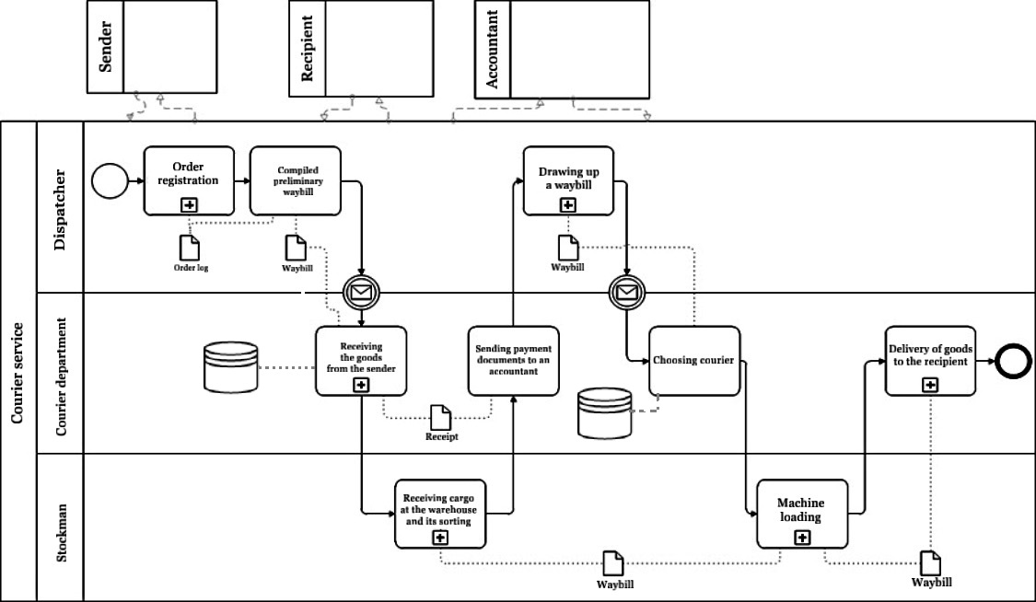

The following business process categories are frequently defined:

* Procedures involved in production and distribution that profit a business system;
* Providing efficient planning and income generating management throughout production distribution implementation through planning and management methods;
* Resource procedures that offer production distribution and storage at a location where an activity is being carried out directly;
* Processes of enhancement that are secondary to and essential for modifying existing technology (i.e. business process optimization, reengineering, redesign and other improvements).

According to consultancy experience, logistic chains' primary business procedures are as follows:

* Management of production;
* Vendors delivering their merchandise;
* Stock management in the warehouse;
* Delivery of products to departments, stores, individual retail shops, and representative offices;
* Management of production handling;
* Optimization of business operations.

Within the confines of the logistic service's operational procedures, the following fundamental goals are carried out:

* The time of cargo being received and sent;
* Examination of data pertaining to transfer businesses;
* Dealing with transfer businesses in negotiations;
* Defining the ideal delivery routes for items;
* The cost of transportation is calculated;
* The creation of an itinerary map;
* Planning the manufacturing delivery system;
* Offering to receive and store items in a company's warehouse; offering to send goods out of a company's warehouse;
* Notifying trade associations and representative offices of the anticipated arrival time;
* Orders being accepted;
* Control over the package at every point.

By maximizing both performance and costs throughout the whole firm, a well-run external logistics function enhances the efficiency of the entire supply chain. By improving the effectiveness and costs of some internal procedures throughout the whole firm, a well-run internal logistics department boosts the performance of the organization, although on a smaller scale.

**IT architecture model**

**Enterprise Service Bus (ESB)**

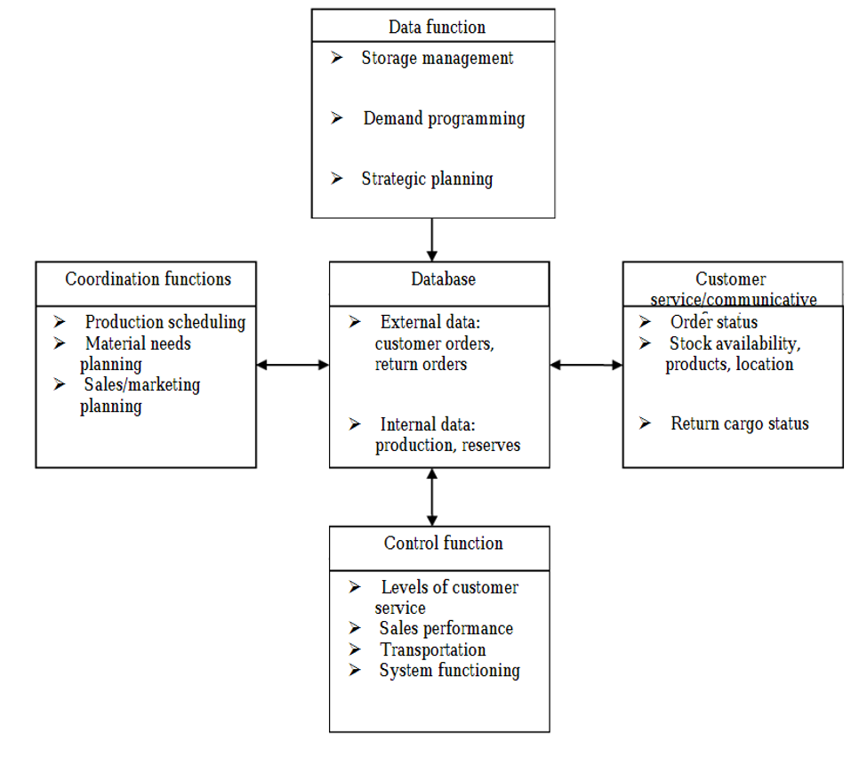

IT architecture refers to the framework of a software-based system, as well as the characteristics of those elements that are visible from the outside and how they interact. Software architecture is organized into perspectives, which are comparable to the many forms of building architectural plans. For the diagram above the Enterprise Service Bus was used. Middleware based on SOA is known as ESB. Its foundation is made up of event pipelines, service users, and network operators. The Enterprise Service Bus, or event bus, is created by service providers who then publish events to it. Those who use services participate in events that interest them. Asynchronous and synchronous event flows are both supported by the ESB. ESB has a variety of functions that are necessary while messages are being transmitted over it. It involves payload enhancement, service orchestration, message transformation, and protocol conversion. All ESB implementations from various manufacturers have access to these functionalities right now. The integration of the solution with many corporate platforms is beneficial.

All of the aforementioned features could be used if it had a single common database. The logistics information system, which often does not operate independently but is connected with the corporate management framework, may include any of the aforementioned tasks. The logistics information system is divided into many subsystems, such as those that gather, process, store, and support decisions. The information-gathering subsystem's primary duty is to keep an eye on the business's surroundings and internal operations in order to obtain data that is essential for making logistics-related choices. The information-gathering subsystem's primary duty is to check up on the business's surroundings and internal operations in order to obtain data that is essential for making logistics-related choices. The reports on the status of the logistics system and the implementation of logistical procedures are other important sources of information. They offer data on, among other things, sales trends and predictions, logistics expenses, inventories, orders, purchases, and logistics schedules.

**Legal consideration**

The richness of data gathered from clients and other stakeholders throughout the supply chain is the foundation of any successful logistics activities, which eventually results in greater efficiency and lower lead times. Since many businesses are currently undergoing digital transformation, the majority of sensitive customer information, including delivery addresses, purchase histories, and other confidential info, is stored on internal or external cloud-based systems. New rules and legislation have been passed to police data privacy, including the EU's General Data Protection Regulation (GDPR), Australia's updated Australia Privacy Act, and Japan's Personal Information Protection Act (PIPA). Organizations also have the added duty of making sure that all consumer data is collected and used properly; this is a challenging task considering the volume of data that moves across the logistics supply chain. In the industry, processing data, especially personal data, is essential to corporate operations. More than ever, logistics managers feel a growing need to directly grasp data privacy laws and regulations, as well as to be aware of how these laws affect their day-to-day operations. The day when an IT or legal professional was solely responsible for data protection is long gone. The logistics sector's stakeholders all have a part to play in ensuring the privacy of its clients, staff, and business partners.

Although there are minimal universal norms that apply worldwide, it is important to remember that each nation or area is different and its laws might vary greatly. Particularly, there must be a legal basis for data subjects, and it must be done so transparently and only for the purposes for which they were collected. In addition, safeguards must be in place to guarantee the security of data and the rights of personal information, among other factors.

Depending on the country's laws, there are several ways to gain data subjects' permission. Depending on the situation, some nations have severe regulations governing the proper form of consent, while other nations have no laws addressing consent needs at all.

The term "processing" of data is defined differently according to country laws and regulations. This may be confusing, especially when personal data is transferred across international borders. As it might include a diverse range of processes involving personal data, such as handling, gathering, recording, storing, or deleting, data processing can be a broad notion.

**Risk management plan**

Project management has a branch called risk management that deals with controlling possible hazards. Undoubtedly, one of the most crucial elements of project management is risk management. These are the primary steps in the risk management process:

Risk Identification: Identifying project hazards is the first step in managing them. To evaluate all the potential risks that might have an influence on your project, you'll need to leverage data sources like details from previous projects or the views of subject matter experts.

Risk assessment: After identifying your project's hazards, you must rank them according to their likelihood and severity.

Risk Mitigation: To control the risks associated with your project, it is now time to develop a contingency plan containing risk mitigation measure. You must also specify which team members will serve as risk owners and be in charge of managing risks.

Risk Monitoring: In order to be controlled, risks must be tracked throughout the course of a project.

A risk management plan outlines the steps that will be taken to carry out the project's risk management procedure. This covers the resources, equipment, and strategies that will be applied to the tasks involved in risk detection, assessment, management, and tracking.

Legal risks occur when the supplier is unable to fulfill the terms of the contract or when there are disagreements over those clauses. The privacy of the information, claim processes, the parties' shared connection, severability, and other issues are only a few of the frequent terms and conditions specified in the contract. Such phrases are frequently interpreted incorrectly, leading to conflicts that go to court.

Software is designed to make a firm stronger, more efficient, and more rapid. Unintentionally, this might lead to organizational mindsets that can only think in ways that the program permits. This might indicate that supply chain employees invest a lot of effort into entering data into the system yet have trouble extracting the data they require to make wise business choices. Making strong alliances with important partners and suppliers is one way to make sure of this. Working with the best in the business allows an organization to learn about new systems and technologies without having to take the risk of investing in them before being certain that the investment will be worthwhile.

The risks involved in international logistics are ever-changing and are clearly acknowledged in financial or public statements, which can escalate small hiccups into board-level disputes. Every year, businesses confront fresh difficulties and unforeseen dangers like COVID-19. This is why it's critical to reassess risks and reevaluate the adopted plan. Firms may now react to their networks and fight to safeguard their bottom line thanks to the intelligence given by supply chain management businesses.

|  |  |  |  |  |  |  |  |  |  |
| --- | --- | --- | --- | --- | --- | --- | --- | --- | --- |
| Risk Priority | Risk  Name | Risk Category | Description | Probability of occurrence | Level of damage (%) | Level of severity | Action | Responsible for action | Risk management cost |
| A | Operational mistakes | Technical | The server is under stress during periods of high activity | Medium | 70% | High influence | Evaluation and the assignment of a new server | IT department | ~$600 |
| B | Program leak | Information safety | Internal software is distributed by staff | Medium | 65% | Significant influence | Creating a confidential contract for software | IT department, Legal department | ~$350 |
| B | Private data leak | Information privacy | Executives utilize data for reasons unrelated to the business's operations | Medium | 80% | Critical influence | ensuring that staff follow corporate regulations and standards while enforcing best practices for cybersecurity | IT department,  HR department | ~$1000 |
| C | Accidents by workers | Operational problems | Losing important files or documents, sending email to the wrong person etc. | Low | 35% | Slight influence | Verification of all data and fix the problem through the network | IT department | ~$0 |

**Digital project implementation plan**

Implementation strategies include detailed directions for anything from online marketing efforts to putting an end to hunger in rural areas. They are employed to translate theoretical ideas included in strategy plans into practical actions. The main drawback is that carrying out implementation strategies might be difficult. BPMN, or business process modeling notation, is a method that enable to visually depict your processes using more than 100 unique items. A strategic plan, often known as a project implementation plan, combines strategy, method, and action. It describes the measures a team will take to accomplish a common goal. A project's budget, timing, and staff are all included in the implementation plan.

An ideal project plan would contain:

* Goals and prerequisites;
* Scope evaluation;
* A list of the deliverables;
* Task deadlines;
* Scheduling;
* Risk evaluation;
* Plans for managing stakeholders, teams, and processes;
* Roles and duties of team members;
* Resource administration;
* Tools for communication.

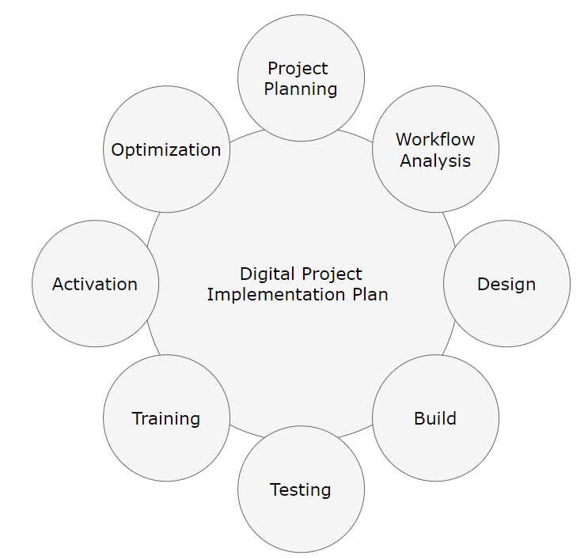

Implementation plans are made by project managers. To add crucial details, they could decide to work together with the team heads, subject matter experts, suppliers, and stakeholders. However, project managers are in charge of creating, amending, and continuously overseeing implementation plans.

**Conclusion**

As a result of the deployment of the suggested BIS solutions, this report covers the full business process. The execution of the whole business model using functional BIS solutions is covered in this study. IT architecture that demonstrates in detail how solutions will operate both within and outside the program. The report also considers any potential legal repercussions that may result from using these BIS solutions, as well as certain dangers and strategies to mitigate them. Following a thorough study, the report suggests a plan for implementing these BIS solutions together with a Gantt chart that will let the company schedule each activity according to its allotted time.

**Reference list**

Ariyarathne, J. (2019). *What do you really need within your integration solution? ESB or Microservices?* [online] Medium. Available at: https://medium.com/@jagathsisira/what-do-you-really-need-within-your-integration-solution-esb-or-microservices-1552d9803cb4 [Accessed 20 Nov. 2022].

bpmn.io. (n.d.). *Web-based tooling for BPMN, DMN and CMMN | bpmn.io*. [online] Available at: https://bpmn.io/ [Accessed 20 Nov. 2022].

Draw.io (n.d.). *Flowchart Maker & Online Diagram Software*. [online] app.diagrams.net. Available at: https://app.diagrams.net/ [Accessed 20 Nov. 2022].

lot.dhl.com. (2019). *As supply chains undergo rapid digitalization, data protection has emerged as a key challenge for the logistics sector. | DHL Logistics of Things*. [online] Available at: https://lot.dhl.com/data-protection-and-its-legal-implications-on-logistics/ [Accessed 20 Nov. 2022].

parcelindustry.com. (2007). *What the Heck Is Internal Logistics?* [online] Available at: https://parcelindustry.com/article-773-What-the-Heck-Is-Internal-Logistics.html [Accessed 20 Nov. 2022].

Scavetta, A. (2019). *How to Make a Risk Management Plan*. [online] ProjectManager.com. Available at: https://www.projectmanager.com/blog/risk-management-plan [Accessed 20 Nov. 2022].

Soosay, C., Ferrer, M., Santa, R. and Hyland, P. (n.d.). *INTERNAL AND EXTERNAL INTEGRATION: STRATEGIES FOR LOGISTICS COMPETITIVENESS*. [online] Available at: https://www.anzam.org/wp-content/uploads/pdf-manager/1996_SOOSAYCLAUDE_272.PDF [Accessed 20 Nov. 2022].

Strasser, K. (2022). *What is Trucking Logistics? (with pictures)*. [online] About Mechanics. Available at: https://www.aboutmechanics.com/what-is-trucking-logistics.htm.

SVadmin (2021). *What is software architecture model?* [online] Special Project. Available at: https://powerpointmaniac.com/other/what-is-software-architecture-model.html?ysclid=lb5ci7e3pr335447407 [Accessed 20 Nov. 2022].

Waida, M. (2022). The Ultimate Guide to Implementation Plans. *wrike*. Available at: https://www.wrike.com/blog/implementation-plan-ultimate-guide/?ysclid=lb55qtvt3f379045578 [Accessed 20 Nov. 2022].

Wojno, R. (2021). The complete guide to business process modeling (BPM). *mondayblog*. Available at: https://monday.com/blog/project-management/business-process-modeling/ [Accessed 20 Nov. 2022].