***“GLOW UP”***

***WEB APPLICATION***

*A project undertaken as part of BSc (Hons) Business Information Systems Degree, Westminster International University in Tashkent*

*Student: Gaybullaeva Diyora*

*Email:* [*idaory19@gmail.com*](mailto:idaory19@gmail.com)

*Course: Business Information system*

*Submission date: 7/04/2023*

*Supervisor: Shirin Primkulova*

Contents

Abstract 2

Introduction 3

Problem overview 4

Literature review 5

Market analysis 6

Project objectives 7

Business Methodology 10

Methodology Computing 14

**Target audience** 18

Business plan 19

Competitor analysis 20

Products 21

Supplier 21

Attracting customers 22

4P’s analysis 23

SWOT Analysis 24

Strengths 24

Weaknesses 24

Opportunities 24

Threats 24

PESTLE analysis 25

Economic 25

Technological 25

Legal 26

Environmental 26

Monetization 26

Further improvements 29

Improving landing pages 29

Call to action 29

Calling from the site 29

Control the statistics of exits from the site 29

Increase website traffic 29

Conclusion 30

Bibliography 31

# Abstract

The Internet has evolved into a contemporary media shop where customers can make purchases and combine display, catalogue, and mail order. Customers may browse goods, evaluate sizes and pricing online, and place orders without ever leaving the website. Governments may enhance the competitive environment and chances for economic growth, according to David Dean and Dominic Field, authors of a BCG study. E-commerce unites all websites and services that accept payments online. It starts out by including online merchants that take credit cards. In actuality, e-commerce encompasses not only commercial or financial transactions carried out across networks but also the networks of international business procedures used to carry out such transactions. E-commerce offers enormous opportunities for the development of one's business. However, in order to use it effectively, it is not enough to be a talented entrepreneur, just as it is not enough to know how to navigate the boundless virtual space. It is also necessary to have a number of high-tech tools for running an e-business. In our current world, there are things that are always needed in daily life. People will eat, drink, wear clothes and shoes in any economic situation and in any season. That is why there are several win-win options among business ideas. An online store is a great solution for first-time entrepreneurs, because at the initial stage it requires virtually no investment. As a result, it can make no less profit, and sometimes even much more than regular stores, but before entrepreneur make a profit, he/she first have to work very hard on the site. An e-shop is an intermediary between the buyer and the manufacturer's warehouse, which only needs a resource on the Internet and a telephone. A virtual store does not need a representative office, storage space, does not incur expenses for maintenance of premises, the store owner can manage sales even from his apartment. That is why prices in such stores are minimal. Purchased items are delivered to the consumer directly from the manufacturer's warehouse.

# Introduction

The world of technology is constantly evolving. There is no longer a need to spend hours looking for the right thing in stores. If person have a computer, laptop, tablet or smartphone with Internet access at home, he/she can shop from the comfort of own home. Nowadays, any product in the online stores can be found and also the search will take a minimum amount of time. Filters allow a user to select the necessary things in a matter of seconds. It is not even necessary to go for them, if the store provides a courier delivery. No wonder that the popularity of online shopping is increasing every year. In the West, the convenience and numerous benefits of online shopping have long been appreciated. In Uzbekistan, too, online shopping has been growing in popularity in recent years. There was a particularly sharp jump during the pandemic, when some stores were simply closed, others were restricted, and people were afraid to leave their homes unnecessarily. Moreover, growth was observed in all segments of commerce. It was during this period that customers fully appreciated the advantages of online shopping, when a person can get any necessary goods without leaving home, without wasting time on the road and without standing in queues. Stores were also forced to adjust to the situation, develop official websites, organize a convenient delivery system so as not to lose customers and maintain turnover. Even after the restrictive measures were lifted, many people did not return to offline stores, but continued to order things and products online. E-shops are gaining more and more trust and popularity, and undoubtedly a great future awaits them.

# Problem overview

Shopping in online stores is very convenient, but in Uzbekistan not all of them can be trusted. It should not be forgotten that online shopping, in addition to the pluses, has its minuses. In order not to experience disappointment, it is necessary to remember the dangers that await buyers on the Internet. The following examples are the worst and most common experiences with online shopping in Uzbekistan according to the secondary data.

1. The risk of running into scammers. Unfortunately, the gullibility of buyers can be taken advantage of by fraudsters. There is always the risk of paying for a product and not getting it, or of getting things of inadequate quality. To minimize the risk, it's worth buying from large online stores with a high rating.
2. Problems with delivery. It can be too expensive, especially if the goods are large-sized or ordered from another city. The delivery methods offered by the store are not always suitable for customers. The pickup point may be too far from the house, and there may be no courier delivery.
3. Loss of a parcel. Even ordering from verified online stores will not save you from this trouble. It's not always the seller's fault. The carrier may also be to blame, but looking for lost cargo, especially if it has already been paid for, and wasting time on it is in any case unpleasant.
4. Damaged goods in transit. Crumpled or torn packaging, damaged fragile items, or goods that do not meet customer requirements. Unfortunately, this is not uncommon. It is especially unpleasant if the goods were purchased as a gift.
5. Difficulties with returns. The ordered goods may not fit for any reason, or they may be faulty. Then a customer will have to return the product or maybe even pay for its delivery back to the warehouse.
6. Poor service. As in a regular store, when shopping online a user may encounter poor service. After all, orders are placed by the manager. It is not always quick to process an application, place an order, or answer buyers' questions in a timely manner. Mistakes occur in the assembly of an order, when they can put a thing of a different article, size or colour.

# Literature review

The Internet sector is expanding in the 21st century. Businesses that use the Internet for business purposes, such as interacting with consumers and suppliers, are selling their products online and seeing faster economic growth. With 8.5% of GDP ($2.3 trillion), the U.K. economy accounts for the largest share of global e-commerce. The online shopping market share in the U.K. was 13.5% in 2010 and is projected to increase to 23% by 2016. The online sector has outpaced industries such as construction, education and healthcare in its contribution to the UK economy. The explosive growth of the UK Internet economy serves as an excellent barometer for small and medium-sized firms in the industry. BCG (Boston Consulting Group) study indicates that over the last three years, the revenues of businesses that use the Internet in their operations have increased by 12.5% yearly. Leading the Internet economy were countries like South Korea (7.3% of GDP), China (5.5% of GDP), Japan (4.7% of GDP), and the United States (4.7% of GDP). Economic growth is significantly influenced by the Internet. The Internet has transformed marketing and services, using its special skills to expand geographic boundaries, target online audiences, and create business partnerships with partners. Small and medium-sized firms are benefiting from the high productivity of the Internet, new sales and service channels, and modern business practices. The Internet has a significant impact on organizational productivity because it makes communication easier, accelerates and automates many corporate operations, and lowers transaction costs. Also, the Internet offers clients the widest possible access, which helps many businesses optimize their sales channels and logistics. The Boston Consulting Group forecasts that in the global Internet economy, businesses who master the "new Web's" technologies are going to gain major edge, including:

1) A new user paradigm for Online resources is the mobile Internet. The internet connectivity through mobile devices becomes commonplace, fixed access will no longer be the decisive criterion for access to the online;

2) "The web becomes everything" - IDC expects that the number of smartphones sold each year will exceed 1.5 billion. They will enable ubiquitous network connection, endangering established sectors and perhaps altering fundamentally how consumers and businesses behave;

3) Ecosystem - initially it concerned only the infrastructure of Apple, now their own ecosystems are forming other large companies, including Amazon, Facebook, Coogle in the U.S., the Chinese Baidu and Tencent, the Russian Yandex, etc.;

4) The global Internet economy will develop to a value of more than 5.5 trillion dollars due to investments in the network and the creation of new employment, putting conventional economies under additional pressure;

5) Internet use for daily purposes – The Internet is a need in daily life;

6) the birth of a new Internet generation, which will bring with it new expectations and ways of thinking and have an immediate influence on business and society as a whole;

As a result, businesses that want to lead in the modern digital economy must radically alter and adapt their business models. Considering the rate of change, many companies will have to forsake long-term and cyclical planning in favour of a rigorous examination of the "Internet economy," weighing the pace and scope of its influence against their own strengths and skills. By 2040, up to 95% of all purchases will be conducted online, predicts Nasdaq. Global trends in the development of e-commerce include:

Conscious consumption (eco-friendly recyclable goods as opposed to disposable ones);

Seamless (omni-channel) shopping;

Implementation of augmented and virtual reality;

"Invisible" payments and payments by sight.

In other words, retailers work to make shopping not just convenient and pleasant, but also enjoyable.

# Market analysis

In 2022, the online market in Uzbekistan had a value of around $1 billion, with a $2.36 average check. In Uzbekistan, there are now over 9.6 million active internet users. On average of 46 purchases totalling $109 were done by one user each month. The research firm XResearch ECOM carried out an investigation on internet shopping brand awareness in Uzbekistan. The main services, OLX, Aliexpress, and Zoodmall (Zoodpay), account for 73% of all answers, the research shows. Moreover, growth was observed in all segments of commerce. It was during this period that customers fully appreciated the advantages of online shopping, when a person can get any necessary goods without leaving home, without wasting time on the road and without standing in queues. Stores were also forced to adjust to the situation, develop official websites, organize a convenient delivery system so as not to lose customers and maintain turnover. Even after the restrictive measures were lifted, many people did not return to offline stores, but continued to order things and products online. E-shops are gaining more and more trust and popularity, and undoubtedly a great future awaits them.

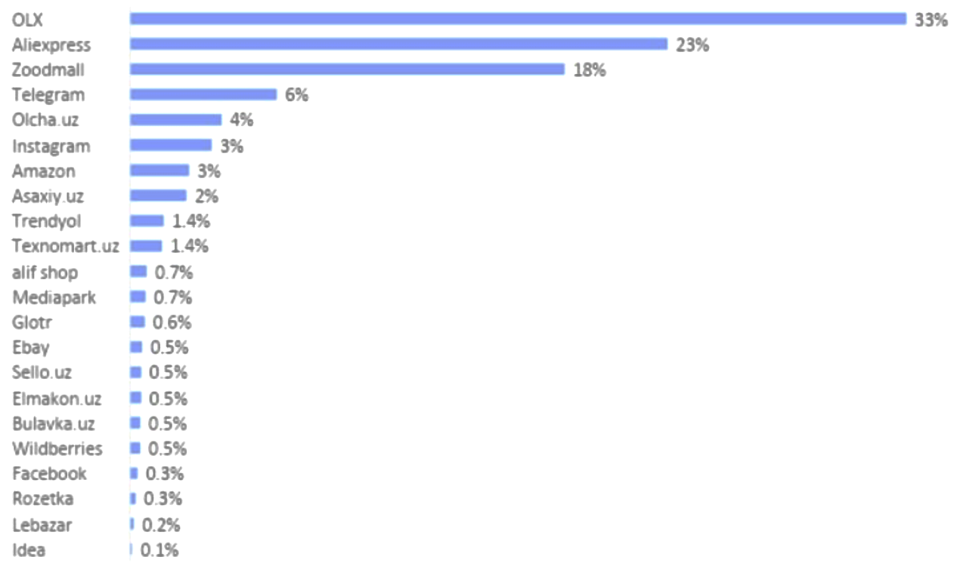

73% of respondents said they had recently made online purchases of clothing, cell phones, laptops, cosmetics, home appliances, and baby supplies. The majority of respondents are familiar with both domestic and international shopping websites, including Aliexpress (23% of responses), Amazon (3% of answers), Trendyol, and Ebay. OLX and Zoodmall are the top local websites. Several consumers mentioned that they made purchases on social media platforms including Facebook, Instagram, and Telegram.

# Project objectives

This initiative, on the other hand, is distinctive and will not be like other ordinary internet retailers. The main idea of the brand “Glow Up” is to convey to the audience that a person can glow up at any age. It will include unique characteristics such as individual fitting and selection of the correct size garments, exact delivery day, time, and location, and easy return and exchange of unsatisfactory items. To run an online store, not enough to find suppliers, have to think about the structure of the site, find a designer, coder and programmer, and choose the right CMS (Content management system). Internet-shop is a set of programs running on the website, which allow the buyer to remotely select a product from a catalogue and place his order. A multi-level hierarchical tree of subsections and categories with lists of product cards within will make up the online shop catalogue. In order for visitors to locate the range of things they want; it must be neatly organized and logical. A product card with information about the product's attributes, such as availability and cost, need to be the last stop in the catalogue navigation process. The catalogue's list is arranged according to supply levels. The list is arranged with active things at the top and withdrawn items at the bottom. The main feature of an online store is that most of the seller-buyer interaction takes place online. Many stages of buying and selling take place quite successfully remotely. This is a great advantage. However, at the same time, this is one of the difficulties that any online store has to overcome - to inspire confidence in the visitor and get him to buy. The visitor accesses the website, adds items to their shopping basket, and then places their order. If a visitor has already made purchases through “Glow Up” website, entering their login information and delivery information is sufficient. Following the selection of the delivery method, the order's total cost is calculated. The choice of payment method comes next. More over half of the population of Uzbekistan, or 22 million individuals, use remote payment systems. Typically, a transfer to the payment system's website occurs, where the user approves and pays for the transaction. The visitor returns to the website after making the payment to obtain verification of whether the payment was successful or not. If not, the option to retry or request assistance from the online shop management is typically provided. The order arrives at the post office or at the address, depending on the method of delivery selected, within the time frame indicated on the website or reported by the management. A customer may occasionally choose favourable delivery dates and hours when using a courier.

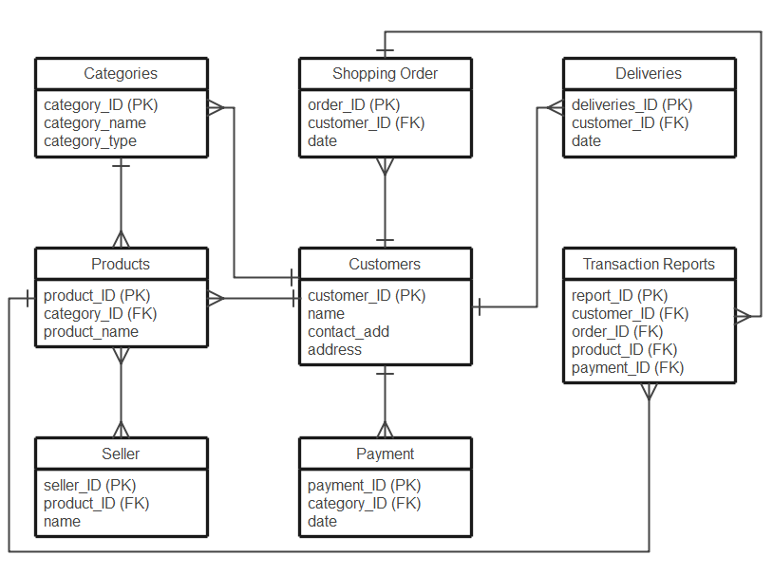

**ER diagram for Online Shopping System**

The discrepancy between the database or storage needs and the sql database that will be utilised in the database management system can be filled using an ER diagram.

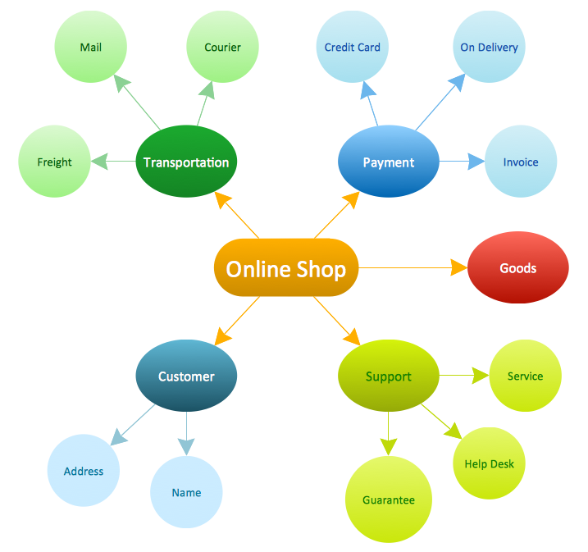

**Concept Map**

An instrument for visualising links between concepts is a concept map. It is helpful to widely refute difficult knowledge.

# Business Methodology

In this section theoretical presumptions, strategy that was utilized are explained and the results of the analysis were summarized. As already mentioned, the functionality of any online store allows the customer to view photos of the product and study its detailed specifications, description and reviews, choose the appropriate model or specification and place an order without getting off the couch. At the core of this type of project are complex server-based (executed on the server hosting the online store's executable files) and browser-based (executed in the computer's browser) software scripts which process user requests (e.g., the customer's product selection is recorded in the database, reflected in the cart) and directs them to the appropriate web pages. Thus, after choosing the appropriate items in a virtual catalogue user can proceed to the cart, if necessary, adjust the details of the order (the number of items, delivery method, etc.), after which the scripts calculate - how much it will cost to buy, what is the discount, etc., and displays information about the order, with which the user can agree to submit an order form (if necessary, immediately on the site having paid for it) or reject the order, request help desk service, etc. A great advantage over other types of sites is that the online store allows a customer to pay immediately, on the site, immediately after choosing, rather than performing only informational and representative functions. The availability of special programs, site designers, and other technical solutions makes it possible to open and run a business independently. This is relevant even for those who are far removed from the subtleties of site-building, advertising, or working with suppliers. Several trainings depict the process of launching an online clothes company as being very quick. It is feasible to create an online business in a week, but success requires resources with a well-thought-out inventory, website, and advertising strategy. The features of the online store are a complex structure, the ability to offer the most extensive range of products and the ability to sell products that are currently out of stock (drop-shipping), the ability to accept orders around the clock, the convenience of payment due to a wide choice of methods - e-money, bank card, SMS-payments, etc. Also, with e-commerce customers have the opportunity before buying to study in detail the characteristics of the product and reviews of other customers, and delivery can be ordered at any convenient time. Online store requires a significant investment in SEO activities, because the lion's share of buyers come from search engines. An effective result can be achieved by using different promotion methods, including contextual advertising, SMM, and targeting. Opening an online store offering "everything at once" is attractive since clients will be able to get everything, they need in one spot. The average check will be greater, and consumers will be more loyal. This concept is guaranteed to fail. It is difficult to advertise such a shop on their own, even with the help of multiple staff. It will need a competent staff as well as the necessary funds. Such an online clothes business is not for inexperienced young entrepreneurs. The primary procedures are to establish a sole proprietorship or LLC, create an account with a bank, engage in electronic payment systems, select and implement the shop engine, agreement with suppliers, stock the store, and deal with the courier service. Since the government has specific rules for retail firms, a legal organisation must be registered. This implies that receipts for clients and invoices for legal entities will be required. Then there are bank accounts and digital wallet. Most buyers nowadays choose to pay with a credit card or digital money. If a clients feel at ease making a payment on a website, the user is more likely to make a purchase. Paying with digital currencies is more efficient than receiving a bank receipt, hence the option should be provided on the site. What does an online store consist of? Architecturally, it looks like a backend framework, which has a documented API, and on this framework can be "put on" anything: even a website, even an application. The next step is to find a good hosting to host the site. It is worth considering reputable sites such as Bluehost, HostGator and Dreamhost, as they all offer excellent value for money. Then, choosing a content management system (CMS), such as WordPress, Magento, Shopify or WooCommerce, to host the online store. Each CMS has its pros and cons, so it is necessary to do research to see which one will work best for the specific needs. For creating “Glow Up” website Visual Studio Code software was used. Once the e-commerce platform is up and running, it's time to start adding products. There are many ways to purchase products for the store, including drop-shipping, wholesale, and private label. Now about the functionality of the internet store. The client fills out personal information, including their full name, username, password, address, email, and other details, on the page for user registration. The administrator input personal information, including Full name, Username, password, address, email, and other data, on the page for administrator enrolment. It is our responsibility to determine if the user signed in is an admin, a customer, or a vendor when they are prompted to do so on the Home Page. If the logged-in user's name is found in the customers table, then means they were a customer; otherwise, we will examine the admin table. If the password is incorrect, the website will send to a client an error page with the message "Please Input Correct Password"; from there, customer may use the back button to go back to the login form and enter the correct password. If the password is correct, the user will be redirected to the customer home page to view their own private information. If the user logs in as the administrator, they will be redirected to the admin page to view all of their permissions to handle various elements of our site (Add or Update any Department). The error message "Your Username Not Found!" is displayed if the username cannot be located. Insert the right one, please. Since the store's speciality is clothing, it's important paying attention to features like "product categories." In other words, a buyer should be able to select the colour and size of the clothing. In this situation, the price can be adjusted based on the size or colour. Additionally, it is necessary to clarify whether there is such a function as "discounts". Discounts can be varied: "sale", "discount on the quantity of goods", "discount on the order amount", etc. A complicated system can be used when a discount is given for a certain product option, such as size L, or the colour red. All of this is displayed in the product card. Not forget about the storefront. It should be attractive to the customer. Here it will be used to display items that are "in demand". That is, the block of the storefront in online storefront engine should not only be beautifully designed (here the design of the elements and the block itself), but also easy to manage, so that the products on display can be quickly and easily edited. Some people prefer to invest in a unique online store design, hoping in this way to attract more customers. But at the initial stage the wow-effect of the design is not so important. What is important is the general perception of the site - how trustworthy it is. And this, above all, the harmony of the elements, good graphics, quality photos and a decent number of product offerings. Convenient directory and clear system of movement within the site and, of course, the company's contacts. Therefore, the initial stages can begin with a simple design - templates with minor modifications - the background, menu, perhaps some blocks. After that, as the business develops, there will be a unique version of the design. Often stores use "markers" - bestseller, novelty, discount, etc. This attracts the client and allows to highlight the right product. Such markers are present in almost all modern engines and this site is no exception. The importance of marketing activities cannot be overstated because they may help increase sales. It contains "Zoom" photos, which make it easier to see a product in more detail. It also gives users the option to attach videos to the product, which is even better. Before deciding how to open an online clothing store, it is necessary to determine the method of delivery. Its quality and convenience largely determine whether the customer will want to return to the online store again. Along with payment to the courier, it is connected payment by card and e-money. As for delivery, if it's within the same city, perhaps one option will be enough - courier delivery. For delivery to other regions Mail, EMS, transport companies will do. Analytics systems are needed to obtain and analyse information about the number of visits, the behaviour of visitors to the site, etc. In the future, using this information, can be more effective promotion and in general to develop an online store. Creating and promoting an online store - a complex, multi-functional task, which can cope only with a team of experienced professionals. When registering and organizing the activities of an online store does not do without professional legal advice, and the promotion will require the assistance of experienced professionals. Creating own online store - it is the right step on the way to building a successful business.

# Methodology Computing

Agile project management is a rapid and effective method. Although it may be used to any project, this methodology was primarily developed for application development. Huge projects are divided into manageable stages using the agile methodology. A certain outcome is attained at the conclusion of each repetition. Each stage's output must be useable for input from stakeholders or consumers in the future.

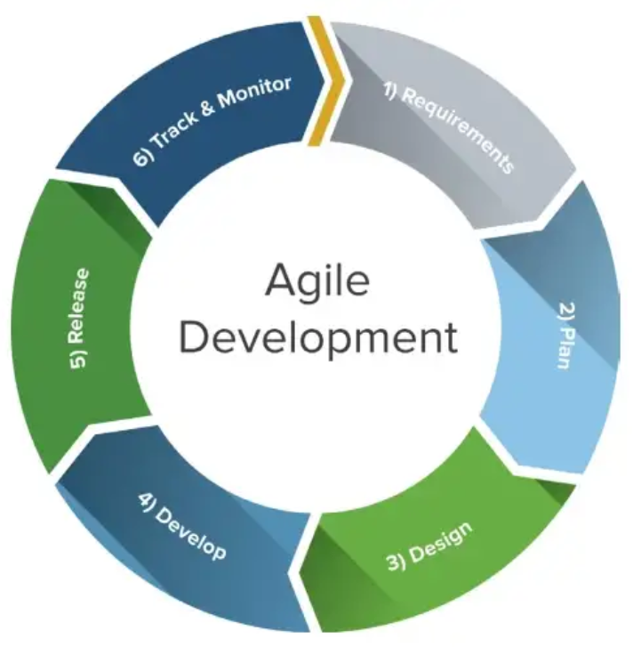

There are several agile approaches. The best procedure must be selected by the team. Each repetition repeats a brief cycle that they all adhere to. The agile development cycle's stages cannot all occur one after the other. They are adaptable, continually advancing, and several of them taking place simultaneously.

*Requirements Analysis:* Important stakeholders and users get together to develop business needs that are quantitative, pertinent, and in-depth.

*Planning:* When the idea's viability is established, the project team gathers to define the functionality, set priorities, and iterate.

*Design:* Based on the established objectives, a design is created. The team then evaluates the product's or solution's appearance and chooses testing methods or a course of action.

*Implementation or development:* Preparation for deployment iterations and feature development.

*Testing:* Testing the code to make sure the finished result truly satisfies the demands of the consumer. Unit testing, integration testing, system testing, and acceptability testing are all part of this step.

*Deployment:* The act of making a product accessible to consumers. Users may run across new issues when using the product, which the project team will need to address in following versions.

There are several distinct strategies for putting agile into practise. Only two of the most popular agile methodologies - Scrum and Kanban will be discussed.

One of the most well-liked ways to apply agile is through **Scrum**. Iterative development is a method frequently used to control the creation of complicated goods and software. The team is able to regularly deploy software thanks to fixed iterations, or sprints, that last one to two weeks. Stakeholders and team members get together to discuss the next steps after each sprint.

Stages of the Scrum process:

*Product backlog:* It means all required product features are included. At the sprint planning meeting, the product owner delivers the key backlog items for each sprint. The work is transferred from the product backlog to the sprint backlog once the team has determined what can be accomplished in the sprint.

*Backlog improvement:* The team and production manager meet at the conclusion of each sprint to make sure the product backlog is prepared for the following sprint. Assignments that are irrelevant may be removed by the team. Moreover, work that could not be finished during the prior sprint could be carried over to the subsequent sprint due to specific bottlenecks.

*Daily Scrum meetings:* They are should occur every day of the sprint at the same time and location. They last for 15 minutes. Each team member must respond to three questions: What did you do yesterday, to start? 2. What do you have planned for today? 3. Do you require assistance or are there any challenges on your path?

*Sprint meeting:* The team presents the work completed in a practical, working presentation at the conclusion of each sprint. The team reviews how Scrum is doing for them at the conclusion of each sprint and proposes adjustments for the subsequent sprint. The Sprint Retrospective is the name of this conference.

**Kanban** is the Japanese word for "visual sign." It is a visual framework for applying Agile that outlines what to produce, when to generate it, and how much to generate. You can overlay Kanban on top of existing processes since it promotes minor, gradual changes to the present system and does not require any special setup or method.

A tool for applying the Kanban approach to projects is the Kanban board. This tool typically takes the form of a physical board with magnets, plastic chips, or sticky notes. Online Kanban boards have been developed in recent years by several project management software packages. A Kanban board is made up of several rows and columns. Three columns, labelled "Running," "In Progress," and "Done," make up the simplest boards. Moreover, they could have columns for "Backlog," "Ready to Develop," "Code Development," "Testing," "Approved," and "Done."

Every Kanban project should follow these basic principles and practices:

*Workflow visualisation:* It is important because it helps people see the overall picture and how the workflow is developing. Users can spot issues early on and enhance team collaboration by making all work transparent.

*Process Management and Improvement:* The Kanban Board's work progress should be continuously observed for potential enhancements. A speedy, continuous flow demonstrates how quickly the team is adding value.

The minimum and maximum quantity of work for each board column or process is defined by the *work-in-progress (WIP)*. Setting a WIP ceiling allows for greater flexibility, speed, and less need for work prioritisation.

*Work standards that are unambiguous:* Everyone should be aware of how things operate or what constitutes "done." Make adjustments to the board to clarify these procedures.

*Constant process improvement:* It is encouraged by the Kanban technique, which favours tiny, lasting adjustments. Once the Kanban system is in place, the team will be able to see issues, comprehend them, and provide suggestions for solutions.

*Programming language*

A collection of web development methods known as AJAX, or asynchronous JavaScript and XML, uses client-side web technologies to produce asynchronous web queries. Basically, AJAX enables users to secretly exchange data with a web server while updating web pages asynchronously. As a result, it is feasible to update certain portions of a web page without having to refresh the entire page. A few of the features that have been used in this web application are shown below.

In this part, JQuery and AJAX will be used in Django templates to construct a login screen where the username's availability may be checked. For the majority of current applications, this is a pretty frequent need.

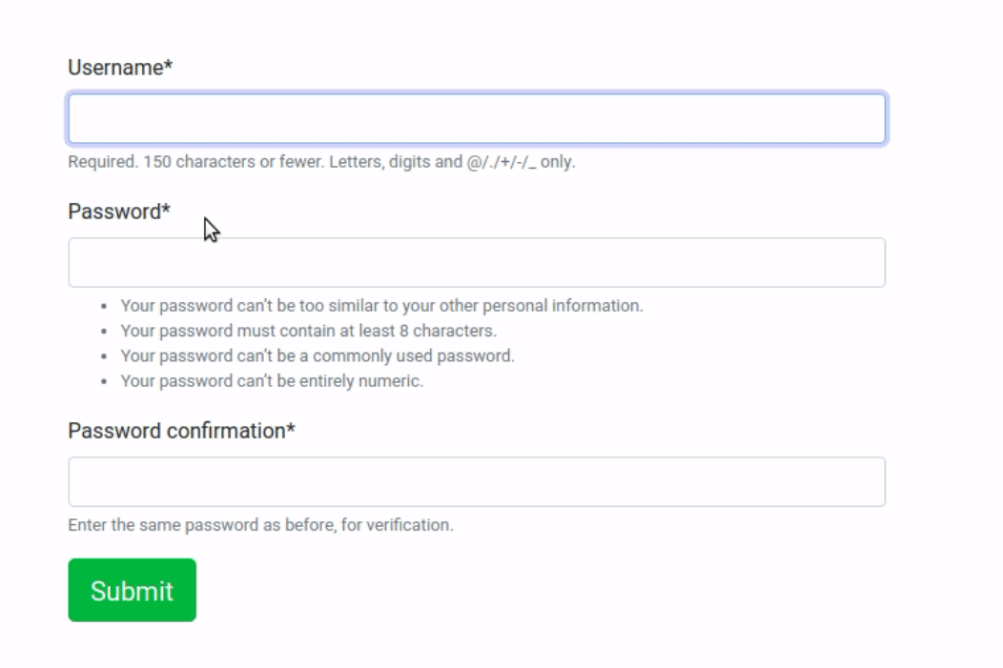

This section demonstrates how to use JQuery and AJAX to create POST requests in Django templates. To develop a contact form and store the user-provided data to the database, utilise JQuery and AJAX.



# **Target audience**

Firstly, it is necessary to determine thetarget audience. A group of potential buyers make up the target audience. These are the individuals whose needs the internet shop can handle. Many traits are frequently used to categorise all clients. Knowing the key traits and requirements will make it simple to identify the online store's target market. Group of customers have the following characteristics:

*Interest.* The customer should be interested in the product and the information about it. It is difficult to sell any product to someone who is not interested in it;

*Purchasing power.* The people to whom the advertising message is directed must have the financial means to buy the product;

*The buyer's willingness to engage in a dialogue*. Some are ready to buy here and now, others have to warm up for a long time;

*Gender, age.* Men and women of certain ages buy clothes of different models and styles;

*Education and social status.* Here clothing preferences also vary greatly;

*Occupation.* Students, mothers on maternity leave, workers from the factory - all have different tastes and preferences in clothing.

The clothes are not designed for a specific gender and age, thus making the store unique. Anyone, from students and young adults to parents to working pros, tends to use the marketplace to meet their needs. Therefore, the assortment can be suitable for teenagers from 14 years old, as well as for people aged 35 years.

# Business plan

In addition to a beautiful website that works properly and is filled with merchandise, a clear understanding is essential:

Where will the funds come from to launch and maintain the store until it breaks even;

Who will make the site and maintain it;

How the assortment will be purchased or made;

How payment processing and shipping will be handled;

Maintaining accounting records;

How will the store be promoted, where will new customers come from;

How to research the customers to make relevant offers to them;

And much more.

The next step is to draw up a business plan. A business plan is required to quantify startup expenses, evaluate firm profitability, and evaluate all potential hazards. It is essentially a how-to manual that provides information on the facts and background information needed to launch a business.

*Start-up costs*. Include all expenses related to the acquisition of goods and cash register equipment, site design, delivery, cost of warehouse rental (if required), etc. Consider the financing options offered by the banks if the startup cost is insufficient.

*Objectives.* How many sales are needed to last through three, six, a year, etc.

*Business ideas for development and promotion.* Description of how the product is going to be promoted, what ideas as to how to get the value of a product to potential customers more quickly. What channels are going to be used to attract new customers. Calculation of the advertising budget.

*Determining the approximate time to break even and make a profit.* For correct calculations, it is better to ask the experts.

The principle is based on buying together with other stores. Owners join together to buy goods from a supplier at wholesale prices rather than retail. The purchase is carried out by a special organizer, who receives a small percentage. He buys the goods, and then delivers them to partner stores. This method has a disadvantage - a great risk of defects, especially in large deliveries. But if a reliable supplier is found, then joint purchases can be very profitable. The work schemes for online stores are not complicated: the client buys the goods, and the store delivers his/her purchases to the client. However, behind this is the synchronization of deliveries, the creation of a separate warehouse, and agreements with suppliers. In addition, the site has to be optimized and new clients have to be attracted all the time.

# Competitor analysis

Moving on to the analysis of competitors. The important point is to analyse companies that are similar to "Glow Up" in terms of price range, turnover, region of delivery, and range of goods. It's important to see how the ordering process works. Placing a simple order or calling the company. Evaluating how the manager communicates, how long it takes to process the order, and what the delivery time is. To write in social networks with a question, and watching how the manager arranges a dialog, etc. Studying the assortment and additional bonuses for customers. Analysing how widely the product line is represented and which brands are a priority. Examining the availability of additional bonuses for future customers and current clients. For example, free shipping depending on the order amount or a discount for a recommendation. What methods are used to promote the site and online stores. If companies actively advertise products, then after visiting their site a visitor will start to see their ads. The next step is to read customer reviews, and but not just on the site, but on third-party services, too. This will help understand better what customers like and what they do not like. By finding their "weaknesses," the company will be able to make them into it's strengths. For instance, the calculations must be done to determine if the business can give free delivery to clients if rivals do not.

# Products

It is essential to have a thought about what kind of products future company will place in the online store. The business should be guided, first of all, by the needs and preferences of the customers. A wide range of goods attracts customers. The assortment should not be sparse - it will scare away your customers, they may think the store is not worth trusting. If at the initial stage there is no possibility of putting out a large assortment, the firm should be focused on a certain category. Further, the range of goods may be extended, if the opportunity and desire is there. For example, “Glow up” will have various types of unisex clothes, so that it will satisfy both genders. It is going to be oversize style, which is have standard size and will suit men and women. Oversize is more than a regular size, which is the basic principle of the style. Oversize does not imply graceful curves, but that does not mean that the images lack femininity or masculinity. First and foremost, it is a style that is based on freedom of action and comfort. Voluminous outfits first appeared in women's closet in the post-war era. After a while youth movement, such as hippies, pick up the idea of freedom and comfort in clothing. Next, the style of oversize is gaining popularity thanks to hip-hop culture. Baggy clothes were often found among the dancers and representatives of rap culture, which could not go unnoticed by the many fans of the musical movement. In turn, designers saw enough potential in baggy outfits to already actively include them in their collections. Oversize style shines on magazine covers and red carpets, in turn, foreign celebrities liked it as well. In particular, Billy Eilish, Hailey Bieber and even Rihanna. The synthesis of style and comfort just cannot help but please today's fashion followers.

# Supplier

In order to find a reliable partner-supplier, there is a lot of analytical work to be done. It is possible to simply search on the Internet, visit specialized exhibitions, find catalogs, or contact the manufacturer directly. Having a list of companies specializing in the supply of goods, it is necessary to find the one that meets the requirements of assortment, prices, delivery, minimum order amounts. At the moment, all companies have a website where it can be observed the assortment offered. Some of it may not be transparent. At this stage, it does not matter. More often than not, large companies in the field do not take the time to create a colorful website. All information should be obtained from reading the company descriptions, price lists, or on the phone.

# Attracting customers

To increase the number of visits to websites, marketers have developed many strategies. It is possible to use such classic ways of promotion as targeting and contextual advertising, but for an online store there are also some tricks to consider:

*Texts.* Many professional sites introduce an additional column in the menu - "Articles". Topics for articles should be thematic, to answer any possible questions from the client about the products. The main task of the texts - "warming up" the client. If a person comes to the site, read something new and useful, then he perceives the authors of the site as experts.

Font. Such a small action as increasing the size of the font helps not only to attract the reader's attention, but also to keep him on the site.

*Social media.* This is an important sales tool. A personal store profile creates an additional influx of customers. Page in the social network should not be empty, it is worth to put it a lot of unique and catchy content, which will make the user go to the store. It is also possible to turn to the top bloggers for advertising.

*Contextual advertising*

The most popular way of promotion. It is possible to get the first customers in a few minutes after the launch of the campaign. It may be expensive, there is a possibility of wasting money if it is not set up correctly. Therefore, it is worth turning to trusted specialists or advertising agencies.

*SMM marketing*

SMM is promotion in social networks, It's not simply promotion on various social media sites; this is full-fledged marketing. Creating communities on all popular channels and entice subscribers there. Encouraging them to write reviews, make contests and drawings, reward active users. For the job, it's a good idea to hire an SMM manager or contact an agency.

*Industry blog*

Driving targeted traffic for a wide range of low- and medium-frequency queries. Customers are looking for useful material on the topic of clothing and get to the site of the online store. Writing articles about fashion, famous couturiers and fashion designers. Customers will defenietly come, read, and then buy.

# 4P’s analysis

When referring to the 4 Elements of Marketing, it is basically talking about marketing strategies that will change the development of a business in a positive way. The four elements of the marketing mix include: **product**, **pricing**, **place**, and **promotion**. To successfully sell a product or service, the four Ps should be carefully studied and effectively utilized. The four Ps are decisive factors that must be carefully considered and put into practice in order to thoroughly advertise an item or service. They encompass an extensive variety of elements that are regarded while promoting an item, including what buyers want, how the item or service fulfils or fails to satisfy those requirements, how the audience perceives the product or service and how it distinguishes from the competitors in the market, and how the company communicates with its customers. There are questions that need to be asked to construct a marketing plan are an excellent way to begin when learning about the 4Ps. It's simple to understand more about and identify each of the four factors by answering the following questions in the table: 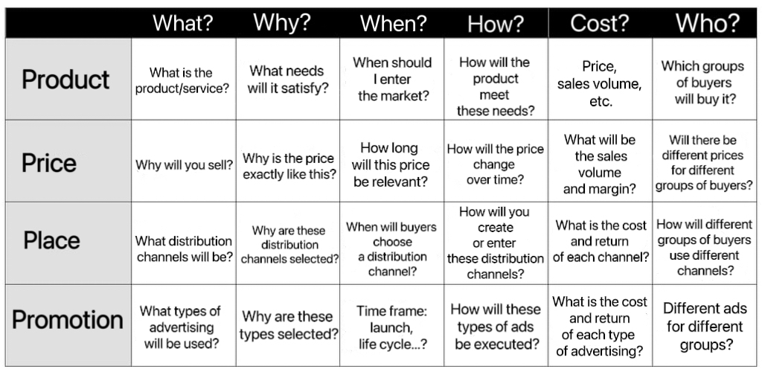

# SWOT Analysis

A SWOT analysis is an excellent tool for evaluating the strengths, weaknesses, opportunities, and threats of an online retailer. Knowing how the store is doing in each of these four areas will assist in identifying where it requires enhancement and what possibilities it should look into.

## Strengths

Focusing on the advantages of the online business first. Convenience is the key benefit of an online business over a physical one. Consumers may simply and swiftly purchase at the store from the comfort of their homes at any time. Also, a shop may provide a considerably wider variety of goods than a physical store, enabling customers to locate just what they need. The retailer may also provide customers with a more individualised experience by using email newsletters, targeted advertising, and special deals.

## Weaknesses

It's crucial to take into account an online store's shortcomings as well. Security is of utmost importance. Online retailers are required to safeguard the security of their systems since they handle client data. Also, since buyers cannot physically contact with the items before making a purchase, the store could not offer the same tactile experience as a physical one. Last but not least, the store charges delivery, which can put off some consumers.

## Opportunities

The online business has a lot to gain from consumer trends, speaking of opportunities. For instance, the retailer could capitalise on the rising popularity of mobile shopping by developing a mobile-friendly interface. Also, the company may execute more successful advertising efforts by utilising social media and influencers. The shop can also look at ways to reduce delivery costs and provide clients with special deals and offers.

## Threats

Last but not least, the retailer has to be aware of any dangers. The competition from other internet retailers comes first. To maintain compliance, the business should also be informed of any anticipated changes to the rules and legislation governing e-commerce. In order to guarantee that customers have a great experience, the shop should assess its client service procedures.

A SWOT analysis is a crucial technique for assessing an online shop, to sum up. It may help a store prosper if it is aware of its advantages and disadvantages, as well as the possibilities and risks it confronts.

# PESTLE analysis

An excellent technique to learn more about the outside elements that may have an impact on an online store's success is to do a PESTLE analysis. It is crucial to recognise the PESTLE factors: political, economic, social, technological, legal, and environmental; that could have a significant impact on the company. Here is short information about every factor.

*Political*

Changes in governmental rules, trade tariffs, taxes, and policies are only a few examples of political issues that could have an impact on an online store. Taxes and regulations may create a barrier to entry and put a strain on finances. It's also crucial to take into account the political stability and legal system of the country where the internet store is situated.

## Economic

The success of the online store can also be influenced by economic aspects. The profitability of a store can be impacted by a variety of variables, including inflation, interest rates, unemployment, and economic growth. It's crucial to take into account the economic performance of the industry, together with the level of competition and the size of the market. Social

The success of the online store may also be influenced by social considerations. Changes in population size, trends, cultural norms, and lifestyles are examples of social influences. It's crucial to take into account the demographics of the shop's customers as well as the local community's perception of new technologies and e-commerce.

## Technological

The performance of the online store may also be impacted by technological issues. The store has to be able to keep up with changes in technology in order to be competitive. The success of the business will be influenced by a number of variables, including the rate of technological progress, the accessibility of new software, and the calibre of IT infrastructure.

## Legal

While doing a pestle analysis, legal considerations are also crucial to take into account. Understanding the essential laws and rules governing internet commerce, consumer rights, product responsibility, and copyright is important. Changes in consumer protection legislation and safety standards are examples of legal causes.

## Environmental

Environmental elements might also impact the e-commerce industry. Environmental legislation, waste management, and climate change are just a few examples of factors that can have an effect.

By looking at each of these factors, it is possible to understand how economic and legislative changes, as well as technological advances, can affect business. It will also provide a better understanding of the social climate, and thus help shape a marketing strategy that targets the right audience. Ultimately, conducting a Pestle analysis is a great way to assess how external factors can affect your online store's bottom line.

# Monetization

Creating and maintaining a website is a cost of development, hosting and domain name fees, filling it with content, and attracting traffic. It is a valuable resource - time, even if a person create a site on a free website builder. Monetizing the site helps to return the money spent. The main task of commercial sites is to sell goods or services. Striking examples: online shops, marketplaces, corporate sites through which brands are promoted. Such sites have a different search engine output. To promote a commercial site in the search engine, following operations needs to be done:

Interaction with consumers: the site should have contacts, addresses, online chats, and so on.

Visible range of goods or services: a catalog with all items, product cards, the division of goods into categories, the indication of discounts and promotions.

The presence of photographs from all angles;

Content filling: the uniqueness of articles, text descriptions of products or services, video reviews, FAQ.

Nice and simple site design: easy navigation.

The queries to the extradition often overlap with infoprojects - the availability of useful and unique content, usability, and audience traffic. For commercial sites, site protection is especially important - a SSL certificate is needed for secure payments.

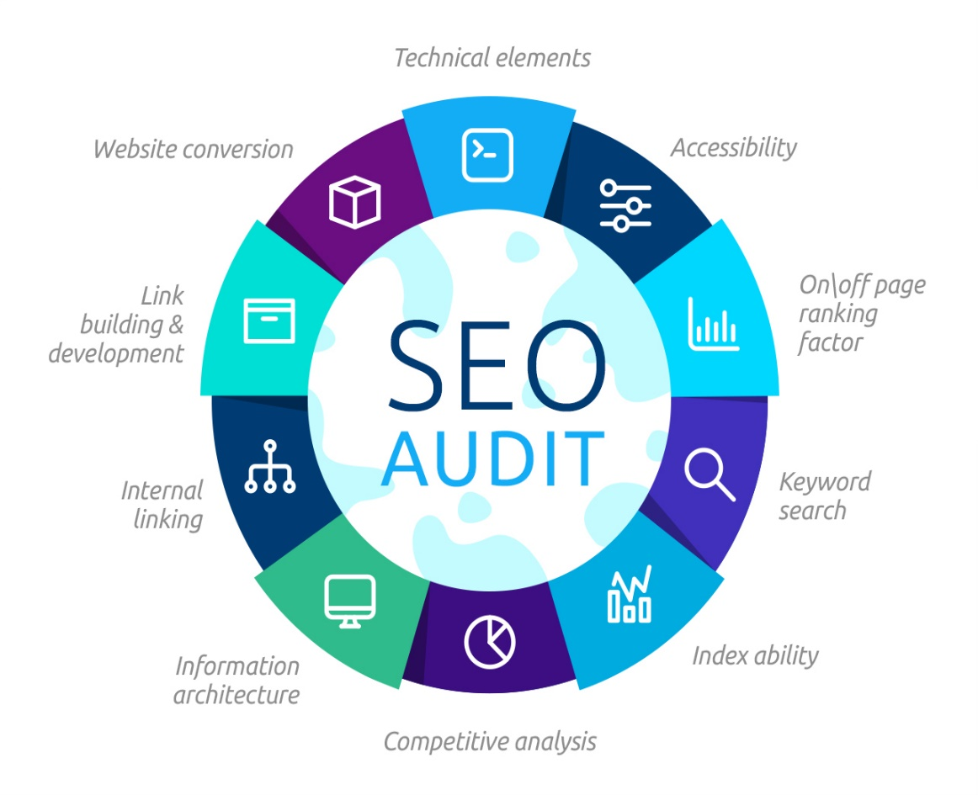

The main thing that is needed to monetize the site - consistently high traffic. Search engine optimisation, or SEO, is a collection of techniques and practises used to elevate a website's importance in the eyes of search engines and boost search traffic. Simply said, by carrying out this particular set of chores, the website will have a better likelihood of ranking in the top 10 of search engines and attracting more people. At first look, SEO optimisation may appear difficult, however with the appropriate direction, actions can be performed to make sure the site is highly visible and prominently shown in search engine results. Being strategic and maintaining the accuracy of the information are essential to success. Finding suitable keywords and phrases that accurately describe the website and its content is the first step. After that, incorporate them into the writing and improve the site's metadata, headlines, and other features. By utilizing web tools and resources, such as Google Webmaster Tools, to pinpoint and resolve any issues in order to create a thorough SEO plan. The efficacy of the site must be continually monitored in order to maintain competitiveness and capitalise on SEO chances. Putting in the effort to review keywords, examine content, and update the website as necessary. In the end, SEO optimisation is a continuous process, therefore it's critical to remain tenacious and work to continuously enhance the website. It is feasible to guarantee that the site ranks well in search engine results and gains from greater exposure and traffic by using the proper strategy.

A brief advertisement that is pertinent to the website's subject matter and the target audience's interests is referred to as contextual advertising on the website. Text, graphic, or video formats are all possible. When a person clicks an ad, the website's owner is compensated. How does it function? the site must first register with a contextual advertising network before receiving a code to embed on the site. Ads are loaded into pages through this code. On the website, contextual advertising may be shown in the header, footer, or sidebar.

By including their content, links, and adverts on the site, sponsors may draw visitors. This choice is advantageous if the location consistently draws several thousand visitors every day. The website, for instance, is all about animals. The website can promote pet grooming businesses, pet schools, and pet supply companies. This approach has the benefit of making placement costs independent. A set rate per posting, a price per thousand impressions, or a cost based on the volume of the information are all possible payment methods. One may supply both the development of the stuff and its placement. The majority of sizable information portals either produce their own advertising material or rigorously edit the content that is submitted.

It is feasible to employ affiliate programmes rather than waiting for offers from direct marketers. They may also be referred to as "affiliate programmes" or "referral programmes". This form of monetization is great for sites with certain themes. The website receives a commission on each affiliate sale, app download, registration, and other action by tying the affiliate links and brand references to the site. Programs for referrals provide AliExpress,

eBay, iHerb, and Aviasales. The terms and conditions vary depending on the programme. The brand does not pay individually for the integration of advertising. The creator only earns a percentage or set fee for each sale. The type of items will determine the affiliate compensation.

# Further improvements

Although having a lot of features, the programme still has more functionality that might broaden and increase the project's scope.

## Improving landing pages

A spectacular headline that attracts attention. Should contain information about the page. When compiling the titles, analyze the main queries that customers are searching for. The most effective headlines are those that call for action.

## Call to action

After reading the useful information and characteristics of the product being sold, the client may still have questions. Here the phrase can help: "Still have questions? Give us a call!" Such a call will increase the number of incoming calls, therefore increasing sales. From there, the manager takes the customer into his own hands.

## Calling from the site

It is not necessary to call the manager by cell phone. Many people have special equipment for making online calls. The ability to call the call center directly from the company website will increase the number of calls received.

## Control the statistics of exits from the site

On the site one or more pages have the largest number of exits - it is this page should be worked on. This means that clients don't find the information they need on it. The potential client is lost.

## Increase website traffic

If more potential customers come to the site, it means that the number of sales will start to increase. How to increase visits? By mastering the expanses of the World Wide Web. This can be done by registering on sites that post ads, establish activity on forums, create groups in the most popular social networks and actively develop them.

# Conclusion

The primary characteristic of an online business is that the majority of seller-buyer communication happens online. Remotely conducted transactions at several phases of buying and selling are quite successful. This is a significant benefit. Instilling the visitor with confidence so that he would make a purchase is one of the challenges that each online company must conquer. Because of the application's wide range of features, there was a good potential of gaining experience as a single member of the team fulfilling the roles of data analyst, project manager, tester, and programmer. Notwithstanding the obstacles encountered during the development phase, the project's major goal is to be completed effectively in accordance with the stated aims. This specific project served as a prime example for developing project management abilities and coding expertise. In terms of education, to do plan will be very obvious when it relates to practical exercise in order to accomplish effective outcomes and prevent project failures. The process of creating this application sheds light on issues that came up regarding the best methodology to use, how to conduct studies, requirement gathering phase, choices among programming languages, database forms of exploitation, and more.

# Bibliography

Baranova, I. (2022). Online Store: A Complete How-To-Start Guide. Available at: <https://ester.co/blog/how-to-start-online-store> [Accessed 1 Feb. 2023].

Bhat, A. (2018). *Business Research: Methods, Types & Examples*. [online] QuestionPro. Available at: <https://www.questionpro.com/blog/business-research/?ysclid=lfzt8uxjee42256931#Business_research_Types_and_methodologies> [Accessed 1 Feb. 2023].

Cebi, S. (2013). A quality evaluation model for the design quality of online shopping websites. *Electronic Commerce Research and Applications*, 12(2), pp.124–135. doi:https://doi.org/10.1016/j.elerap.2012.12.001.

Davis, H. (2006). *Search Engine Optimization*. [online] *Google Books*. ‘O’Reilly Media, Inc.’ Available at: <https://books.google.co.uz/books?hl=ru&lr=&id=hYSMBAAAQBAJ&oi=fnd&pg=PT6&dq=Search+engine+optimization&ots=2c9D0DJkgp&sig=gTSsHT5E0Ej2peqEPQTlLM4E-i4&redir_esc=y#v=onepage&q=Search%20engine%20optimization&f=false> [Accessed 7 Apr. 2023].

Dayal, S. (2020). Interesting facts about e-commerce industry. Available at: <https://medium.com/daas-labs/interesting-facts-about-e-commerce-industry-ccd2b2aa5a1a> [Accessed 1 Feb. 2023].

Draw.io (2023). *Flowchart Maker & Online Diagram Software*. [online] app.diagrams.net. Available at: <https://app.diagrams.net/> [Accessed 1 Feb. 2023].

e-pepper. (2023). *Онлайн-рынок Узбекистана в 2022 году - E-pepper.ru | eCommerce хаб*. [online] Available at: <https://e-pepper.ru/news/onlayn-rynok-uzbekistana-v-2022-godu.html?ysclid=lfzob1bbv1678277015> [Accessed 1 Feb. 2023].

Gurl, E. (2017). SWOT ANALYSIS: A THEORETICAL REVIEW. *demo.dspacedirect.org*. [online] doi:http://dx.doi.org/10.17719/jisr.2017.1832.

Jain, A.S. (2020). *Top 10 Benefits of Online Shopping (and 10 Disadvantages)*. [online] ToughNickel. Available at: <https://toughnickel.com/frugal-living/Online-shopping-sites-benefits> [Accessed 1 Feb. 2023].

Kemp, S. (2022). *Digital 2022: Uzbekistan*. [online] DataReportal – Global Digital Insights. Available at: <https://datareportal.com/reports/digital-2022-uzbekistan> [Accessed 1 Feb. 2023].

Mallapragada, G., Chandukala, S.R. and Liu, Q. (2016). Exploring the Effects of ‘What’ (Product) and ‘Where’ (Website) Characteristics on Online Shopping Behavior. *Journal of Marketing*, 80(2), pp.21–38. doi:https://doi.org/10.1509/jm.15.0138.

Manthei, L. (2017). *The Four Ps of Marketing: Why the Marketing Mix Is Still Relevant | Emarsys*. [online] Emarsys. Available at: <https://emarsys.com/learn/blog/4-ps-of-marketing-importance/> [Accessed 4 Feb. 2023].

Mavink.com. (2023). Available at: <https://mavink.com/post/6CAC9B10C2ACB44DF2E82B934EB4861D20AM5AEBB9> [Accessed 3 Feb. 2023].

Nordqvist, C. (2017). *Online shopping - definition and...* [online] Market Business News. Available at: <https://marketbusinessnews.com/financial-glossary/online-shopping-definition-meaning/> [Accessed 1 Feb. 2023].

Perera, R. (2017). *The PESTLE Analysis*. [online] *Google Books*. Nerdynaut. Available at: <https://books.google.co.uz/books?hl=ru&lr=&id=ZWpLDwAAQBAJ&oi=fnd&pg=PA2&dq=pestle&ots=DufYwN0uJE&sig=zmhPI6Jun64q9ZisUSKH0Fx-WNk&redir_esc=y#v=onepage&q=pestle&f=false> [Accessed 7 Apr. 2023].

Stack Overflow (2022). *Stack Overflow - Where Developers Learn, Share, & Build Careers*. [online] Stack Overflow. Available at: <https://stackoverflow.com/> [Accessed 4 Feb. 2023].

Stack Overflow. (n.d.). *python - How do I integrate Ajax with Django applications?* [online] Available at: <https://stackoverflow.com/questions/20306981/how-do-i-integrate-ajax-with-django-applications> [Accessed 4 Feb. 2023].

SurveySparrow (2021). The 4Ps Of Marketing | Understanding The Marketing Mix. Available at: <https://surveysparrow.medium.com/the-4ps-of-marketing-understanding-the-marketing-mix-eb904fd2c02> [Accessed 1 Feb. 2023].

T, T. (2022). *What Is eCommerce? A Complete Guide With Examples*. [online] Hostinger Tutorials. Available at: <https://www.hostinger.com/tutorials/what-is-ecommerce> [Accessed 1 Feb. 2023].

Tan, J., Tyler, K. and Manica, A. (2023). Business-to-business adoption of eCommerce in China. *Information & Management*, 44(3), pp.332–351. doi:https://doi.org/10.1016/j.im.2007.04.001.