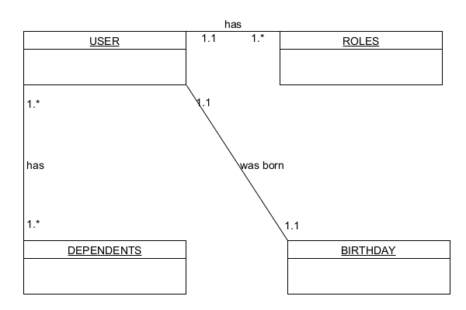

// in users

{

“name”: “Johnson”,

“roles”: [

{

“type”: “CEO”,

“salary”: 100000

},

{

“type”: “Executive”,

“salary”: 50000

}

]

“birthday”: [

{

“date”: 1985-10-12

}

]

“dependents”: [

{

“name”: “Lisa”,

“relation”: “wife”

},

{

“name”: “Danielle”,

“relation”: “daughter”

}

]

}