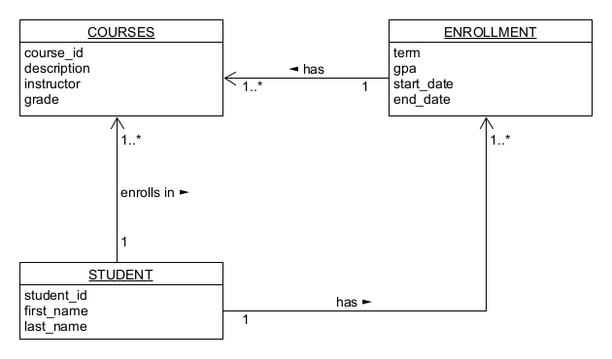

// in STUDENT

{

“student_id”: “21353825”

“first name”: “Johnson”,

“last name”: “Davis”,

“enrollment”: [

{

“term”: “Spring”.

“gpa”: 3.0

“start_date”: 2023-02-21

“end_date”: 2023--05-07

“courses”: [

{

“course_id”: “CYBR410-S1”.

“description”: “Data/Database Security”

“instructor”: “Dr. Thompson”

“grade”: 93

},

{

“course_id”: “CYBR430-S2”.

“description”: “Cybersecurity Introduction”

“instructor”: “Mr. Brown”

“grade”: 99

},

{

“course_id”: “COMP-S1”.

“description”: “Introduction to Computer Management”

“instructor”: “Ms. Susan”

“grade”: 85

}]

},

{

“term”: “Summer”.

“gpa”: null

“start_date”: 2023-05-15

“end_date”: 2023--08-30

“courses”: [

{

“course_id”: “MUS-S1”.

“description”: “Introduction to Music History”

“instructor”: “Dr. Thompson”

“grade”: null

}]

}]

“grades”: [

{

“course_id”: “CYBR410-S1”.

“description”: “Data/Database Security”

“instructor”: “Dr. Thompson”

“grade”: 93

},

{

“course_id”: “CYBR430-S2”.

“description”: “Cybersecurity Introduction”

“instructor”: “Mr. Brown”

“grade”: 99

},

{

“course_id”: “COMP-S1”.

“description”: “Introduction to Computer Management”

“instructor”: “Ms. Susan”

“grade”: 85

},

{

“course_id”: “MUS-S1”.

“description”: “Introduction to Music History”

“instructor”: “Dr. Thompson”

“grade”: null

}]

}