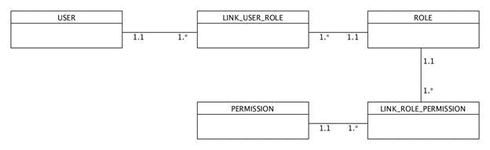

1. Business Rules:
   1. A USER can have many LINKED USER ROLES.
   2. Many LINKED USER ROLES can belong to one ROLE.
   3. A ROLE can have many LINKED ROLE PERMISSIONS.
   4. Many LINKED ROLE PERMISSIONS can belong to one PERMISSION.

