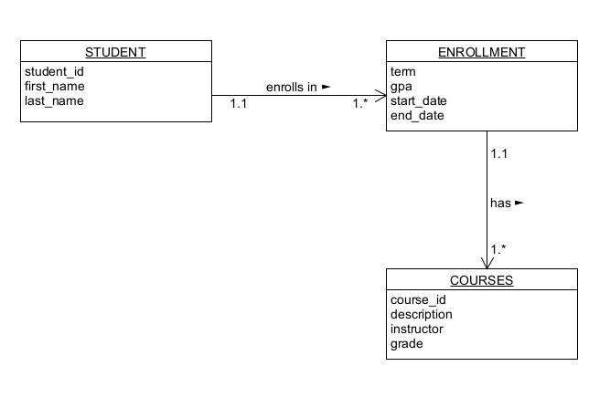

// in STUDENT

{

“student_id”: “14352464”

“first name”: “Alice”,

“last name”: “Bobbert”,

“enrollment”: [

{

“term”: “Summer”.

“gpa”: 3.5

“start_date”: 2023-5-15

“end_date”: 2023-8-30

“courses”: [

{

“course_id”: “CH-115-S1”.

“description”: “General Chemistry I”

“instructor”: “Ms. Charlie”

“grade”: 95

},

{

“course_id”: “CH-306-S2”.

“description”: “Biochemistry”

“instructor”: “Mr. Davidson”

“grade”: 95

},

{

“course_id”: “AR-104-S1”.

“description”: “Understanding Art”

“instructor”: “Ms. Finch”

“grade”: 87

}]

},

{

“term”: “Winter”.

“gpa”: null

“start_date”: 2023-09-05

“end_date”: 2023--12-18

“courses”: [

{

“course_id”: “AR-204”.

“description”: “Introduction to Painting”

“instructor”: “Dr. Sarah”

“grade”: null

},

{

“course_id”: “CJUS-335”.

“description”: “Crime in America”

“instructor”: “Dr. Jones”

“grade”: null

},

{

“course_id”: “HI-110”.

“description”: “World History I”

“instructor”: “Prof. Thomas”

“grade”: null

}]

}]

}