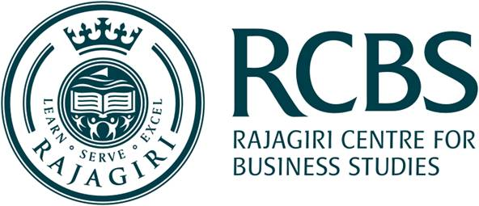
NITHIN N
Date of Birth: April 1 1994
Email: b2344@rajagiri.edu
Mobile: 9645732053
Address : Pudhukkulangara, Varakkad, Kottamala P O, Kasaragod,
Kerala, 671314
Course : MBA

Academics
Course | Institute & University | Year of Passing | Aggregate Percentage
MBA | Rajagiri Centre for Business Studies, Cochin , MG University | 2020 | 65
B tech | SNGCET Payyannur , Kannur University | 2016 | 61.84
Class 12 | Jawahar Navodaya Vidyalaya Periye Kasaragod , CBSE | 2012 | 73.6
Class 10 | Jawahar Navodaya Vidyalaya Periye Kasaragod , CBSE | 2010 | 76

Projects & Initiatives

- Modified electric scooter.
The main objective of my project was to design a hybrid scooter. The charging section of the electric scooter is done with a solar panel and also had an automatic headlight system.

- Summer Internship at Landmark Group in Retail Operations (April 2019 – May 2019).

Positions of Responsibility

- Operations committee member of INFLORE
- Coordinated RBL games committee
- Coordinated tech fest in my college.
- Coordinated National level conference on Technology Advancements in Engineering.

Achievements & Certifications

- Dropshipping master course (ongoing)

Other Skills & Interests

Skill

MS Word, Power Point, MS Excel

Languages Known

English, Malayalam, Hindi

Interests

Share Trading, Swimming, Playing Cricket, Playing Basketball, Traveling

