**DOCUMENTATION**

**Introduction**

* **Purpose**

This document provides comprehensive documentation for FindIt, detailing its features, usage, installation, and other relevant information.

* **Scope**

The documentation covers the setup and usage of the web application. It also includes information about troubleshooting, security considerations, and the API.

This documentation is intended for administrators, users who have lost or found items, and anyone involved in the operation of the Lost and Found System.

* **Overview**

FindIt is a web application that helps users find their lost items. It is designed to enable users to efficiently track, store, and recover misplaced items, ensuring a seamless experience for both staff and customers alike. At its core, this software serves as a comprehensive digital database, cataloging lost items and their associated information. The application is built using HTML,Javascript ,CSS and Django with the ability to quickly add, update, and search for items within the system, students can effortlessly match found items with their respective owners.

**Getting Started**

**System Requirements**

Ensure that your system meets the following requirements before installing FindIt.

**Software Requirements:**

* Operating System:

Windows, Linux, Android, iOS.

* Web Browser:

Latest versions of Google Chrome, Mozilla Firefox, Safari, or Microsoft Edge.

* Network:

Stable internet connection for real-time updates and notifications.

**Installation**

* Download the Installer Package:

Visit the official Lost and Found System website or download page.

Download the installer package suitable for your operating system (Windows, macOS, or Linux, android, iOS).

* Run the Installer:

Locate the downloaded installer package.

Double-click or run the installer to start the installation process.

* Follow Installation Wizard:

The installer will launch an installation wizard that guides users through the process.

Read and accept the license agreement, if prompted.

* Click "Next" or "Continue."
* Complete Installation:

Click "Finish" or "Complete" to finalize the installation.

* Launch the Application.

**Features**

**User Registration and Authentication**

any new user is directed to this page. The page displays the sign up tab. It also displays simple instructions of how to create a login account for the users and the information to supply. Below is a screenshot.

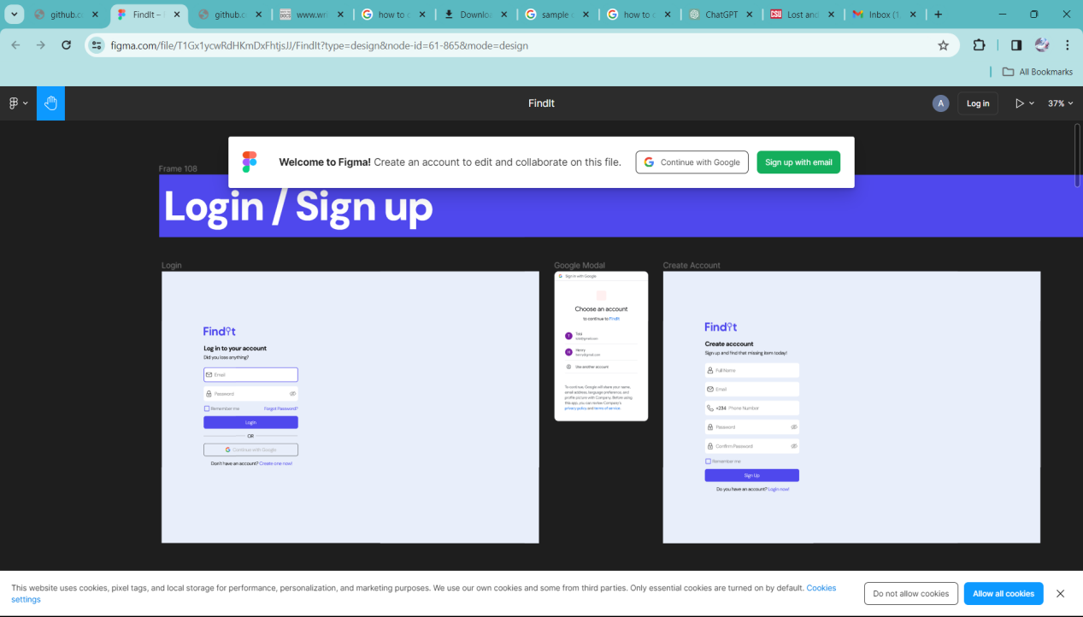

**View lost items**

This feature typically presents a catalog or a filtered list of lost items, offering details such as item descriptions, categories, locations, and timestamps. Users can use search and filtering options to refine the displayed list based on specific criteria, making it easier to locate a particular lost item. The "View Lost Items" feature is essential for individuals looking to reclaim their belongings by providing a comprehensive overview of reported lost items within the system, aiding in the identification and retrieval process.

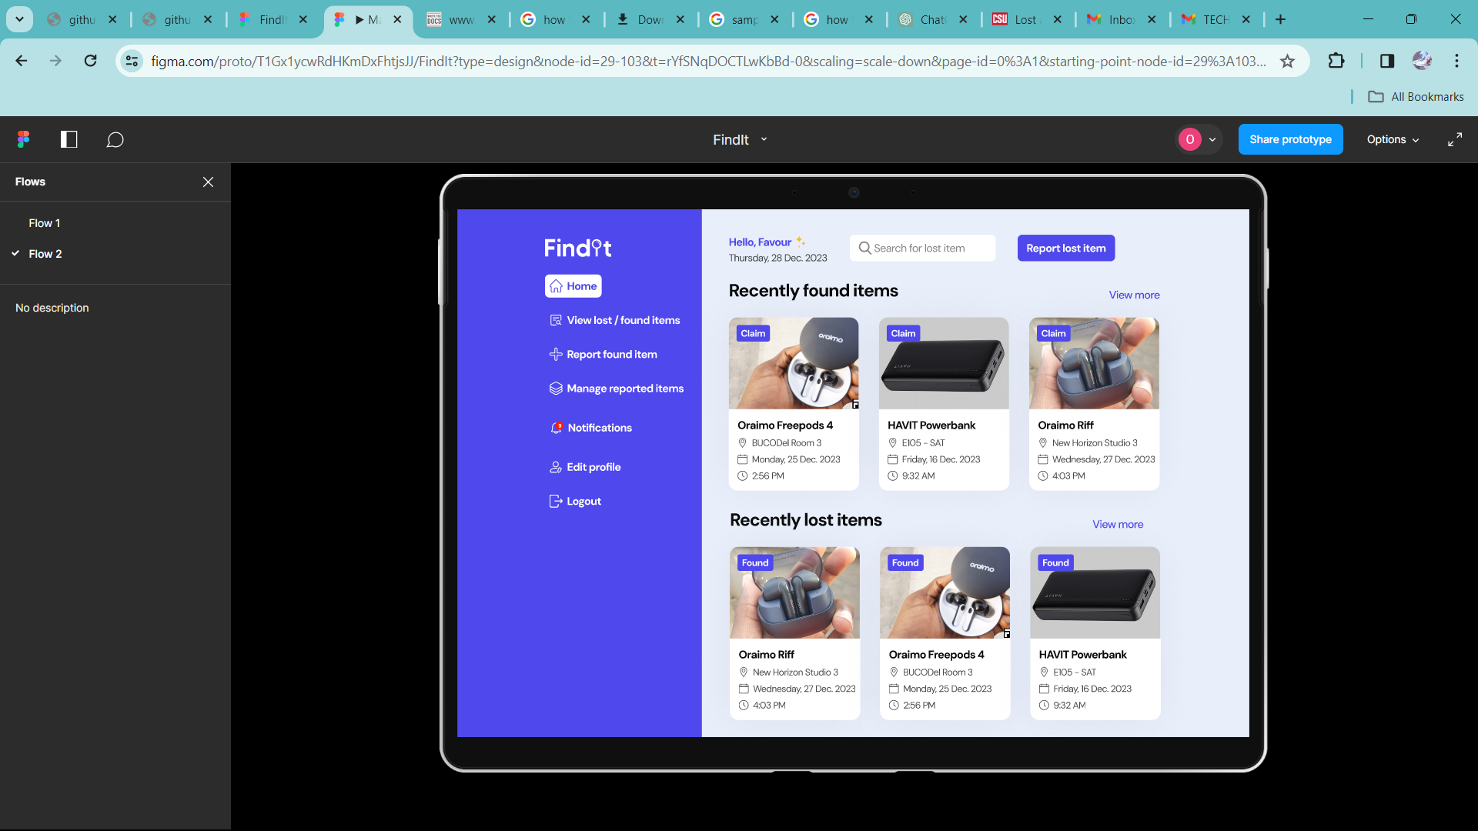

**Found Item Submission**

Users reporting found items in the Lost and Found System can follow a simple process. After logging in, they navigate to the "Found Items" section and initiate a new report. A detailed form is provided, allowing users to describe the item, specify the location and date found, upload photos, and select a category. Upon completing the form, users submit the report, receive a confirmation message, and may check for updates on matches or claims. The process aims to be user-friendly, encouraging efficient and accurate reporting to facilitate the reunification of lost items with their owners.

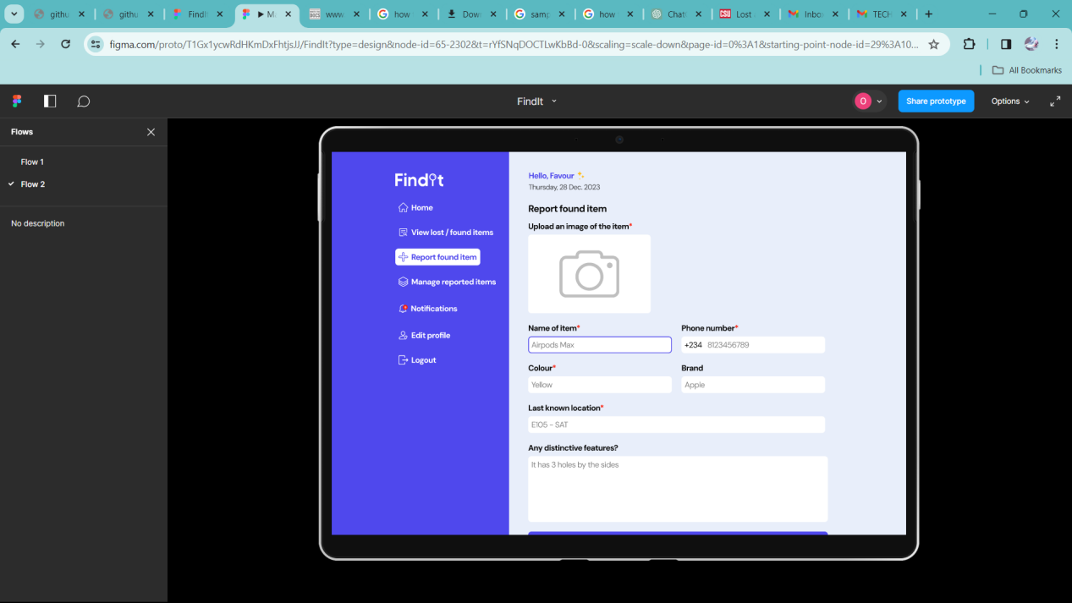

**Search For Lost Items**

The search bar enables users to find relevant lost or found items based on various attributes such as descriptions, categories, locations, or dates. Users can type in keywords related to the item they are searching for, and the system will return a list of matching items.



**Manage Reported Item**

Users can manage reported items in the Lost and Found System by logging in and accessing the "Manage Reported Items" or a similar section. Within this section, users can view a list of items they have reported as found or lost. The system typically provides options to edit or update the details of a reported item, mark an item as claimed, or delete a report if necessary. Users can also check the status of reported items, such as whether they have been claimed or matched with a lost item. Notifications or a dashboard interface may alert users to any changes or actions related to their reported items, ensuring efficient management of the lost and found reports.

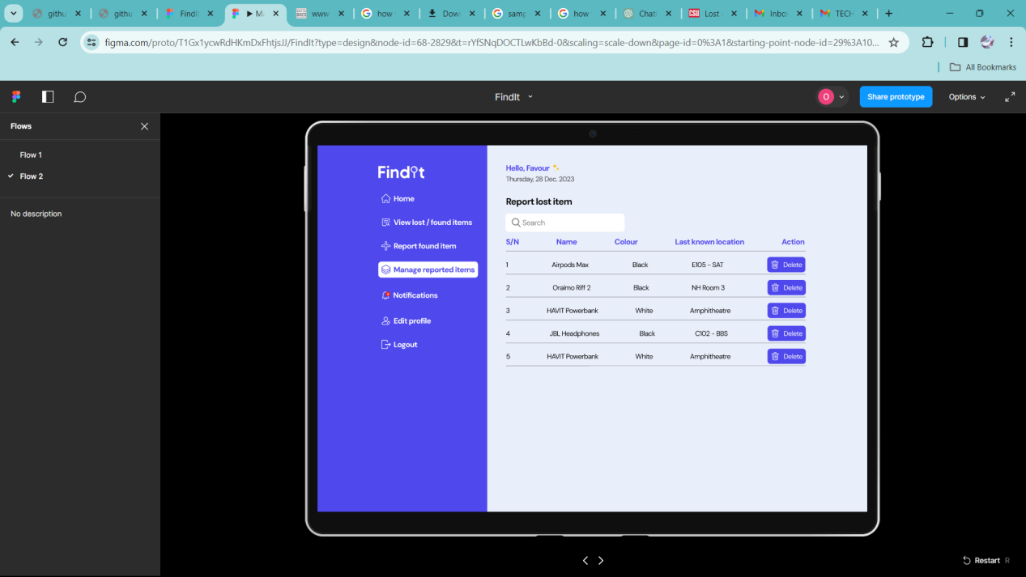

**Edit profile**

The "Edit Profile" feature enables users to manage and personalize their account information. Users can access this feature through the application's user dashboard or settings section. Within the "Edit Profile" interface, individuals can modify details such as their contact information. This feature enhances user engagement and experience by allowing individuals to keep their profiles up-to-date, ensuring that the Lost and Found system can efficiently communicate with users about their reported items. After editing their profiles, users typically save the changes, ensuring that the information is accurate and reflective of their current preferences within the application.

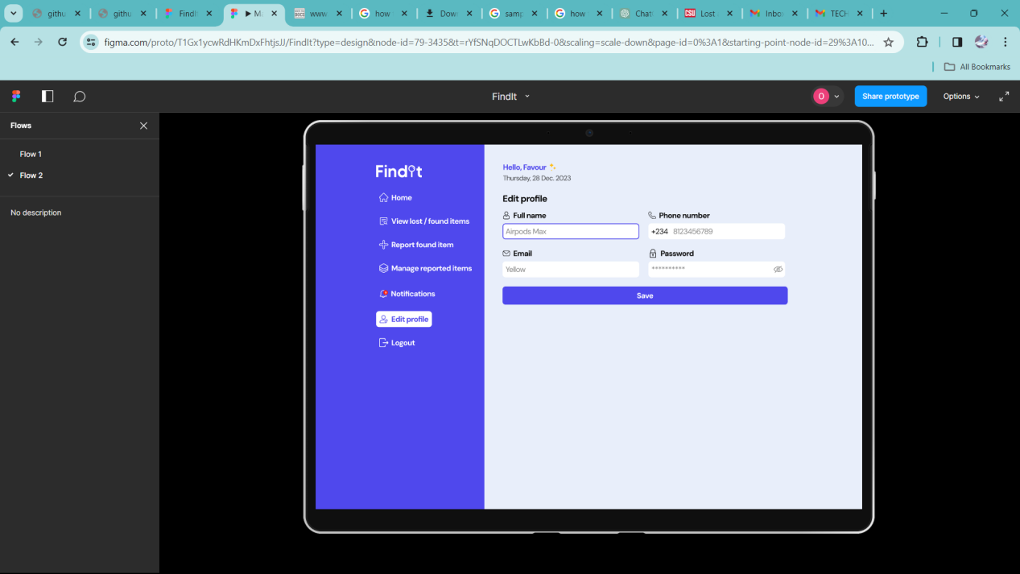

**Notifications**

Upon logging in, users navigate to the "Notifications" section, where they can choose to send a whatsapp message to the finder. 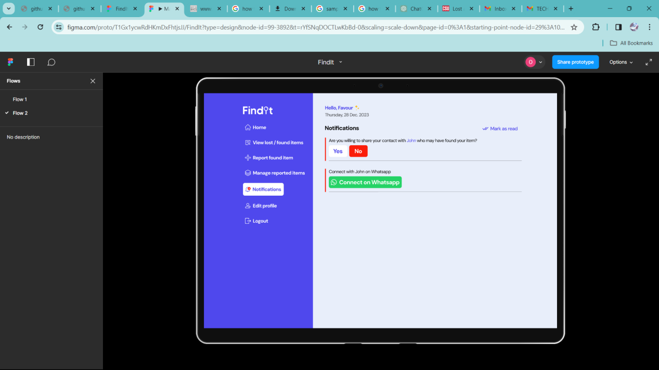

**Security**

The security measures within the Lost and Found app may include user authentication, allowing only authorized users to report, search, and claim items. Authorization controls help define who can access specific features or actions within the application. Data encryption ensures that sensitive details about lost or found items, as well as user information, are transmitted and stored securely. Regular security audits help identify and address potential vulnerabilities, securing the overall functionality of the Lost and Found system and instilling confidence in users that their information is protected.

**Usage**

**User Roles and Permissions**

In the Lost and Found System, user roles determine the level of access and permissions within the application. The administrator role, typically assigned to system administrators, has full control over the system, including managing users, configurations, and reported items. Regular users, who report lost or found items, have limited access to their own reports and related actions, such as editing or claiming items. Moderators, if applicable, may have additional permissions to review and validate reported items for accuracy. The system ensures a hierarchical structure of user roles, allowing for efficient management and control while maintaining security and privacy.

**Reporting Lost or Found Items**

Login to the System:

Access the Lost and Found System and log in using your credentials.

Navigate to Report Section:

Look for an option such as "Report Lost Item" or "Report Found Item" in the main dashboard or navigation menu.

* Choose Lost or Found:

Select whether you are reporting a lost or found item.

* Provide Item Details:

Fill out a form with detailed information about the item, including its description, location, date, and any relevant details.

* Upload Photos (if applicable):

Attach images of the item to aid in identification. This step might be optional but is beneficial for both reporting and claiming purposes.

* Click the "Submit" or "Report Item" button to submit the information.
* Check for Updates:

Regularly check the system for updates on your reported item, including matches, claims, or any relevant notifications.

**Searching for Items**

To search for lost items in the Lost and Found System, log in to your account and navigate to the "Search" or "Find Items" section. Use the provided search filters, including keywords, categories, and date ranges, to narrow down the results. Review the list of matching items and click on individual entries for more details. Regularly check for updates or new matches to enhance the chances of locating the lost item.

**Claiming Items**

Locate the specific item you wish to claim from the list of found items. Click on the item to view its details and ensure it matches your lost item. Follow the on-screen instructions to initiate the claiming process, which may involve providing additional verification details or contacting the system administrator. Monitor your notifications for updates on the claim status and further instructions from the system.

**Notifications and Alerts**

In the Lost and Found System, users receive notifications about found items by configuring their notification preferences in the account settings. After logging in, users navigate to the "Notification Settings" section where they can choose to receive alerts via Whatsapp. The system sends real-time notifications whenever a found item report matches the details of a lost item. Users are promptly alerted to potential matches, allowing them to review and claim their lost items efficiently. Regularly checking the notifications or dashboard interface keeps users informed about any developments in the Lost and Found System.

**Conclusion**

Thank you for using the Lost and Found System. If you have any further questions or need assistance, please refer to the support section or contact our team.

