How to Capture High Quality Audio in a  
Google Hangout Presentation

Mike Koss

Updated Clive Boulton September 29, 2014

One of the problems we’ve had in capturing GDG events is getting high quality audio recordings of the speaker.

|  |
| --- |
| **Very simple set up**   1. Producer’s Computer 2. Wireless (Bluetooth) Microphone headset  On the Producer’s Computer:  1. Sign into your GDG chapter YouTube account (assuming account setup) 2. Start a Hangout on Air (HOA saves to YouTube) 3. Position MBP / Chromebook camera to capture speaker and slides. 4. Pair the bluetooth mic/headsets with this computer. 5. Turn off MBP / Chromebook speakers to avoid audio feedback from Bluetooth Mic. |

## What follows is the preferred setup for a Hangout on Air (HoA) to live stream GDG event and capture quality speaker to Youtube video using two computers.

1. Presenter’s Computer
2. Producer’s Computer
3. Wireless (Bluetooth) Microphone (or headsets)
4. USB Camera

# Setup

## On the Producer’s Computer:

1. Sign-in to your GDG chapter YouTube account (otherwise video saves to personal)
2. Start a Hangout on Air
   1. Invite the presenter if they are using their own account on their computer.
   2. (optional) invite GDG Seattle Discuss members
3. Plug in the (front facing) USB camera.
4. Pair the bluetooth mic/headsets with this computer.
5. Choose hangout Settings (gear icon) and select the USB camera and the bluetooth headset in the drop downs.
6. Plug in headphones to monitor the audio quality on this computer - or turn off the speakers to avoid feedback.
7. Get the YouTube link from the lower right corner of the HoA screen.
8. If this is for a Google Plus event place the YouTube video above the comment stream:
   1. Click Edit Event
   2. Click Edit Options/Advanced/Show more options
   3. Paste the YouTube link in the YouTube URL (optional) field.
   4. Click Save

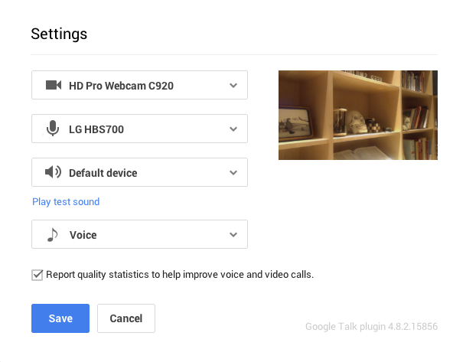

## On the Presenter’s Computer

1. Accept the producers Hangout request.
2. Turn off the mic and audio in the Hangout controls.
3. Open the presenter’s slides in another window.
4. In the Hangouts window, click screen share icon and select the window containing the presenters slides.  
   

## Back on Producer’s Computer

1. Verify sound check from presenter wearing Bluetooth headset at the distance from the podium.
2. Verify you can switch between USB Camera view and Presenter’s slides as the broadcast video of the hangout.
3. When ready, click the HOA Start Broadcast button.
4. Be sure to manually click back and forth between the camera and slides as appropriate (usually switch to slides when they are first shown, and stay on them as long as the presenter is referring directly to the material shown. Go back to the camera view when the presenter is speaking more generally).

**Tips**

1. Do the very simple setup the first time.
2. HOA works best with a dedicated producer, a co-organizer dedicated to focusing on capturing the speaker, the slides, pictures of the audience (the main organizer running the event is too busy handling pizza, doors, check-in, introducing speaker, etc)
3. For quality audio [LG HBS-700 or 730](http://www.lg.com/us/cell-phone-accessories/lg-HBS700-tone) class devices work well and look good.
4. Make sure to turn off the microphone on the producers and presenters computers: Capture audio on the presenters wireless (Bluetooth) Microphone (or headsets)
5. Definitely do a dry run with both a Producer and Presenter before your first event.
6. Sign into your GDG YouTube channel on the Producers computer so HOA saves.
7. Allow 1 hour before your event first event of uninterrupted time to setup G+ HOA. Thereafter it will take you less time and become second nature (just like learning to ride a bike).
8. Enjoy!

**Infographic**

Heres a supplemental by Akil Head

<https://sites.google.com/site/meetuphangouts/>