Problem set #3 Fall 2014

**GEOL1370: Environmental Geochemistry**

**Thermodynamics (Due Thursday, 09/10)**

1. At the last glacial maximum, ~21,000 years ago, Earth was considerably colder than today and there were large ice sheets in the northern hemisphere (e.g., Rhode Island was near the southern limit of the Laurentide Ice Sheet and was covered by ~1km of ice). Atmospheric CO2 concentration at that time was also lower than today, with *p*CO2 = 1.6×10-4 atm (today is 10-3.5 atm). Following example 1 in the lecture notes:

a) Compute the molar concentration of CO2 dissolved in rain water at 25°C and 15°C, respectively, using Henry’s Law. Henry’s constants for CO2 at different temperatures can be found on Page 33, Table 2-1 of your textbook.

b) Compute the equilibrium constant K for the reaction at 25°C: H2CO3 ⇔ H+ + HCO3- (this reaction is equivalent to CO2(aq) + H2O ⇔ H+ + HCO3-). Gfo (H2CO3) =   
-623.2 kJ/mol; Gf° (H+) = 0 kJ/mol; Gfo (HCO3-) -586.8 kJ/mol.

c) Use the Van’t Hoff equation to compute the equilibrium constant of the above reaction at 15°C. You can find Hf° values for H2CO3(aq) = -699.09 kJ mol-1, H+ = 0 and HCO3-= -689.93 kJ mol-1 in Appendix II of your text book.

d) Compute the pH of natural rain at the last glacial maximum on Earth at 25°C and 15°C.

1. a) Groundwaters tend to have much higher concentrations of most inorganic constituents than do surface waters, and deep groundwaters that have been in contact with rock for a long time tend to have higher concentrations than shallow and or young waters. Explain why briefly.

b) The groundwater in calcite bedrock underneath a household has relatively old, and steady composition with 1.6 x10-3 mol L-1 Ca2+; and 4 x10-6 mol L-1 CO32-, determine the saturation index of the groundwater with respect to calcite. Comment if the calcite is dissolving.

c) A deep well was dug near the house for drinking water and for irrigation of lawn and crops. Over time, the concentration of the calcium in the groundwater slowly declined. After a period of heavy rain fall the groundwater composition is 1.6 x10-4 mol L-1 Ca2+; and 1.1 x10-6 mol L-1 CO32-. Determine if this water is saturated with respect to calcite. Discuss briefly how human activities might speed up the formation of sinkholes in regions with extensive carbonate bedrocks.

d) A seismic survey of region with carbonate bedrock indicates a large underground cavity underneath a house. The cavity is currently capped by limestone rock about 2 m thick. What would you do to assess the risk of sinkhole formation and thread to the house?

e) Another readily soluble mineral in earth surface conditions is pyrite. Write the chemical reactions occurring during the dissolution of pyrite. Discuss the causes of major environmental hazards associate with pyrite dissolution and various engineering solutions to deal with the problems.

1. The following diagram illustrates the changes in cadmium species distribution when chloride ion concentrations are altered. Alpha () is the proportion of cadmium present in a particular form.

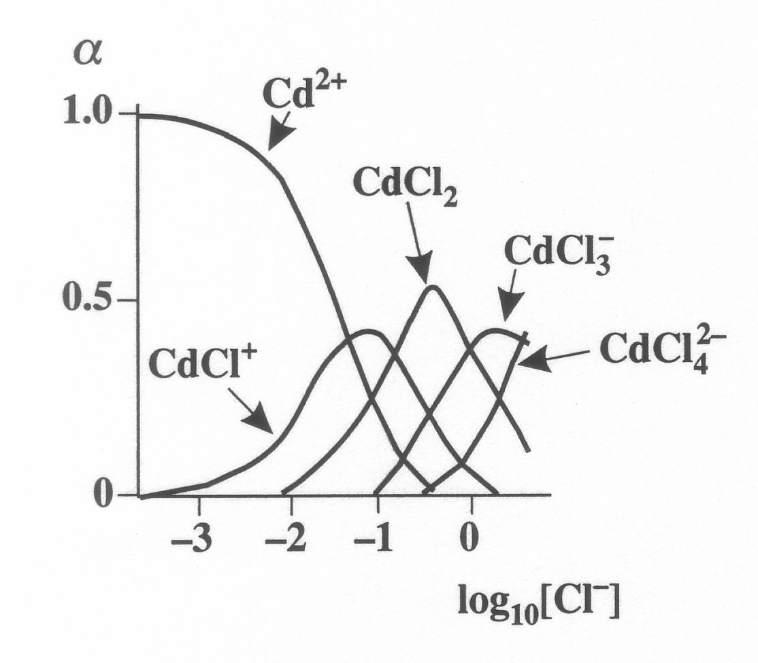Factory waste containing dissolved cadmium is discharged into a river.

1. Outline the changes which occur in cadmium speciation as dissolved cadmium moves down the river, through an estuary, and into the sea.
2. If you measured Cd in the water using ICP-MS or atomic absorption, you would obtain a **total** concentration of all Cd species. In order to use this value to assess the potential toxicity of Cd to aquatic organisms, what adjustments or precautions should you take during your data interpretation? Note: Cd2+ is the most toxic species to organisms, while increasing complexation often reduces toxicity.
3. Since you already have the total concentration of Cd2+ in the water, can you derive the equations to calculate the precise percentages of each cadmium species at any given Cl- concentration based on equilibrium thermodynamics (assuming 25oC)? You do not need to calculate numbers for this problem – just find equations needed to calculate the species concentrations.

**Hint:** You have a total of five unknown species (Cd2+, CdCl+, CdCl2, CdCl3-, CdCl42-) to calculate concentrations for, hence you will need five parallel equations. All cadmium species should sum up to the total cadmium concentration – this is your first equation. Write out the four remaining equilibrium reactions (e.g., Cd2+ + 2 Cl- = CdCl2) so that you get the other four equations. The equilibrium constants of these four reactions can be calculated from standard free energy of formation of individual cadmium species, hence can be considered as known.

1. a) Calculate the solubility product Ksp of CaSO4 (anhydrite) in water at 25°C. Gfo (CaSO4) = -1321.8 kJ/mol; Gfo (Ca2+) = -553.6 kJ/mol; Gfo (SO42-) =   
   -744.0 kJ/mol.

b) Calculate the solubility of CaSO4 in pure water at 25oC (i.e. [Ca2+] in water, which is equal to [SO42-]).

c) Activity can be considered to be effective concentration. At high ion concentrations (or high ionic strength), activity is often smaller than concentration (aCa<[Ca2+]; and aSO4<[SO42-]), because ions are surrounded by other ions of opposite charge which restrict their movement and their ability to behave as a real free ion in the solution. Since Ksp = aCa × aSO4, demonstrate that solubility of the CaSO4 is greater if we consider the effect of activity. (To make your life easier, you do not need to calculate activity constant for this problem. Simply write out the relationship between activity and concentration, and find out if the concentration of calcium ion would be greater when activity coefficient is smaller than 1).