Problem set #4 Fall 2014

**GEOL1370: Environmental Geochemistry**

**Thermodynamics and Acid-Base reactions (Due Thursday, 10/16)**

1. 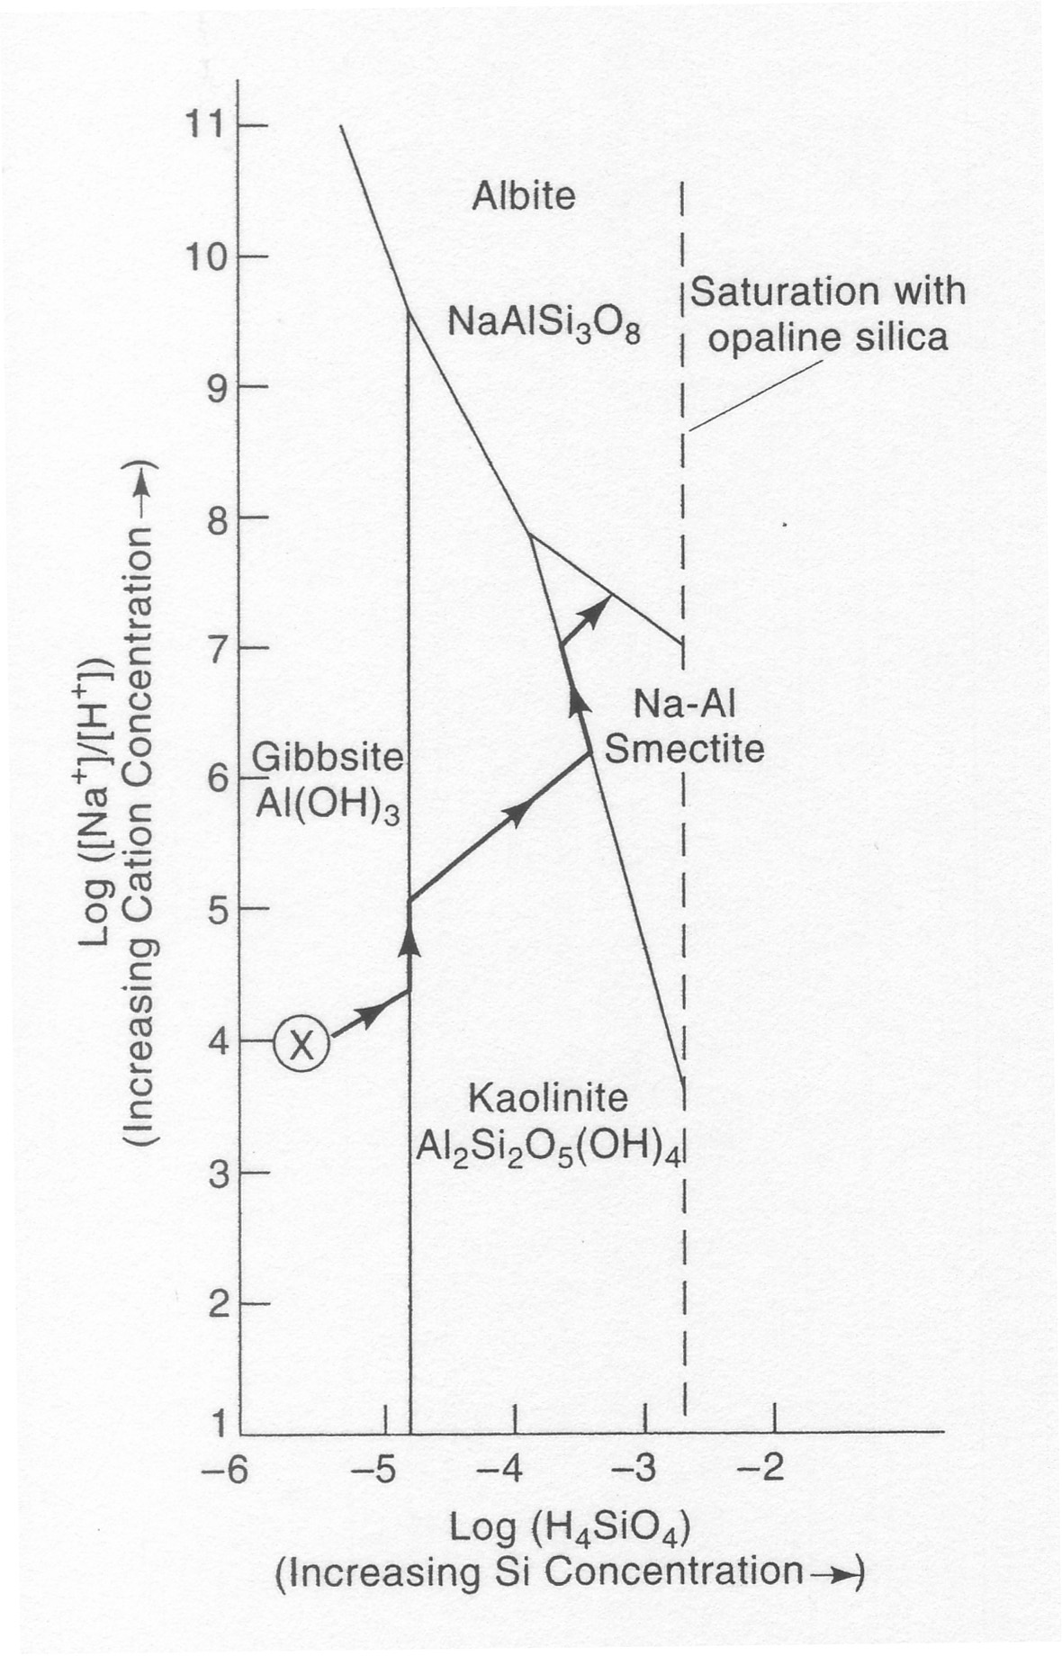**MINERAL STABILITY DIAGRAMS** Mineral weathering and precipitation often control soil formation and water chemistry of streams, lakes and groundwater. Mineral stability diagrams are useful for predicting mineral weathering and precipitation in natural environments. A well-known example is that weathering of feldspars (which are the most abundant minerals in the earth crust) will yield different proportions of clay minerals and gibbsite in soils under different climate regimes (particularly precipitation). Using these diagrams to interpret mineral stability is very straight forward: simply plotting the ion concentrations (measured in the lab) will allow you to determine the most stable mineral phase in equilibrium with the particular water. An important question, however, is how the boundary lines in the mineral stability diagrams are drawn. This problem will show you that these important boundary lines can easily be established using the basic thermodynamic approach covered in class:

(a). The reactions from Albite to Kaolinite (1) and Kaolinite to gibbsite (2) and are (Gfo values are obtained for minerals in standard thermodynamic database):

(1) 2NaAlSi3O8 (s) + 2H+ + 9H2O ↔ 2 Na+ + Al2Si2O5(OH)4 (s) + 4H4SiO4 (aq)

Gfo -3711.7 0 -237.1 -261.5 -3797.5 -1307.8

(2) Al2Si2O5(OH)4(s) + 5H2O ↔ 2Al(OH)3 (s) + 2H4SiO4 (aq)

Gfo -3797.5 -237.1 -1154.9 -1307.8

Compute the standard free energy change (Gro) of the above two reactions.

(b). Use the relationship between the equilibrium constant (Keq) and the standard free energy change (Gro) of the reaction: Log Keq = -Gro/5.708, to compute the equilibrium constants for the two reactions.

(c). Write out the expressions of equilibrium constant (Keq) for the reactions (1) and (2). Note: concentrations (in fact, activities) of H2O and solid minerals are always 1.

(d). Take “log10” on both sides of the equilibrium constant expressions that you have obtained in step (c), then re-arrange the equations so that one side of the equation has the log (Na+/H+) as the variable, whereas the other side has the log(H4SiO4) as the variable. Note that the reaction (2) does not contain Na+ and H+, and therefore, you will get a fixed value for log (H4SiO4).

(e). Plot the relationships you obtained from (d) on the above stability field diagram with log(Na+/H+) as the Y-axis and log(H4SiO4) as the X-axis. Compare your lines with the lines in the diagram (small discrepancies may result from the continuing revision of thermodynamic database by scientists, and sometimes differences in published values in different databases).

(f). You could repeat the same practice above to create this very useful diagram, which will allow you to accurately predict mineral stability and dissolution in natural waters. We discussed previously how mineral weathering reactions can lead to the formation of different soil clay minerals under different rainfall conditions. *Based on this diagram, design a chemical weathering path that can transform the primary mineral, Albite, into smectite, kaolinite, and gibbsite sequentially.* How you would change the composition of the water in contact with the mineral in order to destabilize the mineral, so that formation of a new mineral is thermodynamically favored?

(g). Instead of using the thermodynamic approach, one may argue that we can dissolve the mineral in the lab and wait until it reaches equilibrium, and then find the stability boundaries. Can you explain why this approach may not be practical?

1. **BJERRUM PLOTS** A Bjerrum plot illustrates the activities (concentrations) of different species in a closed carbonate system as a function of pH. For a total concentration of carbonate in solution CT, we have

CT = [H2CO3o] + [HCO3-] + [CO32-] (1)

K1=[H+][HCO3-]/[H2CO30] (2)

K2 =[H+][CO32-]/[HCO3-] (3)

For any given CT and [H+], we have three equations, and three unknowns. Therefore, we have enough equations to solve for the [H2CO3o], [HCO3-], and [CO32-] with respect to CT and [H+], We can derive,

[CO32-] =  (4)

[HCO3-] =  (5)

[H2CO3o] =  (6)

Where αH = [ + + 1] and K1 = 10-6.45, K2 = 10-10.33

(a). Verify [CO32-] = 

(b). For a CT = 10-3, use an Excel spreadsheet to obtain concentrations of [H2CO3o], [HCO3-], and [CO32-] at pH values of 0 to 14 at an interval of 1, based on equations (4), (5) and (6). Then plot [H2CO30], [HCO3-], and [CO32-] versus pH on a pH versus log concentration diagram (Refer to the Bjerrum plot in the class notes for reference). Connect the points so that your Bjerrum plot resembles the class examples.

(c). Because [H+][OH-]=10-14 in aqueous solution, verify pH = 14 + log [OH-].

(d). Plot both pH = - log [H+] (definition of pH) and pH = 14 – (-log [OH-]) on the pH versus log concentration diagram. You have now completed a Bjerrum plot for the carbonate speciation in aqueous systems.

(e). Write out the definition of alkalinity of the carbonate system. Mark the alkalinity end point (e.g., the point where alkalinity=0) on the diagram.

(f). Mark the range of pH values frequently encountered in natural waters on the Bjerrum plot. People often state “alkalinity is the concentration of bicarbonate”. Explain why this is true for most natural waters. At what pH values is this statement is no longer true?

(g) In the class I showed you how you can draw a Bjerrum plot by hand approximately. I showed you that the slope of the plot between log [CO32-] and pH is about 1 between pH values 6 and 10. Following a similar approach, demonstrate that the slope of the log [CO32-] vs pH line is about 2 between pH values 2 and 5. Extend the Y axis range in the equation you derived in (a) to visualize this change in slope.

3. SiO2 can present in the form of either quartz (as you see the sands on beach), or amorphous silica (as your window glass or shells of diatom algae in aquatic system which are also called biogenic opal). Opal is far more soluble (~ 20 times) than quartz in water. At 25 oC,

SiO2 (Quartz) + 2H2O = H4SiO4 (aq) (this is called silicic acid) K = [H4SiO4] = 10-4

SiO2 (Opal) + 2H2O = H4SiO4 (aq) K = [H4SiO4] = 2 x 10-3

Silicic acid can be dissociated into two charged species (other dissociated species are too low in concentration and can be ignored):

H4SiO4 = H3SiO4- + H+ K1 = 10-9.9

H3SiO4- = H2SiO42- + H+ K2 = 10-11.7

The total dissolved silica concentration in water is:

CT = [H4SiO4] + [H3SiO4-] + [H2SiO42-]

Make plots showing the changes in species concentrations as a function of pH for Quartz and opal, respectively. Also plot the total concentration of dissolved silica as a function of pH on the same charts.

Hint: refer to your textbook page 69 and page 317-318 for relevant discussions

4. **pH CALCULATION WITH DISSOLVED IONS** Seawater contains a very large concentration of dissolved salts but only a few of its components have any significant effect on its pH. For example, sodium and chloride ions have no affinity for each other; i.e., sodium chloride is completely ionized in solution. Most importantly, Na+ has no affinity for OH- ions and Cl- has no affinity for H+. Sodium ions and chloride ions are therefore not going to influence the pH of the sea and can be ignored in our calculation.

The pH of the sea can be estimated by considering it to be a simple solution containing **calcium ions** and **carbonate species**. As water is in contact with atmosphere, the dissolution of **gaseous carbon dioxide** CO2 (g) will be an important factor governing its pH.

What is the pH of the sea water? The relevant equilibrium constants are: Ksp (CaCO3) = 10-8.3; K1 (H2CO3) = 10-6.4; K2 (HCO3-) = 10-10.3, KCO2 (Henry’s constant for CO2-H2O) = 10-1.5. The CO2 partial pressure is 10-3.5 atm.

**Hint for this problem**: First write out all the equilibrium constant expressions, including: CaCO3↔ Ca2+ + CO32- that we did not need to consider when we calculated pH of the rain. The charge balance now should also reflect the presence of Ca2+. You can use a rough estimate of seawater pH to simplify at least one of these expressions, which will greatly simplify your entire solution.

Also, refer to your textbook page 70-71 for relevant discussions