Problem set #5 Fall 2014

**GEOL1370: Environmental Geochemistry**

**Redox (Due Thursday, 10/23)**

1. **Lead–acid batteries**, invented in 1859 by French physicist Gaston Planté, are the oldest type of rechargeable battery. Despite having a very low energy-to-weight ratio and a low energy-to-volume ratio, their ability to supply high surge currents means that the cells maintain a relatively large power-to-weight ratio. These features, along with their low cost, make them attractive for use in motor vehicles to provide the high current required by automobile starter motors. The overall reactions of leaf acid battery during discharge is: PbO2 (s) + 2H2SO4 + Pb (s) = 2PbSO4 (s) + 2 H2O
2. Separate this redox reaction into two half-cell reactions, and specify the reduction half reaction and oxidation half reaction.
3. Write out the Nernst Equations describing the half-cell potentials of both the oxidation and reduction half reactions, respectively.
4. Subtracting the anode cell potential from cathode cell potential gives the overall potential of the battery. The standard cell potential for cathode is Eo = 1.685 V, and for anode is Eo = -0.356 V. What is the overall standard voltage for an acid lead battery? Based on the Nernst equation, how do pH values affect the overall battery potential? – explain the necessity of sulfuric acid for this battery.
5. Water samples are collected from a monitor well located just down gradient from an unlined municipal landfill. The ground water temperature is 25oC and the pH is 7.5. The concentration of H2S is 10-4.15 m, and the concentration of sulfate ion (SO42-) is 10-5 m. The redox half cell reaction for the sulfate reduction is: SO42- +8e- +10H+ ↔ H2S + 4H2O. The standard electrode potential Eo for this half cell is 0.3 V. Using the Nernst equation, calculate the Eh of the water. Eh<0 is considered anoxic groundwater that is likely contaminated by plume from landfill. Is this groundwater contaminated?
6. (a) Write out the half cell redox reaction for the oxidation of water to O2.

(b) Assuming that the partial pressure of oxygen in water is that of actual atmospheric O2, 0.21 atm, rather than 1.00 atm that we used in the class example, derive an equation describing the oxidizing pE limit of water as a function of pH. How much difference did it make?

(c) For the half cell reaction: Fe(OH)3 + 3H+ +e- 🡪Fe2+ + 3H2O, derive the boundaries between Fe(OH)3 and Fe2+ by assuming [Fe2+] = 10-6 and 10-8 m, respectively. How much difference for the boundaries did you see between [Fe2+] = 10-6 and 10-8 m.

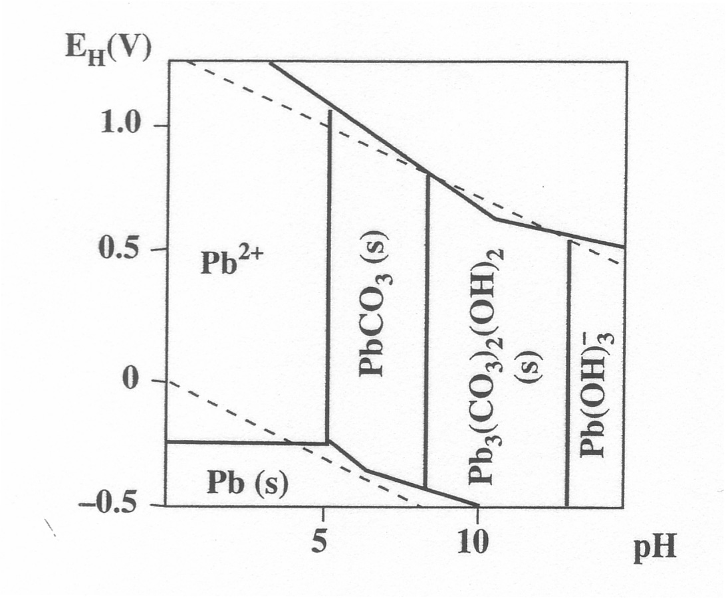To save your time in this problem, you should follow the examples and use the same Gfo values in your handout.

4. The diagram to the right illustrates some oxidation/reduction chemistry of lead.

Estimate the pH and redox conditions in the following types of water by drawing circles on the pH-Eh diagram to indicate the approximate positions:

* 1. Surface ocean water
  2. Normal stream water
  3. Aerobic acidic mine drainage waters
  4. Anaerobic saline lake water
  5. Water logged soil
  6. Surface water of a New England lake that has been severely affected by acid rain
  7. For each of these water types identify the most stable lead species.
  8. What pH range of the natural waters will most likely mobilize Pb according to the stability field diagram?

5. (a). What are terminal electronic acceptors? Describe the redox ladder.

(b). Explain the conceptual changes in species concentrations in groundwater as it travels away from the recharge area (see figure below). The confined aquifer is hypothetical: it contains organic carbon and all the major electron acceptors.



6. High concentrations of Arsenic in Bangladesh’s groundwater has had devastating effect on human health and has received attention from scientists around the world. There are major debates on the causes of the high arsenic concentrations in the groundwater. Early studies sponsored by the World Health Organization (WHO) suggested oxidation of arsenopyrite as the mechanism of releasing As into the groundwater. However, a careful examination on the pe-pH diagram of the As species suggests the mobility of As species under oxidized conditions is unlikely. Charles Harvey et al., (2002) suggested an alternative mechanism to explain the high concentration of As in Bangladesh’s groundwaters. Please read this paper (posted on Canvas) and two other related papers and answer the following questions:

1). What is the predominant oxidation state of the dissolved As species in the groundwaters? Why is As unlikely to be mobile under oxidized conditions?

2) Is arsenopyrite (or pyrite with high arsenic content) or iorn oxide (with significant amount of As absorbed on it) the main direct source for dissolved As in ground waters?

3) In Fig.1 of Harvey et al. (2001), the highest concentration of dissolved As is at around 30 to 40 m. At around the similar depth, sulfate concentrations reach the minimum, whereas ammonium and calcium concentrations peak. Explain these concentration changes and correlations.

4). In Fig.2A of Harvey et al (2001), authors describe how As concentration in groundwaters respond to artificial injection of nitrate. Please explain the observations that As levels fall rapidly when nitrate is added.

5) In Fig.3 of Harvey et al. (2001), dissolved inorganic carbon (DIC) in the groundwater is significantly younger (as determined by radiocarbon dating) than the dissolved organic carbon (DOC). Also, DIC (-5 to -10 ‰) has much higher carbon isotopic ratio (δ13C) than DOC (-25 to -28 ‰). Can you explain the observation? Hint: δ13C value of marine carbonate minerals is about 0 ‰, whereas δ13C value of plant organic matter is about -25 to -28 ‰. Therefore if the carbon comes from carbonate dissolution, the δ13C value would approach 0 ‰.

6). Explain the concentration trends in the As (III), As (V) and Fe (II) during the incubation experiments carried out in Islam et al (2004). According to the paper, is the reduction of As (v) to As (III) by microbes an assimilative or dissimilative process? Why?