Doe, A Deer

This composition is trash! Come back next week!  
If you don’t show up with any work again, you’re off the band!

$$\frac{4}{10}$$

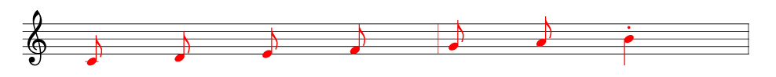An original composition

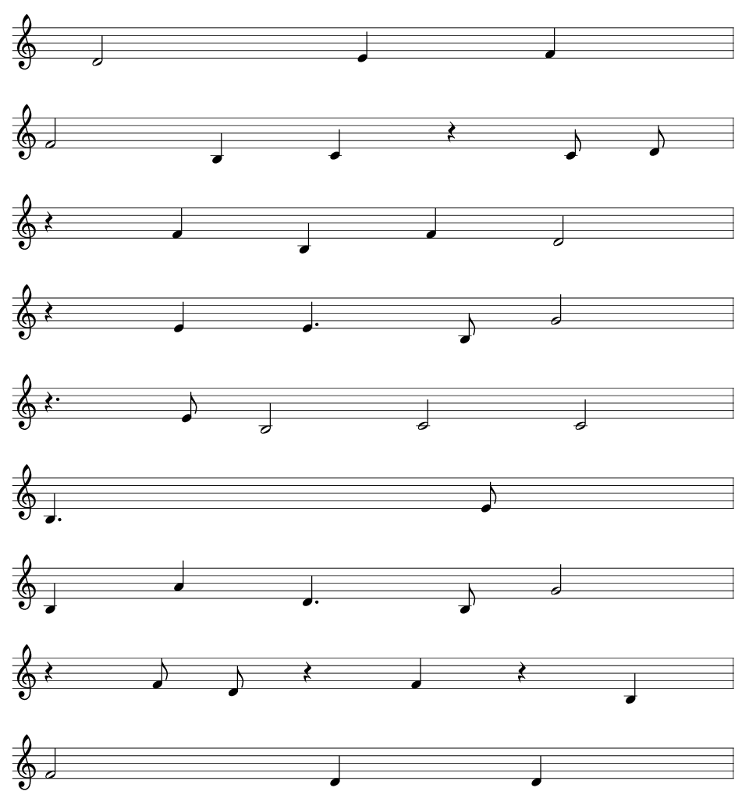

This isn’t even music

I absolutely hate this part

You call this an ending?