Shreedhar Khorate
P1-C:
Error Containing Code
#include <stdio.h>
int genaiNum() {
int a = 94;
int b = 37;
int result;
if(a > 0 && b > 0);
{
int first = a % 10;
int second = b % 10;
result = first * 10 + second;
}
if(result >= 10 && result <= 99)
return result;
else
return -59;
}
int main() {
int final = genaiNum() ();
printf(final);
return 0
}
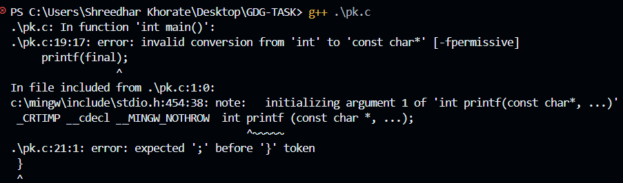

Correct Code:
#include <stdio.h>
int genaiNum() () {
int a = 94;
int b = 37;
int result;
if(a > 0 && b > 0) {
int first = a % 10;
int second = b % 10;

result = first * 10 + second;
}
else {
return -59;
}
if(result >= 10 && result <= 99)
return result;
else
return -59;
}
int main() {
int final = genaiNum() ();
printf("%d\n", final);
return 0;
}
Generated Number:47

P2-C:
Error Containing Code
#include <stdio.h>
int main() {
int a = 72;
int b = 48;
int first = (a / 10) + (b % 10);
int second = a % 10 + b / 10 % 10;
int temp = first * 3 + second * 2;
int result = (temp / 10) * 10 + (temp % 10);
if(result >= 10 && result <= 99 && result % 2 == 0)
printf("%d\n", result);
else
printf("%d\n", 50);
return 0;
}
Corrected code:
#include <stdio.h>
int main() {
int a = 72;
int b = 48;
int first = (a / 10) + (b % 10);
int second = (a % 10) + (b / 10);
int temp = first * 3 + second * 2;
int result = temp % 100;
if(result >= 10 && result <= 99)
printf("%d\n", result);
else
printf("Invalid\n");
return 0;
}
Generated Number:
57

P3-C:
Error containing code:
#include <stdio.h>
int main() {
int a = 72;
int b = 48;
int temp = (a / 10 + b % 10) * 3 + (a % 10 + b / 10) * 2
int result = temp % 100;
if(result >= 10 && result <= 99 && result / 10 = result % 10)
printf("%d\n", result);
else
printf("%d\n", 50);
return 0;
}
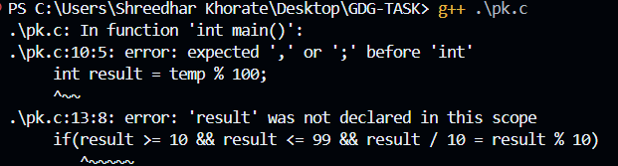
Correct code:
#include <stdio.h>

int main() {

int a = 72;
int b = 48;

int temp = (a / 10 + b % 10) * 3 + (a % 10 + b / 10) * 2;

int result = temp % 100;

if(result >= 10 && result <= 99 && result / 10 == result % 10)
printf("%d\n", result);
else
printf("%d\n", 50);

return 0;
}

Generated Code:
50

PC1-Java
Error Containing Code:
public class MMNNSS {
public static void main(String[] args) {
float a = 72f;
float b = 48f;
float temp = (a / 10 + b % 10 * 3 + a % 10 + b / 10) * 2;
float result = temp % 100;
if(result >= 10 && result <= 99 || result == 57f)
System.out.println(result);
else
System.out.println(50);
}
}
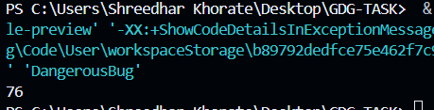
Corrected Code:
public class MMNNSS {
public static void main(String[] args) {
float a = 72f;
float b = 48f;
float temp = ((a / 10 + b % 10) * 3 + (a % 10 + b / 10) * 2);
int result = (int)(temp % 100);
if(result >= 10 && result <= 99)
System.out.println(result);
else
System.out.println(50);
}
}
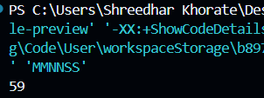
Generated Number:
59
P2-Java
Error Containing Code:
public class vit {
public static void main(String[] args) {
int num = 7248;
int result = 0;
boolean flag = true;
while(Flag) {
int temp = (num % 100 * (num / 100)
+ (num % 10) * 3;
result = temp % 100;
if(result >= 10 && result <= 99)
flag = false;
num = num / 2;
};
System.out.println(result);
}
}
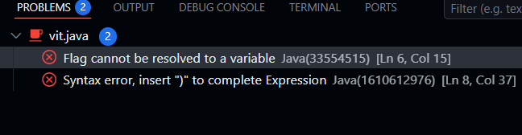
Corrected Code:
public class vit {
public static void main(String[] args) {
int num = 7248;
int result = 0;
boolean flag = true;
while(flag) {
int temp = (num % 100) * (num / 100)
+ (num % 10) * 3;
result = temp % 100;
if(result >= 10 && result <= 99)
flag = false;
num = num / 2;
}
System.out.println(result);
}
}
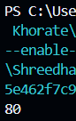
Generated Code:
80

P3-Java
Error Containing Code:
public class GDG {
public static void main(String[] args) {
int num = 7248;
int result = (num * 3) / (num % 7) % 100;
switch(result % 10) {
case 0:
System.out.println(result);
break;
case 1:
System.out.println(result + 10);
case 2:
System.out.println(result - 5);
break
default:
System.out.println(50);
}
}
}
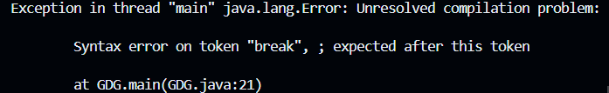
Corrected Code:
public class GDG {
public static void main(String[] args) {
int num = 7248;
int result = (num * 3) / (num % 7) % 100;
switch(result % 10) {
case 0:
System.out.println(result);
break;
case 1:
System.out.println(result + 10);
break;
case 2:
System.out.println(result - 5);
break;
default:
System.out.println(50);
}}}
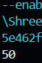
Generated Code:
50

P1-Python:
Error containing code:
num = 7248
digits = []
while num > 0:
digits.insert(0, num % 10)
num //= 10
extra = (digits[0] * digits[-1]) % 10
digits.insert(2, extra)
mid = (digits[1] + digits[2]) // 2
digits.append(mid)
temp = digits[1:4]
temp.reverse()
result = temp[0] * 10 + temp[1]
if result >= 10 and result <= 99 or result == 36:
print((bool)result)
else:
print(50)
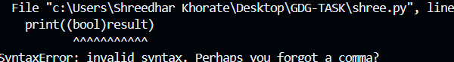
Corrected code:
num = 7248
digits = []
while num > 0:
digits.insert(0, num % 10)
num //= 10
extra = (digits[0] * digits[-1]) % 10
digits.insert(2, extra)
mid = (digits[1] + digits[2]) // 2
digits.append(mid)
temp = digits[1:4]
temp.reverse()
result = temp[0] * 10 + temp[1]
if result >= 10 and result <= 99:
print(result)
else:
print(50)
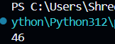

Generated Number:
46
P2-Pyhton:
num = 811910
digits = []
result = 0
while num > 0:
digits.insert(0, num % 10)
num //= 10
while True:
temp = (digits[0] * digits[-1]) + digits[1]
result = temp % 100
if result >= 10 and result <= 99:
break
while result >= 10 or result <= 99
print(result)
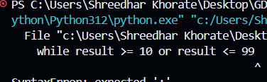
Correct code:
num = 811910
digits = []
result = 0
while num > 0:
digits.insert(0, num % 10)
num //= 10
index = 0
while True:
temp = (digits[index] * digits[index + 1]) + digits[2]
result = temp % 100
if 10 <= result <= 99:
break
index += 1
if index >= len(digits) - 1:
break
print(result)
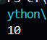
Generated Code:
10
P3-Python
Error Containing Code:
num = 811910
digits = []
result = 0
while num > 0:
digits.insert(0, num % 10)
num //= 10
i = 0
while i < len(digits):
temp = (digits[i] * digits[-(i+1)]) + (digits[i] + digits[-1])
digits.insert(i, temp % 10)
sub = digits[i:i+3]
if len(sub) < 2:
break
result = (sub[0] * 10 + sub[1]) % 100
if result >= 10 and result <= 99:
i += 2
else:
i += 1
if len(digits) > 12:
break
print(result)

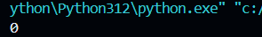
Corrected Code:
num = 811910
digits = []
result = 0
while num > 0:
digits.insert(0, num % 10)
num //= 10
i = 0
while i < len(digits) - 1:
left = digits[i]
right = digits[-(i+1)]
temp = (left * right) + (left + digits[-1])
sub = digits[i:i+2]
result = (temp + sub[0]) % 100
if 10 <= result <= 99:
break
i += 1
print(result)
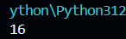
Generated Number:
16

