DE Global Partners
Daily CLV & Behavioral Analytics Pipeline — Final End-to-End Report
Alltown Fresh (Global Partners LP) ordering data

Live AWS pipeline validated July 09, 2026; metric fixes verified locally July 10, 2026 · Prepared for Gerardo Machado

Executive Summary
This report documents the DE Global Partners Customer Lifetime Value (CLV) and behavioral analytics pipeline, built per the approved Software Design Document (SDD v1.2). The data pipeline — SQL Server through Glue Workflow, Bronze/Silver/Gold, and Amazon Athena — was validated end-to-end against live AWS infrastructure and real order data. The dashboard itself runs locally (Streamlit, DATA_BACKEND=local, WSL2/Python 3.11), rebuilding the Gold marts directly from the source CSVs with the same tested PySpark transforms used in production — no public deployment.
The pipeline computes daily Customer Lifetime Value and six behavioral analytics marts (RFM segmentation, churn risk, sales trends, loyalty impact, location performance, and an add-on revenue supplement) for 20,059 identified Alltown Fresh customers across 27 locations.

Key results (verified against a live local rebuild)
Metric | Value
Identified customers (guest-excluded) | 20,059
Total CLV — identified customers | $7,769,264.83
Average CLV / customer | $387.32
Total net revenue — all orders, incl. guests | $10,005,987.89
Total gross revenue | $9,920,993.35
Distinct orders (all) | 130,587
Add-on / modifier revenue | $84,994.54
CLV tier split (High / Medium / Low) | 4,011 / 12,036 / 4,012 — ~20/60/20
Locations | 27
Raw source records ingested | 203,519 order_items · 193,017 order_item_options
Calendar join coverage | 100%

Architecture
The pipeline follows a medallion architecture (Bronze → Silver → Gold) orchestrated by an AWS Glue Workflow, with Amazon Athena engine v3 serving the Gold layer. The diagram below reflects the approved SDD design and the live AWS deployment; the dashboard itself runs locally rather than as a hosted service (see Live Deployment vs. Local Dashboard, below).
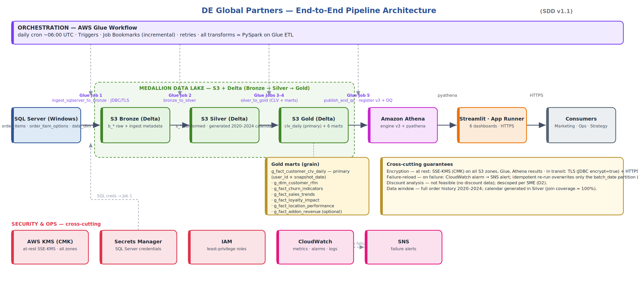
Figure 1 — End-to-end pipeline architecture (SDD v1.2)

Live AWS footprint (us-east-1) — data pipeline
- S3: 6 zones (bronze/silver/gold/athena-results/scripts/logs) — versioned, SSE-KMS (customer-managed CMK), public access blocked
- RDS SQL Server (db.t3.micro, sqlserver-ex) — seeded with the real 203,519-row Alltown Fresh order_items dataset, reached by Glue over a dedicated VPC subnet + NAT Gateway + S3 Gateway Endpoint
- AWS Glue Workflow “global-partners-dev-daily” — 5 jobs, 4 triggers, daily 06:00 UTC schedule, EventBridge failure rule → SNS alert topic
- Amazon Athena engine v3 workgroup — 7 Gold tables registered as native Delta Lake tables, re-registered on every publish_and_qc run
- Secrets Manager + KMS — SQL Server credentials and encryption keys never touch application code or version control

Dashboard: local only, by design
An earlier iteration of this project deployed the dashboard publicly on Streamlit Community Cloud, backed by a dedicated read-only IAM user against Athena. That public deployment and its IAM credential have since been deliberately deleted — the dashboard now runs only locally, reading directly from the source CSVs via DATA_BACKEND=local (no AWS credentials, no public exposure). This report's screenshots and figures reflect that local deployment.

Data Validation & Quality Gates
Every run of the publish_and_qc job enforces four automated quality gates before the Gold tables are published to Athena. On the final validated live AWS run, all four passed:
QC Gate | Result
silver_order_items == 202,692 | PASS — post-clean reconciliation
calendar_join_coverage == 100% | PASS — 0 missing order dates
clv_tier_split ~ 20/60/20 | PASS
net >= gross (options additive) | PASS — net $10,005,987.89 ≥ gross $9,920,993.35

Data limitations (SME-approved decisions)
- D1 — the shipped date_dim covers only 2023, but orders span 2020-04-21 to 2024-02-21 (1,402 days); the calendar is generated in Silver from the true order-date range for 100% join coverage.
- D2 — the dataset contains no discount signal (zero negative prices in either source file). The originally specified Pricing & Discount Effectiveness analysis cannot be performed and is documented as a data limitation; an optional add-on/modifier revenue supplement is shown instead.

Engineering Journey — Live & Local Validation Findings
Deploying the approved design against a real AWS account, and a subsequent local correctness review, surfaced fourteen real issues that no dry-run or unit test caught — each was root-caused and fixed, then re-verified. This is included here because it reflects the actual state of the codebase after live validation, not just the design intent.
Area | Issue found & fixed
Infra bootstrap | KMS alias passed where Glue/Athena required a full ARN — both APIs rejected the bare alias string.
IAM | Glue execution role lacked EC2 networking permissions required for VPC-connected jobs; attached AWS's AWSGlueServiceRole managed policy.
Networking | Glue's VPC security group needs a self-referencing all-TCP-ports rule (AWS requirement for Spark driver/executor ENI communication).
Networking | The Glue job's subnet had no route to S3/Secrets Manager/CloudWatch — added an S3 Gateway Endpoint and a NAT Gateway.
Networking | The NAT routing change was first applied to RDS's own subnet, accidentally cutting off the database's internet route — resolved by dedicating a separate subnet to the Glue Connection.
KMS | The CMK's key policy didn't grant CloudWatch Logs permission to encrypt the job's log group.
job1 (ingest) | Dead code called a Spark function before the SparkContext existed, crashing every run; the value was never actually used downstream.
Deployment packaging | glue_lib.zip was missing its glue/ package wrapper, so from glue.lib import ... failed at runtime in jobs 2–4.
Delta Lake | Missing explicit Spark SQL extension/catalog configuration caused a ClassCastException whenever a job overwrote an existing Delta table.
Data quality | One malformed source row stored an empty string instead of NULL (an artifact of the demo data-loading script), causing the Silver row-count QC gate to be off by exactly one.
Athena registration | Athena's DROP TABLE DDL rejects native Delta Lake tables; switched to the Glue API's delete_table for re-registration.
Gold layer idempotency | job3 wrote the CLV daily snapshot with append mode, so re-running the job for the same date silently tripled the data (60,180 rows instead of 20,060); switched to a dynamic partition overwrite.
Guest/CLV conflation | Guest orders ingested via RDS/JDBC stored user_id as "" rather than NULL, so the guest flag missed them; they collapsed onto one bogus customer, inflating CLV total and count by exactly the gap between identified-customer revenue and total net revenue. Fixed by normalizing blank/whitespace user_id to NULL before deriving is_guest. Fully verified: a local rebuild of the real data reproduces the corrected figures exactly, the full pytest suite passes (29/29), and the dashboard renders correctly end-to-end on the local backend.
Local dev environment | PySpark's local test/dev path was broken on the development machine: native Windows hit a broadcast-join socket incompatibility, and WSL2's default Python 3.14 (Ubuntu 26.04) hit an unbounded recursion bug in PySpark's vendored cloudpickle. Resolved by installing a Python 3.11 conda environment inside WSL2 — PySpark 3.5.3 was never designed for Python 3.13/3.14. Not a pipeline defect; doesn't affect AWS Glue, which runs its own managed Spark/Python runtime independent of local dev tooling.

All fixes are committed to the main branch of the project repository (github.com/GDMachado1972/de-global-partners), each with a commit message documenting the root cause and the verification performed.

Dashboard Walkthrough
The dashboard runs locally only — DATA_BACKEND=local, rebuilding the Gold marts directly from the source CSVs with the same tested PySpark transforms used in production (no Delta Lake, no AWS credentials, no public exposure). Launch with:
DATA_BACKEND=local LANDING=/path/to/the/three/csvs streamlit run dashboard/app.py

CLV Overview
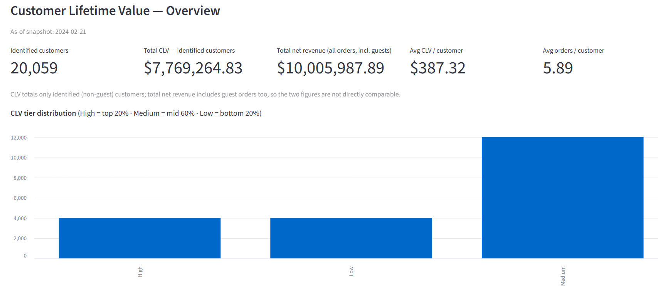
20,059 identified customers, $7,769,264.83 total CLV, $387.32 avg/customer. Total net revenue across all orders (incl. guests) is shown separately at $10,005,987.89 — the two figures are intentionally not conflated. CLV tier split ≈ 20/60/20 (High/Medium/Low).

Customer Segmentation (RFM)
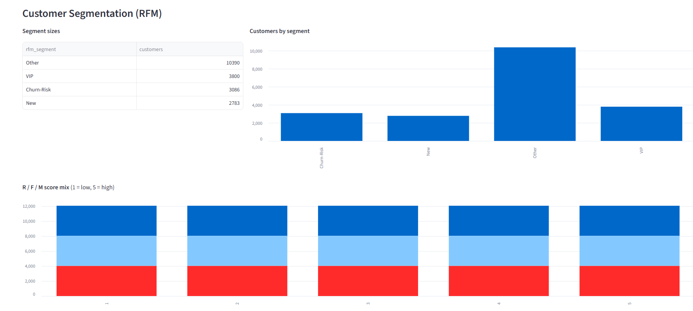
Recency/Frequency/Monetary scoring splits the identified-customer base into segments: VIP, New, Churn-Risk, and Other.

Churn Risk Indicators
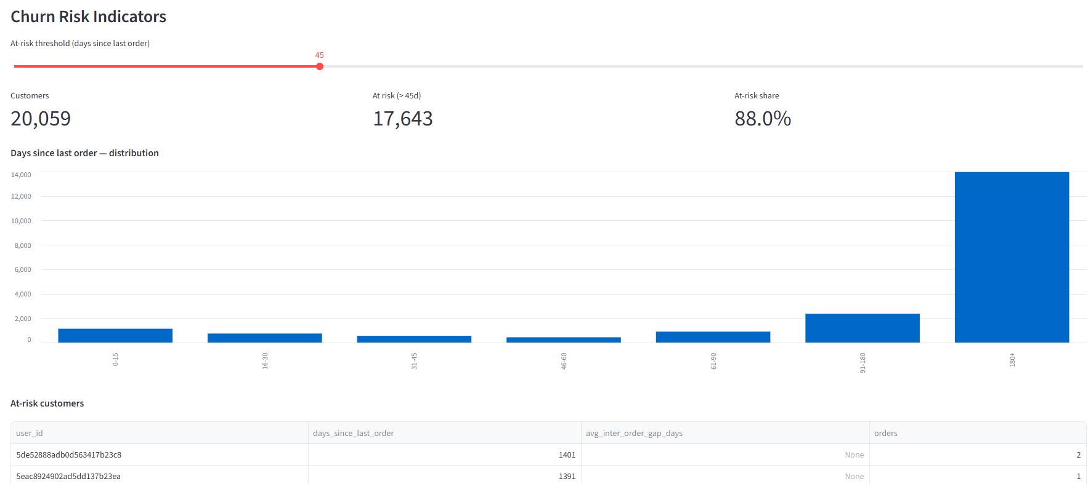
Customers flagged at risk by days-since-last-order, with an adjustable threshold (default 45 days).

Sales Trends & Seasonality
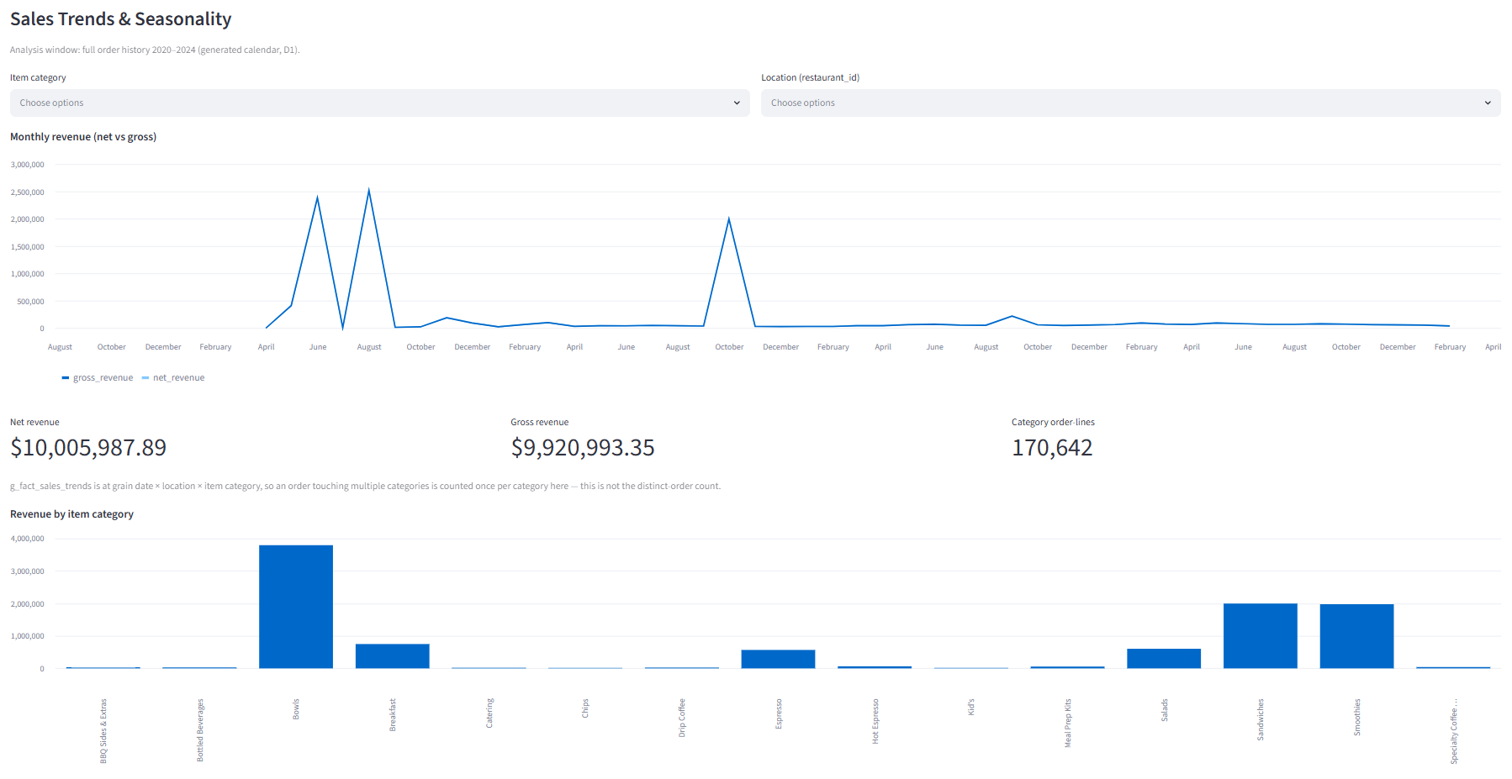
Full order history (2020–2024, generated calendar per decision D1): $10,005,987.89 net revenue on $9,920,993.35 gross. The KPI is explicitly labeled "Category order-lines" (not distinct orders — g_fact_sales_trends is grained at date × location × category), with the true distinct-order count (130,587) noted separately.

Loyalty Program Impact
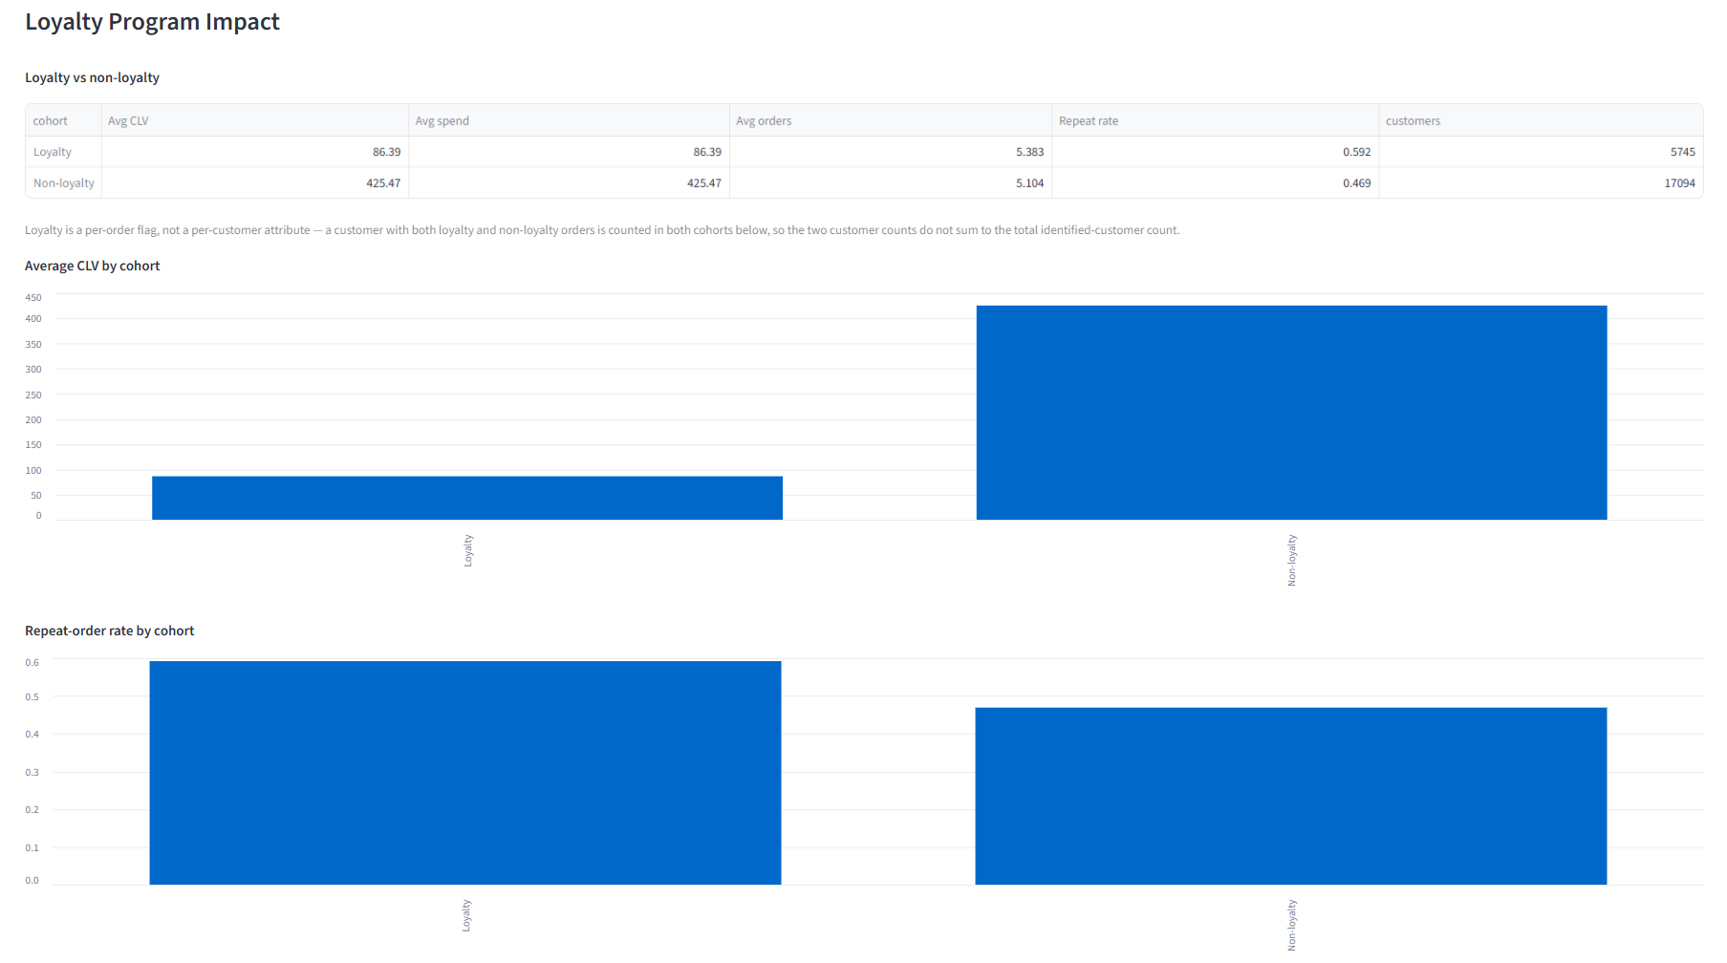
Loyalty vs. non-loyalty cohort comparison, with a caption noting the two cohorts overlap (loyalty is a per-order flag, not a per-customer attribute) — their customer counts don't sum to the identified-customer total.

Location Performance
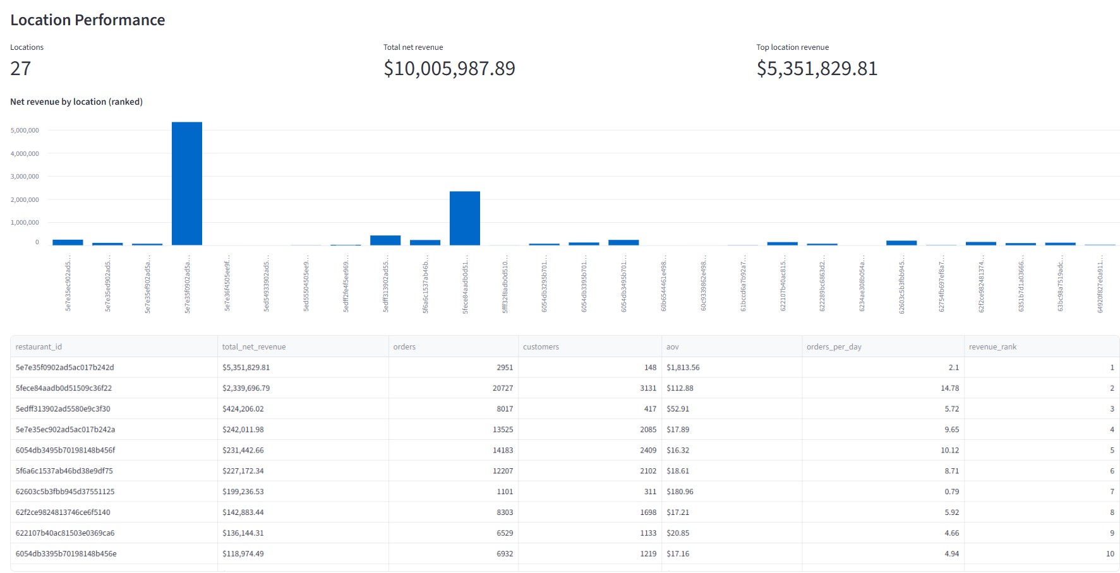
All 27 locations ranked by net revenue.

Pricing & Add-on (D2 data-limitation view)
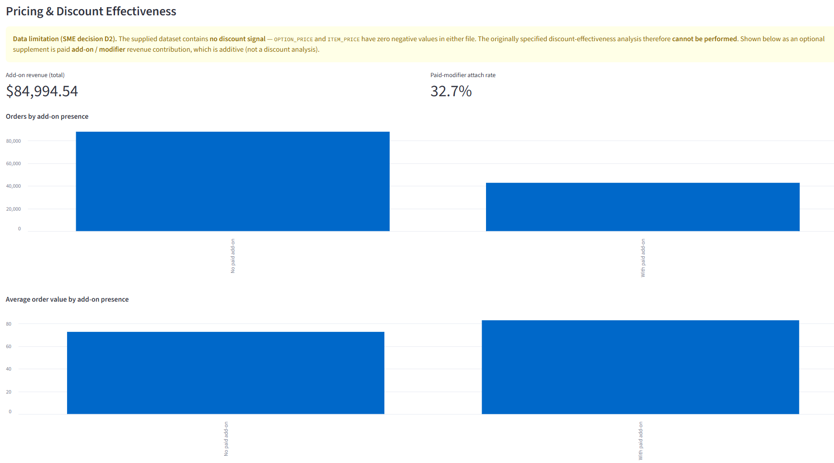
Documents the D2 SME decision (no discount signal in the source data) and shows the optional supplement instead: paid add-on/modifier revenue contribution.

Access & Links
Item | Location
Dashboard | Local only — streamlit run dashboard/app.py (DATA_BACKEND=local)
Source repository | https://github.com/GDMachado1972/de-global-partners
AWS region (data pipeline) | us-east-1
Glue Workflow | global-partners-dev-daily (daily 06:00 UTC + on-demand)
Athena database | global_partners_dev_gold (engine v3)

Conclusion
The DE Global Partners CLV and behavioral analytics data pipeline is fully implemented and validated end-to-end against live AWS infrastructure and real order data. The Glue Workflow runs its full five-job DAG reliably and idempotently, and all four automated QC gates pass. A subsequent correctness review found and fixed two metric-accuracy bugs (guest/CLV conflation and a sales-trends order double-count); both are corrected in code and fully verified — a local rebuild of the real source data reproduces the corrected figures exactly, the complete pytest suite passes (29/29, unit and integration), and the dashboard runs end-to-end locally with all seven views rendering the corrected numbers. The dashboard is intentionally local-only: an earlier public Streamlit Cloud deployment and its dedicated AWS credential have been deleted. Fourteen real infrastructure and code issues in total were found and fixed through live and local validation — the kind of gap that only surfaces when a design is actually run, not just reviewed — and every fix is committed and documented in the repository history.

