1.0 Golf bag

The golf bag is one of the crucial parts of the project as it holds the release mechanism of the golf club and the essential electronics. An old golf bag had been modified as manufacturing a new golf bag is unrealistic. The old golf bag had been dismantled to accommodate the release mechanism, compartment such as electrical base and mechanical base had been implemented to ensure the mechanism isn’t disturbed by the electrical system.

1.1 Golf Bag Infrastructure

The whole bag had 3 different parts, the top base of the golf bag, the mechanical compartment and the electrical compartment as shown in Figure Golfbag.png . The top base of the golf bag is used as a support and segregation compartment for the golf clubs. The mechanical compartment consists of the motor compartment and the release mechanism. The motor compartment is placed in between of two support to ensure the motor keep in place during operation. The release mechanism is on top of the motor compartment. It had a support base to ensure the tube and the release mechanism stay aligned. All the electronics and the cabling are placed in the electrical compartment to ensure the cabling do not disturb the mechanical system and also for the ease on waterproofing all the electronics.

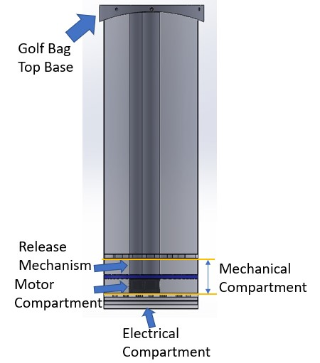

Figure Golfbag.png : Infrastructure of Golf Bag

1.2 Top part of golf bag

The initial top part had been removed due to unfriendly design; the initial top part had uneven spacing for all the holes. By removing the initial top part, we could fully utilize the available space of the bag. A new design (Figure Toppart.png) had been implemented to fit 14 equal size release mechanism for the golf club. Each slot had equal spacing and had sufficient space between the slots. The new design had been initially laser cut with Plywood. The tube fitted the design and are well supported by it. Due to the limitation of the 3D printer size (250 x 210 x 210mm) , the new design had a dimension of (255 x 230 x 41 mm). It had been sliced into 4 equal pieces and been sent for 3D printing. The 3D printed parts had been assembled together by hot glue and glued on the frame of the old golf bag top frame as shown in Figure 3Dparts.png .

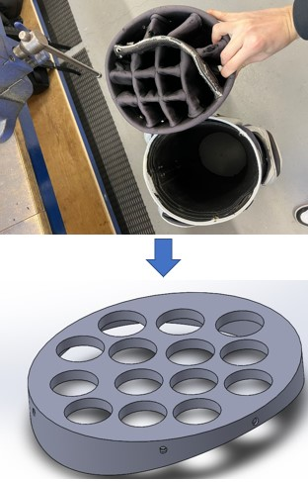 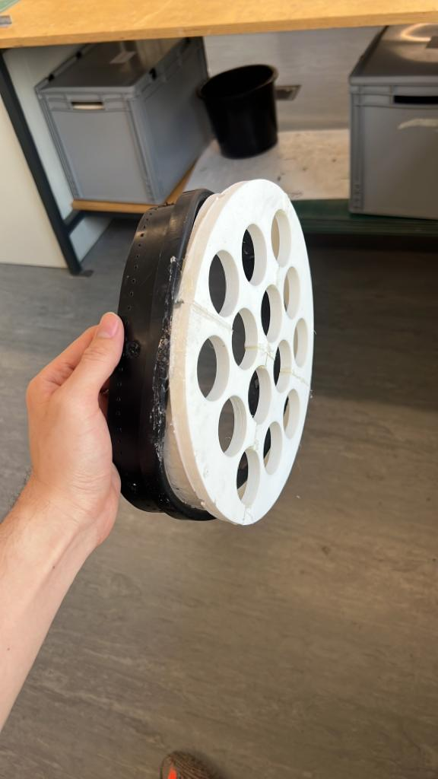 Figure 3Dparts.png : 3D printed top part

Figure Toppart.png : Top part of golf bag

The design in Figure 3Dparts.png had been used as the support for the release mechanism during testing. Due to the final changes in the of the release mechanism. A new top base had been designed to fit the latest release mechanism.

1.3

Extension of Golf Bag

The release mechanism used up 150mm of vertical height space of the whole golf bag . To prevent the golf club being extended too high in the mid air. The golf bag need to be extended to compensate the height used up by the mechanism. Therefore , the bag had been extended using rolled metal sheet. The extended part is used to fit in the mechanical base and the electrical base. The extended part is necessary as the release mechanism require an extra 90mm space. Therefore , the bag had been extended by 150mm. 90mm are used for the release mechanism , 50mm are used to fit the motor and 10mm are for the electrical base.

1.4 Mechanical Compartment

1.5 Electrical Compartment

The electrical compartment consist of the cabling, perfboard , Raspberry Pi. All the electronics are placed in the electrical compartment for ease of water proofing the electronics and to ensure the cabling do not disturb the mechanical system. All the cabling will be joined on a multiplexer so a main cable could be used to connect the connection between the golf bag and the caddy.

2.1 LCD Screen Casing

The LCD screen currently do not have any casing and all the electrical parts are exposed to the environment. In order to protect the LCD screen from environment damage such as rainwater damage and physical debris damage, a LCD screen casing had been made which are well compatible with the screen holder. The overall casing design are shown in Figure casing.png . The casing contains a top casing and a bottom casing having the screen in between them.

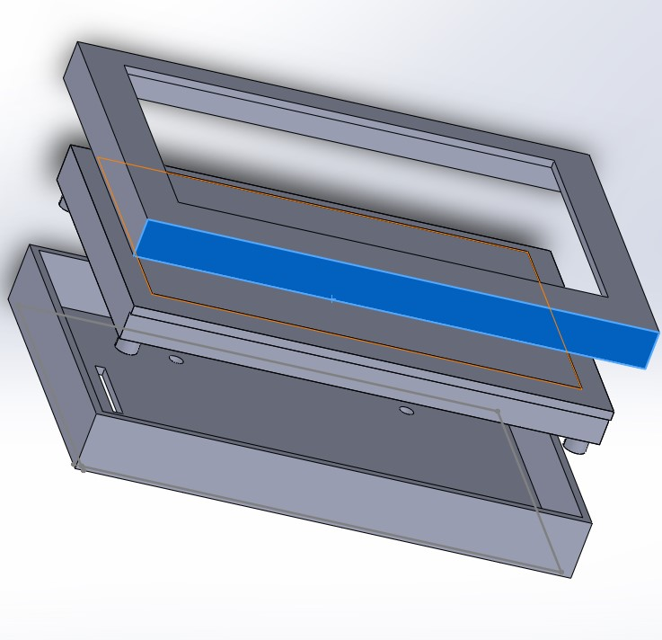

Figure Casing.png : Both top part and the bottom part of the casing with the LCD screen in between

2.2 Bottom casing

The bottom casing fit the LCD screen perfectly, there is a slot behind to allow the electrical ribbon to connect to the caddy. The bottom casing fits perfectly with the screen holder. All of the holes on Figure bottomcasing.png will screw directly to the LCD screen except for hole A and B. The screw will go through the holder and the casing to the LCD screen to ensure the screen and the casing hold firmly on the screen holder.

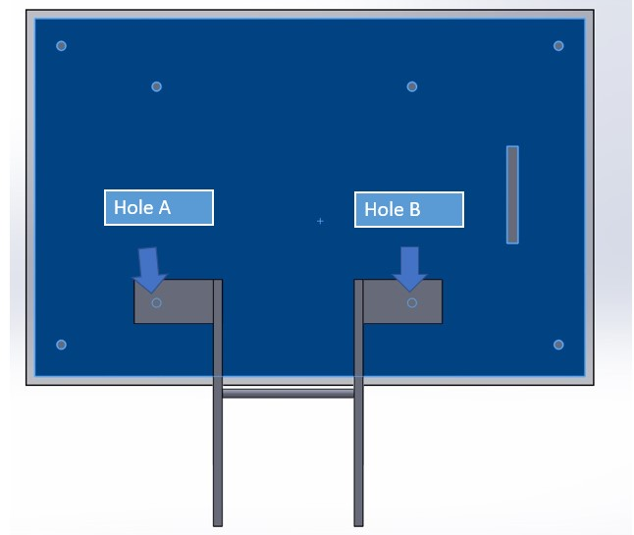

Figure bottomcasing.png : Bottom view of the bottom casing with all the holes

2.3 Top screen

The top screen covers the bottom casing edges and also the LCD screen as shown in Figure topcasing.png . The orange line represents the LCD screen, the yellow line represents the bottom casing while the grey line represents the top screen casing. There is an empty slot on the top screen to install a screen protector on it. The screen protector will be glued on the casing and a layer of resin will be added to prevent water intake. The screen protector does not affect the touch screen functionality yet it provide rain resistance.

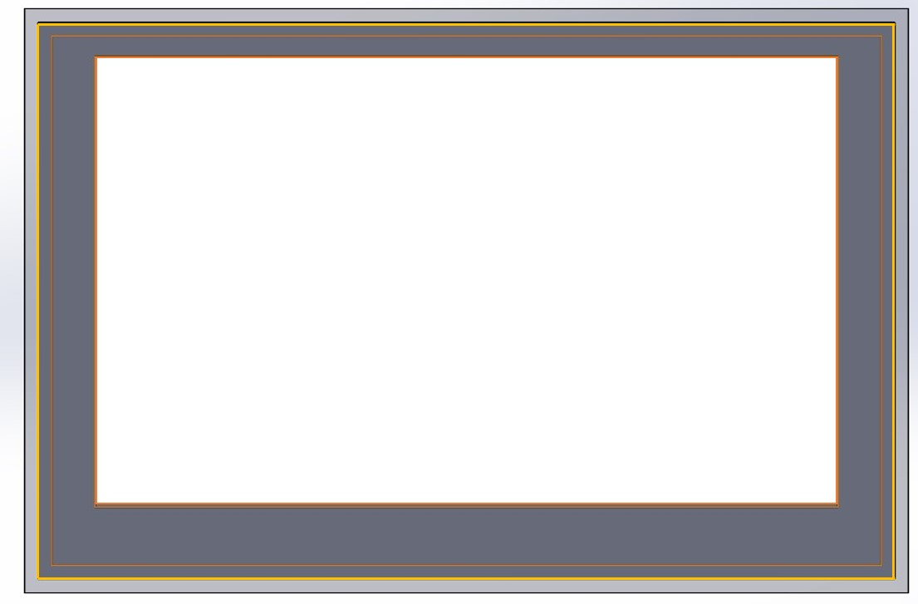

Figure topcasing.png: LCD screen (orange line), bottom casing (yellow line), top casing (grey line)

2.4 Friction hinge for screen

The screen had been installed right below the caddy handle. The location of the screen is well placed as it utilizes the abundant space of the caddy, it does not affect the folding operation of the caddy. The screen can be folded and unfolded by using a friction hinge design as shown in Figure caddy.png . The folding action took place by pushing the hinge 90 degree. The hinge shown in Figure hinge.png relies on the friction provided from the bolts and nut. The tighter the bolts and nut , the harder to rotate the hinge.

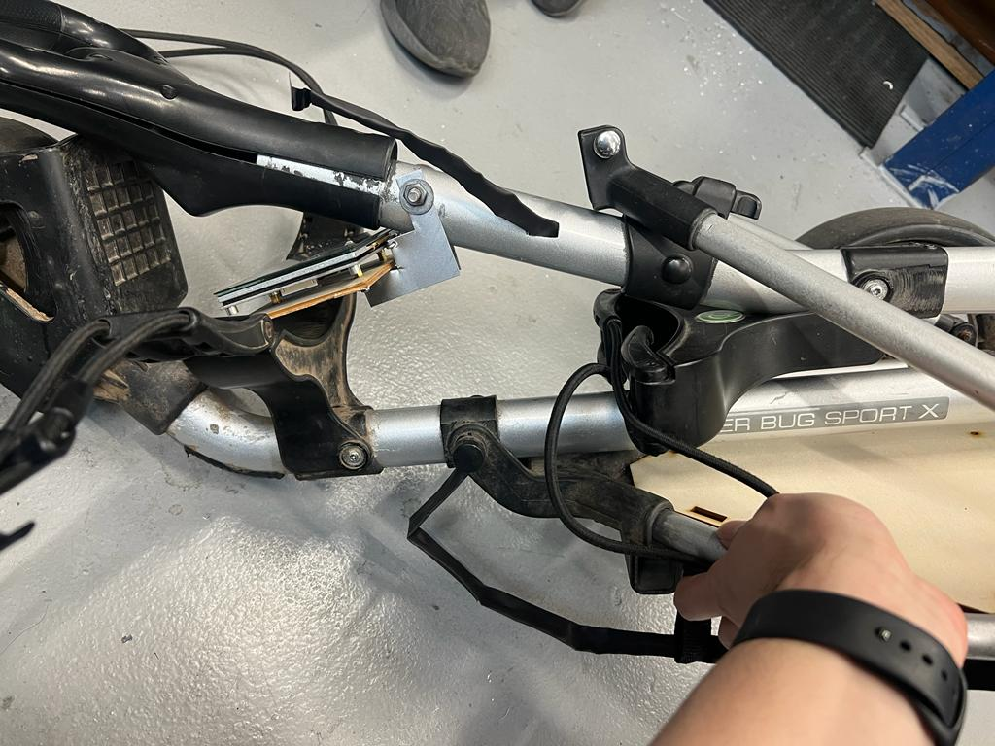

Figure Caddy.png : LCD screen fit well without affecting the caddy folding operation

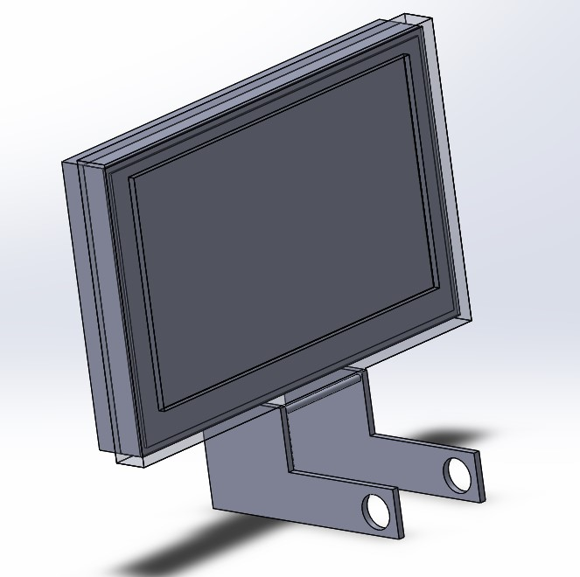

Figure hinge.png : Friction hinge for the LCD screen