

Booking plugin for WordPress

# **Initial setup**

How to install the plugin and connect it to the Hostify API.

**Table of Contents**

Initial setup 1

1. Install Hostify plugin 2

2. Connect to API 3

3. Setup pages 4

4

## 1. Install Hostify plugin

Hostify booking plugin is not listed in the WordPress plugin directory.   
So this plugin can be installed using the upload option in the admin area or using FTP.

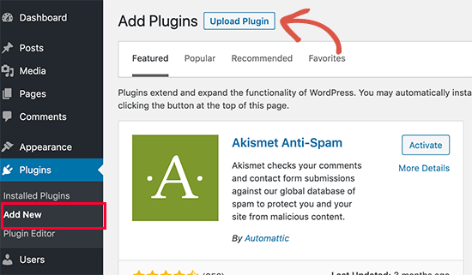

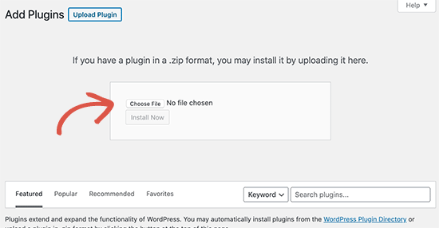

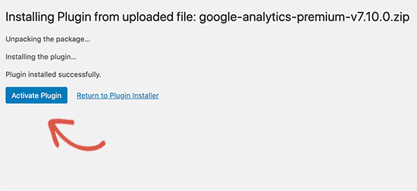

## 2. **Connect to API**

Open the plugin settings and specify the URL and WPKEY to connect to the hostify API:

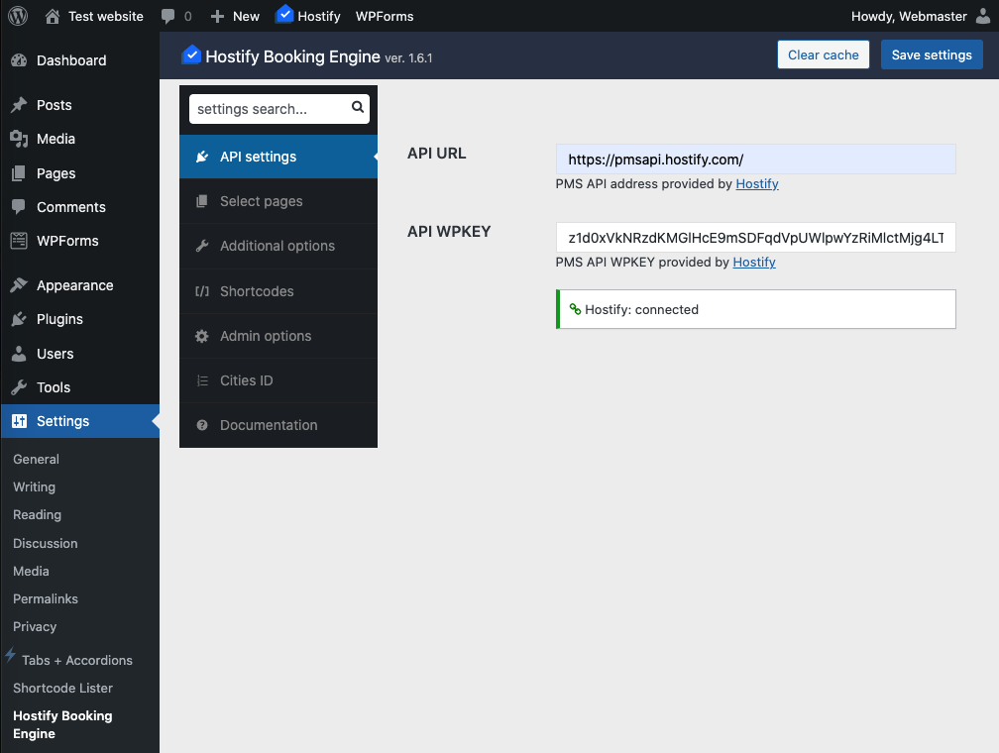

## 3. Setup pages

Next, select or create new pages. This is necessary to link these pages with the necessary functionality.

You can create a new page or choose from existing ones:

