

Booking plugin for WordPress

# **Guest area setup**

How to build Guest area (also known as "User account" or "Member") functionality for logged in user.

**Table of Contents**

Guest area 1

1. Install user management plugin 2

2. Setup pages, menus, widgets 3

2.1. Select or create pages 3

2.2. Add custom page for list of user bookings 4

2.3. Add menu links 4

## 1. Install user management plugin

There are WP plugins that allow to extend the basic WP functionality for users management: customize registration and login, manage profiles, roles and other user related things: Ultimate Member, ProfilePress, BuddyPress, S2Member, WP User Manager, bbPress and others.

First you need to install one of these plugins.

The Hostify booking plugin allows to add some features that will only be available to a registered and logged in user:

* automatic substitution of the user's names and personal data in the payment or inquiry form;
* user can see a list of his bookings: upcoming, current, past, cancelled;
* user can add listings to his own wishlist;
* user can cancel upcoming reservation (TODO)

## 2. Setup pages, menus, widgets

First, define and create places, widgets and pages where the plugin' shortcodes will be placed - the corresponding blocks will be displayed instead.

### 2.1. Select or create pages

In the plugin settings, select or create new pages. This is necessary to link these pages with the necessary functionality:

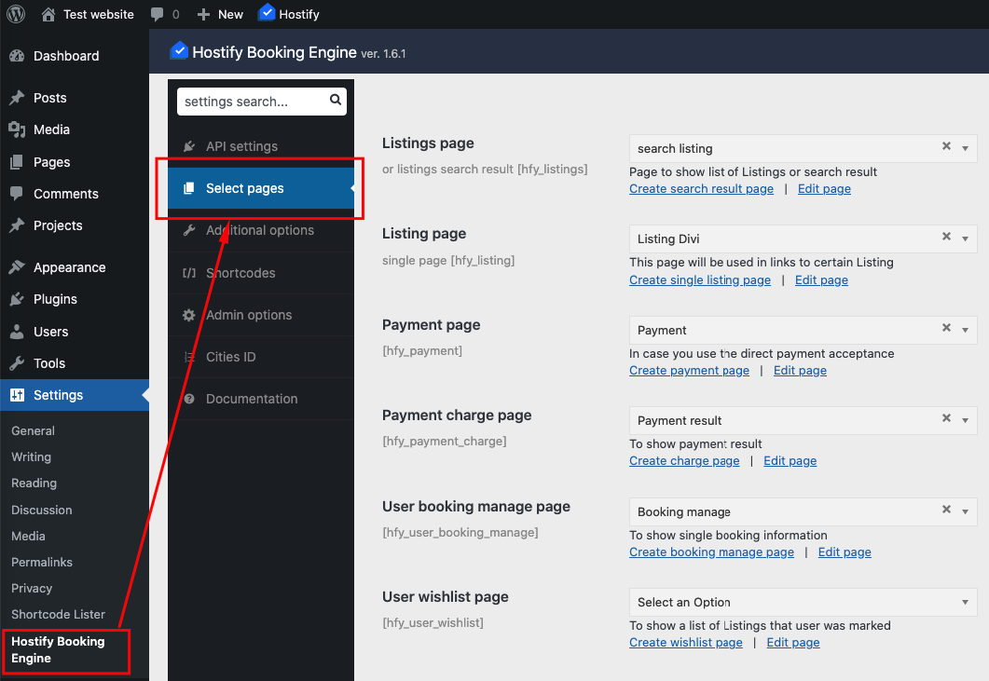  
The **user booking manage page** will contain this shortcode:

| [hfy_user_booking_manage] |
| --- |

which shows information about the selected reservation, as well as a button to request cancellation of this reservation.

The **user wishlist page** will contain this shortcode:

| [hfy_user_wishlist] |
| --- |

which shows a list of Listings that user was marked.

### 2.2. Add custom page for list of user bookings

Place this shortcode on this page:

|  |  |
| --- | --- |
| [hfy_user_bookings_list] |  |

to show a list of user reservations.

By default, all reservations are displayed: current, future, past, cancelled.

The output can be splitted to show only the groups you need:

|  |  |
| --- | --- |
| [hfy_user_bookings_list type="current"] |  |
| [hfy_user_bookings_list type="future"] |  |
| [hfy_user_bookings_list type="past"] |  |
| [hfy_user_bookings_list type="cancelled"] |  |

This will allow, for example, placing lists in separate tabs.

Example page (edit mode, Gutenberg):

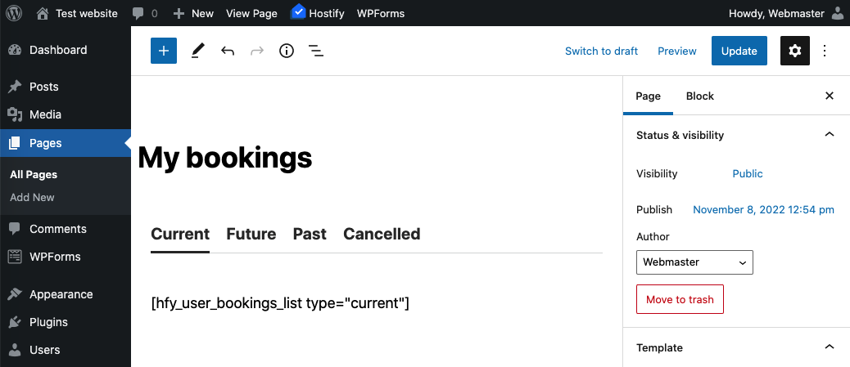

### 2.3. Add menu links

Add page links to menu on your site:

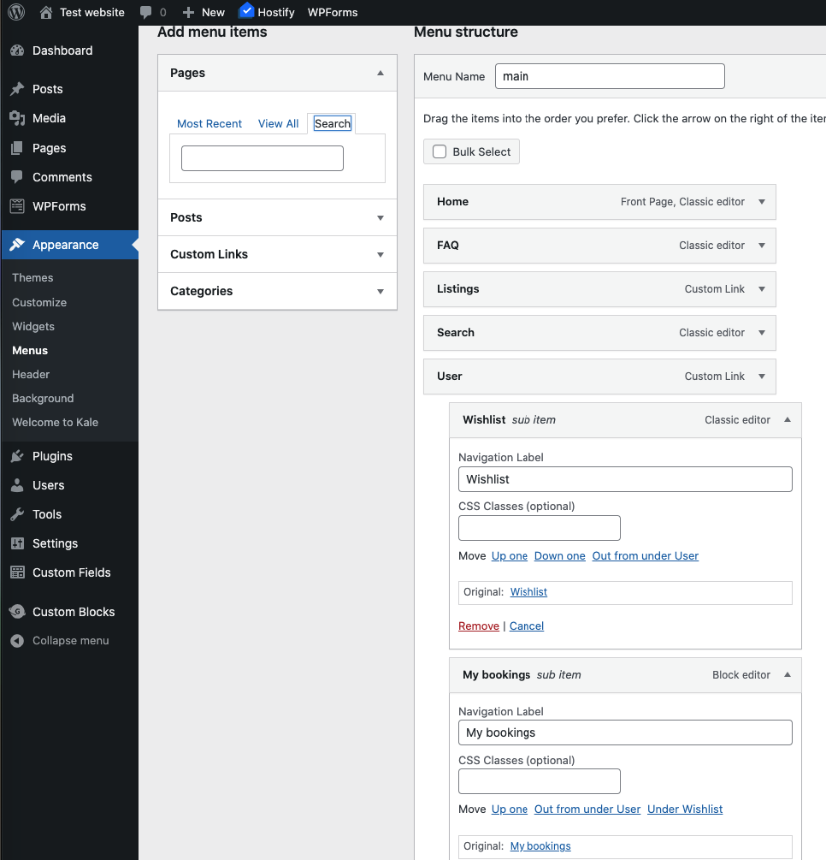

So, finally you will get something like this (depending on the theme you use):

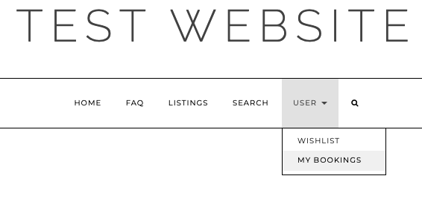

Of course, it all depends on the methods, plugins and theme you use.

Using the options of Member plugin you use or additional plugins / shortcodes / functions, you can hide or show the corresponding menu items for logged / non-logged users.

_______