**Day-30 Task**

1. Find the **title** of each film

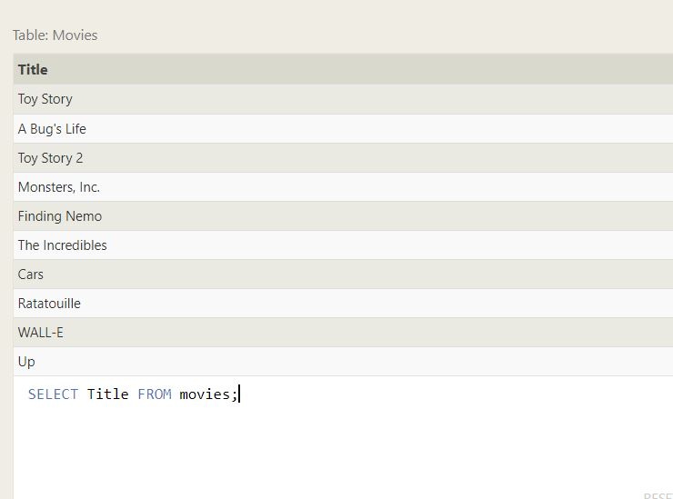

1. Find the **director** of each film

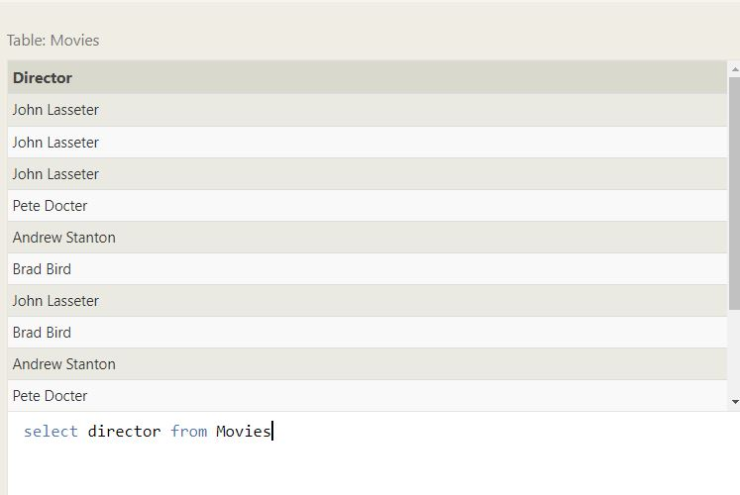

1. Find the **title** and **director** of each film

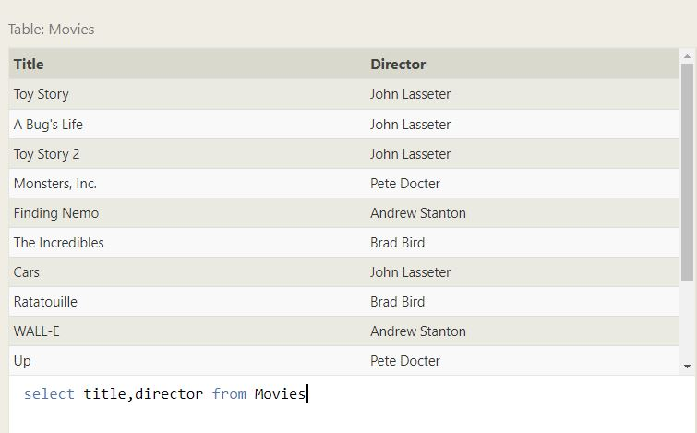

1. Find the **title** and **year** of each film

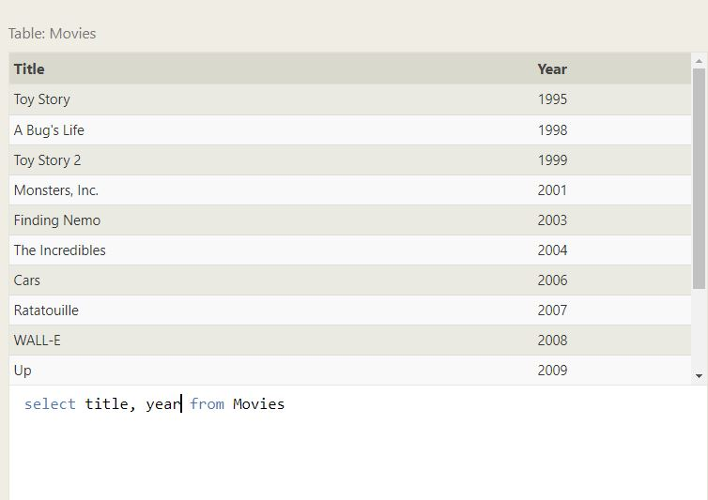

1. Find **all** the information about each film

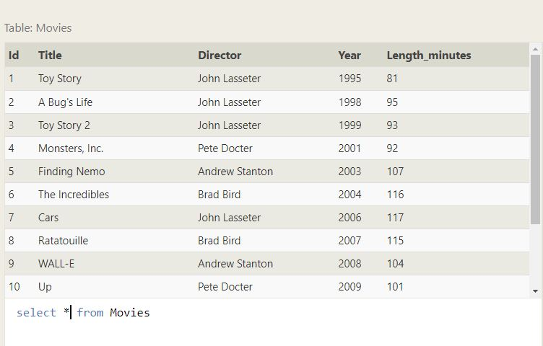

1. Find the movie with a row **id** of 6

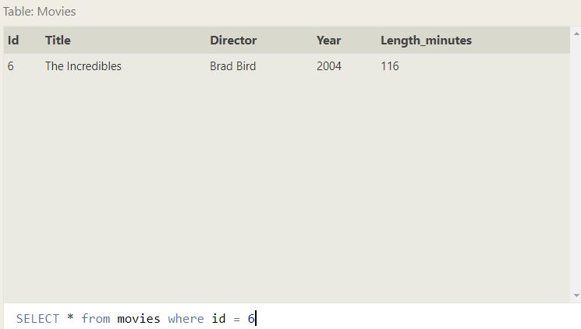

1. Find the movies released in the **year**s between 2000 and 2010

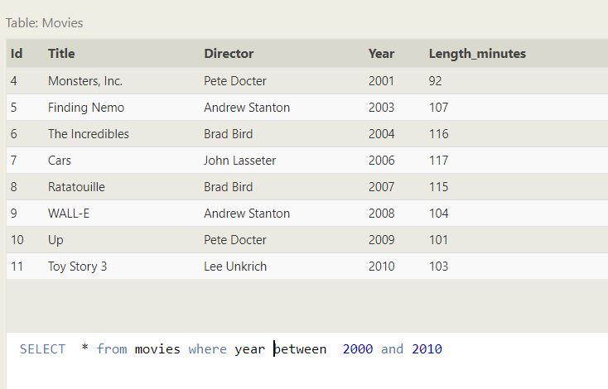

1. Find the movies **not** released in the **year**s between 2000 and 2010

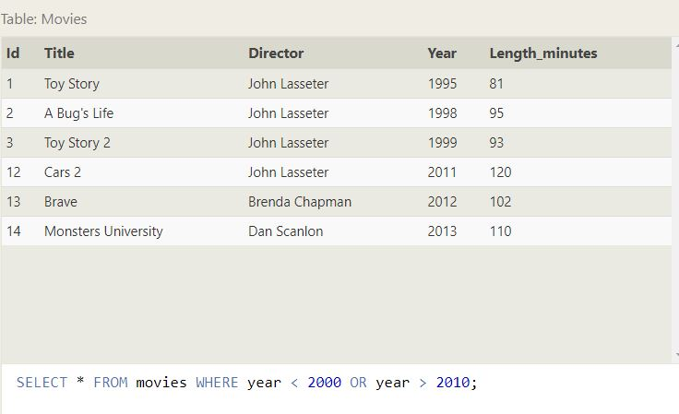

9. Find all the movies title and Year released in the **year** lesser than or equal to 2003.

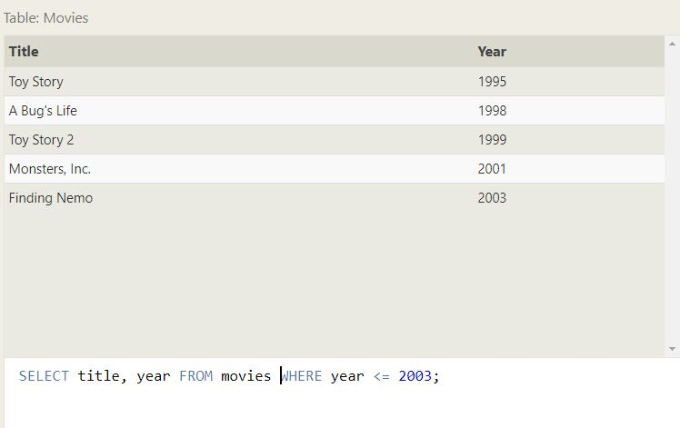

1. Find all the Toy Story movies

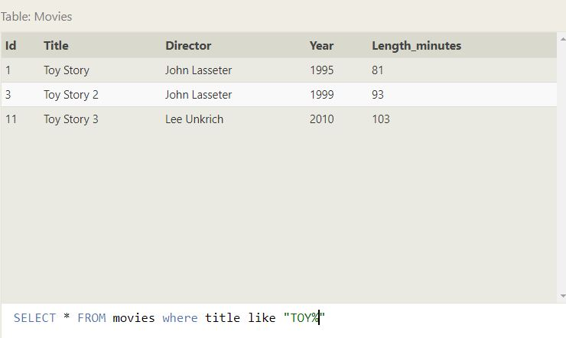

1. Find all the movies directed by John Lasseter

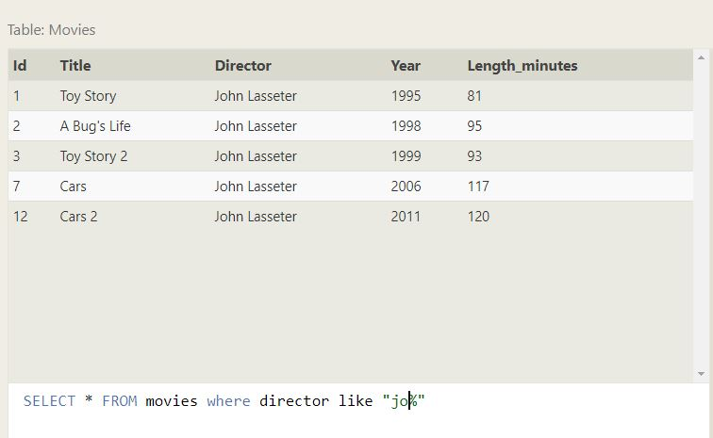

1. Find all the movies (and director) not directed by John Lasseter

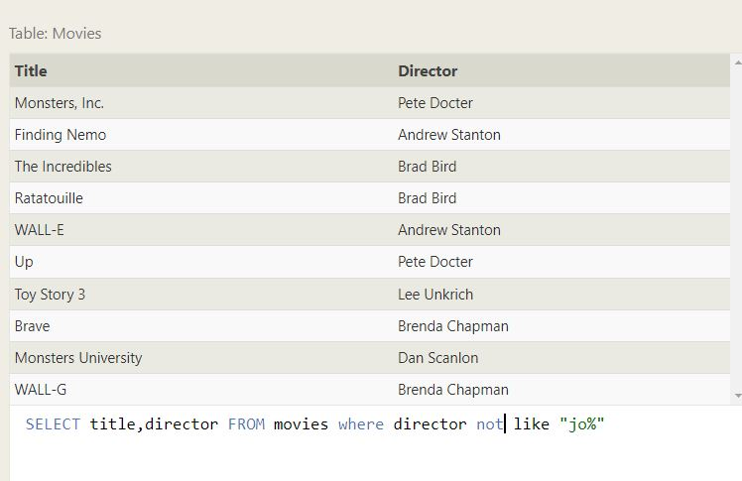

1. Find all the WALL-* movies

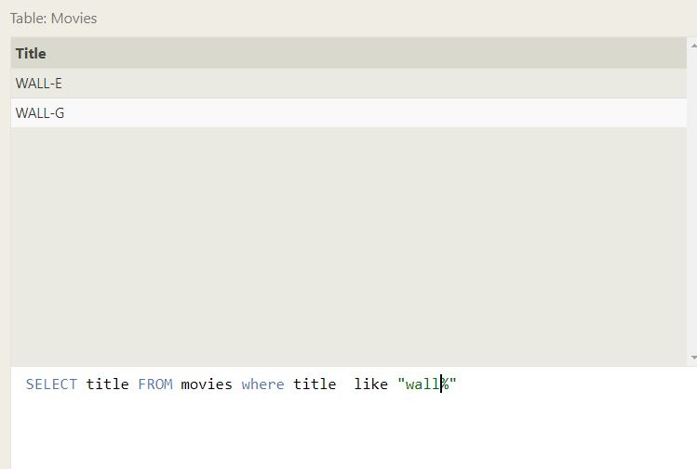

1. List all directors of Pixar movies (alphabetically), without duplicates

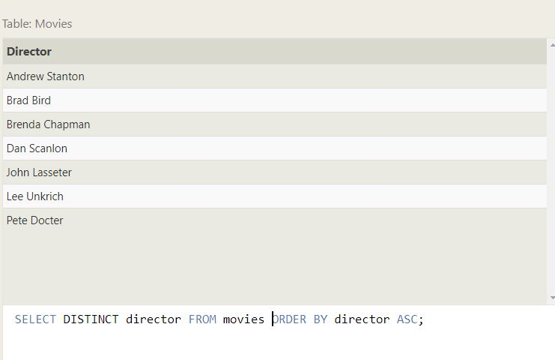

1. List the last four Pixar movies released (ordered from most recent to least)

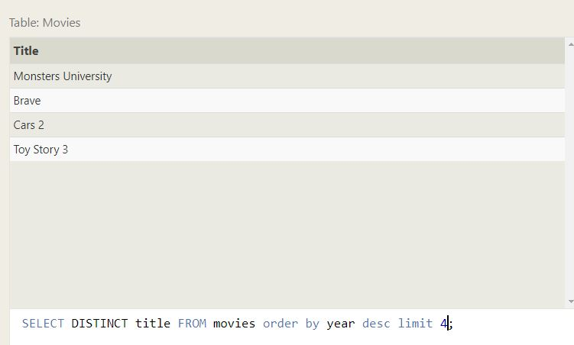

1. List the **first** five Pixar movies sorted alphabetically

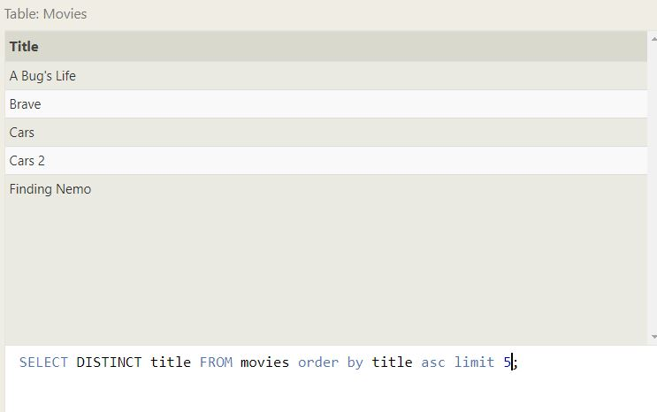

1. List the **next** five Pixar movies sorted alphabetically

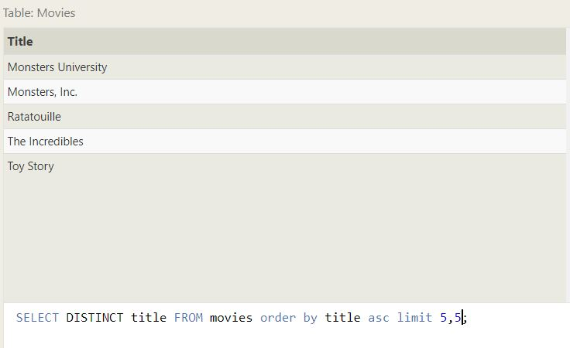

1. List all the Canadian cities and their populations

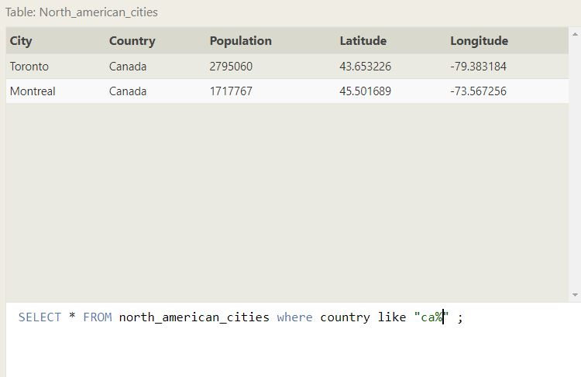

1. Order all the cities in the United States by their latitude from north to south

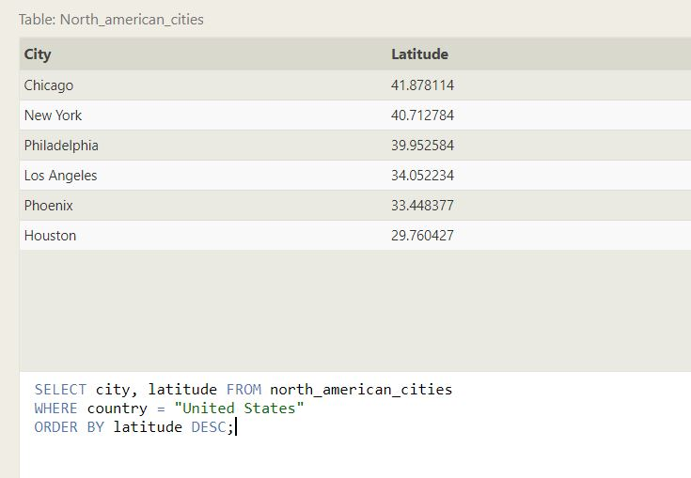

1. List all the cities west of Chicago, ordered from west to east

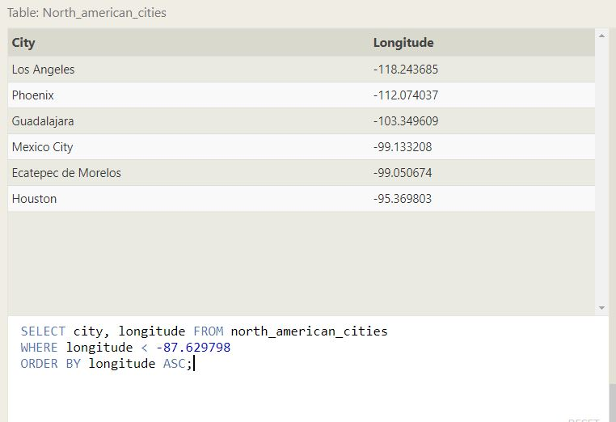

1. List the two largest cities in Mexico (by population)

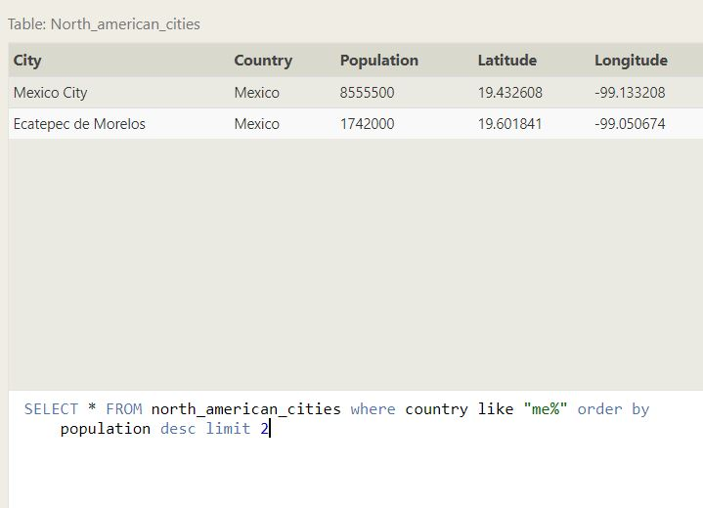

1. List the third and fourth largest cities (by population) in the United States and their population

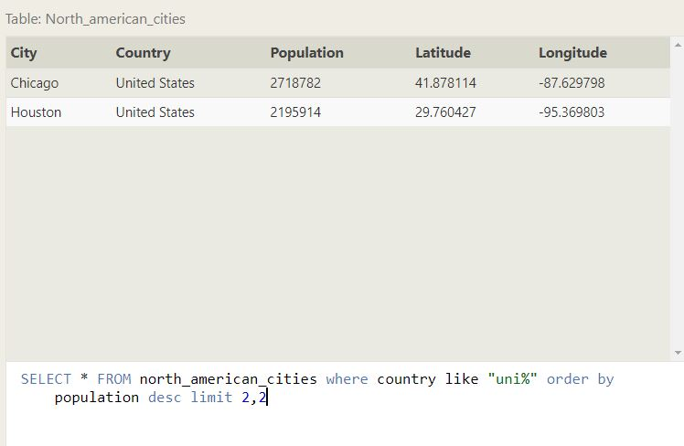

1. Find the domestic and international sales for each movie

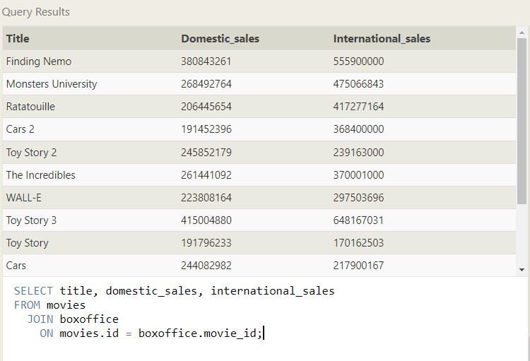

1. Show the sales numbers for each movie that did better internationally rather than domestically

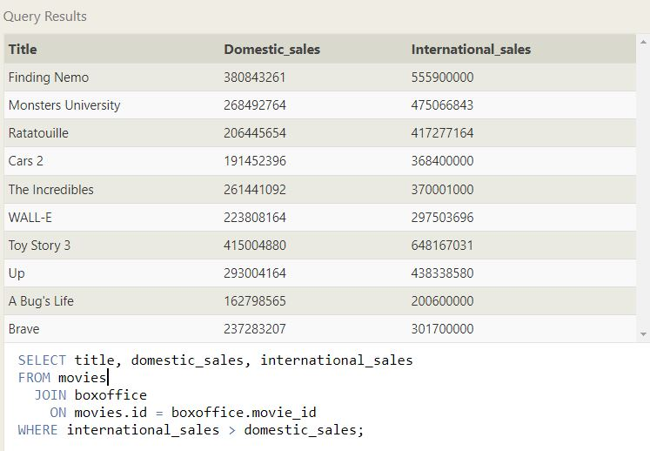

1. List all the movies by their ratings in descending order

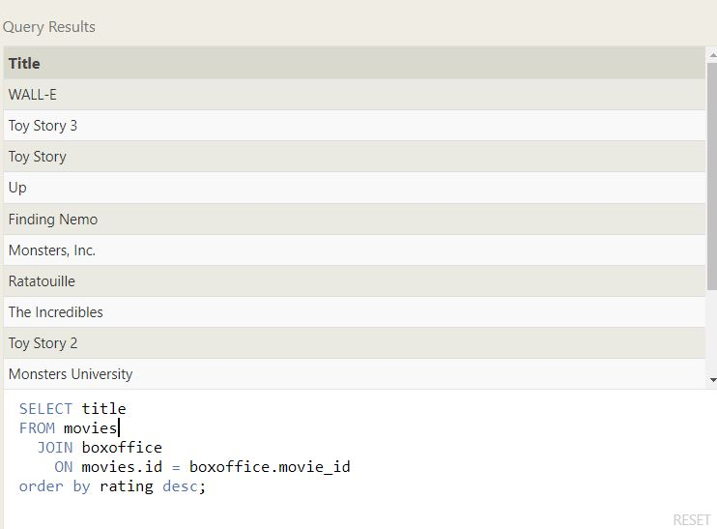

1. Find the list of all buildings that has no roles.

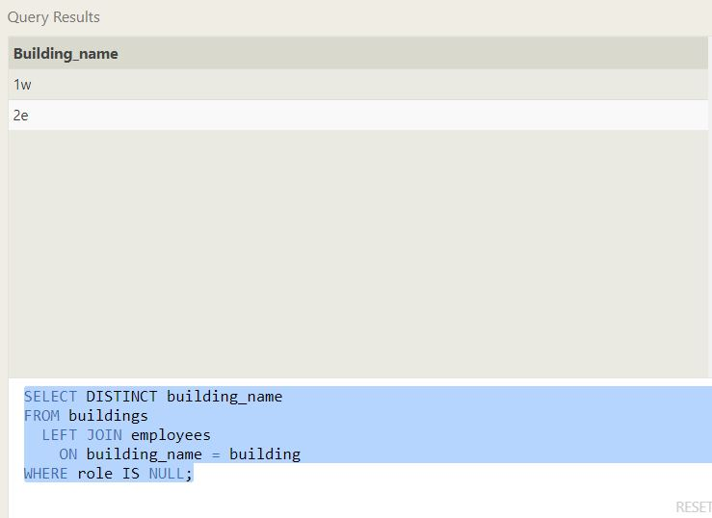

1. Find the list of all buildings and their capacity

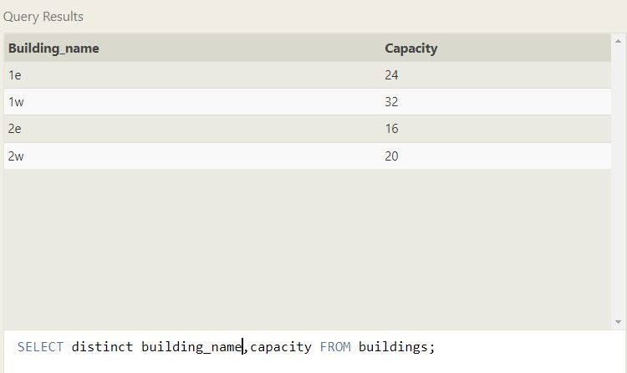

1. List all buildings and the distinct employee roles in each building (including empty buildings)

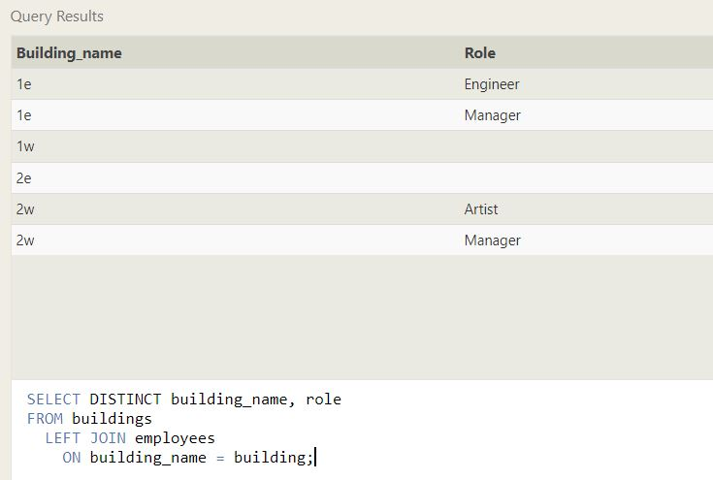

1. Find the name and role of all employees who have not been assigned to a building

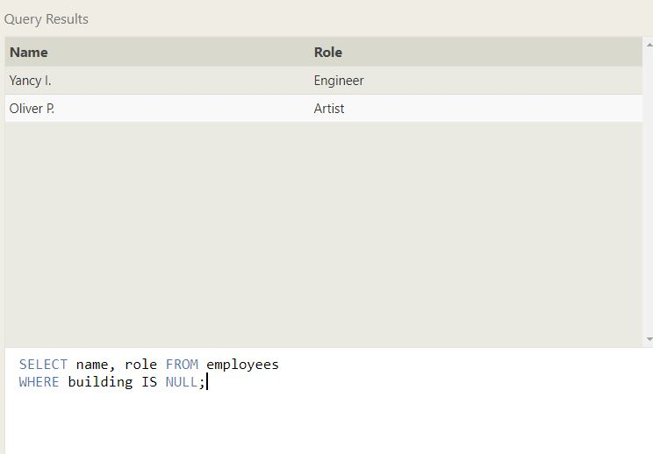

1. Find the names of the buildings that hold no employees



1. List all movies and their combined sales in **millions** of dollars

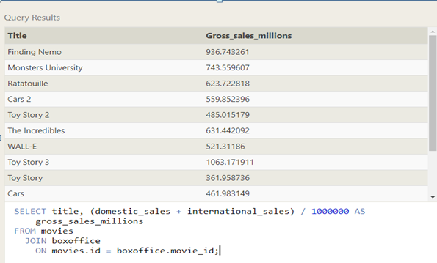

1. List all movies and their ratings **in percent**

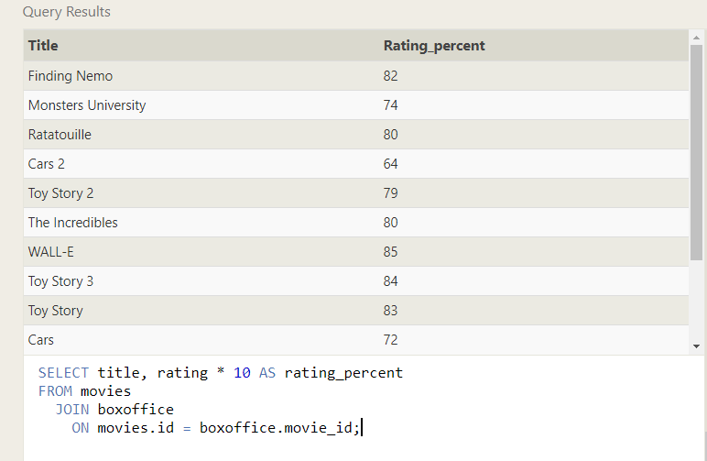

1. List all movies that were released on even number years

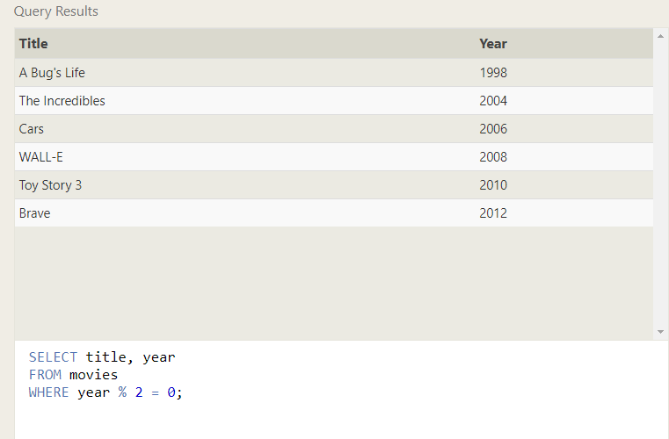

1. Find the longest time that an employee has been at the studio

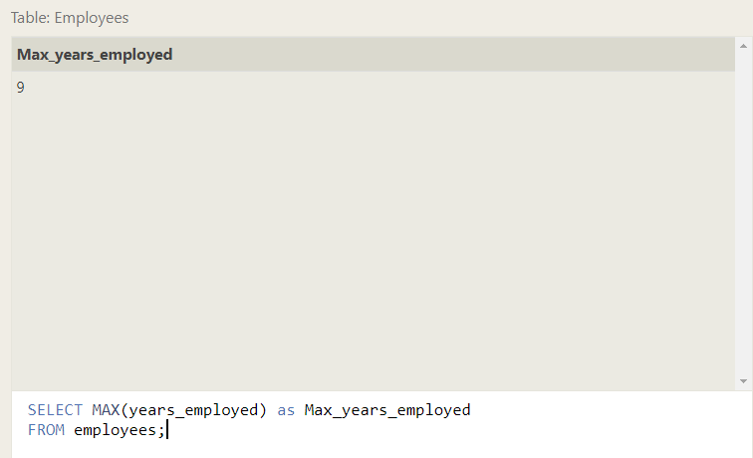

1. For each role, find the average number of years employed by employees in that role

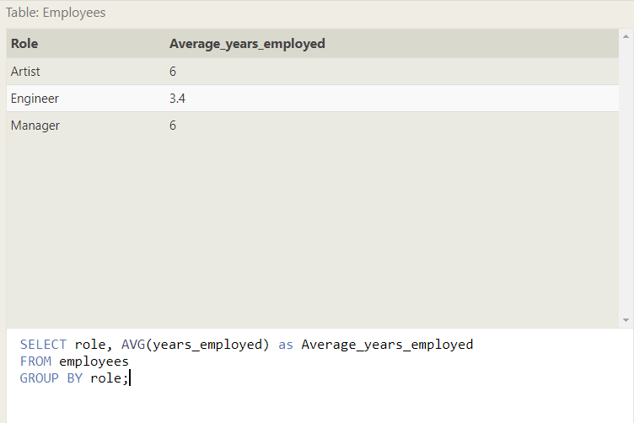

1. Find the total number of employee years worked in each building

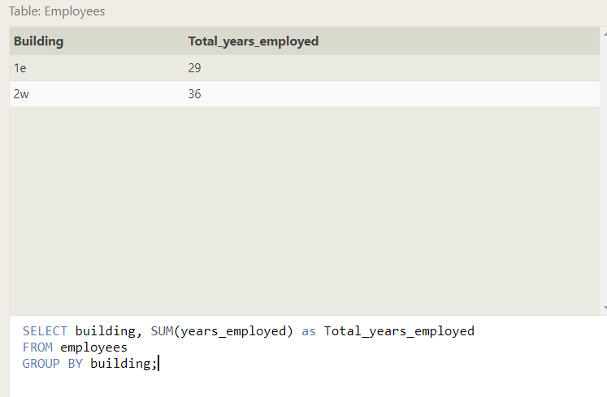

1. Find the number of Artists in the studio (without a **HAVING** clause)

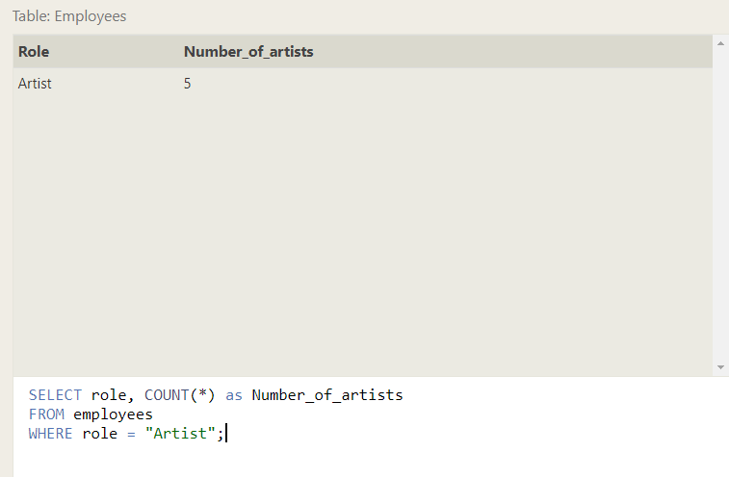

1. Find the number of Employees of each role in the studio

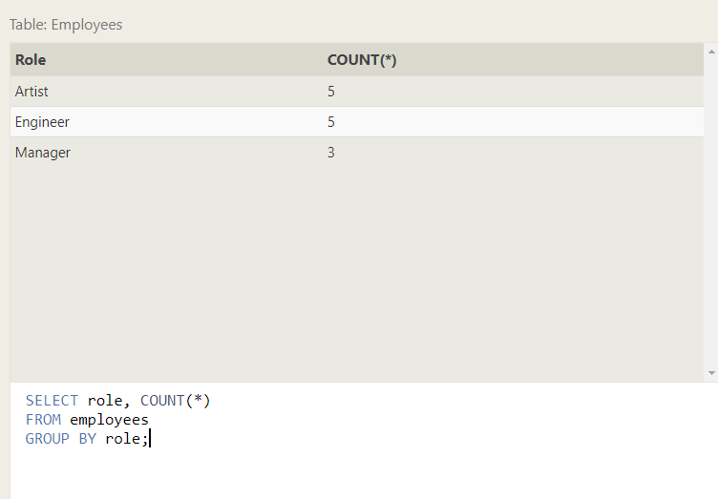

1. Find the total number of years employed by all Engineers

