(REDACTED)

Software Design Document

May 2020

TABLE OF CONTENTS

1. INTRODUCTION 3
1.1 Purpose 3
1.2 Scope 3
2. SYSTEM OVERVIEW 3
3. FUNCTIONAL DECOMPOSITION DESCRIPTION 5
4. DATA DESCRIPTION 6
5. COMPONENTS 6
6. HUMAN INTERFACE DESIGN 7
6.1 Overview of User Interface 7
6.2 Screen Images 7
6.3 Screen Objects and Actions 8
7. LEVEL ONE REQUIREMENTS MATRIX 9

1. INTRODUCTION

1.1 Purpose

This document describes the architecture and system design of REDACTED, a web-based software application.

1.2 Scope

REDACTED will offer a browser-based solution for users who wish to form groups in order to select events, activities and split the cost between the group to eliminate the hassle of doing this in person. The software will enable, for example, the members of a destination wedding party to book travel, arrange shipping services, find and book activities, make restaurant reservations etc. and pay for all of the events through one interface. The main purpose of the application is to create a way for groups of users to indicate preferences for activities etc. and pay for them through the application, splitting the costs as participation indicates.
Intended audience: The user of REDACTED has money to pay for travel and activities, is most comfortable using browser-based software, and readily accepts the idea of paying through an online interface. The motivation to use the software is to ease the burden of detail in planning a trip with activities with a group, and the pain point it addresses is the choice of activities and hassle of paying for them one by one and splitting costs among a group. REDACTED saves this user time and trouble.

2. SYSTEM OVERVIEW

Business Requirements: The user will view the site, register with personal data and payment information, begin or join a group with a destination and date, receive offerings from third-party vendors presented through the REDACTED site, make decisions with the group about what to do, agree upon activities and services, and have the payment split appropriately between all participating parties without the need for further inquiry.
Functional Requirements:
The user should be able to:
Register by entering personal data
Search for a Group
Join a Group
Start a Group
Enter date and destination for a Group
Search Activities
Search Services
View Activities
View Services
Choose Activities
Choose Services
Participate in Group decisions
Approve Group decision
Decline Group decision
Initiate reservations
Initiate payment
Cancel reservations
Cancel payment

Administrative functions will include:
Report generation

Authorization levels:
The Group initiator will be able to:
Finalize reservations
Signal payment

Quality Requirements: The user experience should be swift and seamless, with services and activities offered accurately according to the group destination. The human interface should be clean, contemporary and elegant.

3. FUNCTIONAL DECOMPOSITION DESCRIPTION
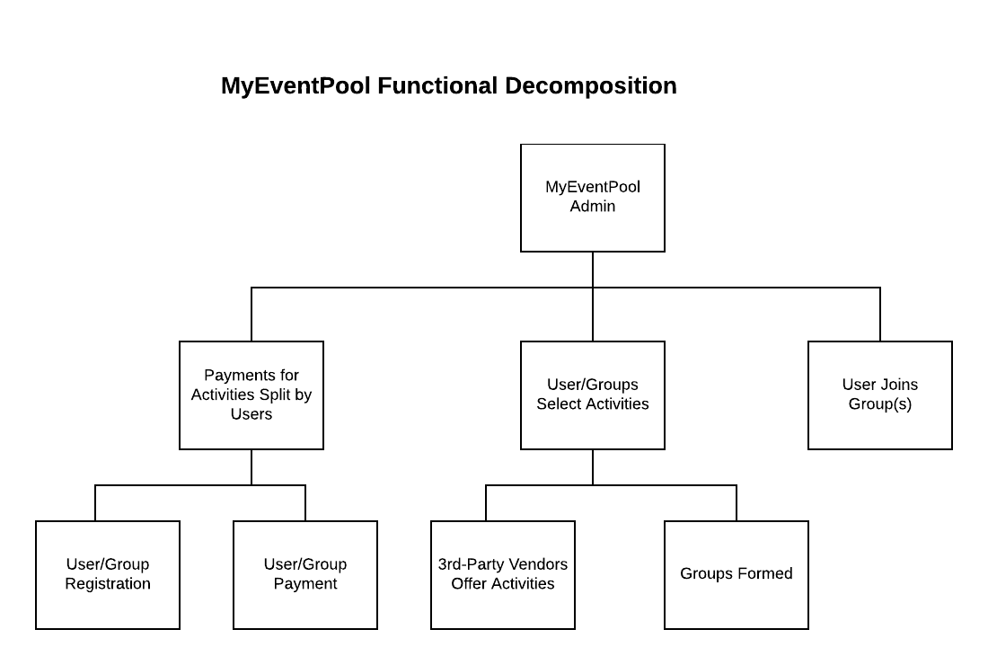

4. DATA DESCRIPTION

User data will be stored in SQL databases. Major data types will consist of:
REGISTRATION
PAYMENT INFORMATION
PAYMENT SPLITS
USER DATA
VENDORS (back-end)
GROUPS
ACTIVITIES
SERVICES

5. COMPONENTS

Components of REDACTED will include:
Users
Groups of Users
HTTP requests and responses
Web Server
Presentation layer
Application layer
Data layer
Database
SQL - User name, location, payment information, group status, destination
Web services
XML data from third-party providers of activities and services

6. HUMAN INTERFACE DESIGN

6.1 Overview of User Interface

The user interface for REDACTED is web-browser based. The user who is not yet registered may read about the product, view the FAQ, fill out a Contact form, and view selected services and activities available from third-party vendors through the website. When registered, the user can join groups of other users, typically persons known to the user, who plan to meet in a destination. The group will have access through the REDACTED website to a full array of travel and leisure options, including activities such as white water rafting and tee time reservations, restaurant reservations, sports and theater tickets, and services such as golf club shipping.
By joining a group, a user will automatically be able to view the services and offerings available in the destination location. When a group has agreed upon a set of activities and/or services, the group’s originator will confirm the reservations, upon which action each group member will be billed for his portion of the fees. The software will track participation in each service or activity; i.e., a group that will all attend a sporting event will each be billed an equal share of the fees, while the same group in which two of four participants use the golf club shipping service, only the two who use the service will be billed. Payment information is obtained during registration for REDACTED membership.

6.2 Screen Images

Screen images are not yet available.

6.3 Screen Objects and Actions

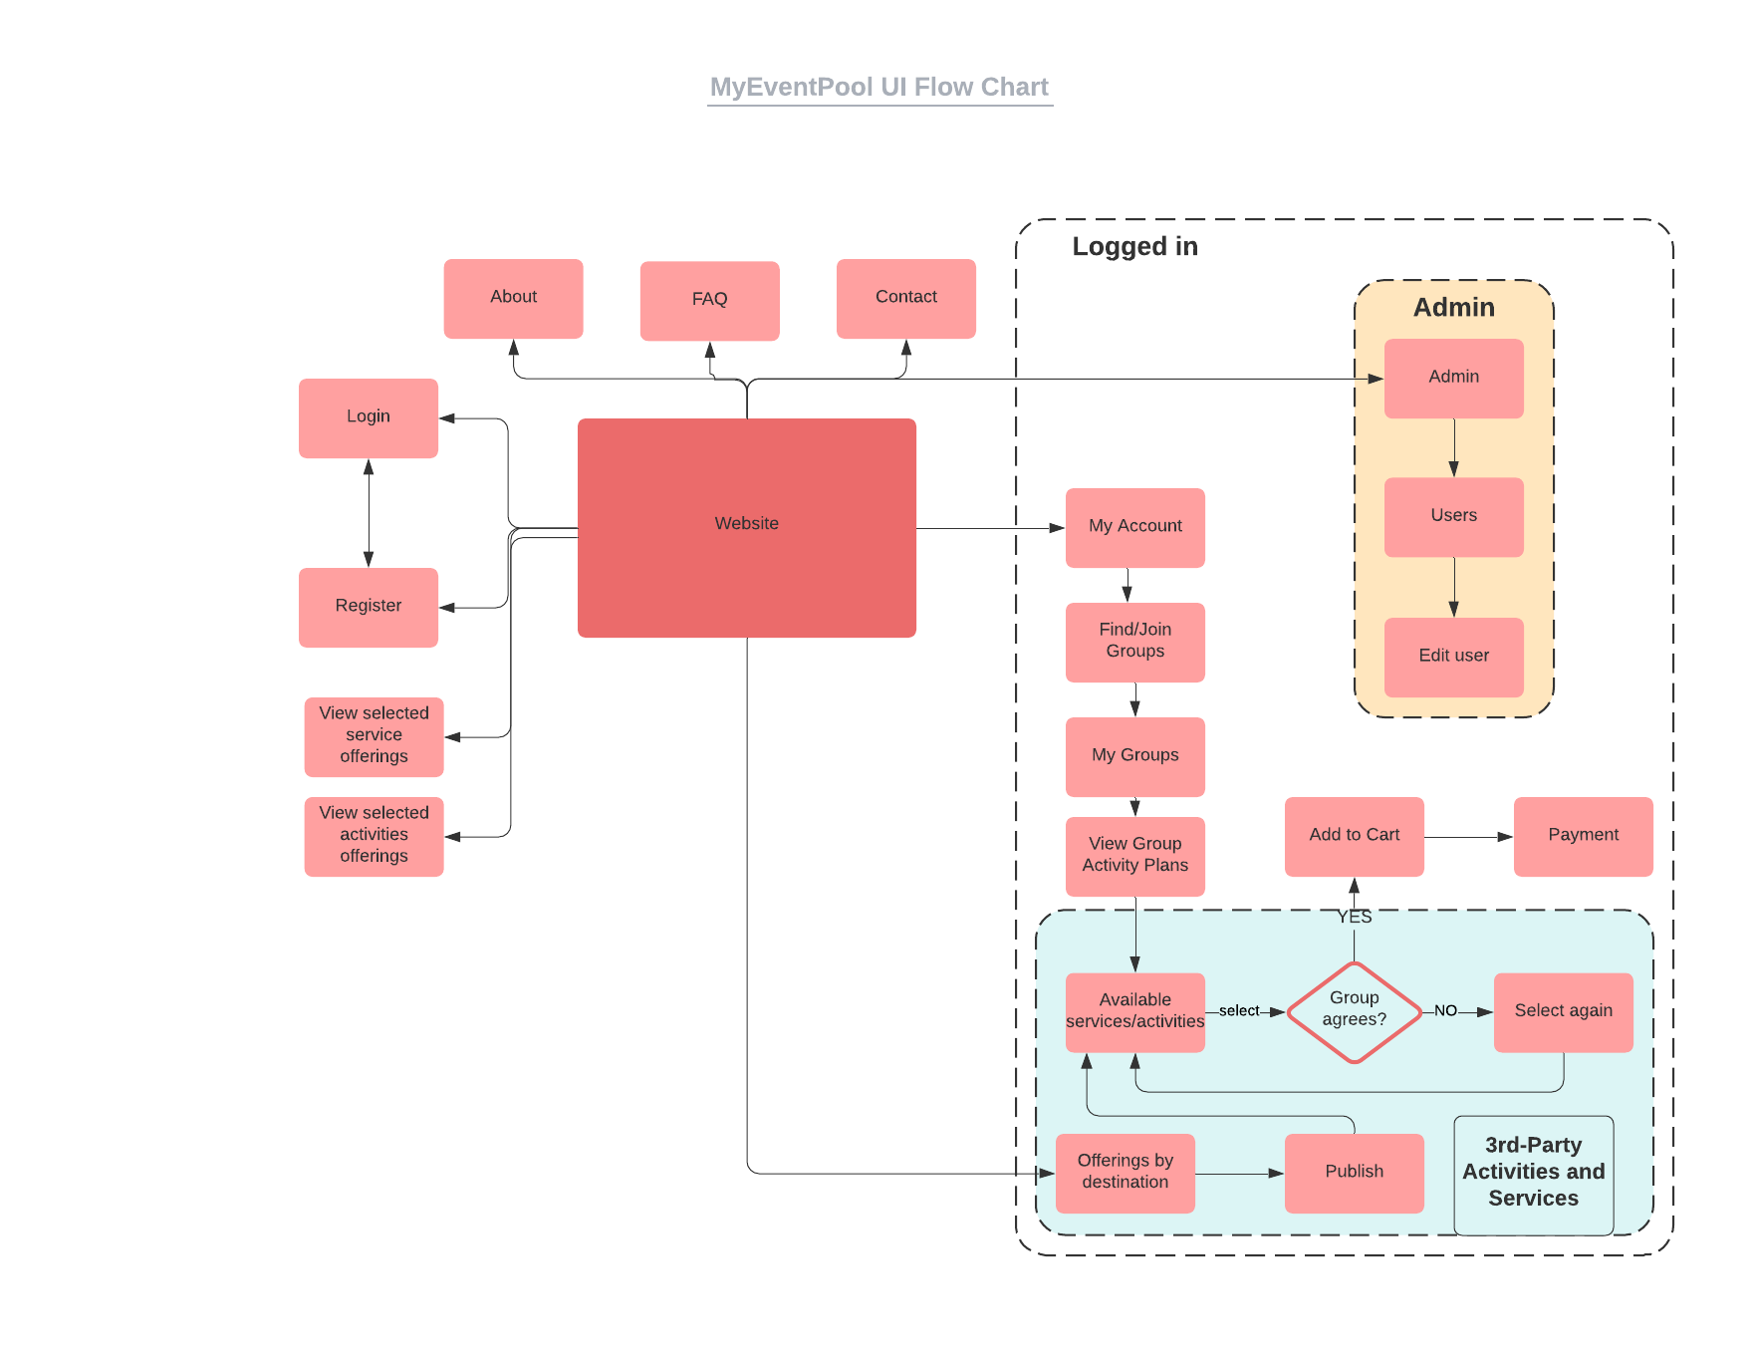

7. LEVEL ONE REQUIREMENTS MATRIX
ACTIVITY
SDD (Client) | X
Initial wireframe (C)
Basic interface content (C)
Graphic illustrations (C)
End-user navigation path (C)
Software Architecture Design (Developer)
Modules for pages:
Registration
Login
Profile Details
Groups (add and Delete)
Activity Preferences
Payment Details (D)
HTML User interface (D)
3rd-Party Vendor interface (D)
Payment processing interface
Message brokering system
Back-end database
End-to-End Demo
Built-out interface content (C)
Stability and Optimization (D)
MVP/Beta Ready for Testing (D)

