**Express**

* Fast, unopinionated, minimalist web framework for node.js
* Web application framework that provides a robust set of features
* Many third-party middleware to extend functionality
* Installing express:
  + In your project folder do: npm install express –save

Express middleware

* Middleware provides a lot of plug-in functionality that can be used within your express application
* Ex:
  + Morgan for logging
  + var morgan = require (“morgan”);
* Serving static web resources:
  + app.use(express.static(__dirname + “/public”));
  + __filname and __dirname give you the full path to the file and directory for the current module
* Npm install can specify the acceptable package version to download
  + Exact: npm install [express@4.0.0](mailto:express@4.0.0)
  + Patch acceptable: npm install [express@”~4.0.0](mailto:express@)”
  + Minor version acceptable: npm install [express@”^4.0.0](mailto:express@)”

Express router

* Express application routes
  + How express supports the development of a REST API server through app.all, app.get, app.post, app.put, app.delete methods
  + 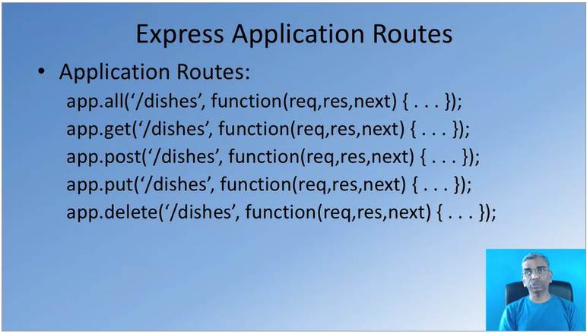Application routes
  + Routes with parameters
  + 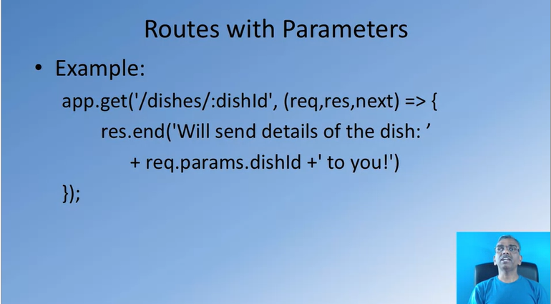body parser
    - Middleware to parse the body of the message
    - Using the body parser
      * Var bodyParser = require (“body-parser”);
      * App.use(bodyParser.json());//parse the JSON in the body
    - Parses the body of the message and populates the req.body property
* Express router
  + Express router creates a mini-express application
  + Var dishRouter = express.Router();
  + dishRouteruse.(bodyParser.json());
  + dishRouter.route(“/”)

Express generator

* quick scaffolding tool to generate an express application skeleton
* installing express generator
  + npm install express-generator -g
* generating an express application
  + express <App name>
    - generates a folder under the current folder w the name <App name>
    - There are various options available to generate express applications. It can use different kinds of new applications (e.g., jade, etc.)
  + then, move to the folder and install the node modules
    - npm install
* generated application
  + app.js: starting application
  + package.json
  + public: static resources
  + routes: application routes
  + views: template engine for generating standard html templates