**Passport**

* Node module that makes authentication easy
* Node.js Authentication middleware that supports various methods for authentication
* Modular, flexible
* Supports various strategies for authentication
  + Local strategy
  + OpenId
  + Oauth (facebook, twitter, G+, etc.) single sign-on
* Supports sessions
* Installing
  + npm install passport –save

example

* app.post(“/login”, passport.authenticate(“local”), (req, res) => { \\if this function gets called, authentication was successful.

\\”req.user” contains the authenticated user

res.redirect(“/users/” + req.user.username);

});

Passport – local

* passport strategy for authenticating a user with a username and password
* installing
  + npm install passport-local –save
* usage:

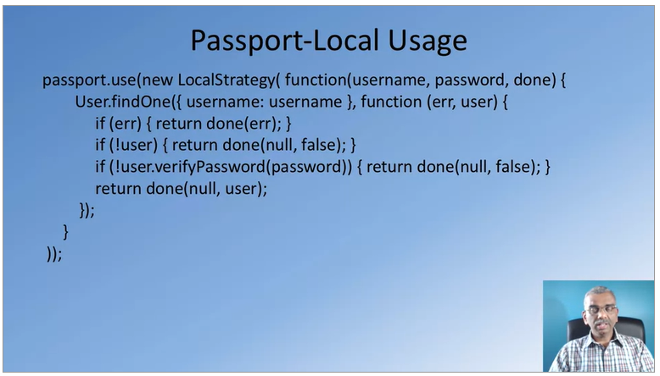

Passport-local-mongoose

* mongoose plugin to simplify building username and password login
* installing
  + npm install passport-local-mongoose –save
* makes available mongoose schema support for managing users
* adds username, hash and salt field to store the username, the hashed password and the salt value
* additional methods to the User schema to support passport local authentication
* example:

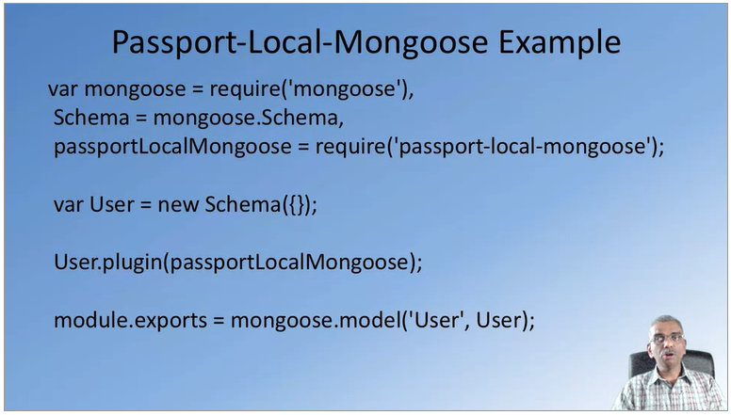

Passport/passport-local configuration

