Spring xml based aop implementation: add following jars

1. aspect.jar
2. aspectjrt.jar
3. aspect-weaver.jar
4. com.springsource.org.aopalliance.jar
5. spring-aop.jar
6. spring-aspects.jar

Logging.java

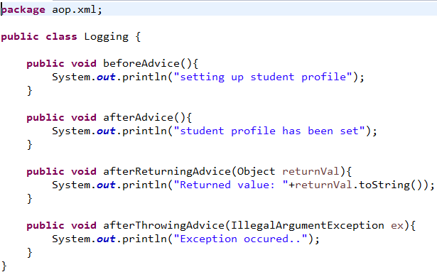

Student.java

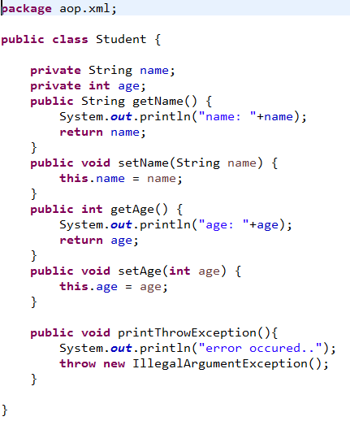

aop-config.xml

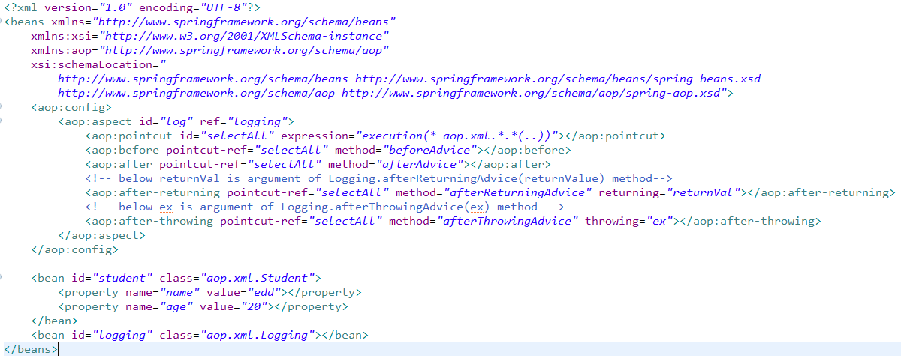

Xmlns used above: <beans xmlns=*"http://www.springframework.org/schema/beans"*

xmlns:xsi=*"http://www.w3.org/2001/XMLSchema-instance"*

xmlns:aop=*"http://www.springframework.org/schema/aop"*

xsi:schemaLocation=*"*

*http://www.springframework.org/schema/beans http://www.springframework.org/schema/beans/spring-beans.xsd*

*http://www.springframework.org/schema/aop http://www.springframework.org/schema/aop/spring-aop.xsd"*

LoggingTest.java

