Spring Jdbc:

1. Inject **org.springframework.jdbc.datasource.DriverManagerDataSource** with driveClassName, url, username, password variable.
2. Inject driver manager data source to our dao object. Using that data source we can create JdbcTemplate object.
3. In Spring Jdbc, we will perform all db operations using JdbcTemplate object.

STUDENT table in db:

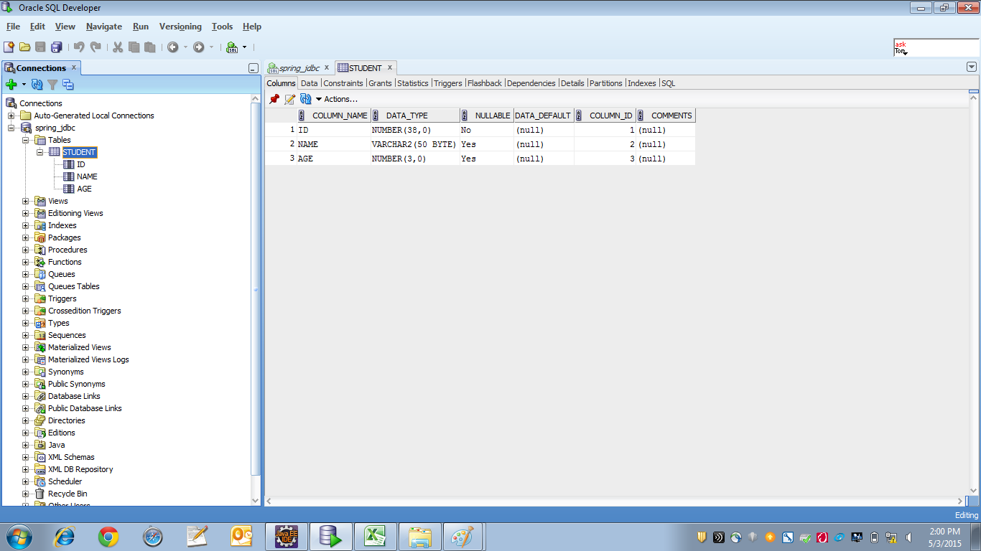

Student.java

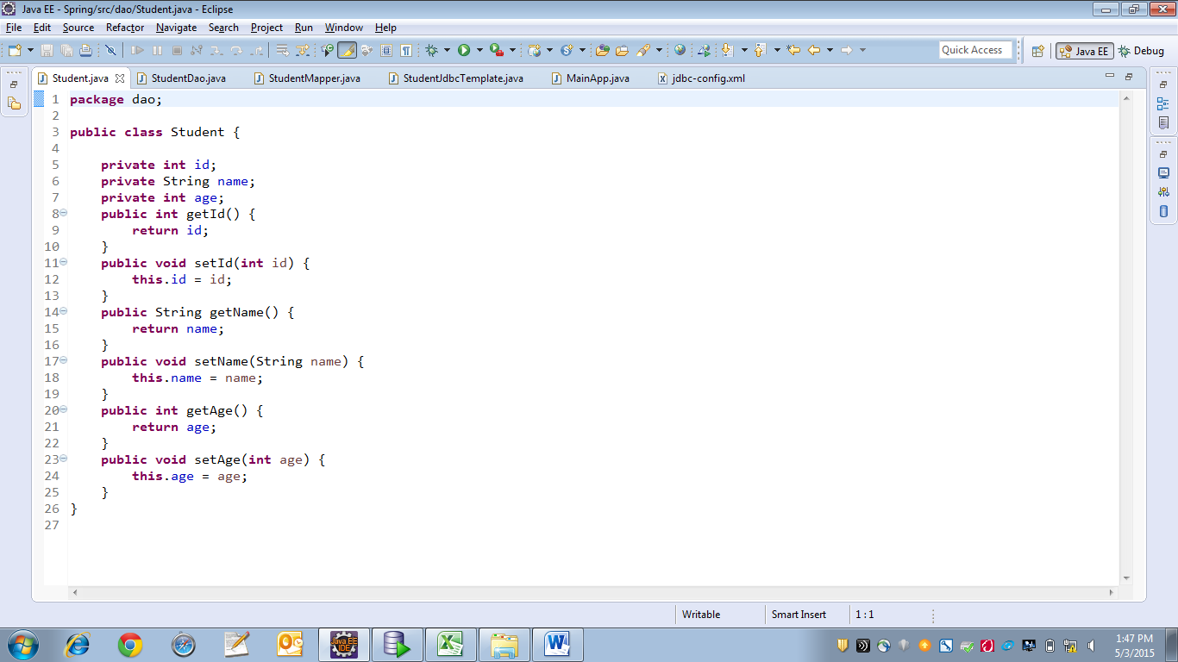

StudentDao.java

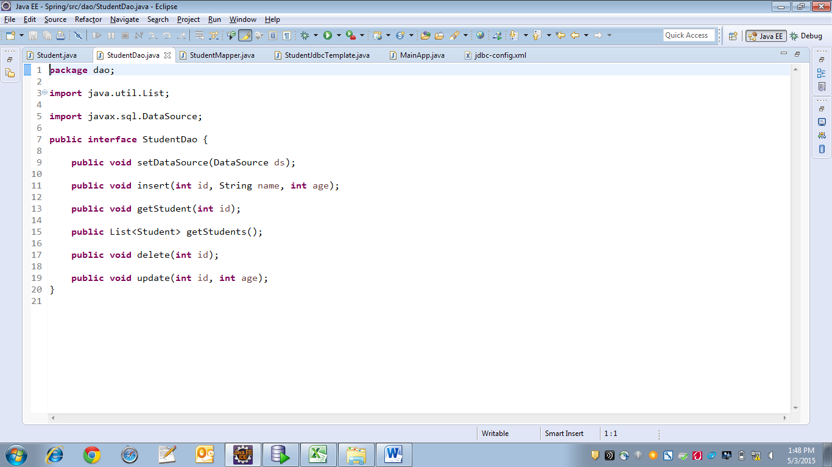

StudentJdbcTemplate.java

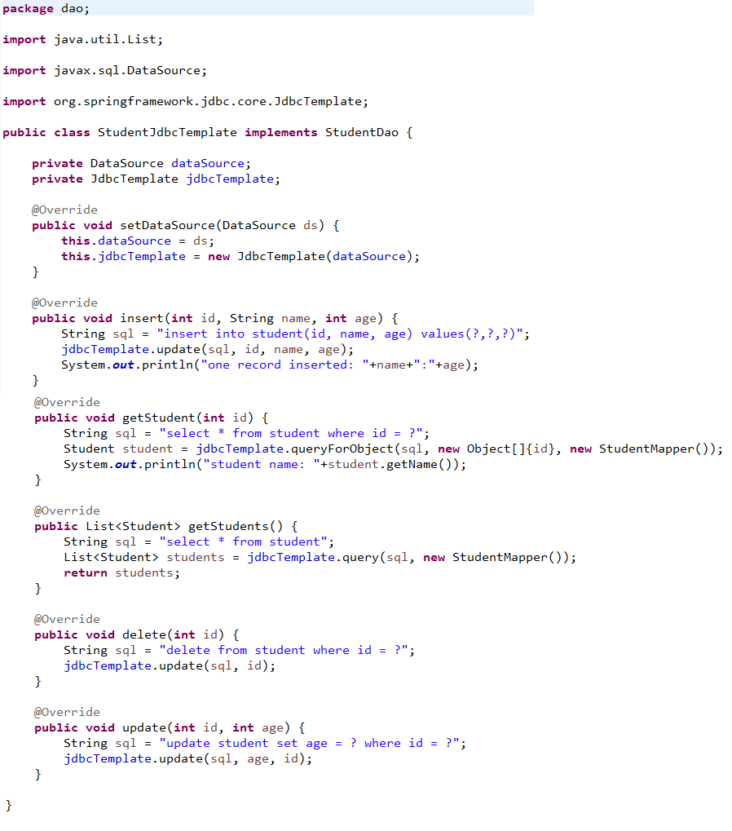

StudentMapper.java

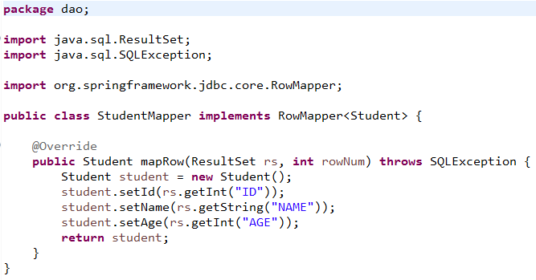

jdbc-config.xml

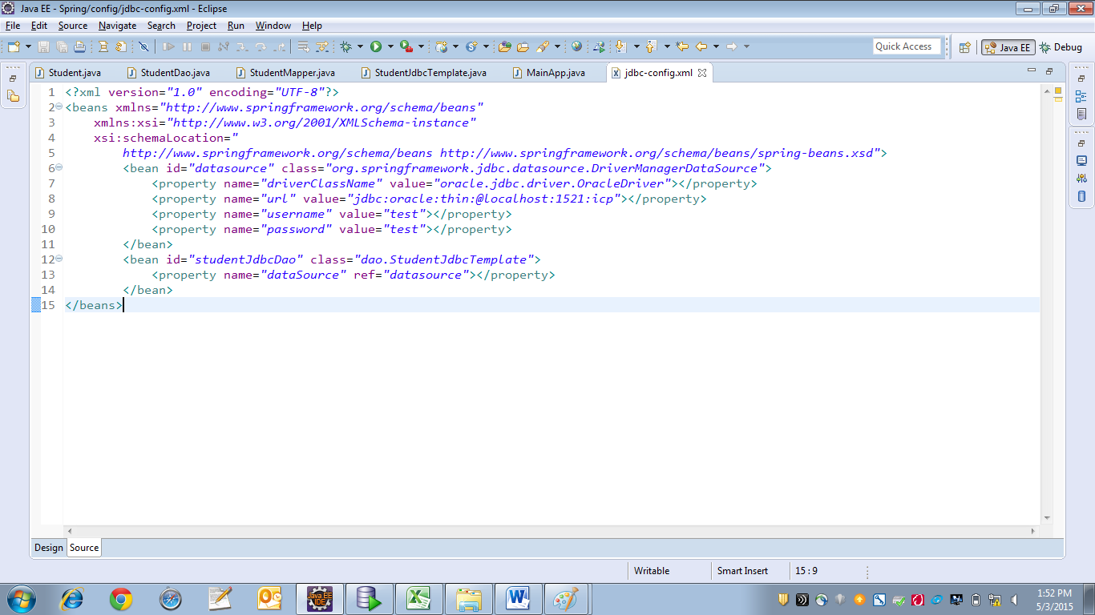

MainApp.java

