Spring Jdbc:

1. Inject **org.springframework.jdbc.datasource.DriverManagerDataSource** with driveClassName, url, username, password variable.
2. All dao classes have to extend JdbcDaoSupport class
3. Inject data source to JdbcDaoSupport class.
4. Get JdbcTemplate object in our dao class using getJdbcTemplate() method. JdbcDaoSupport class will create JdbcTemplate object using the data source we have injected.
5. JdbcTemplate will be used to perform db operation.

Student.java

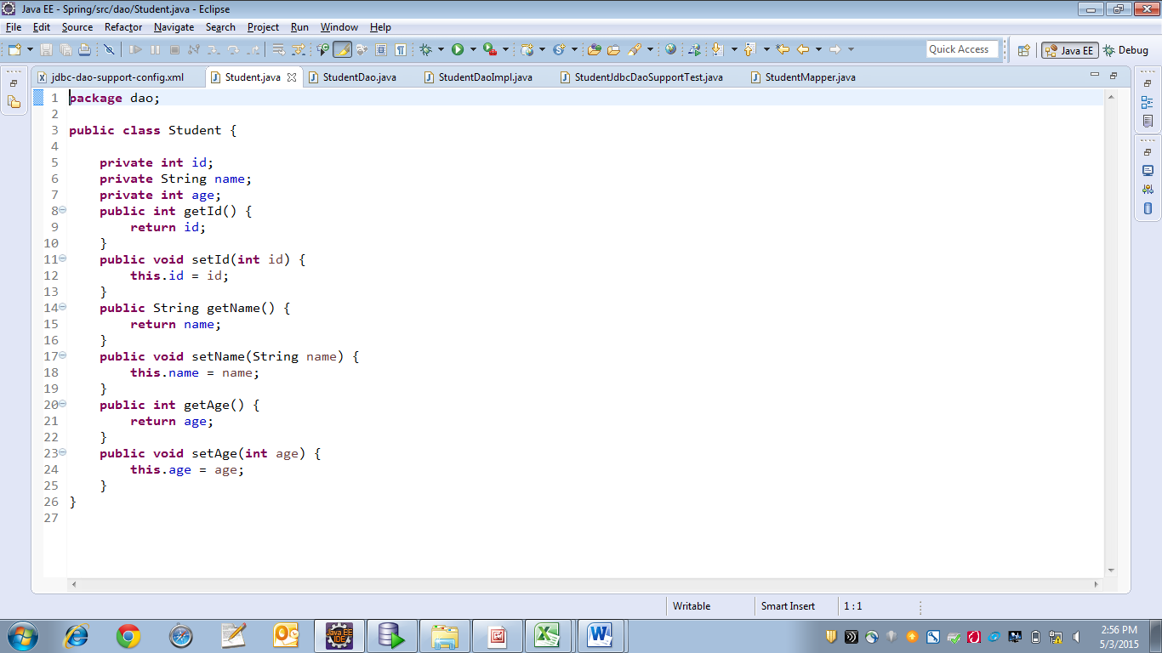

StudentDao.java

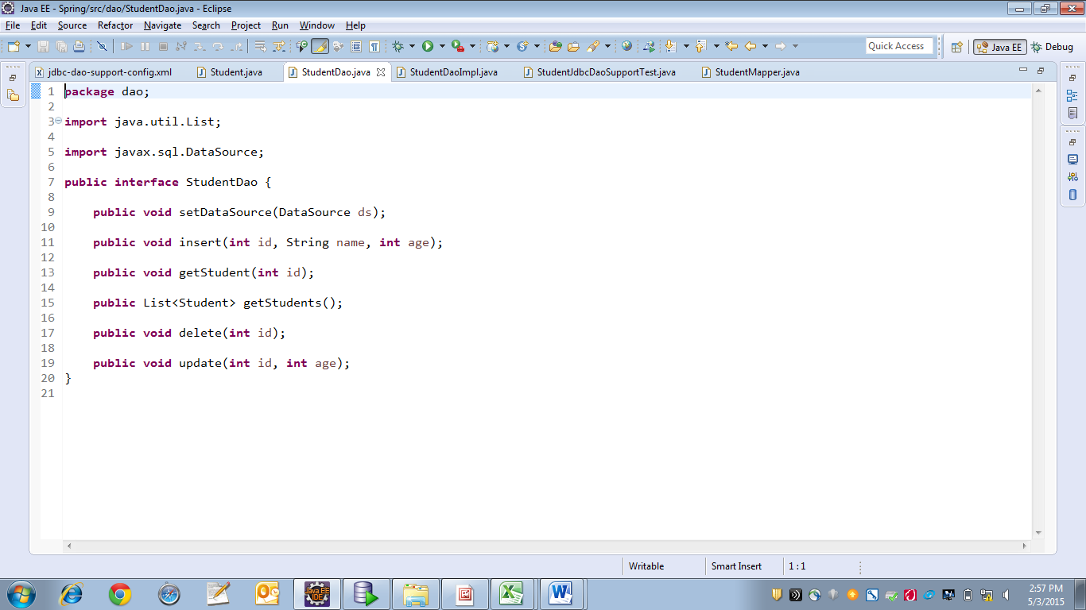

StudentDaoImpl.java

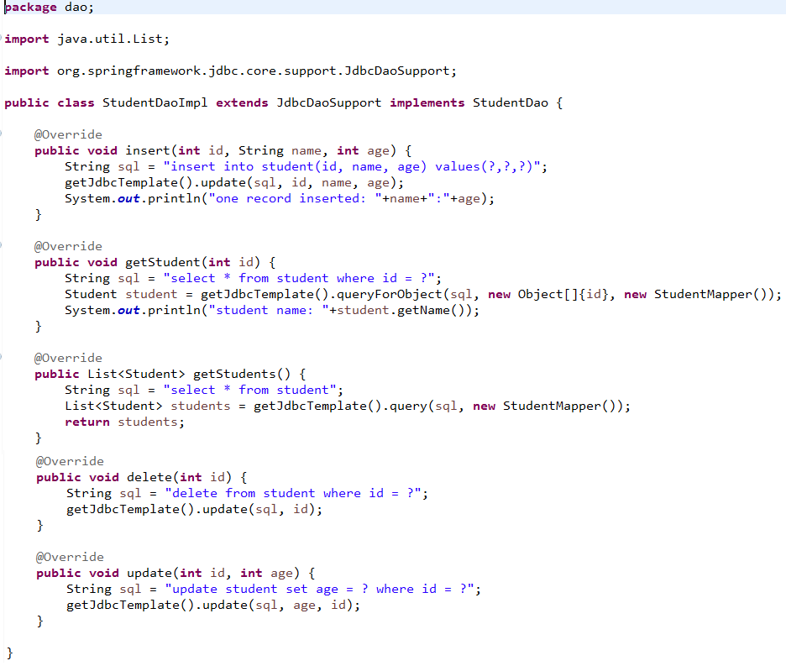

StudentMapper.java

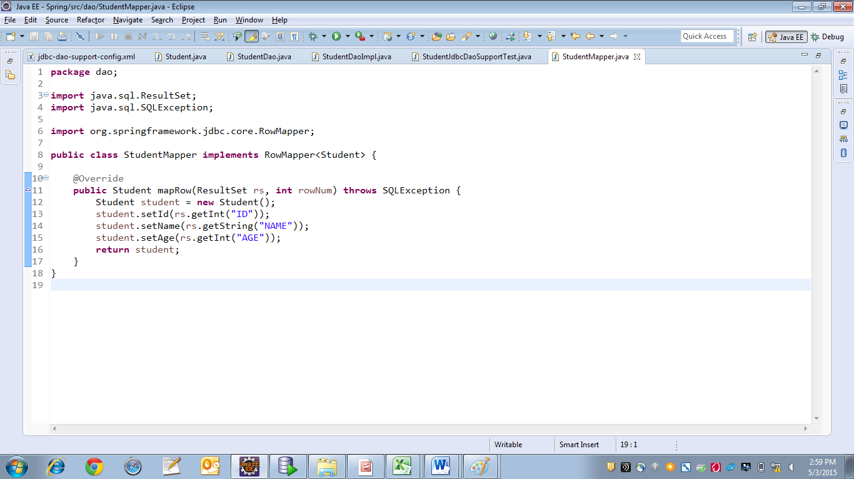

Jdbc-dao-support-config.xml

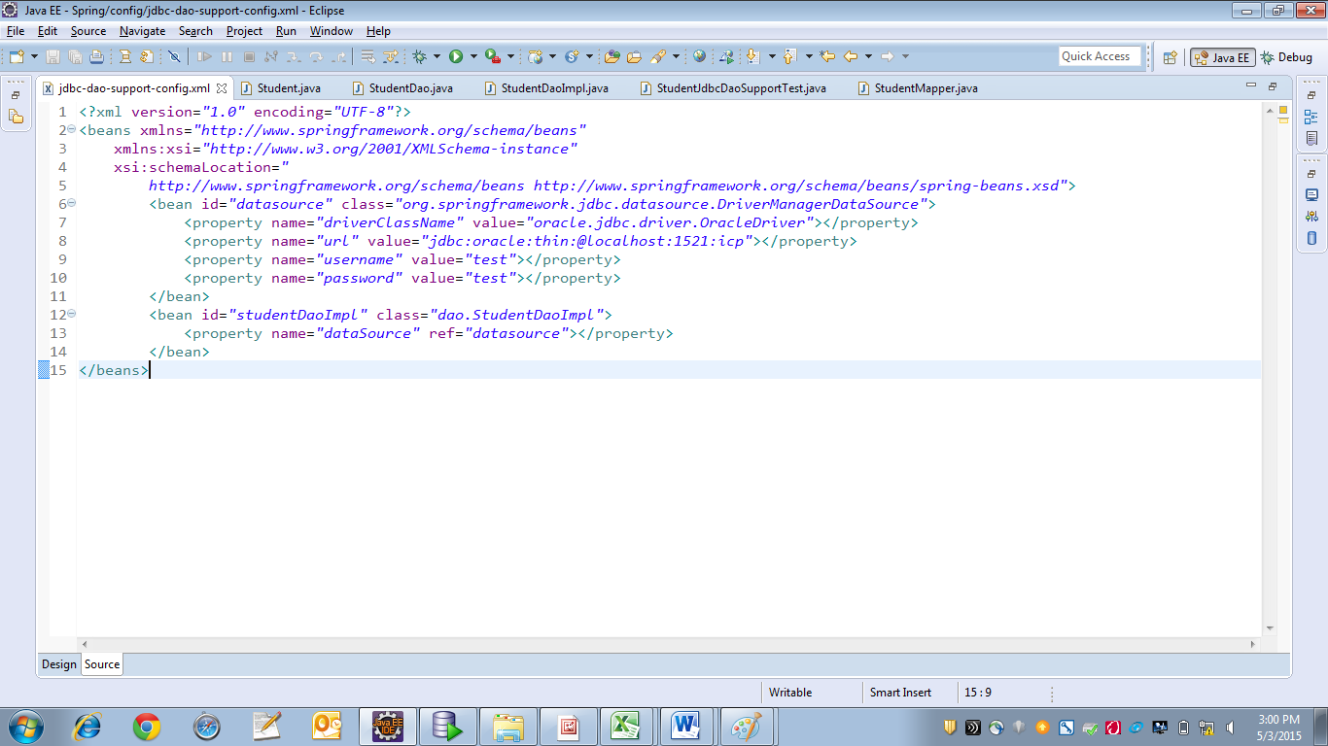

StudentJdbcDaoSupportTest.java

