**Creating Web project with Maven, Importing it to Eclipse, Running it in Wildfly application server**

1. Create folder named “Test” in C: drive

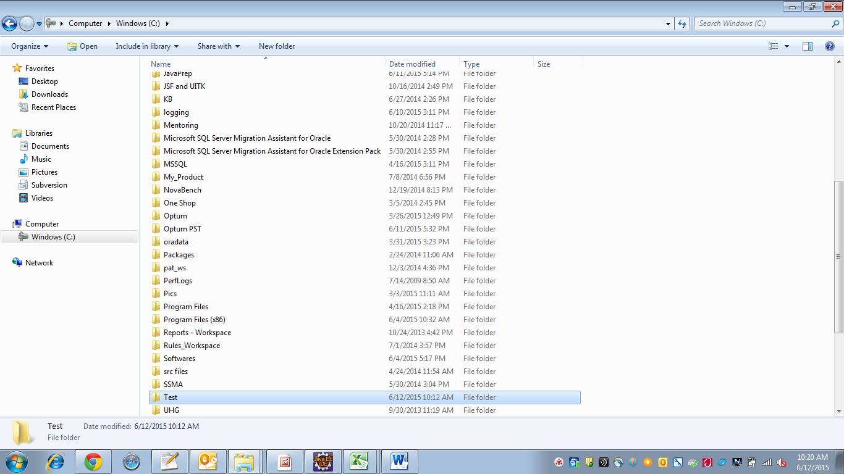

1. Open command prompt and go to Test folder.

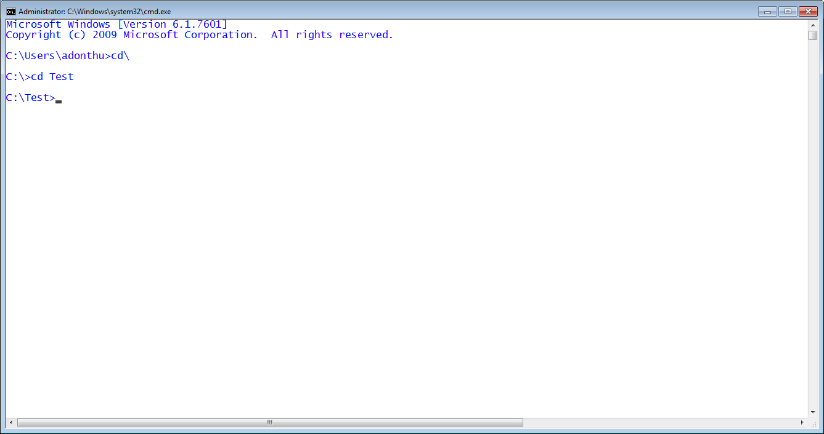

1. Execute the following command:

C:\Test>mvn archetype:generate -DgroupId=com.test -DartifactId=HelloWorld -DarchetypeArtifactId=maven-archetype-webapp -DinteractiveMode=false

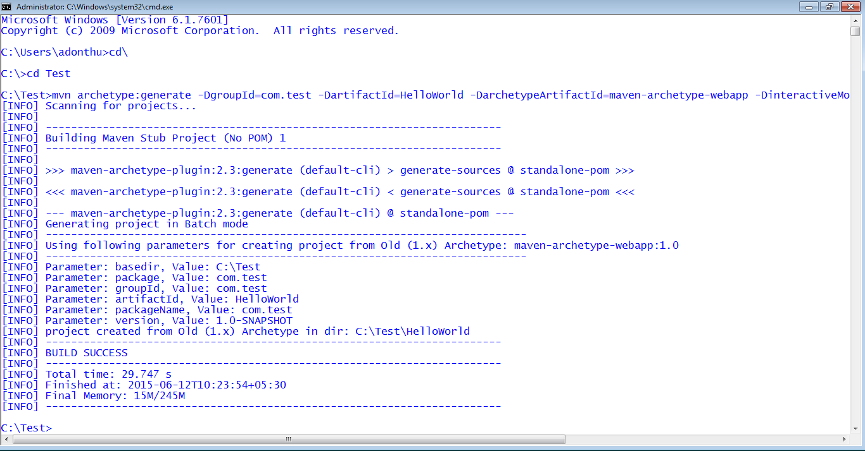

1. Maven web project created in C:\Test folder as follows

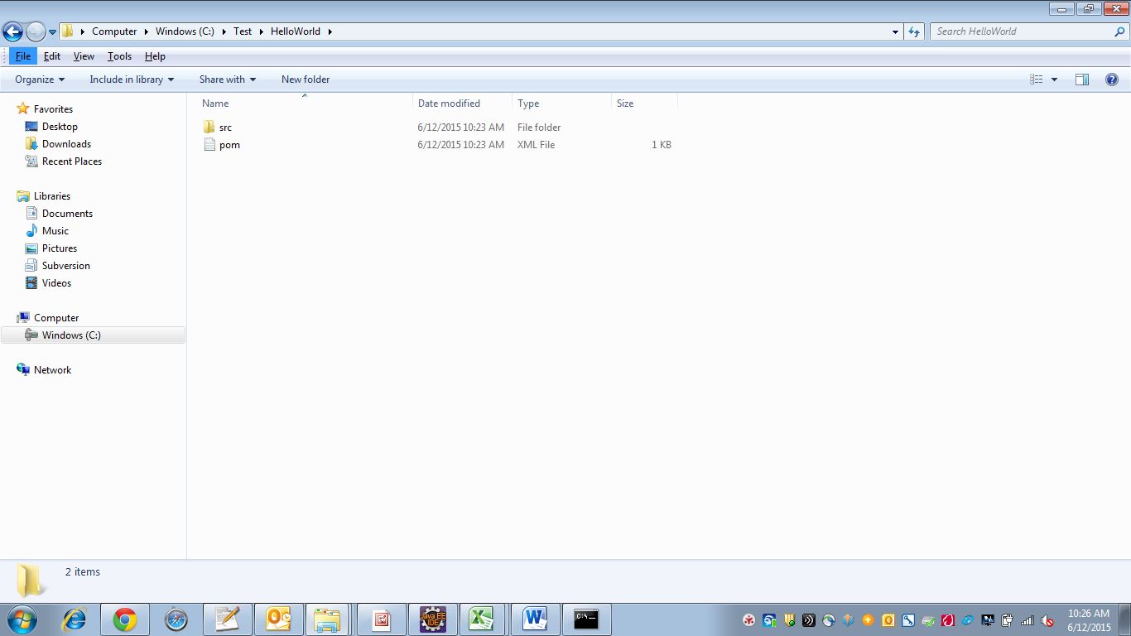

1. Now make this project compatible to import to eclipse.
2. Go to HelloWorld folder in command prompt and run the following command in command prompt.

C:\Test\HelloWorld>mvn eclipse:eclipse –Dwtpversion=2.0

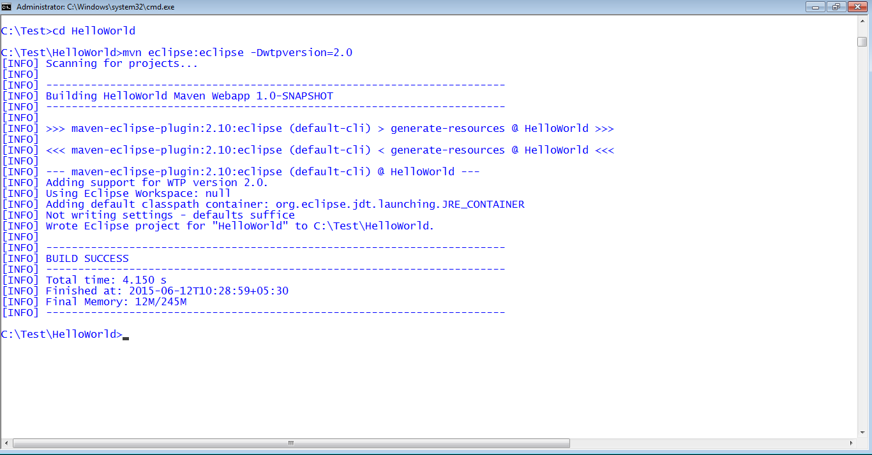

1. .settings folder added in C:\Test\HelloWorld project.
2. CLASSPATH, PROJECT files added in C:\Test\HelloWorld project.

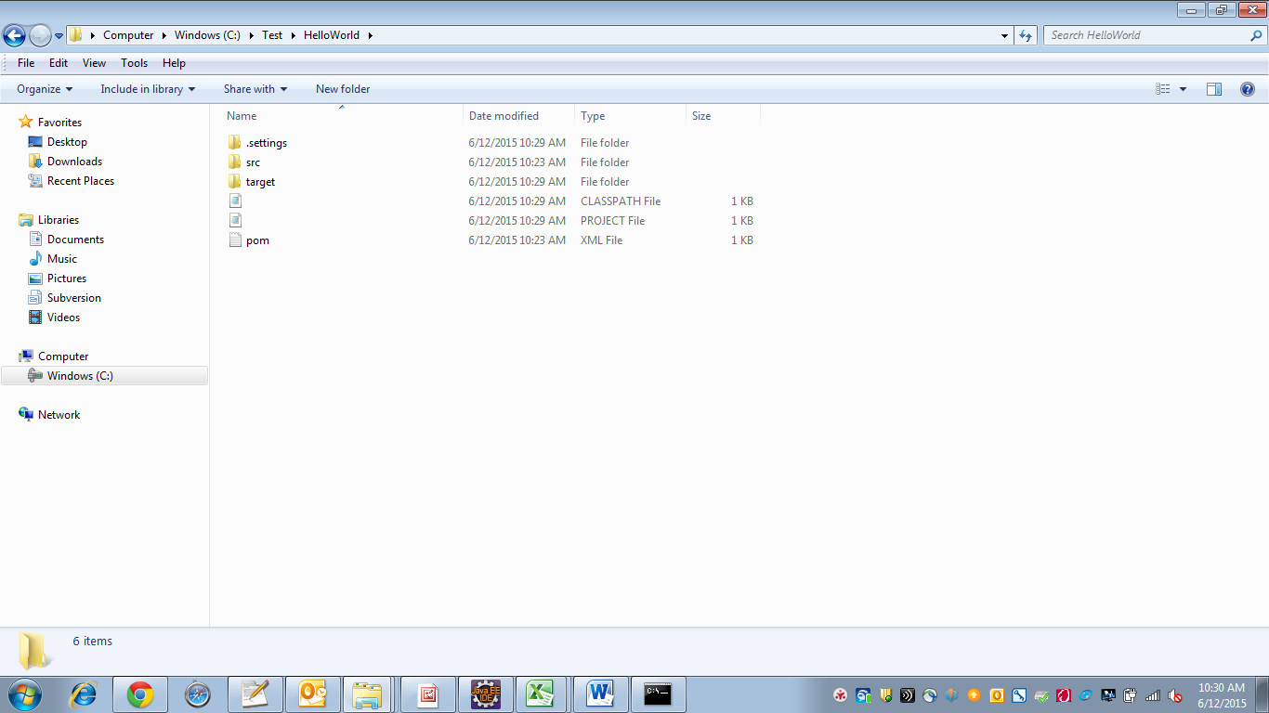

1. Now import to HelloWorld project to eclipse.

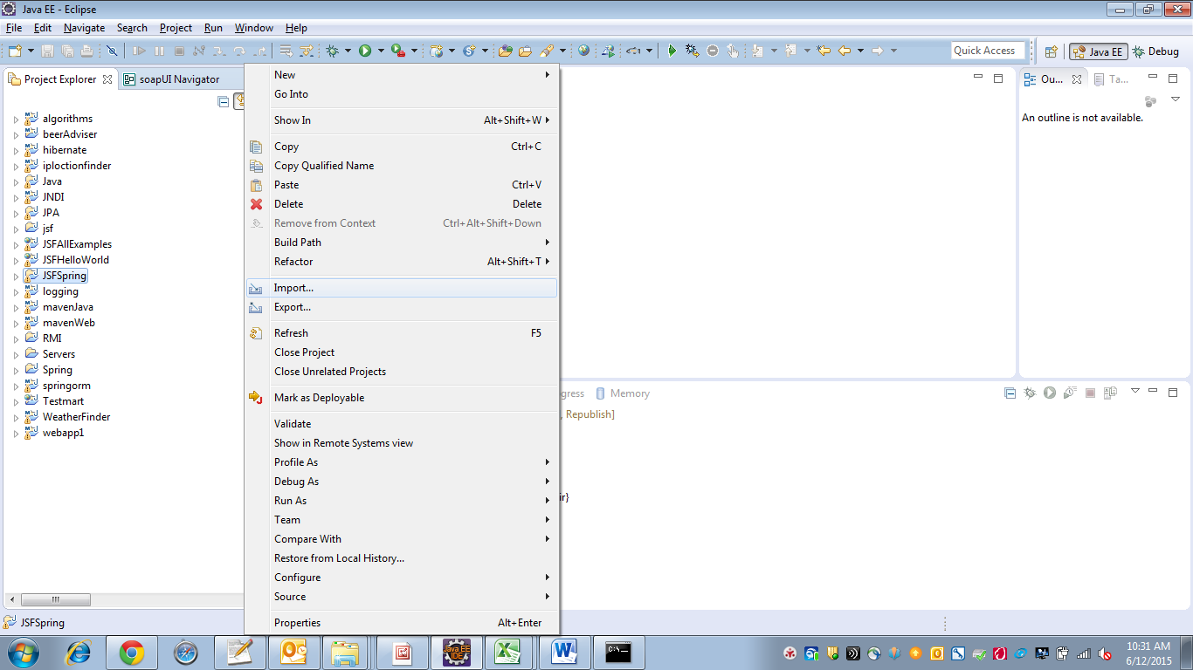

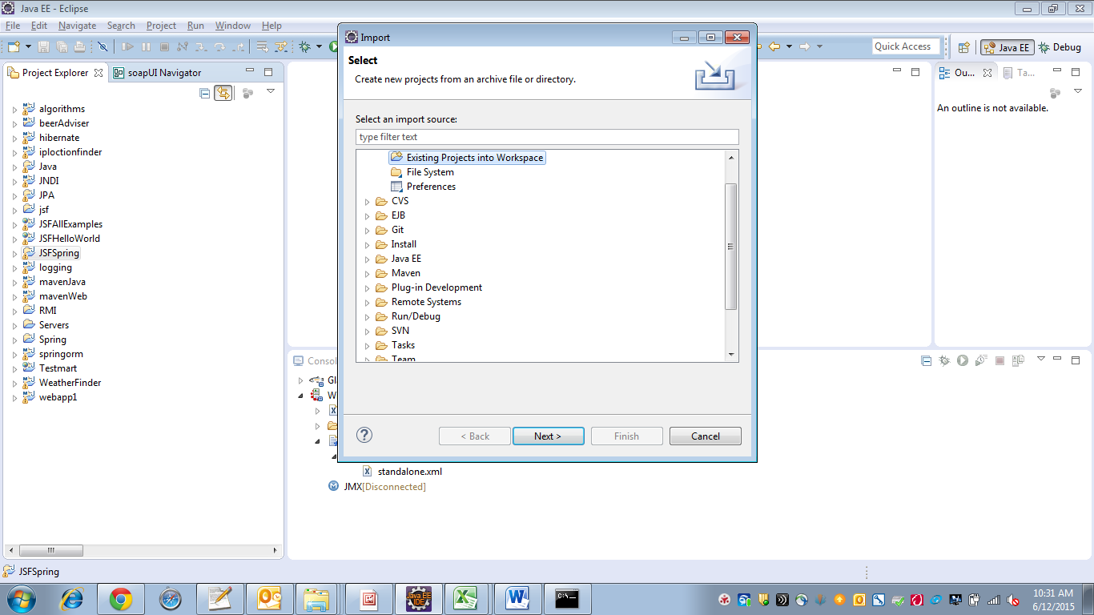

Select “Existing Projects into Workspace” -> Next

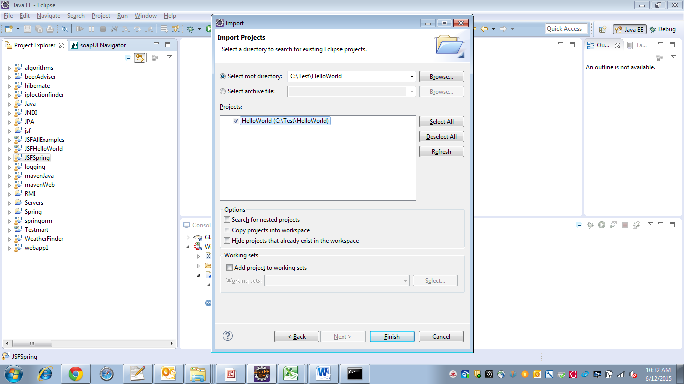

Browse to HelloWorld project location -> Click on Finish

HelloWorld project imported to Eclipse

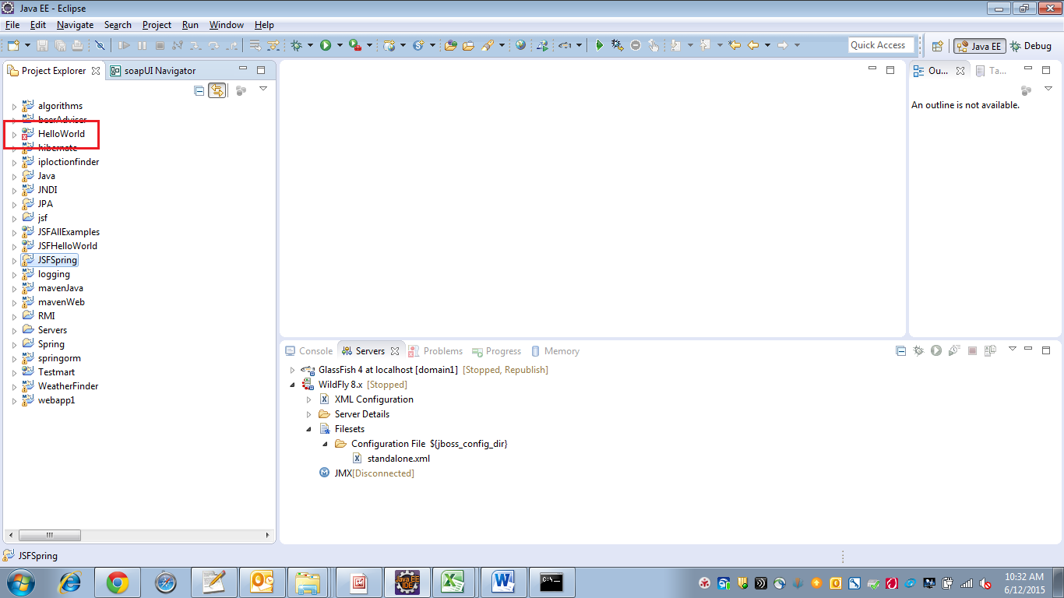

1. Following errors are getting displayed with red symbol on project. This is because some jar files are missing.

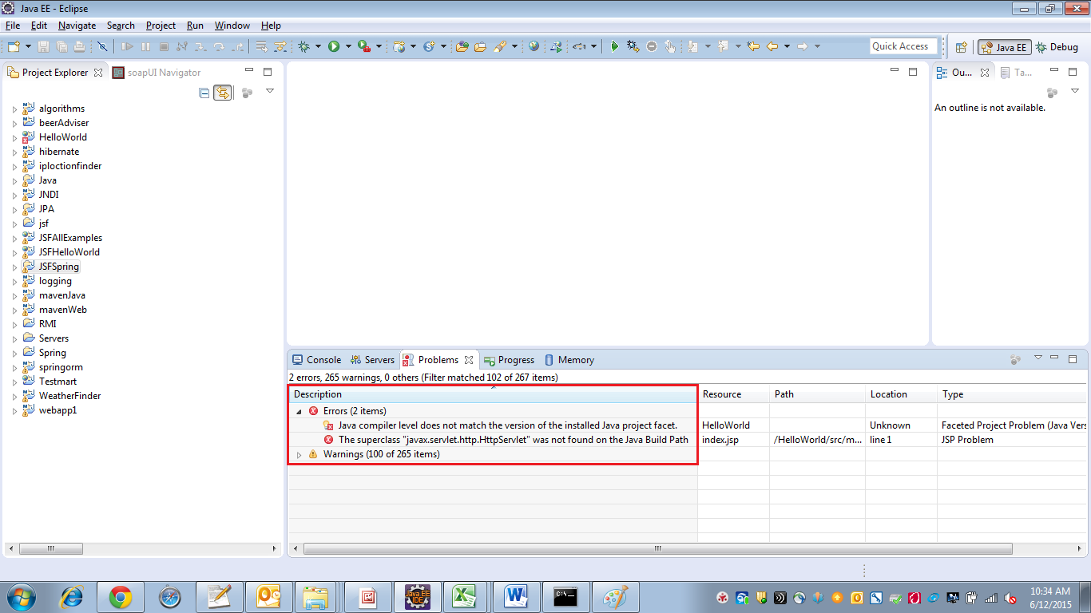

1. Remove project from eclipse. Do not remove from disk. Do not check “Delete project contents on disk(cannot be undone”)

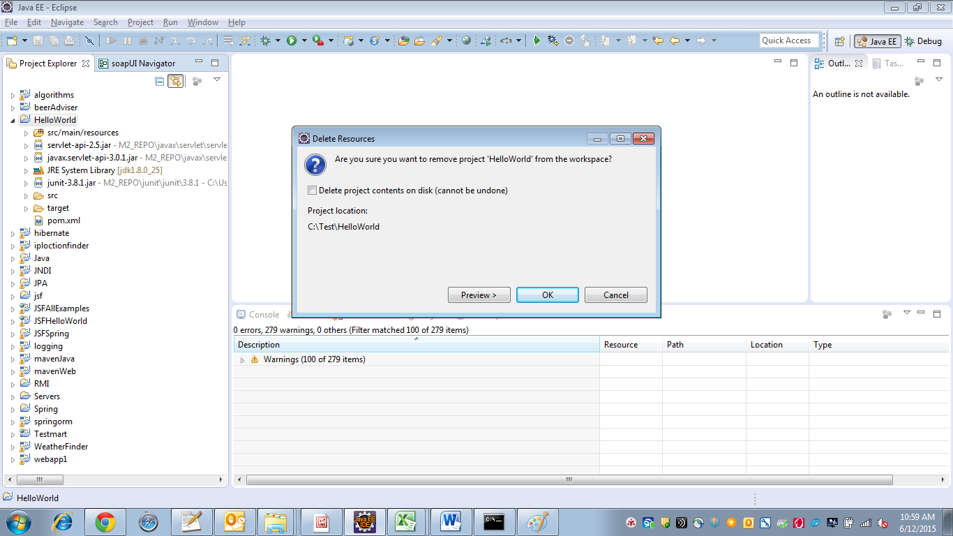

1. Here missing jar file servlet-api.jar. So add maven dependency for this jar to C:\Test\HelloWorld\pom.xml.

To specify compiler version we want to use for this project, we added plug-ins tag as follows.

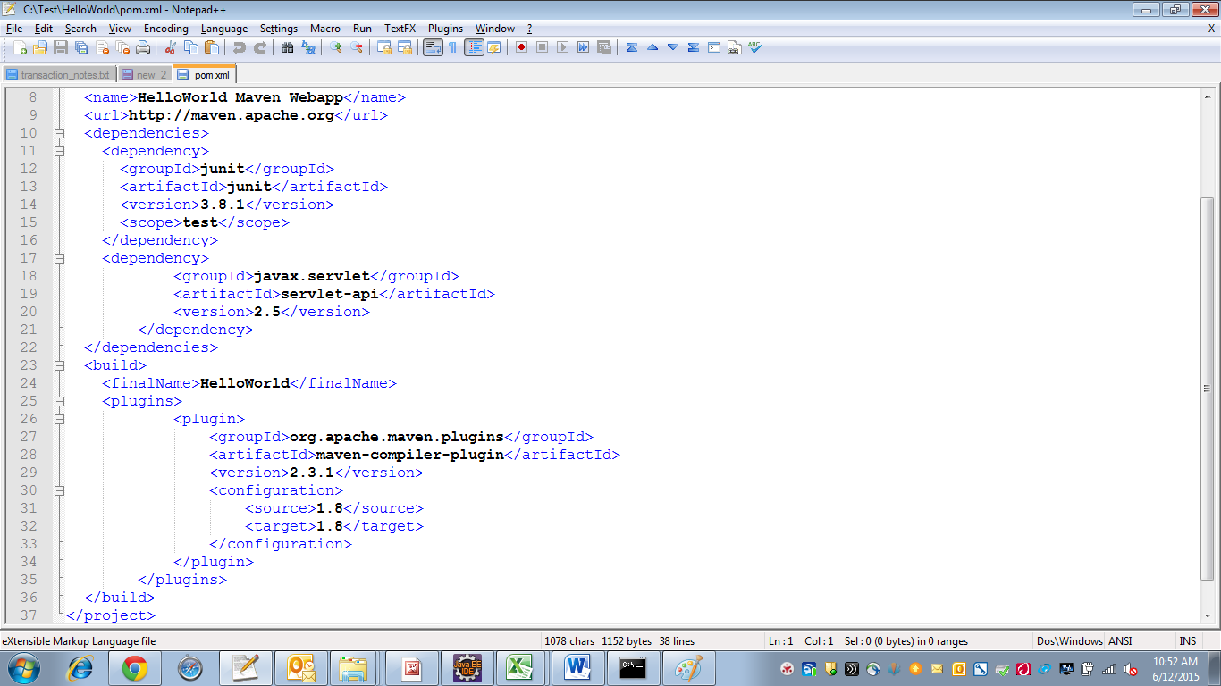

1. Run the following commands in command prompt from C:\Test\HelloWorld

C:\Test\HelloWorld>mvn eclipse:clean

C:\Test\HelloWorld>mvn eclipse:eclipse 🡪 based on jar files added in pom.xml, they will be downloaded if they are not present in local maven repository. If that jar is present in local maven repository that jar will not be downloaded.

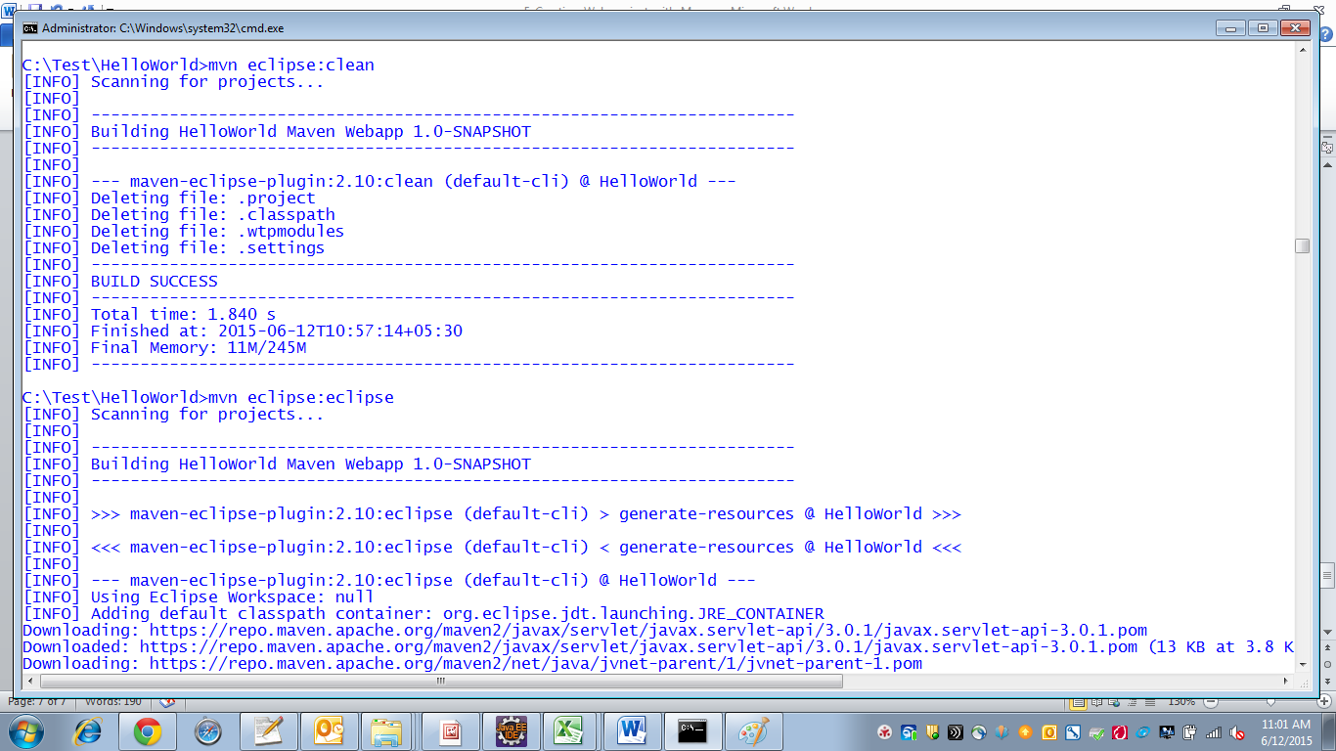

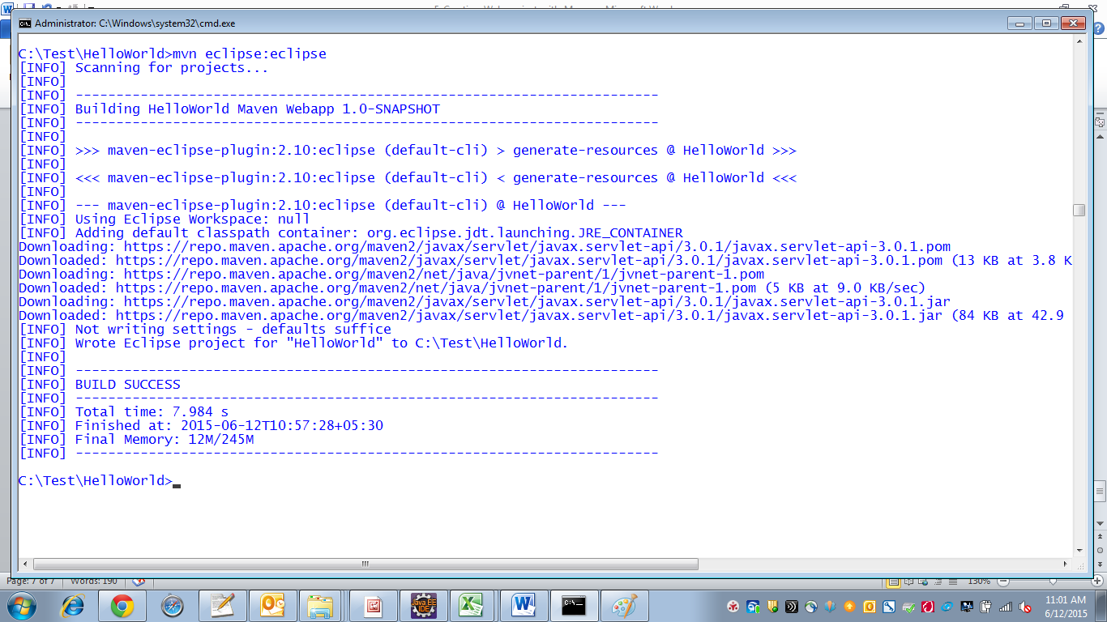

1. Re-import the project into eclipse. Click on Finish.

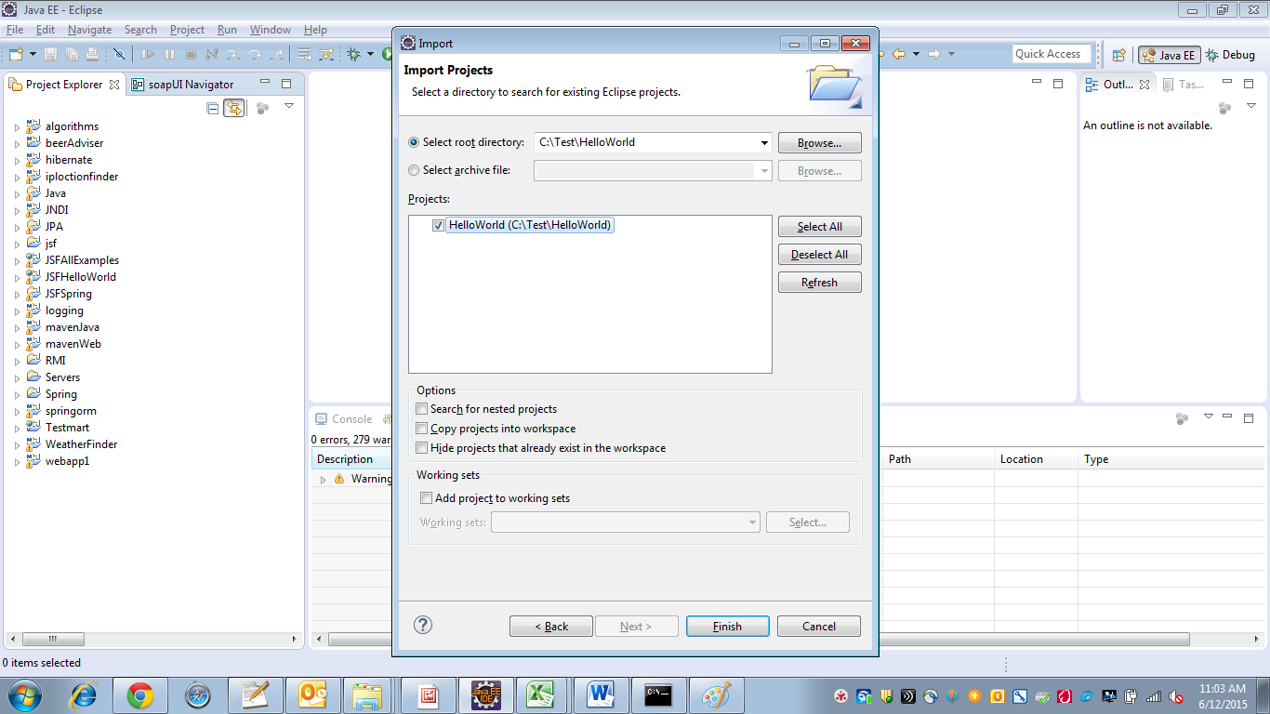

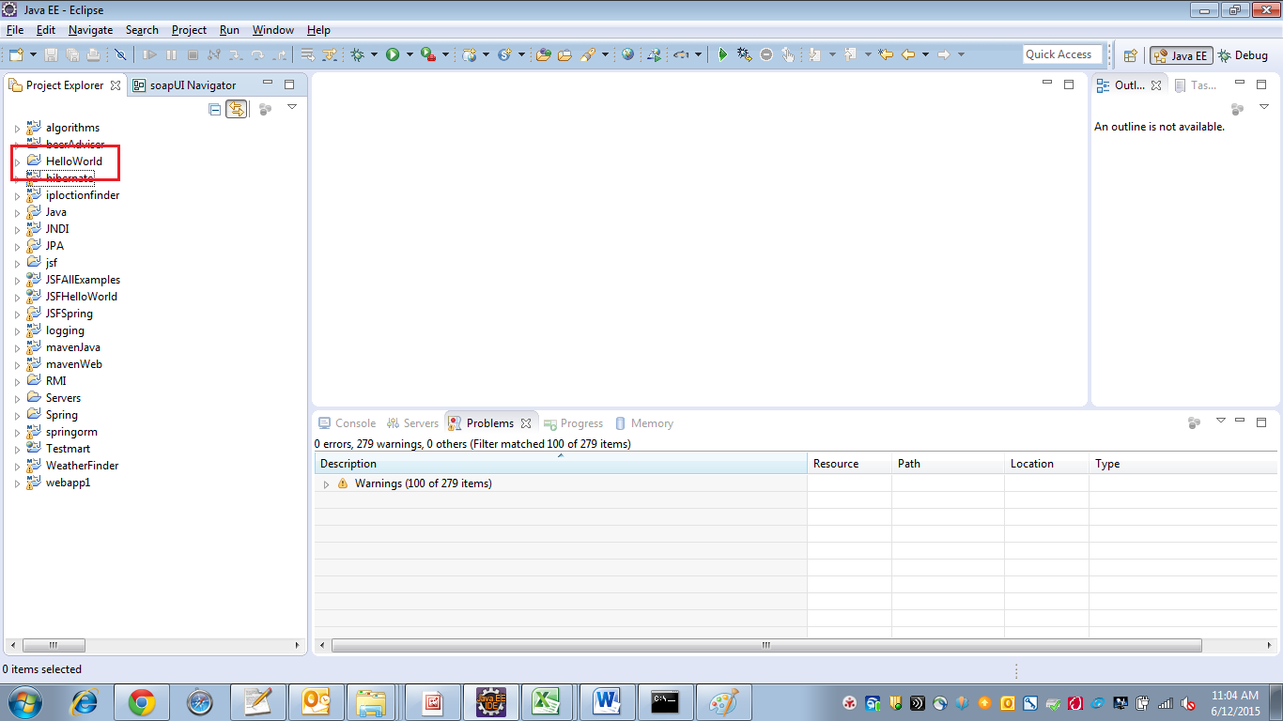

**Now Execute this project in Wildfly application server**

1. Download wildfly application server.

<http://wildfly.org/downloads/>

1. Unzip the downloaded wildfly.

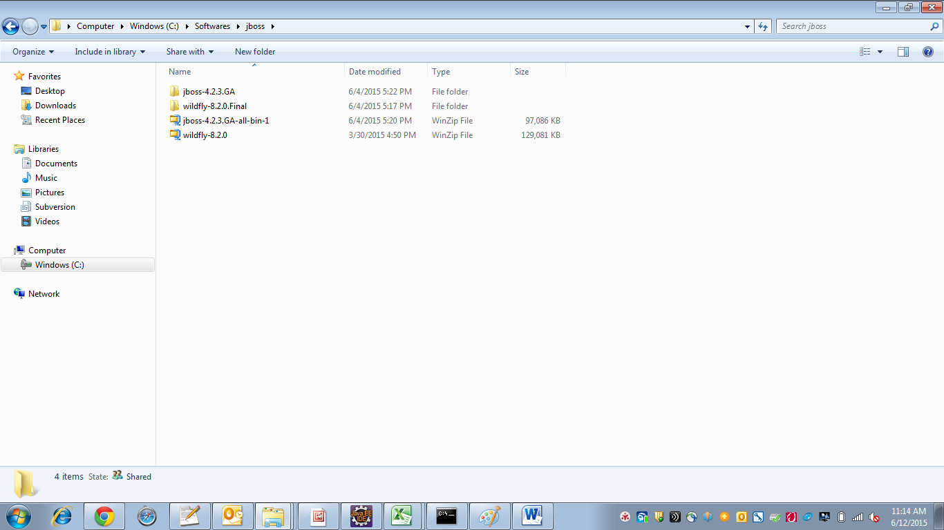

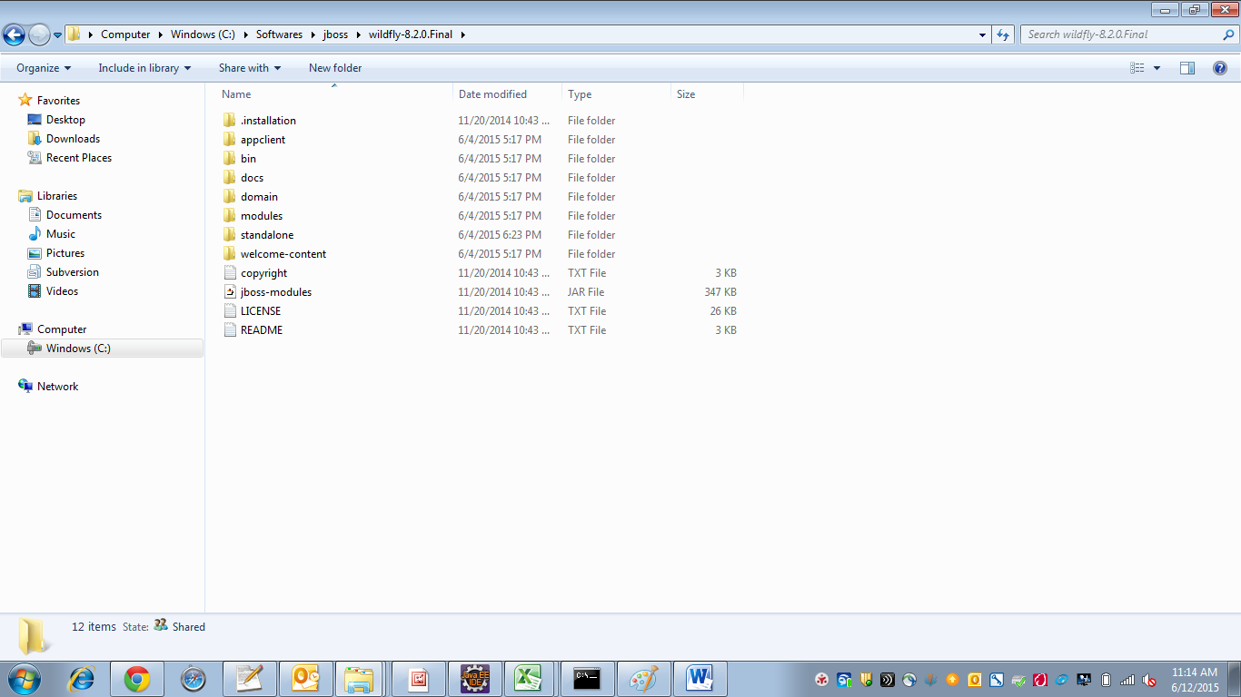

1. Start the wildfly server from command prompt. While starting JBOSS_HOME path will be taken for the path of wildfly.

In my machine another location is given for JBOSS_HOME in environment variable. So temporarily I am changing the JBOSS_HOME path to **C:\Softwares\jboss\wildfly-8.2.0.Final** in the below screen shot. This new value lasts only for this command prompt. For permanent change make changes to JBOSS_HOME environment variable.

Run the wildfly server now. 🡪 execute standalone.bat

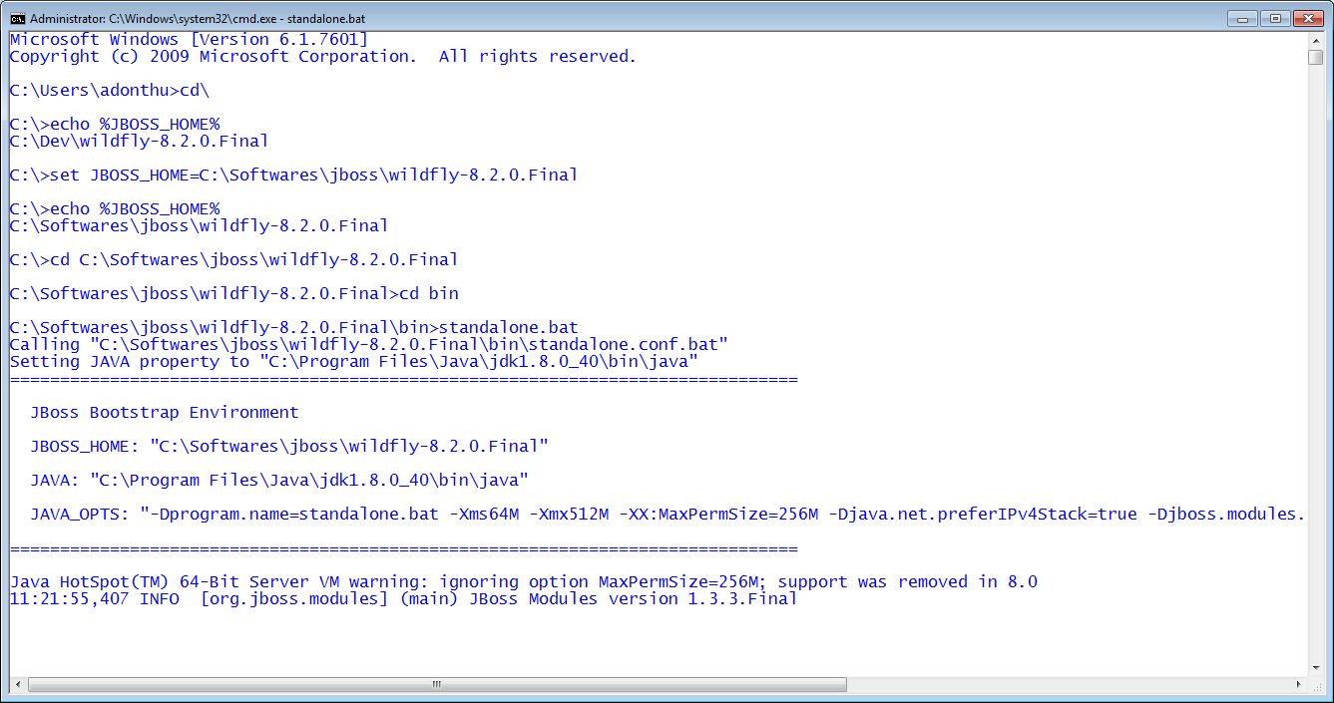

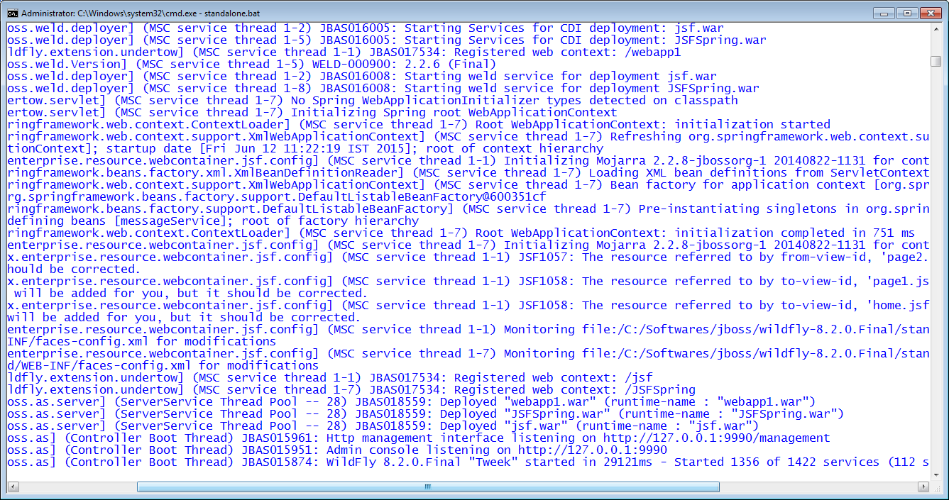

1. Now run following command in command prompt from C:\Test\HelloWorld location.

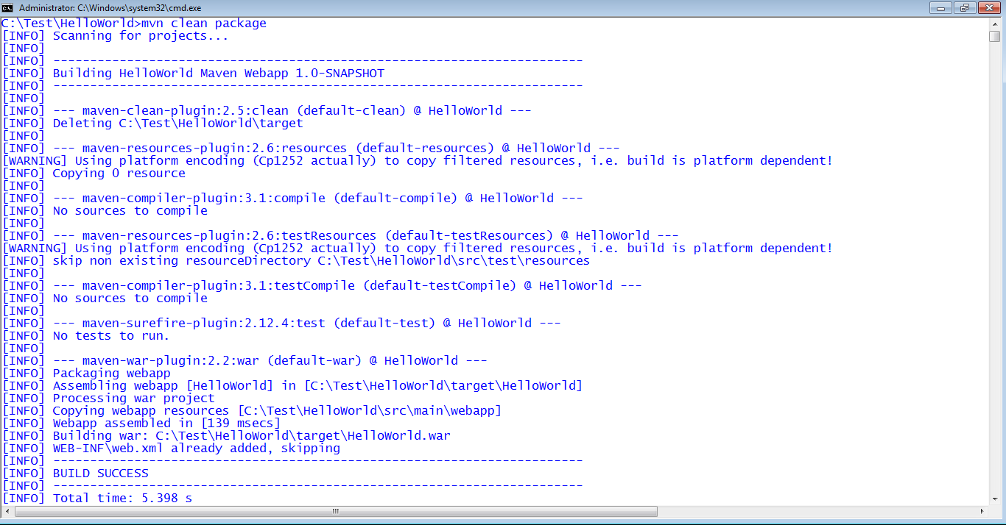

1. Refresh project in eclipse and check war file will be created in target folder in eclipse.

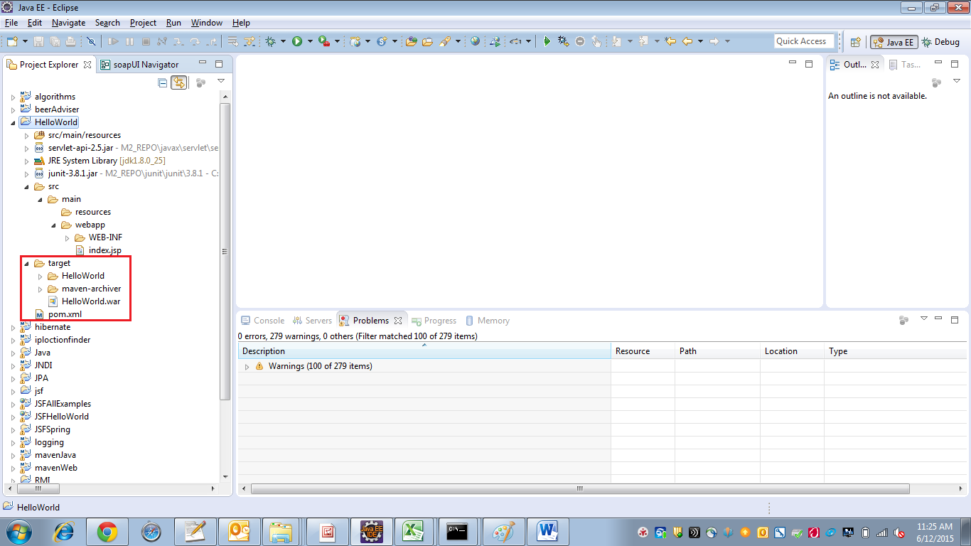

1. Copy HelloWorld.war and paste it in **C:\Softwares\jboss\wildfly-8.2.0.Final\standalone\deployments**
2. After pasting we can see wildfly console for deployment of HelloWorld.war

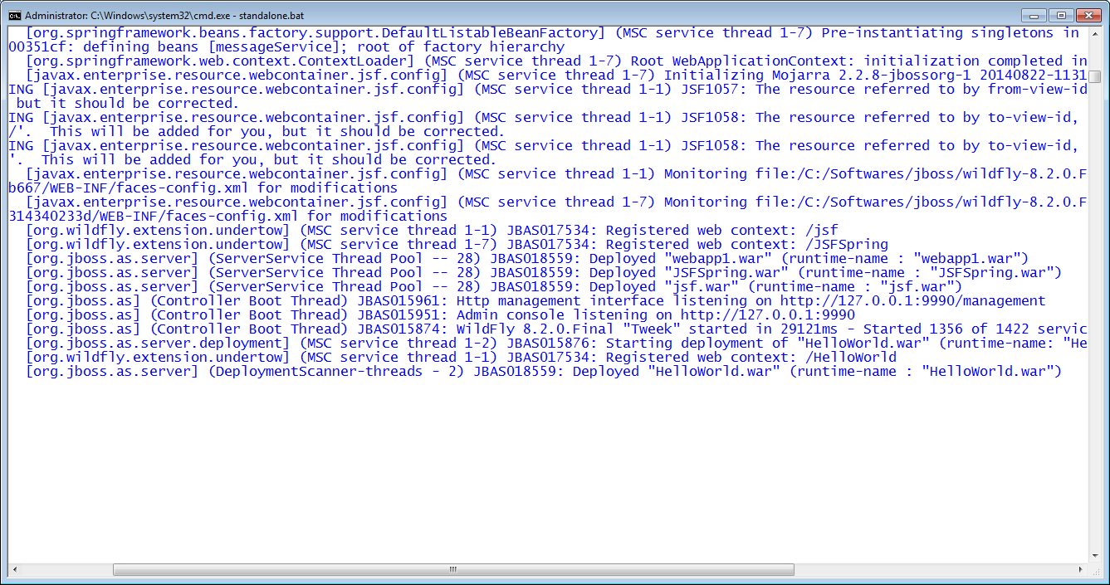

1. Now open browser and go to url

<http://localhost:8080/HelloWorld/>

Viola: ☺

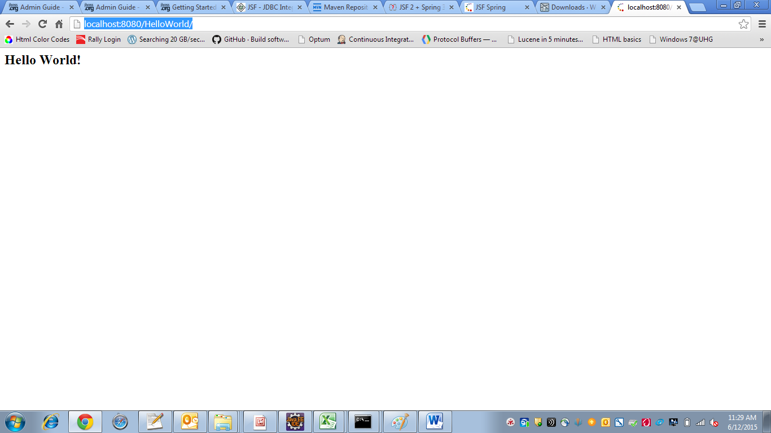

1. Press Ctrl+c to stop the server.

Note: To start wildfly in debug mode run the following command from **C:\Softwares\jboss\wildfly-8.2.0.Final\bin** folder

C:\Softwares\jboss\wildfly-8.2.0.Final\bin>standalone.bat –debug

