**Creating Core Java project with Maven and executing in eclipse**

1. Create Test folder in C: drive.

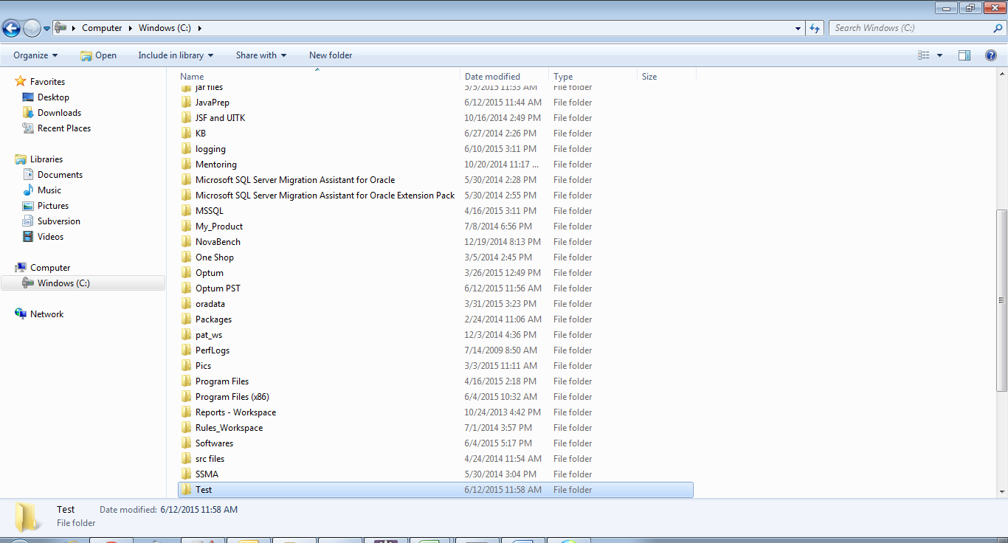

1. Run following command in command prompt.

C:\Test>mvn archetype:generate -DgroupId=com.test -DartifactId=HelloWorld -DarchetypeArtifactId=maven-archetype-quickstart -DinteractiveMode=false

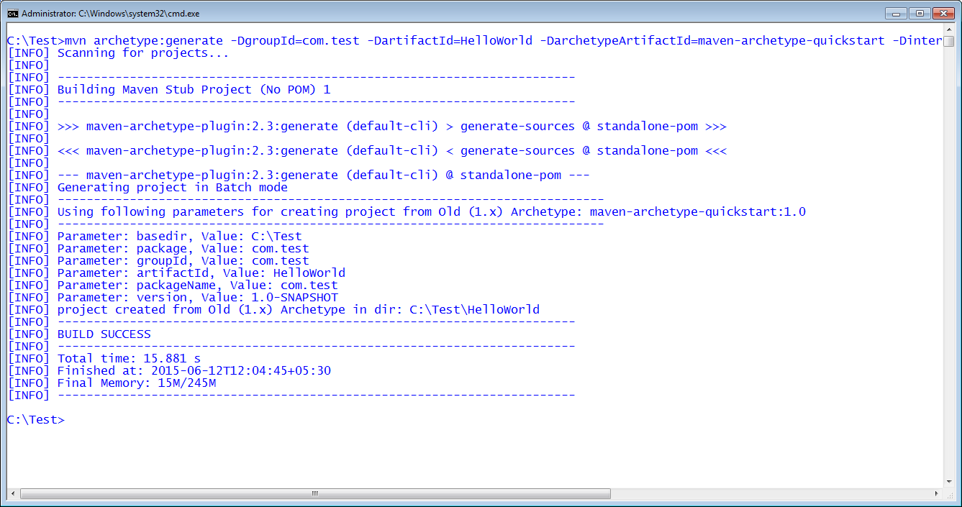

1. Open pom.xml and add compiler version.

<build>

<finalName>jsf</finalName>

<plugins>

<plugin>

<groupId>org.apache.maven.plugins</groupId>

<artifactId>maven-compiler-plugin</artifactId>

<version>2.3.1</version>

<configuration>

<source>1.8</source>

<target>1.8</target>

</configuration>

</plugin>

</plugins>

</build>

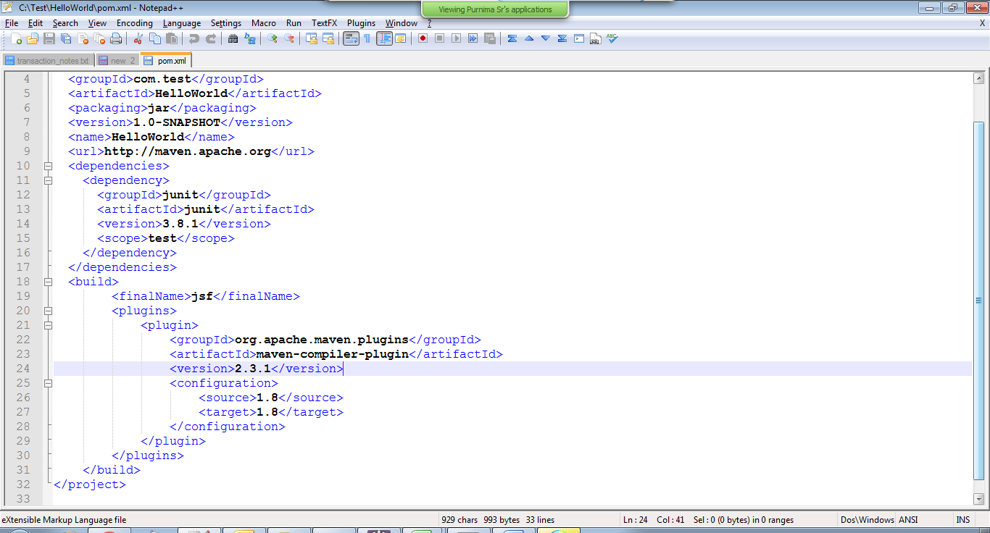

1. Run following commands in command prompt from C:\Test\HelloWorld

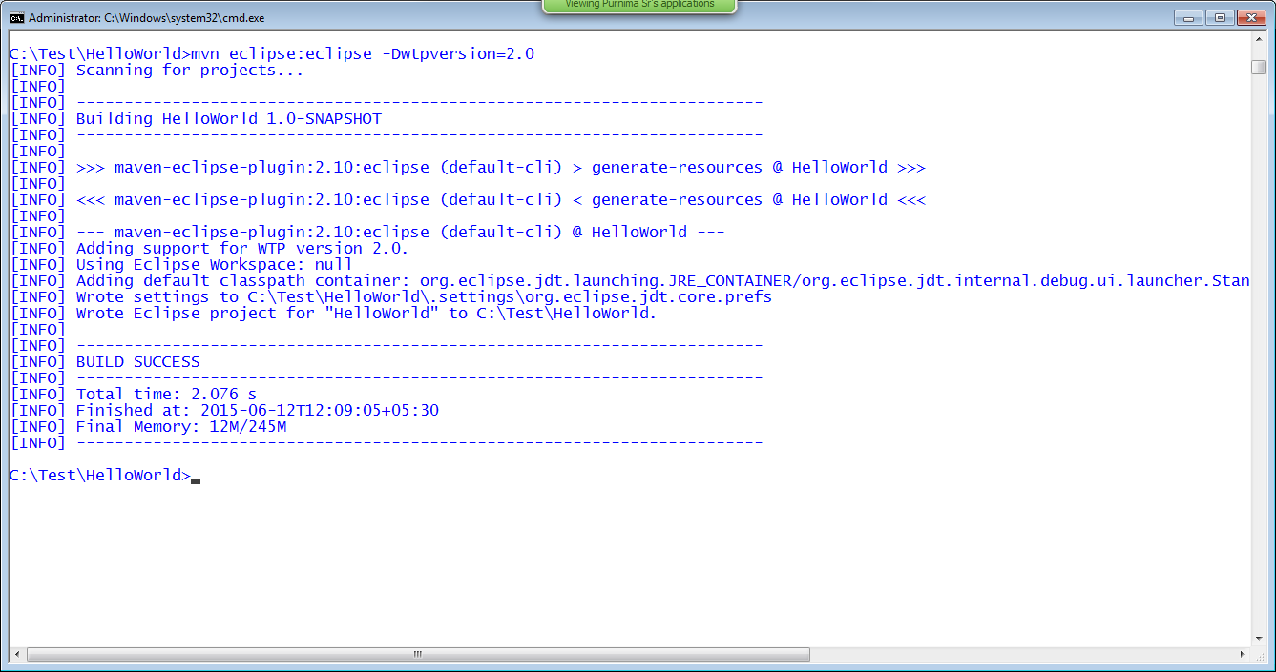

1. Import HelloWorld project to eclipse.

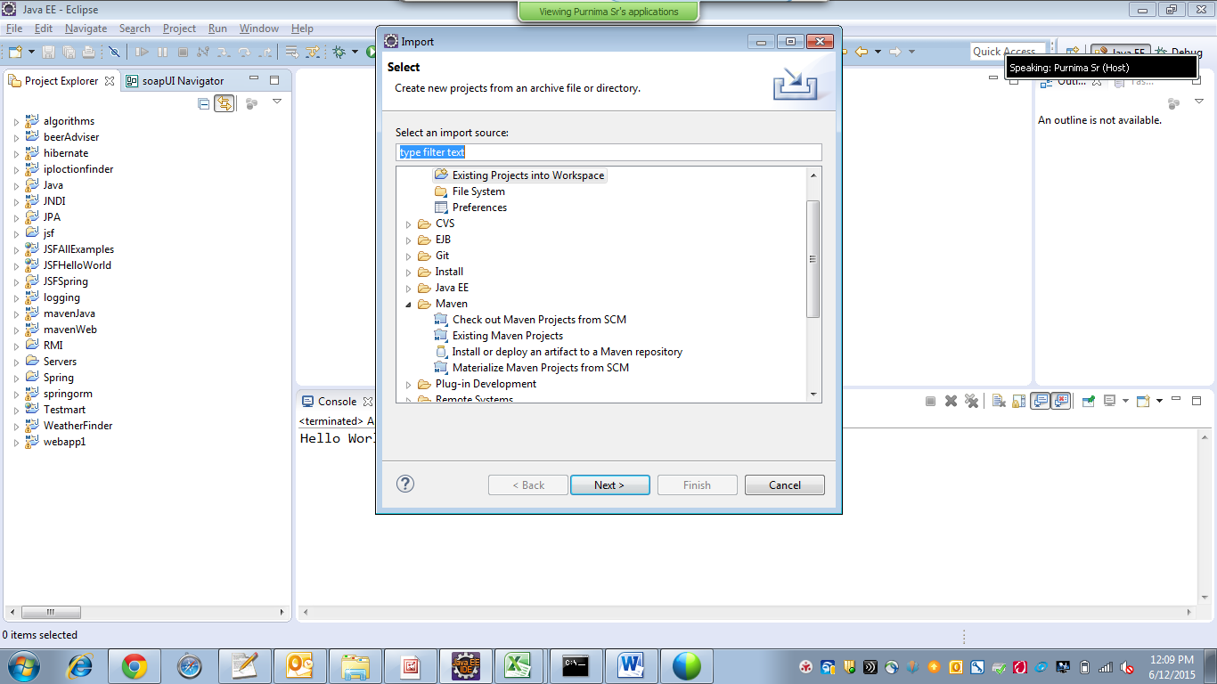

Click on Next

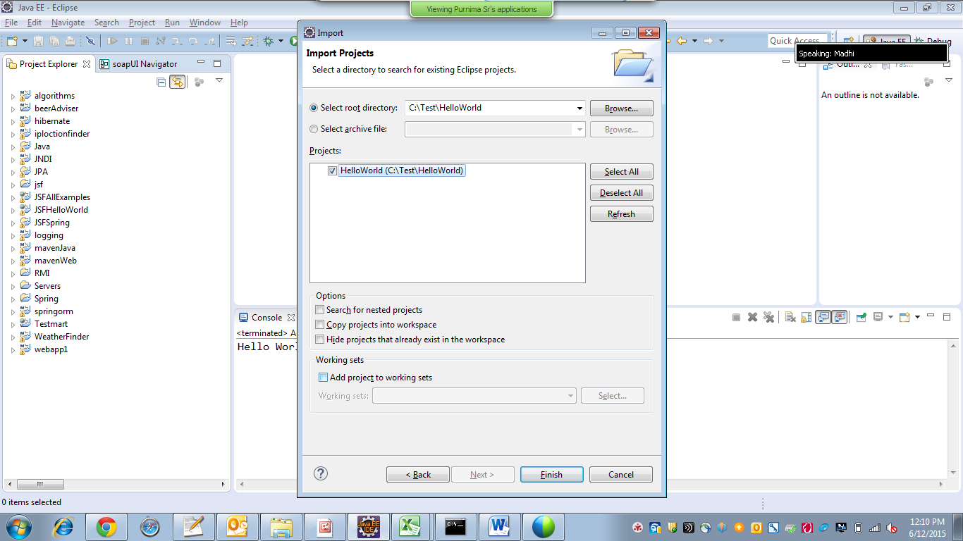

Click on Finish. Project imported successfully to eclipse.

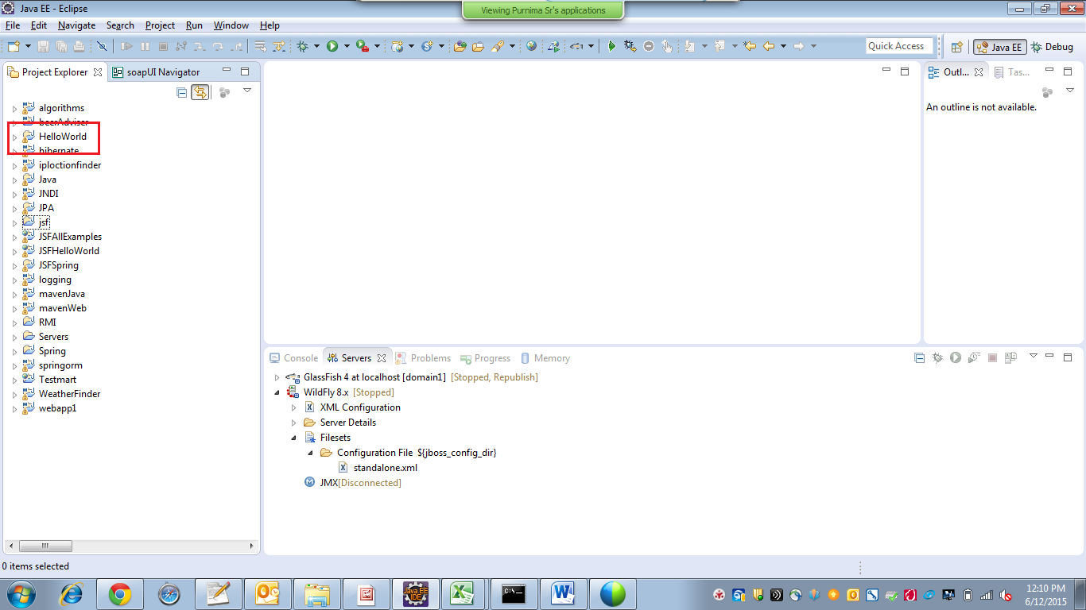

1. Run the HelloWorld -> main class

