How to enable Subversion (SVN) in Eclipse IDE

Eclipse IDE has build-in integration with Concurrent Versions System (CVS), but not Subversion (SVN). Here’s a guide to show you how to make Eclipse IDE support **Subversion (SVN)** via **Subclipse plugin**.

1. Subclipse Plugin

Visit this link : <http://subclipse.tigris.org/> , click on the “*Download and Install*” tab. Get the “**Eclipse update site URL**” for Subclipse plugin, for example <http://subclipse.tigris.org/update_1.6.x>

2. Eclipse IDE

In Eclipse IDE (Helios version), top menu, select “Help” –> “Install New Software…”. And puts<http://subclipse.tigris.org/update_1.6.x> in the “work with” textbox and click on the “Add” button. Select all components and install it.

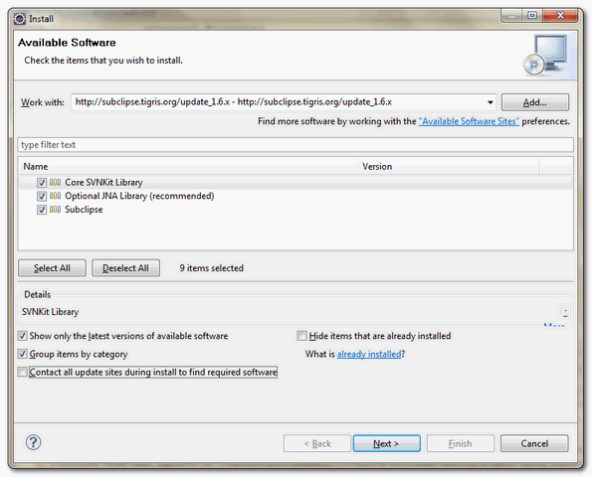

Restart Eclipse IDE to take effect.

3. Test SVN in Eclipse

Eclipse IDE, top menu, select “Windows” –> “Open Perspective” –> “Other…”, choose “**SVN Repositories**“.

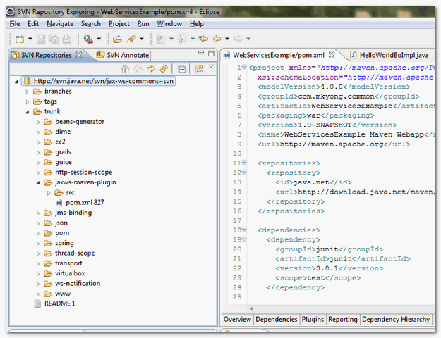

Now, you can perform SVN functionality in this “SVN Repositories” perspective.