Apache Camel Hello World example steps

1. create a maven project using following command in eclipse:

**mvn archetype:generate -DgroupId=com.camel -DartifactId=ApacheCamel -Dversion=1.0-SNAPSHOT -Dpackage=com.camel.hello.world -DarchetypeArtifactId=maven-archetype-quickstart -DinteractiveMode=false**

2. Make this project to import into eclipse:

mvn eclipse:eclipse -Dwtpversion=2.0

3. Import project to eclipse -> add following dependencies in pom.xml

|  |
| --- |
| <!-- http://mvnrepository.com/artifact/org.apache.camel/camel-core -->  <dependency>  <groupId>org.apache.camel</groupId>  <artifactId>camel-core</artifactId>  <version>2.17.1</version>  </dependency> |

4. complete pom.xml is as follows:

|  |
| --- |
| <project xmlns=*"http://maven.apache.org/POM/4.0.0"* xmlns:xsi=*"http://www.w3.org/2001/XMLSchema-instance"*  xsi:schemaLocation=*"http://maven.apache.org/POM/4.0.0 http://maven.apache.org/maven-v4_0_0.xsd"*>  <modelVersion>4.0.0</modelVersion>  <groupId>com.camel</groupId>  <artifactId>ApacheCamel</artifactId>  <packaging>jar</packaging>  <version>1.0-SNAPSHOT</version>  <name>ApacheCamel</name>  <url>http://maven.apache.org</url>  <dependencies>  <dependency>  <groupId>junit</groupId>  <artifactId>junit</artifactId>  <version>3.8.1</version>  <scope>test</scope>  </dependency>  <!-- http://mvnrepository.com/artifact/org.apache.camel/camel-core -->  <dependency>  <groupId>org.apache.camel</groupId>  <artifactId>camel-core</artifactId>  <version>2.17.1</version>  </dependency>  </dependencies>  <build>  <pluginManagement>  <plugins>  <plugin>  <groupId>org.apache.maven.plugins</groupId>  <artifactId>maven-compiler-plugin</artifactId>  <version>3.5.1</version>  <configuration>  <source>1.8</source>  <target>1.8</target>  </configuration>  </plugin>  </plugins>  </pluginManagement>  </build>  </project> |

5. run mvn eclipse:clean and refresh project in eclipse

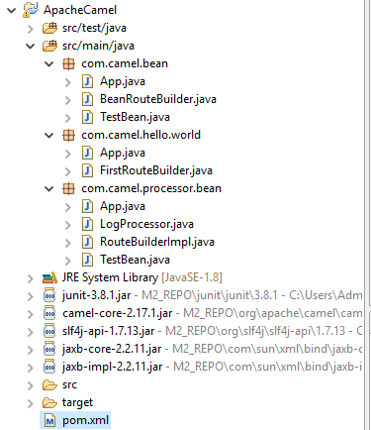

6. write LogProcessor.java

|  |
| --- |
| **package** com.camel.processor.bean;  **import** org.apache.camel.Exchange;  **import** org.apache.camel.Processor;  **public** **class** LogProcessor **implements** Processor {  @Override  **public** **void** process(Exchange exchange) **throws** Exception {  System.***out***.println("com.camel.processor.bean.LogProcessor.process()");  /*to get input body from exchange  exchange.getIn().getBody();*/  }  } |

7. Write TestBean.java

|  |
| --- |
| **package** com.camel.processor.bean;  **import** org.apache.camel.Exchange;  **public** **class** TestBean {  **public** String testBean(Exchange exchange) {  System.***out***.println("com.camel.processor.bean.TestBean.testBean()");  **return** "Test Bean";  }  } |

8. Write RouteBuilderImpl.java

|  |
| --- |
| **package** com.camel.processor.bean;  **import** org.apache.camel.builder.RouteBuilder;  **public** **class** RouteBuilderImpl **extends** RouteBuilder {  @Override  **public** **void** configure() **throws** Exception {  from("file:E:/Backup/JavaPrep/Apache_Camel/router_practice_folder/input?noop=true")  .process(**new** LogProcessor()).bean(**new** TestBean())  .to("file:E:/Backup/JavaPrep/Apache_Camel/router_practice_folder/output3").end();  }  } |

9. Write App.java

|  |
| --- |
| **package** com.camel.processor.bean;  **import** org.apache.camel.CamelContext;  **import** org.apache.camel.impl.DefaultCamelContext;  **public** **class** App {  **public** **static** **void** main(String[] args) {  **try** {  CamelContext context = **new** DefaultCamelContext();  context.addRoutes(**new** RouteBuilderImpl());  context.start();  Thread.*sleep*(1000 * 60 * 2);  context.stop();  } **catch** (Exception e) {  e.printStackTrace();  }  }  } |

output:



