Bamboo setup

1. Download Bamboo from below url. Download based on respective OS. I have downloaded "Bamboo 5.13.1 - ZIP Archive"

https://www.atlassian.com/software/bamboo/download

2. Unzip/extract above download zip/tar.gz. I have unzipped to "D:\Softwares\atlassian-bamboo-5.13.1\atlassian-bamboo-5.13.1" path

3. Go to "D:\Softwares\atlassian-bamboo-5.13.1\atlassian-bamboo-5.13.1\atlassian-bamboo\WEB-INF\classes" --> Open "bamboo-init.properties" file --> give bamboo.home=D:/Softwares/atlassian-bamboo-5.13.1/atlassian-bamboo-5.13.1 --> Save

bamboo.home == above extracted path that is home location of bamboo

4. Open command prompt/Mac Terminal --> Go to D:\Softwares\atlassian-bamboo-5.13.1\atlassian-bamboo-5.13.1\bin --> run startup.bat if windows OS/ sh startup.sh if Mac

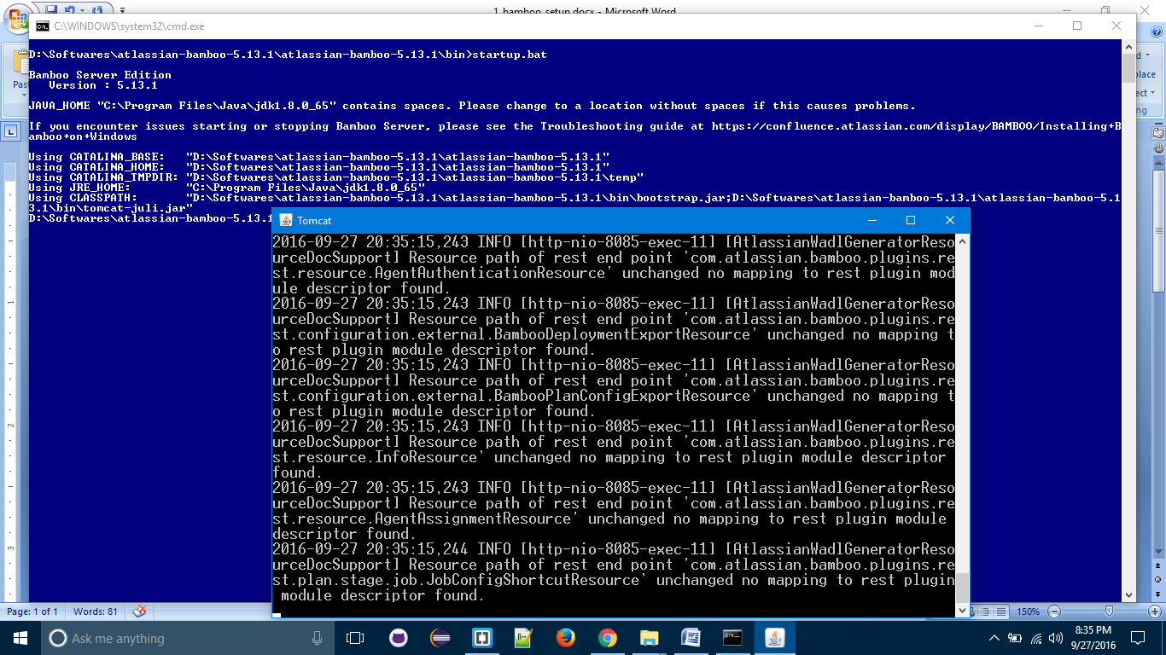

5.Above command will start embedded tomcat server. once server started acess bambo:

http://localhost:8085

6. Follow the steps once bamboo is accessed.

7. Create Plan once initial setup is done

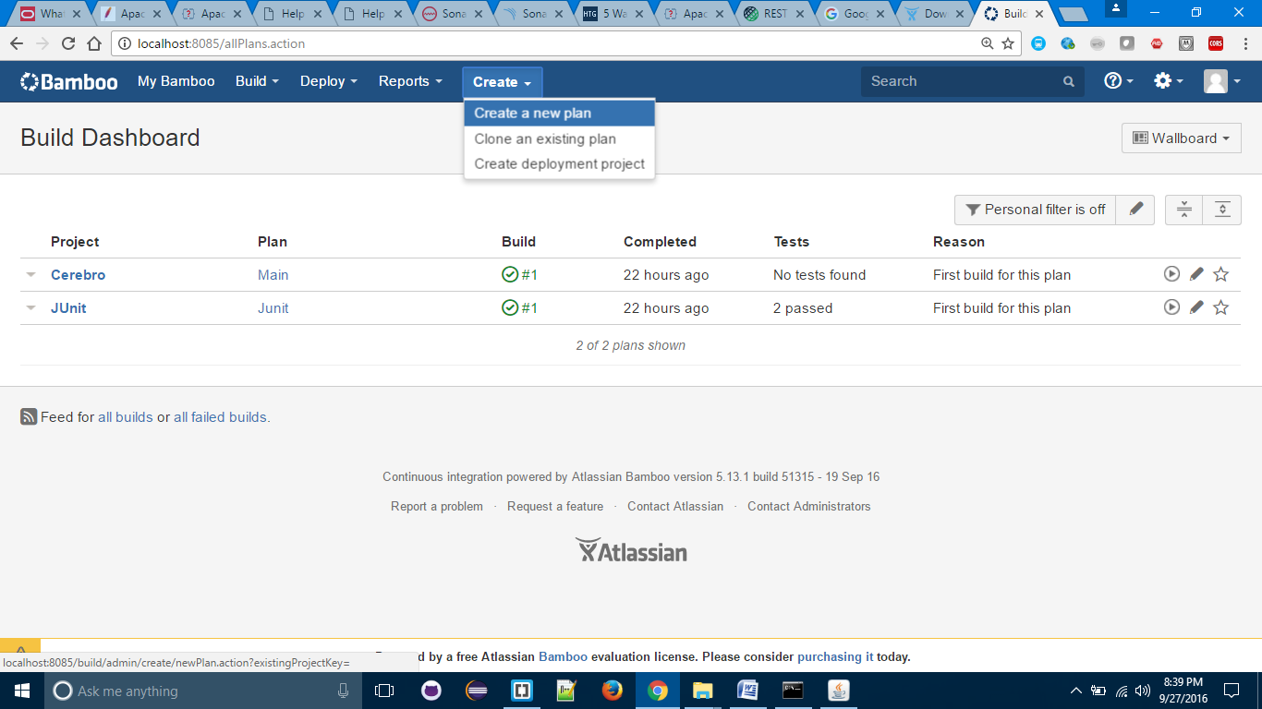

8. Give appropriate values in Configure plan screen:

Project Name: Any Name to identify project

Project Key: Unique key to identify project

Plan Name: Any Name like compiling my project

Plan Key: Unique key to identify our project plan

Repository Host: select appropriate values. select appropriate version control

Display Name: Project name in version control

Username: username of version control

password: password of version control

click on "configure plan"

9. Once plan created -> click on Add Task button

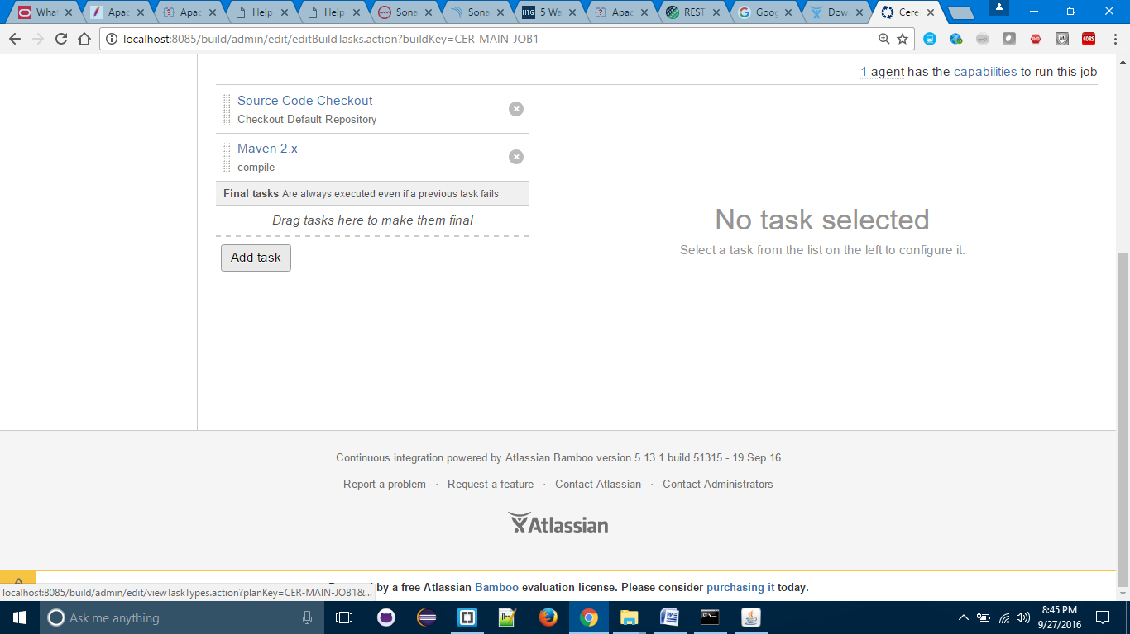

10. Select appropriate build tool. I selected Maven 2.x

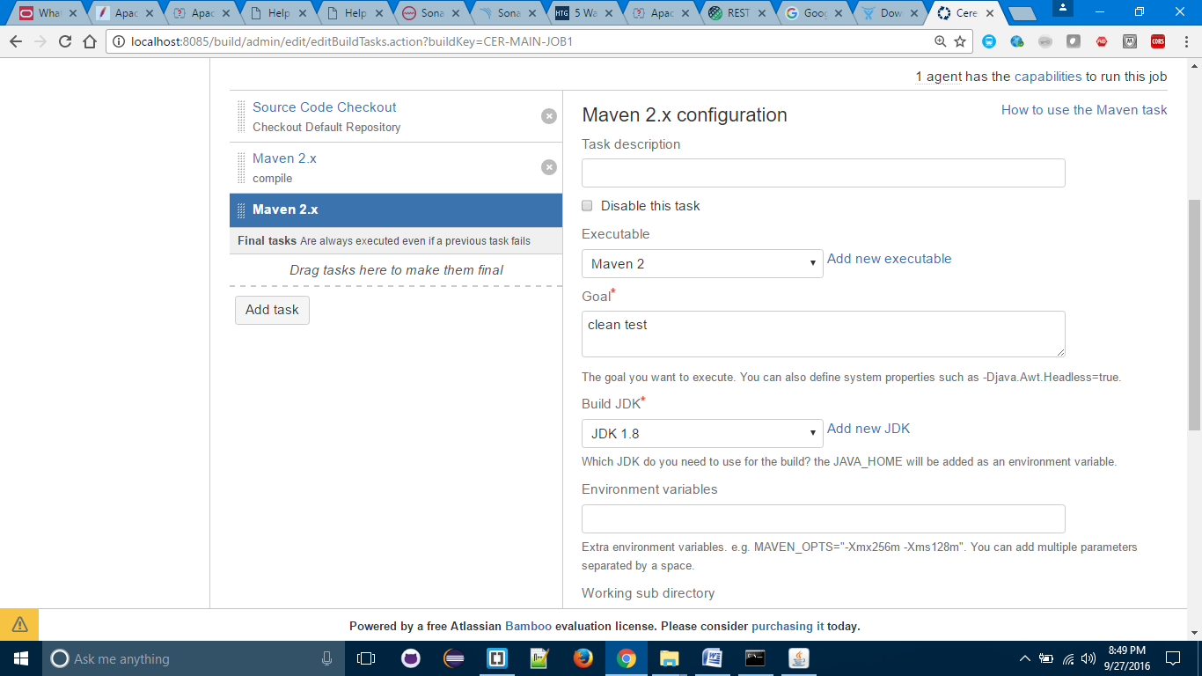

11. click on "Add new executable" link.

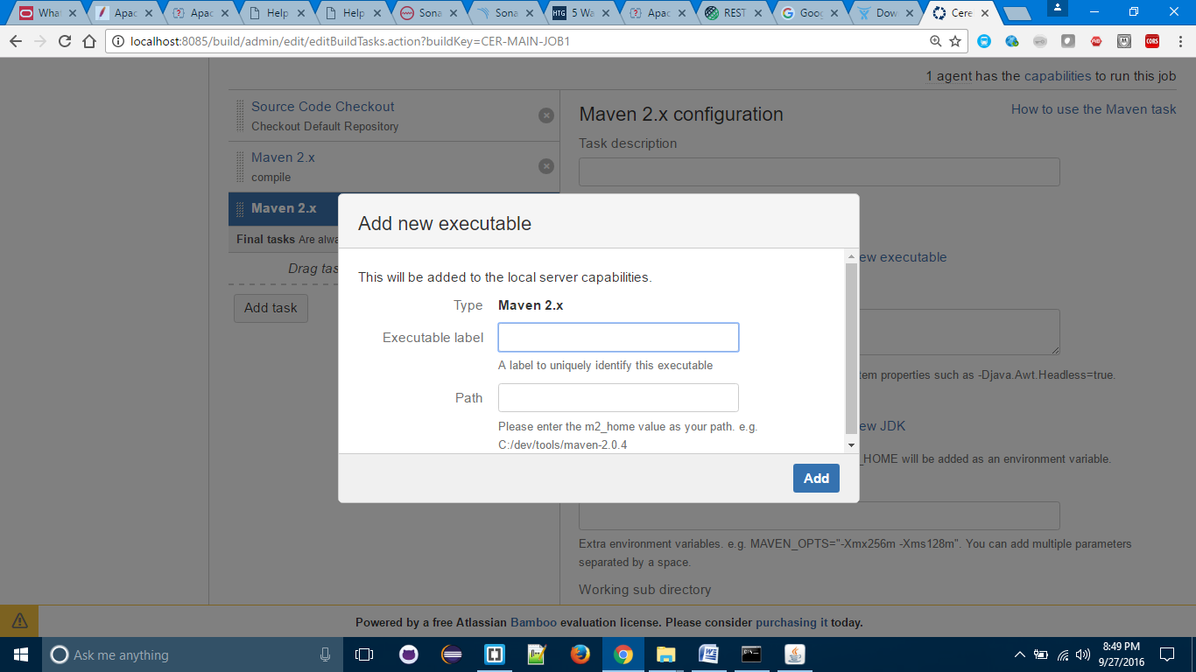

12. Executable Label: Maven 2

Path: path to maven home directory

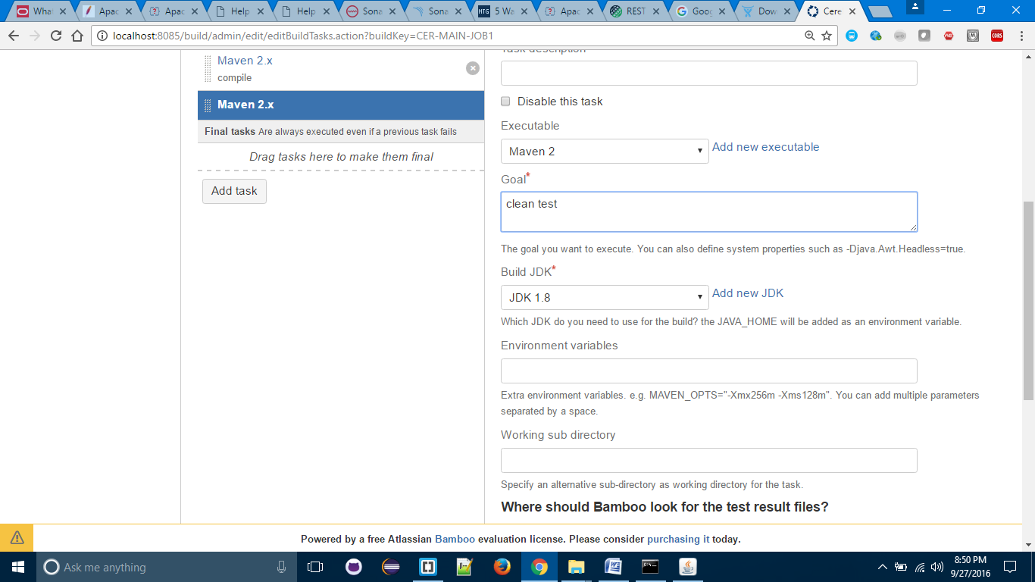

13. Goal: give maven goals

14. Select appropriate values

15. Click on Save

16. Select "Yes Please" check box

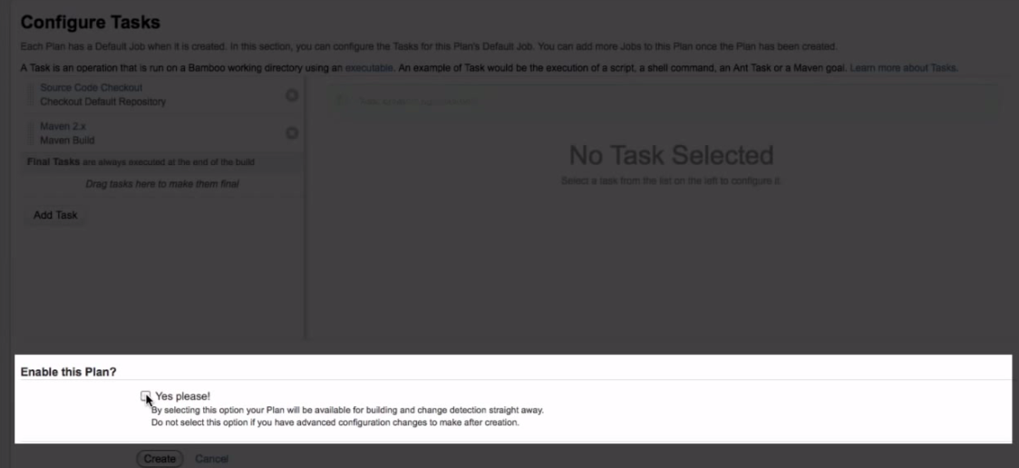

17. Click on Create button

18. Build will be triggered.