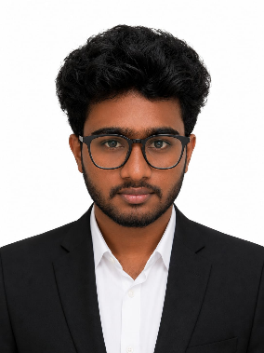
GIRIDHARAN R
+91 9353293224 | gdlion123@email.com | LinkedIn | Portfolio

Summary
2026 Information Science and Engineering graduate with hands-on experience in Python Full Stack Development. Skilled in building responsive web applications using Python, Django, ReactJS, JavaScript, HTML, CSS, and MySQL. Experienced in developing full-stack projects, integrating databases, and creating scalable web solutions. Passionate about software engineering, problem-solving, and continuous learning with a strong interest in modern web technologies and AI-powered applications.

Technical Skills
Programming Languages: Python, JavaScript (ES6+), HTML5, CSS3, SQL
Frameworks & Libraries: Django, ReactJS, Flask, FastAPI, Bootstrap
Databases: MySQL, SQLite, MongoDB
Tools & Platforms: Git, GitHub, VS Code, Power BI, Tableau

Projects

StudySync AI Live Demo
Python, Django, SQLite, JavaScript, CSS3
Built an AI-powered learning platform that generates study roadmaps and summaries based on user topics.
Developed the full-stack application using Django, SQLite, JavaScript, and CSS with progress tracking features.

TripMate: All-in-One Travel Platform GitHub
Python, Django, JavaScript, SQLite, CSS3
Developed a travel booking platform for hotels, transport, and holiday packages.
Implemented backend services, user history tracking, and database management using Django and SQLite.

AI-Powered Document Extraction System
ReactJS, FastAPI, BERT, GPT-4, OCR (Tesseract), SQL
Built a document processing system to extract and organize information from scanned and digital documents.
Integrated OCR, BERT, GPT-4, FastAPI, and SQL for document classification, extraction, and summarization.

Education
AMC Engineering College, Bangalore 2022 – 2026
Bachelor of Engineering in Information Science and Engineering CGPA: 7.7/10

St. Joseph’s Pre-University College 2022
Pre-University Course (PUC) Percentage: 83%

Certifications

Certificate of Internship – Python Full Stack Development
Dhee Coding Lab, Bangalore 2026

