Table of Contents
PI Fast Routine LabVIEW Sample Application
Release: 1.0.0 Date: 2016-11-28
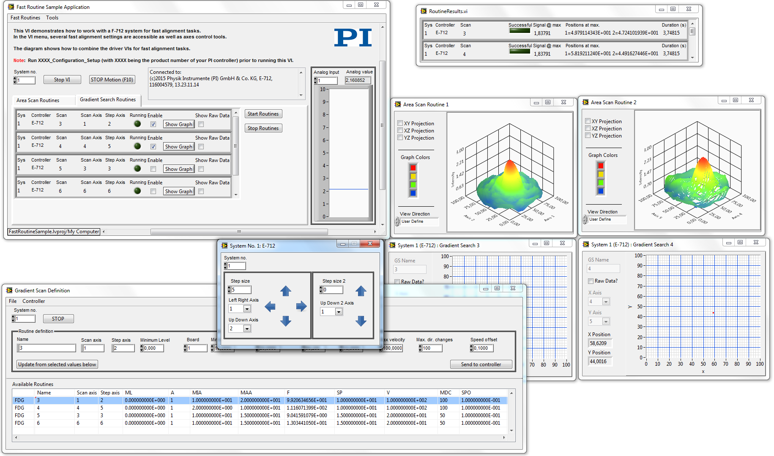
This document describes software for use with the following product(s):
- All Systems
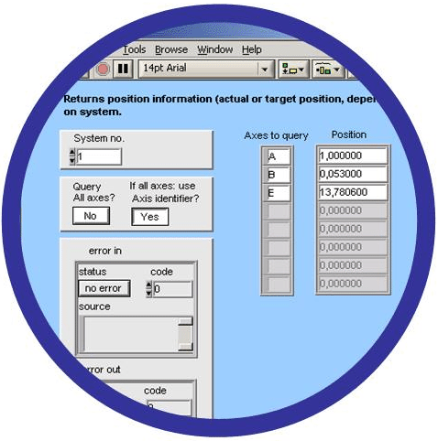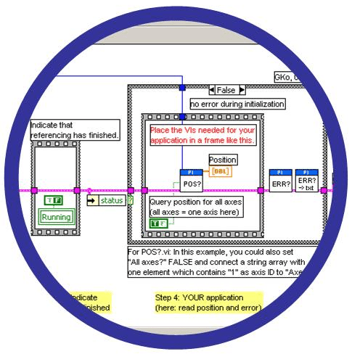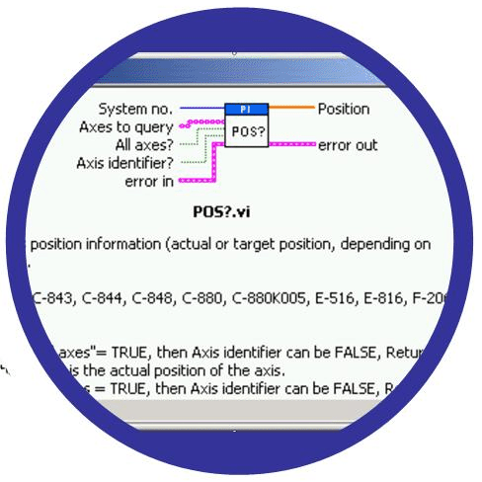

1. Introduction 4
2. Main VIs 5
2.1.1. FastRoutineSample.vi 5
2.1.2. AreaScan3DGraph.vi 6
2.1.3. AxesControl.vi 6
2.1.4. AxesPositions.vi 7
2.1.5. AxesWindow.vi 7
2.1.6. FrequencyAnalysis.vi 8
2.1.7. GradientSearchCoupling.vi 9
2.1.8. GradientSearchGraph.vi 10
2.1.9. InputCalculation.vi 11
2.1.10. ManageAreaScanRoutines.vi 11
2.1.11. CalculateAreaScanVelocity.vi 11
2.1.12. ManageGradientSearchRoutines.vi 12
2.1.13. RoutineResults.vi 12
3. Low Level VIs 13
3.1.1. Build2DArrayFromMultilineString.vi 13
3.1.2. ConfigureDataRecorder.vi 13
3.1.3. CreateArrayHeadersFromRoutineEntries.vi 13
3.1.4. CreateScanDefinitionMenu.vi 13
3.1.5. GetAreaScanAxesRanges.vi 13
3.1.6. GetAreaScanNamesAndAxes.vi 14
3.1.7. GetFastAlignmentInputID.vi 14
3.1.8. GetGradientSearchNamesAndAxes.vi 14
3.1.9. GetRoutineDefinitionFromController.vi 14
3.1.10. GetScanCenterAndRadius.vi 15
3.1.11. QueryFastRoutineResults.vi 15

© 2008 - 2016 Physik Instrumente (PI) GmbH & Co. KG
Physik Instrumente (PI) GmbH & Co. KG is the owner of the following trademarks:
PI®, PIC®, PICMA®, PILine®, PiezoWalk®, NEXACT®, NEXLINE®, NanoCube®, Picoactuator®, PInano®, PIMag®
The following designations are protected company names or registered trademarks of third parties:
Windows, NI LabVIEW.
LabVIEW is a trademark of National Instruments. Neither the driver Software, nor any software programs or other goods or services offered by PI, are affiliated with, endorsed by, or sponsored by National Instruments.
PI owns the following patents or patent applications for the technology field Piezo Stepping Drive (PiezoWalk®, NEXACT®, NEXLINE®):
DE10148267B4, EP1267478B1, EP2209202B1, EP2209203B1, US6800984B2, DE4408618B4
PI owns the following patents or patent applications for the technology field Multilayer Piezo Actuators (PICMA®):
DE10021919C2, DE10234787C1, ZL03813218.4, EP1512183A2, JP4667863, US7449077B2
PI owns the following patents or patent applications for the technology field Ultrasonic Piezo Motors (PILine®):
Germany: DE102004024656A1, DE102004044184B4, DE102004059429B4, DE102005010073A1, DE102005039357B4, DE102005039358A1, DE102006041017B4, DE102008012992A1, DE102008023478A1, DE102008058484A1, DE102010022812A1, DE102010047280A1, DE102010055848, DE102011075985A1, DE102011082200A1, DE102011087542B3, DE102011087542B3, DE102011087801B4, DE102011108175, DE102012201863B3, DE19522072C1, DE19938954A1
Europe: EP0789937B1EP1210759B1, EP1267425B1, EP1581992B1, EP1656705B1, EP1747594B1, EP1812975B1, EP1861740B1, EP1915787B2, EP1938397B1, EP2095441B1, EP2130236B1, EP2153476B1, EP2164120B1, EP2258004B1, EP2608286A2
USA: US2010/0013353A1, US5872418A, US6765335B2, US6806620B1, US6806620B1, US7218031B2, US7598656B2, US7737605B2, US7795782B2, US7834518B2, US7973451B2, US8253304B2, US8344592B2, US8482185B2
Japan: JP2011514131, JP2011522506, JP3804973B2, JP4377956, JP4435695, JP4477069, JP4598128, JP4617359, JP4620115, JP4648391, JP4860862, JP4914895, JP2013539346
China: ZL200380108542.0, ZL200580015994.3, ZL200580029560.9, ZL200580036995.6, ZL200680007223.4, ZL200680030007.1, ZL200680042853.5
International patent applications: WO2009059939A2, WO2010121594A1, WO2012048691A2, WO2012113394A1, WO2012155903A1, WO2013034146A3, WO2013117189A2
PI owns the following patents or patent applications for the technology field Magnetic Direct Drives (PIMag®):
WO212146709A2, DE102012207082A1
PI owns the following patents or patent applications for the technology field Piezo Inertia Drives (PIShift, PiezoMike):
EP2590315A1, WO213064513A1, DE102011109590A1, WO2013020873A1

Software products that are provided by PI are subject to the General Software License Agreement of Physik Instrumente (PI) GmbH & Co. KG and may incorporate and/or make use of third-party software components.
For more information, please read the General Software License Agreement and the Third Party Software Note linked below.
General Software License Agreement
Third Party Software Note
Release: 1.0.0
File:PIFastRoutineSample.pdf

Introduction
The F-712 systems provide routines for fast alignment of one or more senders and receivers. The objective of the routines is to align each sender and receiver so that the maximum intensity of the emitted signal is measured on the receiver side.

The following types of fast alignment routines are provided:
- “Area scan”: Spiral or raster scan to find the position of the global intensity maximum of the measured signal
- “Gradient search”: Circular scan with gradient formation to find the maximum intensity value of the measured signal
Typically, the end position of an area scan routine is used as the start position for a gradient search routine.
The maximum number of routines is identical to the number of motion axes that are present in the system (E-712 controller only).
Multiple gradient search routines can run synchronously for the axes on both the sender and receiver side (E-712 controller only).
Application examples:
Sender and receiver are optical fibers. During the alignment of sender and receiver in axes x, y and z, the power of the optical signal (light) is measured on the receiver side with a power meter. The power meter converts the optical power into an analog signal. Goal of the alignment routines is to align sender and receiver so that the maximum optical power is measured on the receiver side.
Multiple couplings (for example, of the input and output of a waveguide device) have to be optimized (Only with E-712 controller). In this case, gradient search routines for the couplings can be performed simultaneously, ensuring a global optimization, even if the couplings interact. Similarly, for lensed couplings a Z gradient search may also be performed at the same time.

This sample application shows how a fast alignment application software can look like and how the PI GCS LabVIEW driver set can be used.
The sample application is provided “as is” and with no guarantee of working without errors.

The code is open source and can be adjusted to customer’s needs without asking PI for permission.

Main VIs

FastRoutineSample.vi
This VI demonstrates how to work with an F-712 system for fast alignment tasks.
In the VI menu, several fast alignment settings are accessible as well as axes control tools.
The diagram shows how to combine the driver VIs for fast alignment tasks.
Note: Run XXXX_Configuration_Setup (with XXXX being the product number of your PI controller) prior to running this VI.
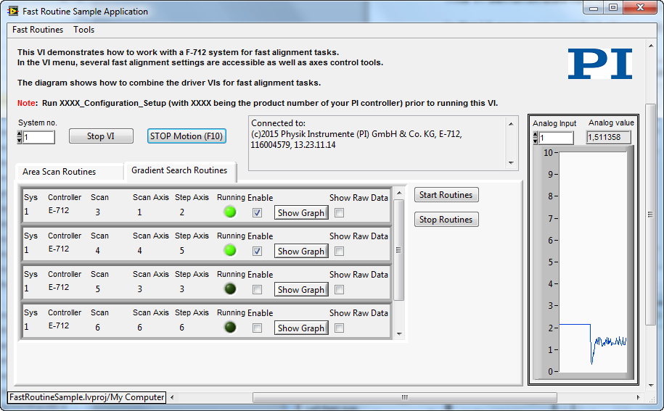

The main application gives an overview of all fast routines that are defined on the controller.
All routines can be started or stopped and visualization graphs can be opened.
It is possible to manage all area scan or gradient search routines and set the coupling (E-712 controller only) or fast alignment input calculation via the "Fast Routines" menu.
The “Tools” menu gives access to axes management like the “Axes Control” window or tools for the axes start up or storing and loading positions.

AreaScan3DGraph.vi
This VI provides a 3D plot of the recorded scan data and the corresponding intensity distribution.
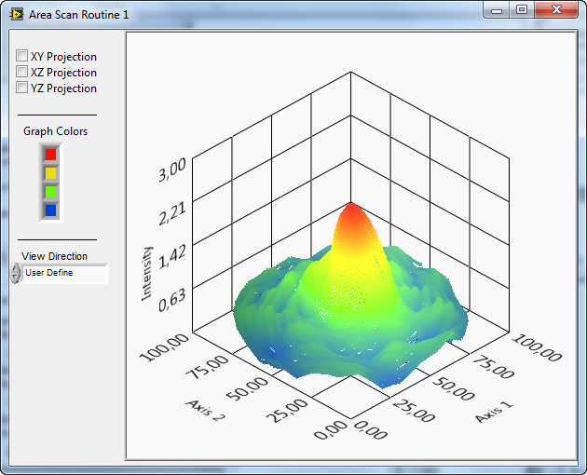

AxesControl.vi
This VI allows the user to perform relative motion with a user-defined step size for every connected axis.
Note: Due to the fact that the physical units between piezo axes and motorized axes differ, the step size is automatically set to zero value when changing the axes assignment to prevent damage to the system setup.
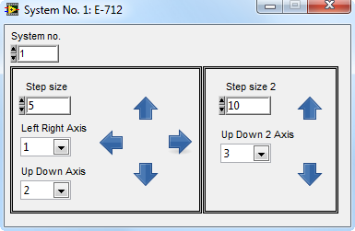

AxesPositions.vi
This VI allows you to save position information to a text file. Also the position information from a text file can be opened again.
Pressing on the "Stop Motion (F10)" button or the “F10” key will send a "#24" command to the controller to stop the motion of every axis.
This VI opens modally so that the communication, especially the “#24” (stop) command, is not disturbed by any other processes.
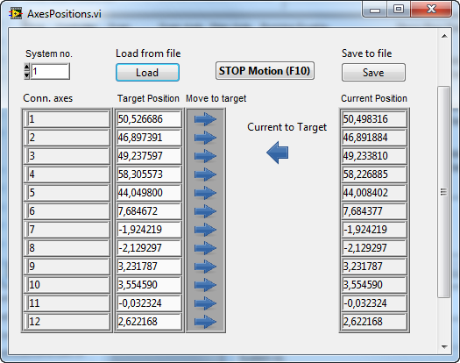

AxesWindow.vi
This VI allows the user to start up the system axes by enabling or disabling the servo and by performing a reference motion of the selected axes.
Selecting "Cancel FRF" or pressing the Escape key will stop the referencing procedure of all axes by sending a "#24" (stop) command to the controller.
This VI opens modally so that the communication, especially the STOP command, is not disturbed by any other processes.
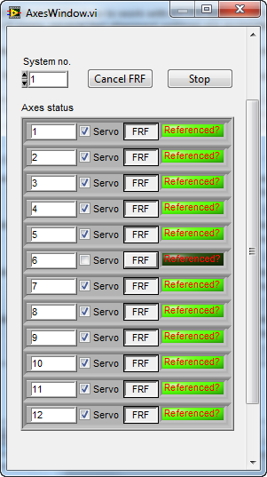

FrequencyAnalysis.vi
This VI allows the user to analyze natural frequencies and oscillations of the system via analyzing the optical signal variation.
To achieve a maximum variation of the signal intensity with a very small variation of the position, the axis that is to be investigated should be moved to the slope of the signal as shown in the following figure:
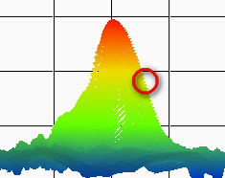
If only a resonance analysis of the system should be performed without any excitation of the axes, choose the analog input channel, the number of data points and press the “Record now” button.
The recorded data will be displayed in the graph window. Press the "FFT" button to display a Fourier transformation of the recorded data.
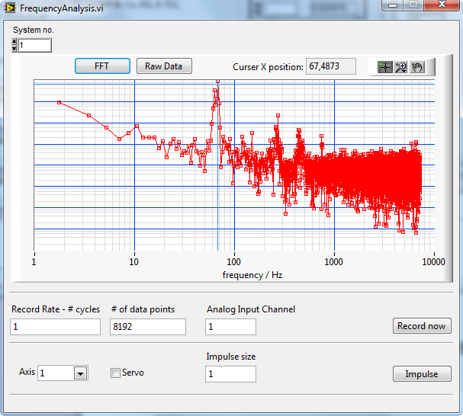
To excite an axis, please choose the axis that is going to be investigated and press the “Impulse” button. This will send the “IMP” GCS command to the controller. (Please refer to the controller’s user manual for more information on the IMP command and how to use it).
To allow an open-loop impulse, the servo of each axis can be switched off. Please ensure that the servo is enabled again before closing this window.

GradientSearchCoupling.vi
This VI allows coupling of gradient search routines using the FRC command.
All changes are sent to the controller by pressing the OK button.
If Cancel is selected or the window is closed, all changes are dismissed and no change is made regarding the routine coupling.
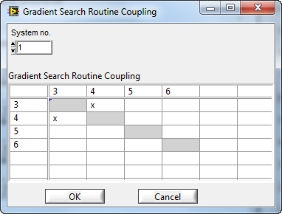

GradientSearchGraph.vi
This VI shows the position of the axes that are used for the selected gradient search routines.
If “Raw Data?” is enabled, the current position (POS?) is shown instead of using the gradient search center and radius.
This VI can also be used to visualize the position even if no scan is running.
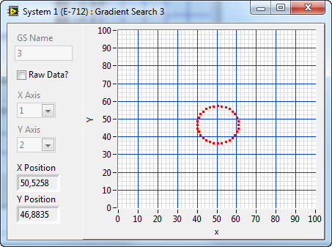

InputCalculation.vi
This VI allows setting the input calculation of the fast alignment input channel.
For more information, please refer to the online help of the SIC and SIC? command.
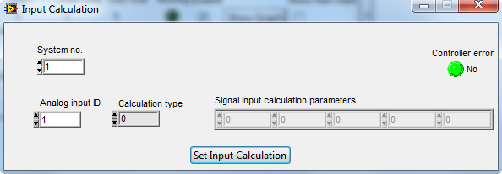

ManageAreaScanRoutines.vi
This VI allows adding or editing of Area Scan Routines (FDR).
Routines can be managed on the controller directly or via text files.

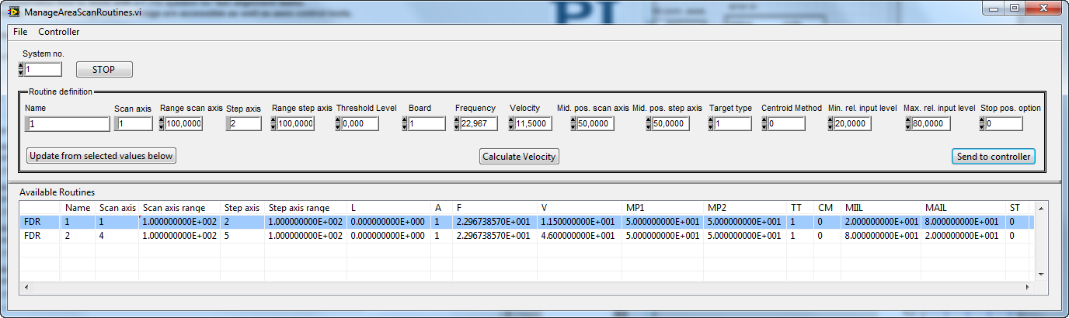

CalculateAreaScanVelocity.vi
This VI calculates the velocity that has to be provided at the area scan routine definition.
You can specify the desired "step size" and the resulting velocity (either the scan axis velocity [sinusoidal] or the radial velocity [spiral]) will be calculated from the frequency and the selected routine type.
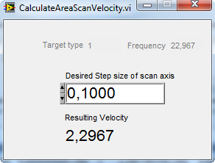

ManageGradientSearchRoutines.vi
This VI allows adding or editing of Gradient Search Routines (FDG).
Routines can be managed on the controller directly or via text files.
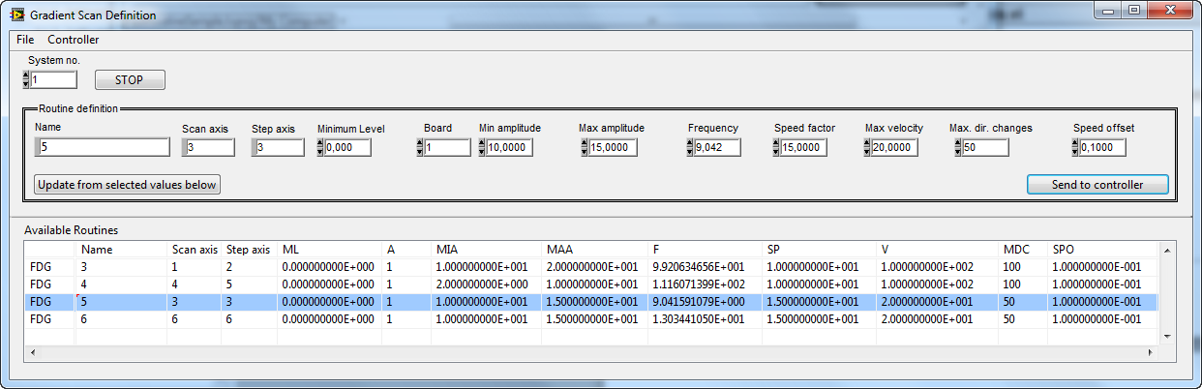

RoutineResults.vi
This VI shows the results queried by the QueryFastRoutineResults.vi.
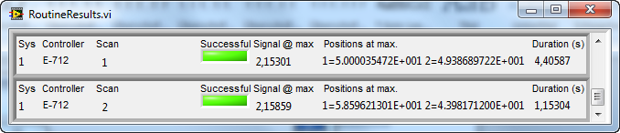

Low Level VIs

Build2DArrayFromMultilineString.vi
This VI builds a 2D array from a multiline text string.
You can choose either a TAB (\t) or a SPACE (\s) constant as a separator for the columns.
This sub VI is used by ManageGradientSearchRoutines.vi and ManageAreaScanRoutines.vi.
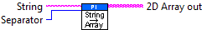

ConfigureDataRecorder.vi
This VI configures the data recorder to record the positions of the scan axis and the step axis as well as the value of the analog input.
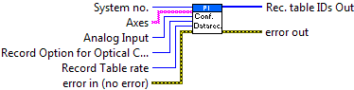

CreateArrayHeadersFromRoutineEntries.vi
This VI creates the array headers for ManageGradientSearchRoutines.vi and ManageAreaScanRoutines.vi.
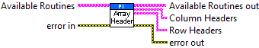

CreateScanDefinitionMenu.vi
This VI creates menu entries for scan definition SubVIs.
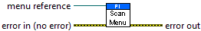

GetAreaScanAxesRanges.vi
This VI reads all area scan routines from controller and calculates the scan ranges.
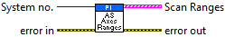

GetAreaScanNamesAndAxes.vi
This VI reads all area scan routine definitions from controller and shows names and axes in a 2-D string array.
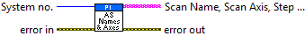

GetFastAlignmentInputID.vi
This VI reads all area scan rotuines from the controller and searches for the keyword "A" in the scan routine definition. The number after the keyword "A" is the fast alignment input ID.
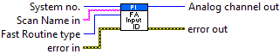

GetGradientSearchNamesAndAxes.vi
This VI reads all gradient search routine definitions from controller and shows names and axes in a 2D string array.
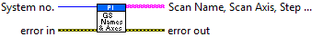

GetRoutineDefinitionFromController.vi
This VI uses FRR? to query all fast routine definitions from controller and diplays them as text string.
Routine definitions can either be FDG (Gradient Search Scan) or FDR (Area Scan Routine).
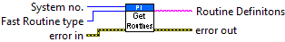

GetScanCenterAndRadius.vi
This VI queries gradient search routines radius and center position via FGC? and FRR? commands. If the routine is not running, POS? is used instead to query the position of the scan and step axis.
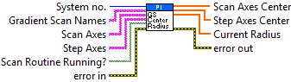

QueryFastRoutineResults.vi
This VI queries FRR? and displays the results for the specified routines.
The parameters used for FRR? are 1, 2, 3 and 5.
Due to limitations of the input buffer size for GCS commands at PI controllers, it is possible to specify the number of Fast Alignment Routines to query with one FRR? command.
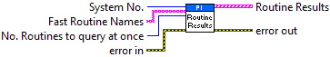

End of document

